**Assignment 204: Layout**

Last modified: 25 January 2022

Make a copy of all of your files from assignment 125 into a new directory under public_html.

The pages you create for this assignment should use valid HTML5 and CSS3 syntax, using the style we have discussed. You should validate your pages using the [W3 validator](http://validator.w3.org/) as well as the [CSS validator](http://jigsaw.w3.org/css-validator/) as described in class.

Make sure any images you link to are less than 128KiB in size.

* Fix any issues I addressed in my feedback on assignment 125 that are relevant to this assignment.
* Use HTML and CSS to create a layout of your main page that approximates the following template.  
  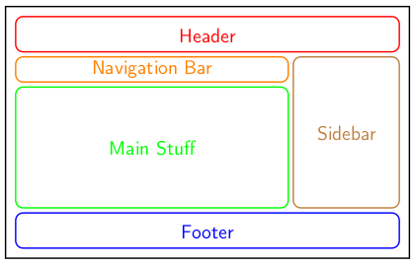  
  Your layout does not have to be exactly like this; for example, you could have a sidebar on both sides, or on the left side only, if you prefer.
* In addition, your product pages should use an appropriate layout to make them attractive and aesthetically pleasing.
* Most of your HTML elements should be labeled with either class or ID, and you must have some of each.
* Use header, nav, section, aside, and footer elements appropriately in your pages. Your main page must have at least one area that has flow-based layout, and at least one area that has non-trivial grid layout. You should not use absolute or fixed positioning.
* In addition to the html files, you must have a single .css file that all of your html files reference. Name this file 204.css and place it in the same directory as the main html file. Make sure your name appears in all files.
* The main purposes of this assignment are to try to:
  + make your site as attractive as possible using CSS styling and layout
  + make each page semantically coherent and well organized
  + make each page of your site as flexible to resizing as possible
  + make your source code very human-readable and aesthetically pleasing
  + use selectors richly and appropriately to select the elements on the site for styling

Create a plain ASCII text document that contains the complete URL of the main page on sand on a single line. This is the document to submit for the assignment.

By 11:30 on Friday, 4 February, submit the text file with the URL to the [homework submission](https://borax.truman.edu/315/submit.php) page.