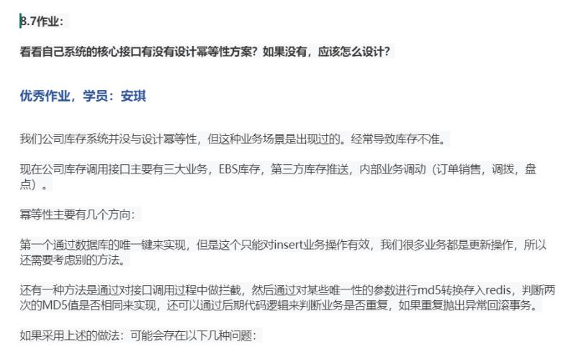

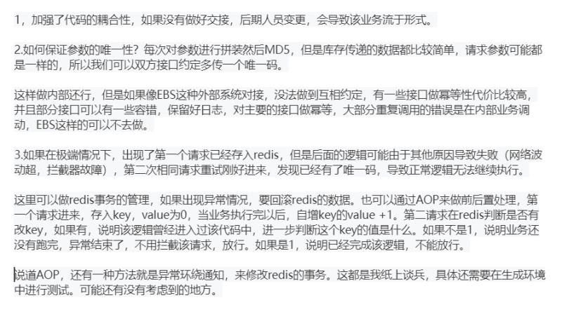

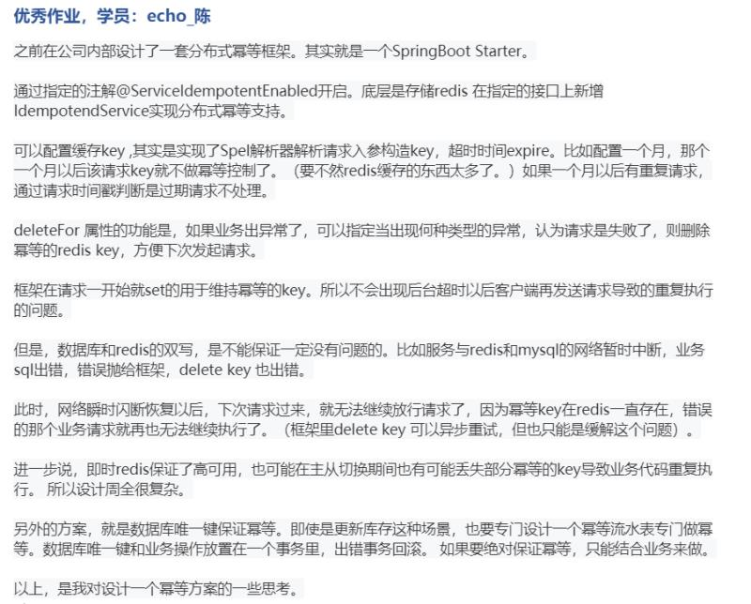

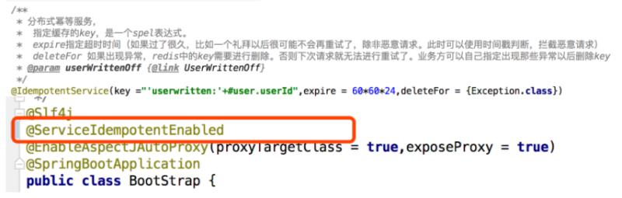



http://wuwenliang.net/2019/03/28/%E8%B7%9F%E6%88%91%E5%AD%A6RocketMQ%E4%B9%8B%E6%B6%88%E6%81%AF%E5%B9%82%E7%AD%89/