Lab 14 Ray casting  
Kyle St.Amant – Game Libraries

Last Updated: 8/21/2016 6:34 PM

Almost water included – it hurts to look at, so please don’t

Mouse Controls:

Standard (Press down key to toggle):

Right click and drag: Rotate avatar (avatar will move using its own coordinate system, not the camera’s  
Left click and drag: Rotate camera around avatar

Middle mouse wheel: zoom in/out

Alternate:

Right click and drag: Rotate avatar and camera

Middle mouse wheel: zoom in/out

Keys:

|  |  |  |
| --- | --- | --- |
| Key | Function | Alternate keys |
| **W** | Move Player Forward | N/A |
| **A** | Move Player Left | N/A |
| **S** | Move Player Backwards (rotates avatar left in camera mode 2) | N/A |
| **D** | Move Player Right (rotates avatar right in camera mode 2) | N/A |
| **R** | Move Player Up (Gravity says otherwise) | N/A |
| **F** | Move Player Down (Ray cast down says otherwise) | Shift |
| **P** | Toggle pause | N/A |
| **0** | Reload config | N/A |
| **9** | Carry/uncarry light | N/A |
| **Z** | Center camera yaw behind object | N/A |
| **DOWN** | Toggle camera mode | N/A |
| - | EXTRA CONTROLS | - |
| **T** | Turn transparency ON | N/A |
| **O** | Turn transparency OFF | N/A |
| **1** | Turn Fullscreen ON | N/A |
| **2** | Turn Fullscreen OFF | N/A |
| **4** | Freeze framebuffer drawing | N/A |
| Y | Decrease grid scale (x .5f) | N/A |
| H | Increase grid scale (x 2.0f) | N/A |
| **.**  **(number pad only)** | Shoot phasor (Stick sphere to wall in camera’s line of sight) | N/A |
| **Spacebar** | Jump | N/A |
|  |  |  |
|  |  |  |
|  |  |  |
|  |  |  |
|  |  |  |
|  |  |  |

Config Values:

|  |  |  |
| --- | --- | --- |
| Key | Description | Type |
| BodaciousQuest.ShowFullScreen | Initial full screen value | bool |
| BodaciousQuest.FpsInterval | Interval of Showfps() | float(can be typed as a double) |
| BodaciousQuest.EnableControls | Enables extra controls | bool |
| BodaciousQuest.LoadCubeFirst | Sets whether cube loads before the pyramid (tetrahedron) | bool |
| BodaciousQuest.CameraWalkMode | Sets initial value for walk mode* | bool |
|  | ObjConverter |  |
| Key | Description | Type |
| ObjConverter.Mode.VertexType | Select pc, pt, pn, ptn | string |
| ObjConverter.Mode.Analyze | Will display num of verts and indices in console, without processing the file | bool |
| ObjConverter.Model | MUST be the name of the obj (without the extension) | string |
| ObjConverter.Color | The mesh’s color | String or three floats |
| ObjConverter.Obj.InputFileFolder | The input file folder | string |
| ObjConverter.Scene.OutputFileFolder | The output file folder | string |
| ObjConverter.Model._____.NumVerts | Indicates num of model verts | string |
| ObjConverter.Model._____.NumIndices | Indicates num of model indices | string |
| ObjConverter.Model._____.NumTexCoords | Indicates num of model texCoords |  |
|  |  |  |
| All the lighting config values |  |  |
|  |  |  |
|  |  |  |
|  |  |  |
|  |  |  |

Notes:   
* Walk mode = freeze camera ‘y’ position when using W, A, S, and D; F and R keys still work.

-My .obj converter concatenates the model name, with an input folder as well as an output folder.

-“random” is lowercase for color

-Analyze only prints out to screen for now…

-MUST set values to 0 in config file to analyze obj’s properly… will fix

-Manual shader set in config:

Screenshots:

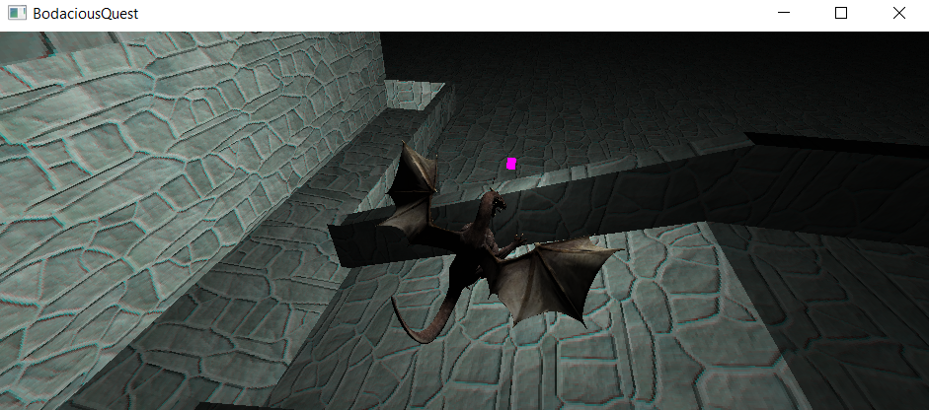

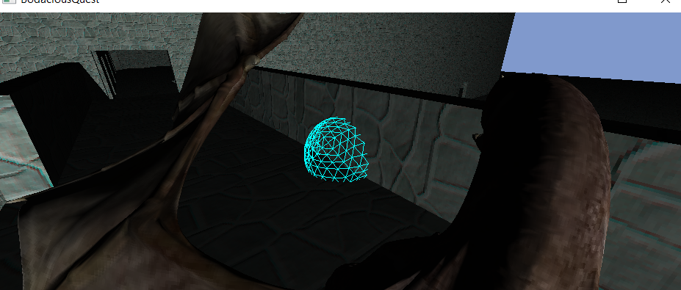

Journal:

8/17/2016:

Spatial and gob components have a strange relationship with yaw – assume the problem is in matrix math, or order of updates

NOTES