Lab 11 Normals Uniforms  
Kyle St.Amant – Game Libraries

Last Updated: 8/9/2016 11:38 PM

IMPORTANT NOTES AT VERY BOTTOM

Keys:

|  |  |  |
| --- | --- | --- |
| Key | Function | Alternate keys |
| **W** | Move Camera Forward | N/A |
| **A** | Move Camera Left | N/A |
| **S** | Move Camera Backwards | N/A |
| **D** | Move Camera Right | N/A |
| **R** | Move Camera Up | Spacebar |
| **F** | Move Camera Down | Shift |
| **P** | Toggle pause |  |
| **0** | Reload config |  |
| **9** | Carry/uncarry cube |  |
|  |  |  |
| - | EXTRA CONTROLS | - |
| **T** | Turn transparency ON | N/A |
| **O** | Turn transparency OFF | N/A |
| **1** | Turn Fullscreen ON | N/A |
| **2** | Turn Fullscreen OFF | N/A |
| **3** | Toggle Camera Walk mode* | N/A |
| **4** | Freeze framebuffer drawing | N/A |
| **9** | Print Camera Info (Pos and Look Vec) | N/A |
| **Q** | Decrease Camera speed | N/A |
| **E** | Increase Camera speed | N/A |
| Y | Decrease grid scale (*.5f) | N/A |
| H | Increase grid scale (*2.0f) | N/A |
| V | Set read model 1 pos to camera pos | N/A |
| C | Make framebuffer plane look at you.(align pos z to point at camera) | N/A |

Notes:   
* Walk mode = freeze camera ‘y’ position when using W, A, S, and D; F and R keys still work.

Config Values:

|  |  |  |
| --- | --- | --- |
| Key | Description | Type |
| BodaciousQuest.ShowFullScreen | Initial full screen value | bool |
| BodaciousQuest.FpsInterval | Interval of Showfps() | float(can be typed as a double) |
| BodaciousQuest.EnableControls | Enables extra controls | bool |
| BodaciousQuest.LoadCubeFirst | Sets whether cube loads before the pyramid (tetrahedron) | bool |
| BodaciousQuest.CameraWalkMode | Sets initial value for walk mode* | bool |
|  | ObjConverter |  |
| Key | Description | Type |
| ObjConverter.Mode.VertexType | Select pc, pt, pn, ptn | string |
| ObjConverter.Mode.Analyze | Will display num of verts and indices in console, without processing the file | bool |
| ObjConverter.Model | MUST be the name of the obj (without the extension) | string |
| ObjConverter.Color | The mesh’s color | String or three floats |
| ObjConverter.Obj.InputFileFolder | The input file folder | string |
| ObjConverter.Scene.OutputFileFolder | The output file folder | string |
| ObjConverter.Model._____.NumVerts | Indicates num of model verts | string |
| ObjConverter.Model._____.NumIndices | Indicates num of model indices | string |
| ObjConverter.Model._____.NumTexCoords | Indicates num of model texCoords |  |
|  |  |  |
|  |  |  |
|  |  |  |
|  |  |  |
|  |  |  |
|  |  |  |

Notes:   
* Walk mode = freeze camera ‘y’ position when using W, A, S, and D; F and R keys still work.

-My .obj converter concatenates the model name, with an input folder as well as an output folder.

-“random” is lowercase for color

-Analyze only prints out to screen for now…

-MUST set values to 0 in config file to analyze properly… will fix

Screenshots:

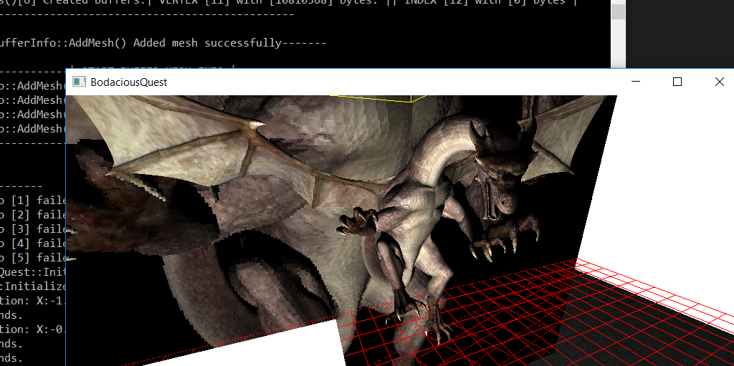

Journal:

8/3/2016:

***Never***_ add the same gob or mesh twice. Causes infinite loops.

NOTES

“BodaciousQuest.LightingTest.Light.Position” is the value that will be reloaded when 0 is pushed

I added lighting and textures, hopefully that makes up for PCTN not being set up yet, and the objects with normald are instead a dargon with program-calculated normal(see obj converter);

Uniform manager doesn’t work

Uniforms are set through a callback, however, only dargon and daniel’s hideout have callbacks as of now, the others are set in render engine. (no time to add).

A weird DTAR folder appeared in my solution directory… don’t want to mess with it right now