**Numerical Analysis – Fall 2024**

Assignment #3

Issued: Sep. 21, 2024 Due: Oct. 8, 2024

**Please upload to the ‘hw3’ directory if you submit your homework in time.**

**Problem 1:**

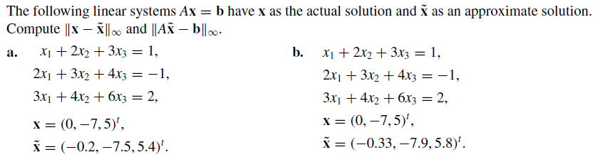

**Problem 2:**



**Problem 3:**

Implement the algorithm of Gaussian elimination with scaled partial pivoting, and solve the following linear systems.

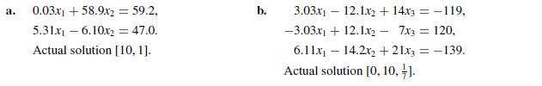

**Problem 4:**

Implement the Jacobi iterative method and list the first three iteration results when solving the following linear systems, using **x**(0) = **0**.

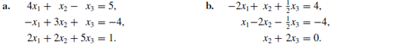

**Problem 5:**

Use the Jacobi method and Gauss-Seidel method to solve the following linear systems, with TOL = 0.001 in the L $∞$ norm.

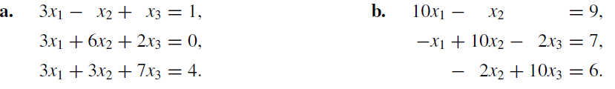

**Problem 6:**

Prove: If **A** is a matrix and $ρ_{1},ρ_{2},⋯, ρ_{k}$ are distinct eigenvalues of **A** with associated eigenvectors $x_{1},x_{2},⋯,x_{k}$, then $\{x_{1},x_{2},⋯,x_{k}\}$ is a linearly independent set.

**Problem 7:**

Prove that a strictly diagonally dominant matrix is invertible.