ImageFlow

Post Effect for Unity Urp

Quick Guide

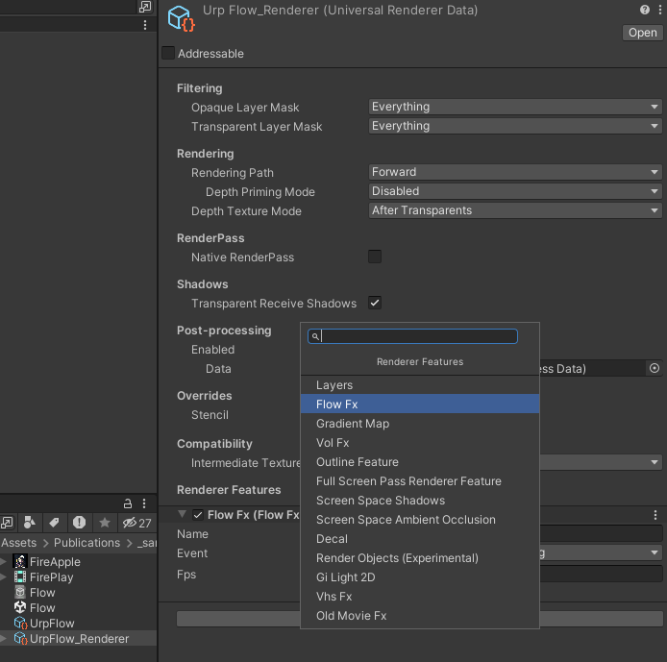Add FlowFx render feature to UrpRenderer

Flow effect works by blending each new frame with the previous one by weight,  
adding displacement and rotation, can be combined with other post effects to create scenes of confusion or strange flow.

Configure Flow settings via VolumeProfile

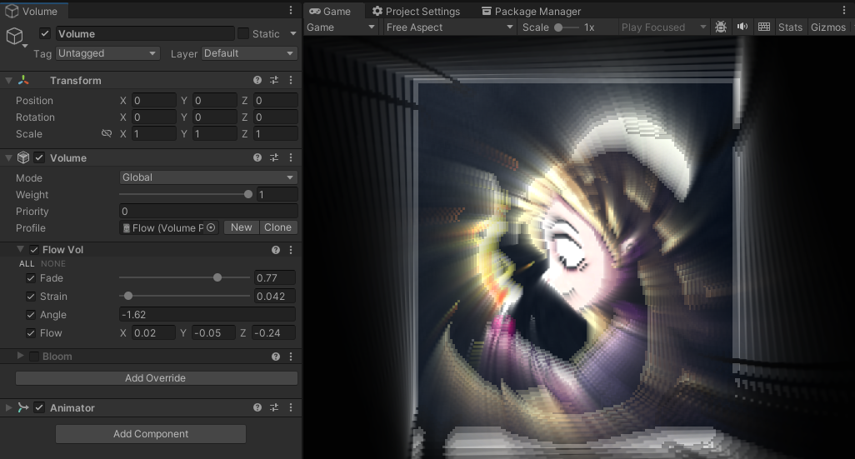

The feature is fps dependent and is rendered with target frame specified in the asset,  
this means that new frames for blending will be taken at the specified frame rate,  
if the frame rate is higher it does not affect the picture, otherwise the effect will look different.