GradientMap

Post Effect for Unity Urp

Quick Guide

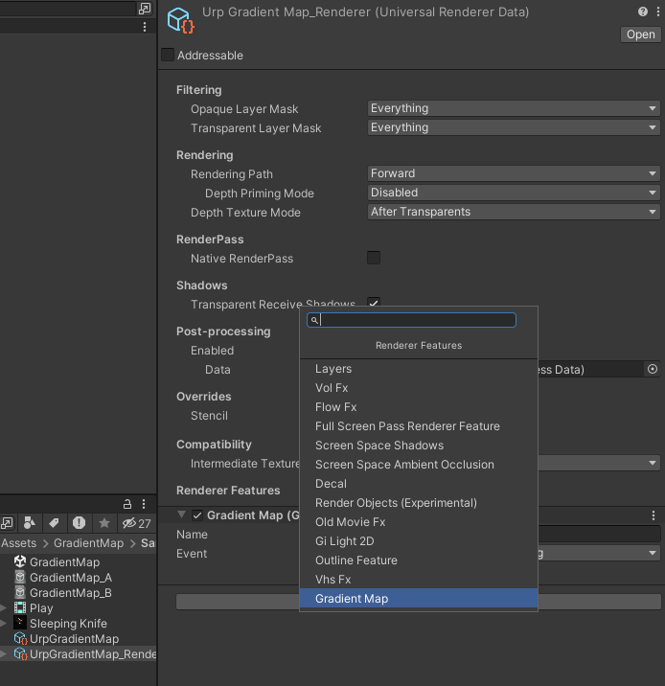Add **GradientMap** render feature to UrpRenderer

The concept is taken from graphic editors when an image a colored  
by gradient from their grayscale values ([gradient map](https://www.bcit.cc/cms/lib04/NJ03000372/Centricity/Domain/299/p6_howto_use_gradient_maps 18.pdf) in photoshop)

Configure **GradientMap** settings via VolumeProfile

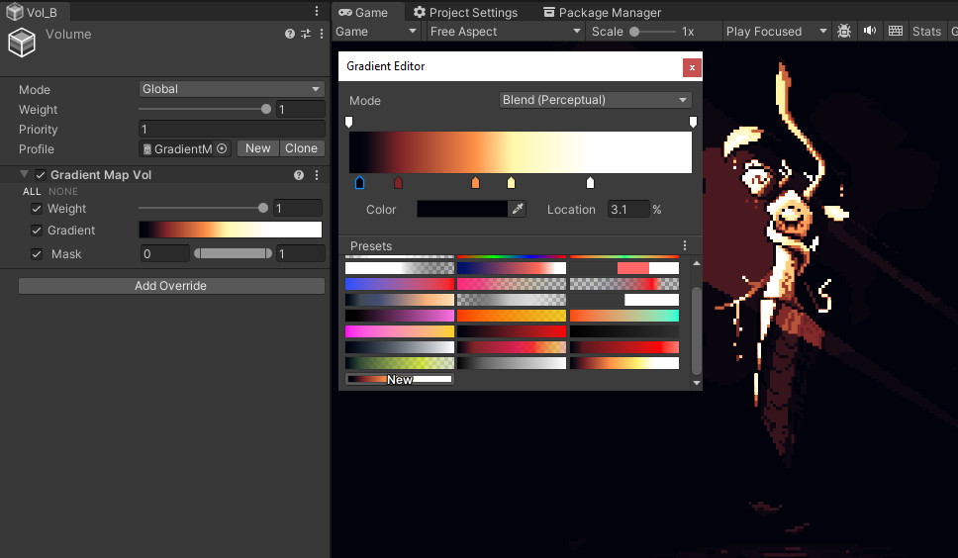

Gradients a support runtime blending and can be used for palette swapping,creating short fx events or static pulsing of light.