THE DEPARTMENT OF COMPETITIVE SAFETY PRESENTS
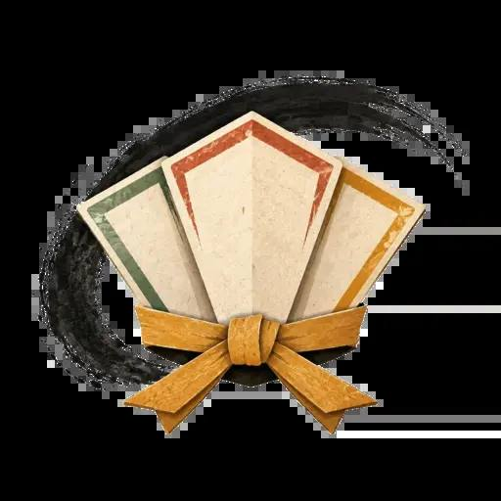

DOJO DECKBUILDER
  - v2.3 Official Glossary · Define Before Yelling

v2.3 · September 2026
Unified Card List · Official Field-Test Edition
Rules and updates: nullableninja.github.io/dojo-deckbuilder

Registered terminology
These are the 59 official terms used by the v2.3 rules and card catalog. Card text uses the capitalized game term when it refers to this definition; ordinary English remains ordinary English, pending departmental review.
Term | Official meaning
Aftermath Combo | A learned Combo whose payoff resolves after its entire printed sequence resolves.
Anytime | Timing that permits play between actions or in a Reaction Window when you have priority; never during another effect's resolution.
Armor | Permanent Equipment that adds DEF only against its printed zone or zones. Armor is ignored by Piercing but not by effects that ignore only a Defense card.
Attack | A legal strike played from hand with a target and declared zone. It contributes printed Attack Power and normally earns 1 XP after resolving.
Attack Limit | A player may normally play two Attacks per turn. Flow and Combo Extension are the only core exceptions.
Attack Power | The attack-side combat total before Defense is subtracted: printed Attack Power, Character ATK, eligible Weapon bonuses, and modifiers.
Belt Exam | The public certification task for your next Belt. Mark it PASSED when complete, then promote during Ascend after reaching the required XP.
Blocked | An Attack that deals 0 damage after final Attack Power and Defense are compared.
Boss Profile | A named Boss card that supplies ATK, DEF, Speed, stage fit, and one deterministic Boss Rule. It pairs with a Boss Stage; it does not use a hand, Focus, Equipment, or choices.
Boss Stage | A Rival, Mini-Boss, or Final Boss overlay supplying HP, Attack Bonus, attack count, and stage rules.
Combo | A learned sequence from the separate face-down Combo Deck. Complete its requirement and resolve its payoff.
Combo Extension | Once per turn, permission to play the third Attack required as a learned Combo's Finishing Technique beyond the normal Attack limit.
Consumable | One-use Equipment returned to the box or supply after resolving.
Controlled Refill | After a Market purchase, reveal two Market cards. The buyer chooses one to fill the empty slot and discards the other. It does not apply to setup or full-row refreshes.
Current Speed | Printed Speed plus active modifiers. Used for initiative, Tempo, Boss comparisons, and card effects unless text says printed Speed.
Damage | HP lost after final Attack Power is reduced by final Defense, minimum 0. Damage prevention applies to this result unless an effect says otherwise.
Defense | A Reaction card played against an incoming Attack. It must protect the declared zone and adds its printed Guard to the defender's combat total.
Defense Practice | Once during your Yell, reveal one Defense from hand, place it in your play area, and gain its printed Focus. It is not played, resolves no text, grants no XP, satisfies no requirements, and is discarded during Hide.
Destroy | Remove a card from the game to the public Destroyed pile.
Direct Damage | HP loss that is not an Attack; it normally uses no ATK, Weapons, Tempo, Combo steps, Attack XP, or Defense window.
Discard | Move a card to its appropriate face-up discard pile. Discarding is not Destroying and grants nothing unless an effect says so.
Draw | Move the top card of your draw deck into your hand. If the deck empties during a draw, shuffle the discard pile only then and continue.
Enraged | Solo Final Boss state at 30 HP or less; it makes two Boss Attacks during its Boss Turn.
Equip | Place permanent Equipment from hand beside the active Character during Initiate, obeying every slot and Hand limit. A legal on-turn Equip generates printed Focus.
Equipment | The umbrella card family containing permanent Weapons, Armor, and Gear plus one-use Consumables and Items. A card's subtype and timing determine how it is used.
Exhaust | Turn a ready permanent Equipment card sideways to pay an exhaust cost. Passive text remains active unless the card says otherwise.
Finishing Technique | The final required card or action in a Combo sequence.
Flow | The first Attack with Flow each turn does not count against the normal two-Attack limit. Only one Attack receives this exemption per turn.
Focus | Temporary purchasing power. Cards played or Equipped from hand during your own turn—and one Defense used for Defense Practice—generate Focus; spend it during Ascend and lose the remainder during Hide.
Focus Cost | The amount of Focus required to buy a Market card or learn a revealed Combo. It is not a play cost or victory value.
Focus Value | The Focus a card generates when legally played or Equipped from hand during your own turn, or when a Defense is used for Defense Practice.
Golden Rule | When a card directly contradicts the rulebook, the card wins. If ambiguity remains after timing and priority, the active player makes a temporary ruling.
Guard | The value a Defense card adds to final Defense against one Attack. Guard is not Character DEF or Armor DEF.
Hand Size | The number of cards normally drawn during Hide: five, or six at Blue Belt. Retained or set-aside cards can make the resulting hand larger.
Hit | An Attack that deals at least 1 damage after final Attack Power and Defense are compared.
Interfere | A Reaction played by a bystander during another player's conflict.
Junk | Starter-deck baggage with no useful printed effect. Bad Habit is Junk, generates 0 Focus, and may still be counted, discarded, or Destroyed by specific effects.
Kata | An on-turn Technique used for training, setup, card flow, Focus, Speed, or Flow. It is not an Attack or Defense unless an effect explicitly treats it as one.
KO | A Character reaches 0 HP.
Market | The seven-card shared purchase area filled from one mixed deck. Purchases use Controlled Refill; setup and end-round refreshes remain random. Combos are separate.
Max HP | The highest current HP a Character may have. Promotions normally raise it, but Quick Duel ignores promotion Max-HP increases and promotion healing.
Modifier Combo | A learned Combo that changes its final required step before that step resolves.
On Reveal | Text resolved immediately when a card enters play by being revealed, before its Ongoing text is used.
Ongoing | A card or effect that remains active in play.
Piercing X | Ignore X Armor DEF for an Attack; do not ignore Character DEF or a Defense card.
Printed | The value or wording physically recorded on a card before modifiers. A copied or modified value is not printed unless an effect says it is.
Reaction | A card or ability played during a specific response window.
Ready | An Equipment card is ready when it is upright and may pay an exhaust cost. All of a player's exhausted Equipment becomes ready at that player's Initiate Phase.
Reversal | Once per round, after a Defense you played Blocks an Attack, immediately play one Attack from hand against that attacker. It resolves normally, does not count against the normal Attack limit, cannot make another Reversal, and grants no Focus.
Revive | Restore a KO'd Character to the printed HP amount without restoring discarded Equipment.
Round | One Honor Phase plus every eligible player and Boss turn in the initiative order locked during Honor.
Scene Change | After its triggering effect finishes, replace the current Location and resolve On Reveal.
Slot | The Equipment position a permanent occupies, such as Head, Chest, Arms, Legs, Feet, Accessory, or one or two Hands. A Character cannot occupy the same limited slot twice unless an effect allows it.
Status Effect | A named temporary condition created by a card or scenario, such as Disarmed or Untargetable. Its creating text supplies its duration and exact effect.
Tag | During Initiate in a roster mode, replace the active Character with a conscious benched Character. Tagging does not change the locked initiative order or refresh Tempo.
Tempo Advantage | Once per round, a faster active fighter may give their Attack +1 Attack Power or their Defense card +1 Guard against a slower opposing active fighter.
Unblockable | Defense cards cannot be played; Character DEF and Armor still apply unless text says otherwise.
XP | Permanent Experience used for Belt promotion and Black Belt Victory. XP is not spent.
Zone | High, Mid, or Low. An Any Attack chooses one zone when declared; a Defense or Armor must match that declared zone unless text says otherwise.

