Heuristic Review

I'm using a 13' macbook pro to run this task, the heuristic I use is as followed:

Custom_score1: (my_moves - 2 * my_opp)

Custom_score2: (my_moves - 1 * my_opp)

Custom_score3: (my_moves - 3 * my_opp)

And the following two result is different with applying 150ms and 300ms time limit.

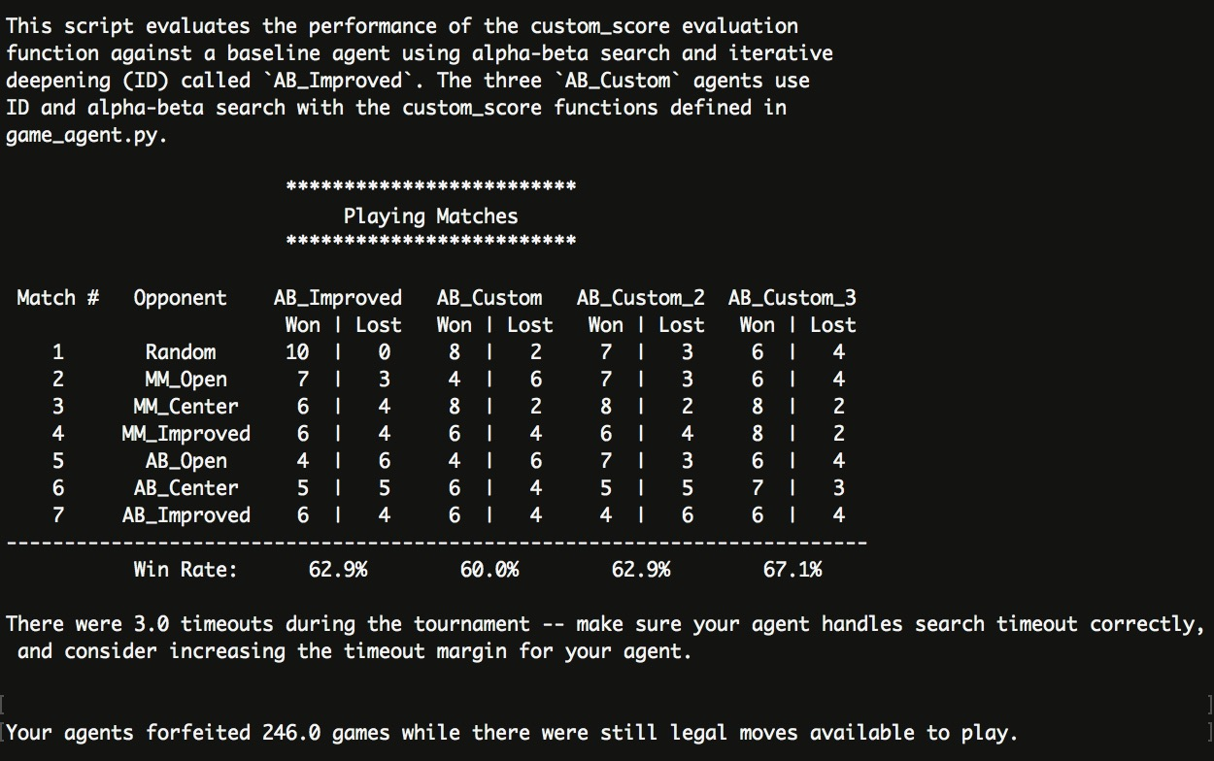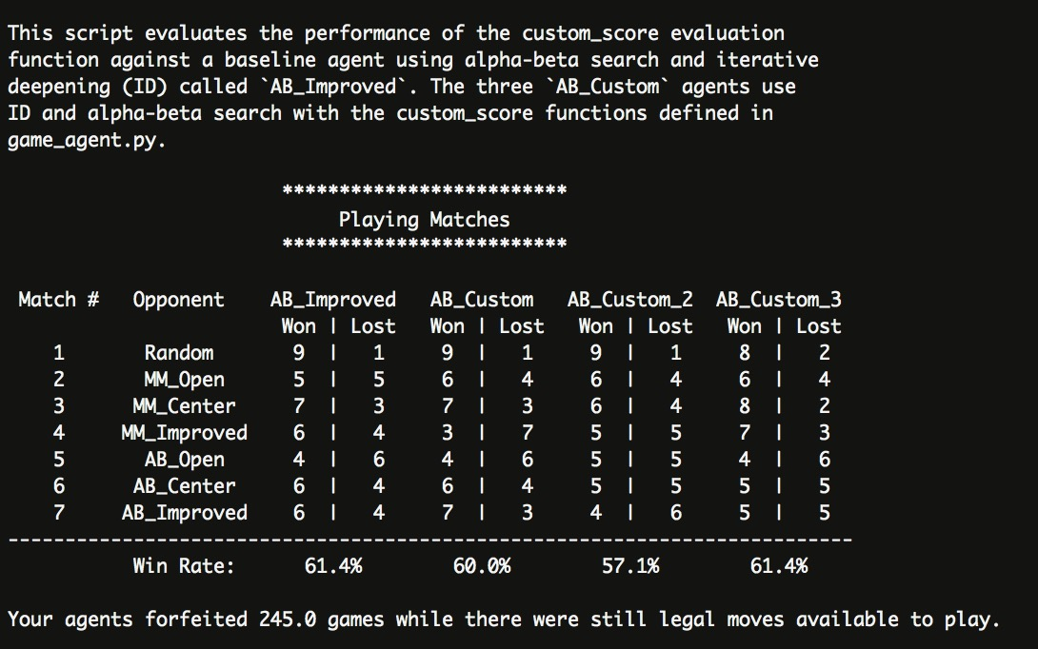

At first case, the timeout happened due to the performance of my laptop, although the search tree is pruned, the agent still can't go deep enough to find the good result. By doubling the time limits, the average performance of AB_Improved and Cumstom_score1(which is given in the lecture) does not change very much (maybe we still not go deep enough so the result doesn't change). But the result of another two heuristic decrease a little. Thus we can say that those heuristic works well with very little time limit, it can give us a swift feedback in small amount of time. But as the tree goes deeper, these heuristic does not robust any more, thus we need a more general and better heuristics. So that I stick with the Custom_score1 since it has a better physical significance.