<?xml version="1.0" encoding="utf-8" ?>

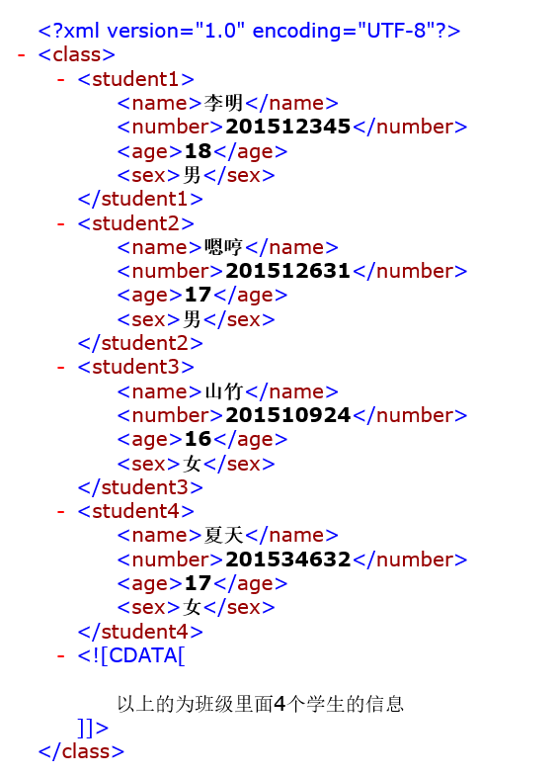

<class>

<student1>

<name>李明</name>

<number>201512345</number>

<age>18</age>

<sex>男</sex>

</student1>

<student2>

<name>嗯哼</name>

<number>201512631</number>

<age>17</age>

<sex>男</sex>

</student2>

<student3>

<name>山竹</name>

<number>201510924</number>

<age>16</age>

<sex>女</sex>

</student3>

<student4>

<name>夏天</name>

<number>201534632</number>

<age>17</age>

<sex>女</sex>

</student4>

<![CDATA[

以上的为班级里面4个学生的信息

]]>

</class>