Bathymetry Cross-Section Test Script

Overview
This script runs a full pipeline test using EcoSons to:
- Load sonar data from .raw files.
- Compute the bottom detection using parameters defined in a JSON config.
- Generate bathymetry from the bottom-detected data.
- Compute transect cross-sections from the bathymetry.
- Plot and export the resulting transects to a file.
It is designed to be run either:
- As an individual test script.
- Or as part of a full package test using Pkg.test().

1. Transect Cross Computation

TRANSECTCROSS, useUTM = computeCrosses(baths;
point_subsampling = config["bathycross"]["point_subsampling"],
use_utm = config["bathycross"]["useUTM"]
)
Computes cross-sectional profiles of the seabed. If useUTM = true, geographic coordinates are converted to UTM for better planar interpolation.

2. Plotting

plot_bathycross(TRANSECTCROSS, useUTM)
Generates and displays a cross-sectional plot of the seabed profile.
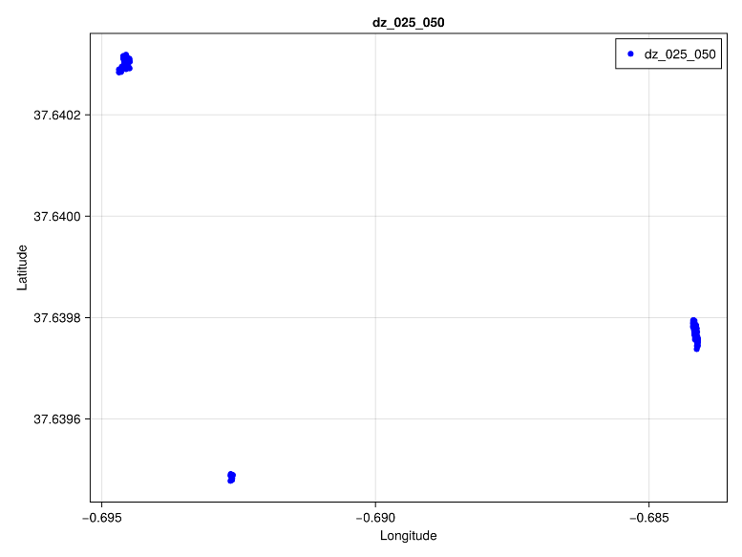

Bathymetry cross-section where the differences of depth are between 0.25 and 0.5

3. Export to File

export_bathycross(TRANSECTCROSS, export_file)
Saves transect cross-section data (e.g., distances and depths) to a .dat file specified in the config.

