Echogram.jl: Echogram Bottom Detection and Export
This test script performs a complete workflow using the EcoSons package, from loading sonar data and detecting the seafloor (bottom), to visualization and exporting. It uses a configuration file (params.json) to control processing parameters.

1. Load Dependencies

using EcoSons
using Test
using JSON
- EcoSons: A package for sonar data processing (custom module).
- Test: ’s built-in testing library.
- JSON: Used to parse the configuration file in JSON format.

2. Define and Start Test Set

@testset begin
Starts a Test block, allowing the entire pipeline to be wrapped in test assertions if needed (though no actual @test expressions are used here — it's primarily a script run under the testing framework).

3. Load Configuration Parameters

json_path = joinpath(@__DIR__, "../config/params.json")
config = JSON.parsefile(json_path)
- Loads a configuration file that contains paths and processing parameters such as:
  - data_dir: Directory containing sonar files.
  - channel: Transducer channel to read.
  - transect: Index or key to select a specific section of the data.
  - bottom_detection: Dict of keyword arguments for the bottom detection algorithm.

4. Prepare File Paths

dir = joinpath(@__DIR__, config["data_dir"])
files = filter(f -> endswith(f, ".raw"), readdir(dir))
full_paths = joinpath.(dir, files)
channel = config["channel"]
- Builds a list of full paths to .raw sonar data files in the specified directory.

5. Load Sonar Data

data, dim = load_sonar_data(channel, full_paths)
- Loads sonar data from the listed .raw files using the specified channel.
- Returns:
  - data: A vector of ping records, each holding metadata and echo data.
  - dim: Dimensional info (number of channels).

6. Save Sonar Data

jld2dir = joinpath(@__DIR__, config["JLD2_dir"]["data"])
saveJLD2("$(jld2dir)", data)

• Constructs output path from config.
• Saves the sonar data in JLD2 format for efficient future loading

7. Select Transect

transect = config["transect"]
- Loads the transect index or filter parameters.
- (Commented-out code suggests the option to select data by lat/lon bounding box.)

8. Apply Bottom Detection

bottom_args = Dict(Symbol(k) => v for (k, v) in config["bottom_detection"])
data = compute_bottom(data; bottom_args...)
- Converts string keys from JSON into symbols for keyword arguments.
- Applies compute_bottom, a function that detects the seafloor in the sonar data using configurable parameters (e.g., thresholding, smoothing).

9. Inspect Sound Velocity (Optional Debug)

println(data[1].Q[2].sampleInterval) # First ping
- Debug/inspection step: prints the sampleInterval of the second transducer header in the first ping.

# set_sound_velocity!(data; velocity = velocityUNESCO(20.0, 35.0, 10.0))
- (Commented out): optionally set sound velocity using the UNESCO formula for temperature/salinity/depth.

10. Subset Data for Transect

data_selected = data[transect]
- Extracts only the data for the transect of interest.

11. Plot the Echogram with Bottom

plot_echobottom(data_selected)
- Displays an echogram (2D grayscale or color image) with detected bottom overlaid:
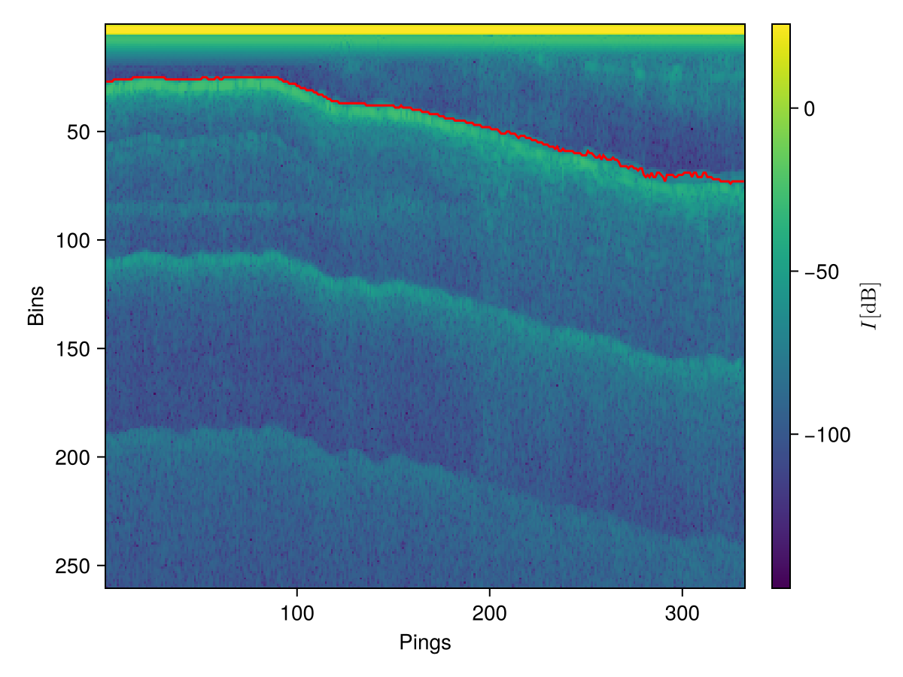

12. Plot a Single Ping

ping = 1
plot_ping(1:length(data[transect].P[ping,:]), data[transect].P[ping,:])
- Plots the echo power (amplitude) for a single ping in the transect.
- X-axis: sample indices; Y-axis: signal strength.
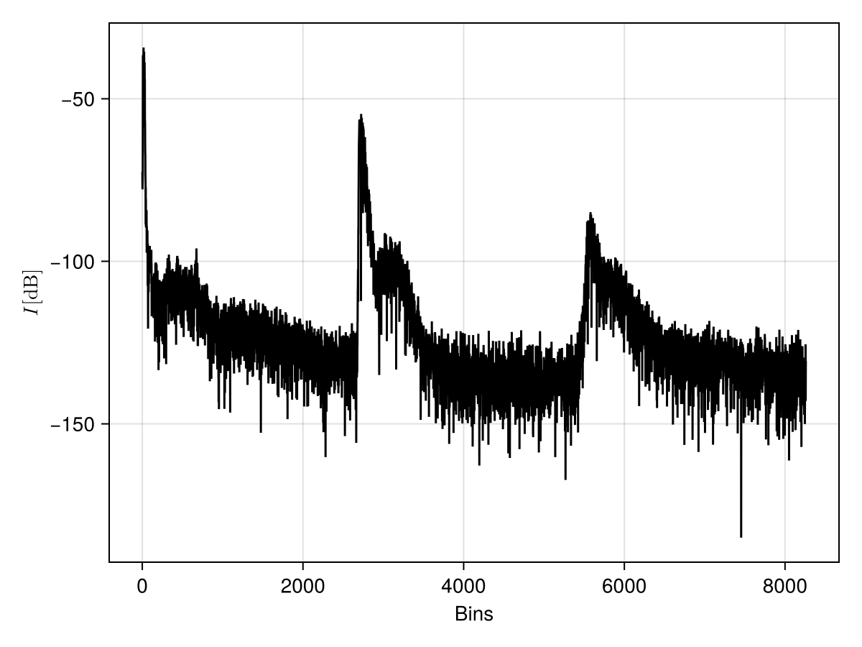

13. Export Bottom-Detected Data

export_name = "echobottom.dat"
export_dir = joinpath(@__DIR__, "..", "data", export_name)
export_echobottom(data_selected, transect, export_dir)
- Exports the processed transect (with bottom detections) to a .dat file for further use or external analysis.

Summary
This script automates a sonar data processing workflow using configuration-driven parameters:
- Loads .raw sonar data files.
- Applies bottom detection.
- Optionally adjusts physical parameters (e.g., sound velocity).
- Visualizes both echograms and individual pings.
- Exports the annotated data for downstream analysis.

