Interpolation.jl

Interpolation Tests
This script performs a series of tests and visualizations for processing echosounder (sonar) data. It covers the full pipeline—from raw data loading to bottom detection, gridding/interpolation, and exporting results for mapping or analysis. The script uses settings from a JSON configuration file and is structured as a unit test block.

Key Steps Explained

1. Bathymetry Interpolation and Plotting
- The bathymetry is interpolated into a regular grid using preproc_interpolation.
plot_interpolation(Is, utmCoords, gX_min, gX_max, gY_min, gY_max, znCoord; sel = 1)
- Options: 1 = colored heatmap, 2 = 3D surface, 3 = contour map
- The interpolated bathymetry is displayed using CairoMakie.
- The interpolated data is also exported to disk using export_interpolation.

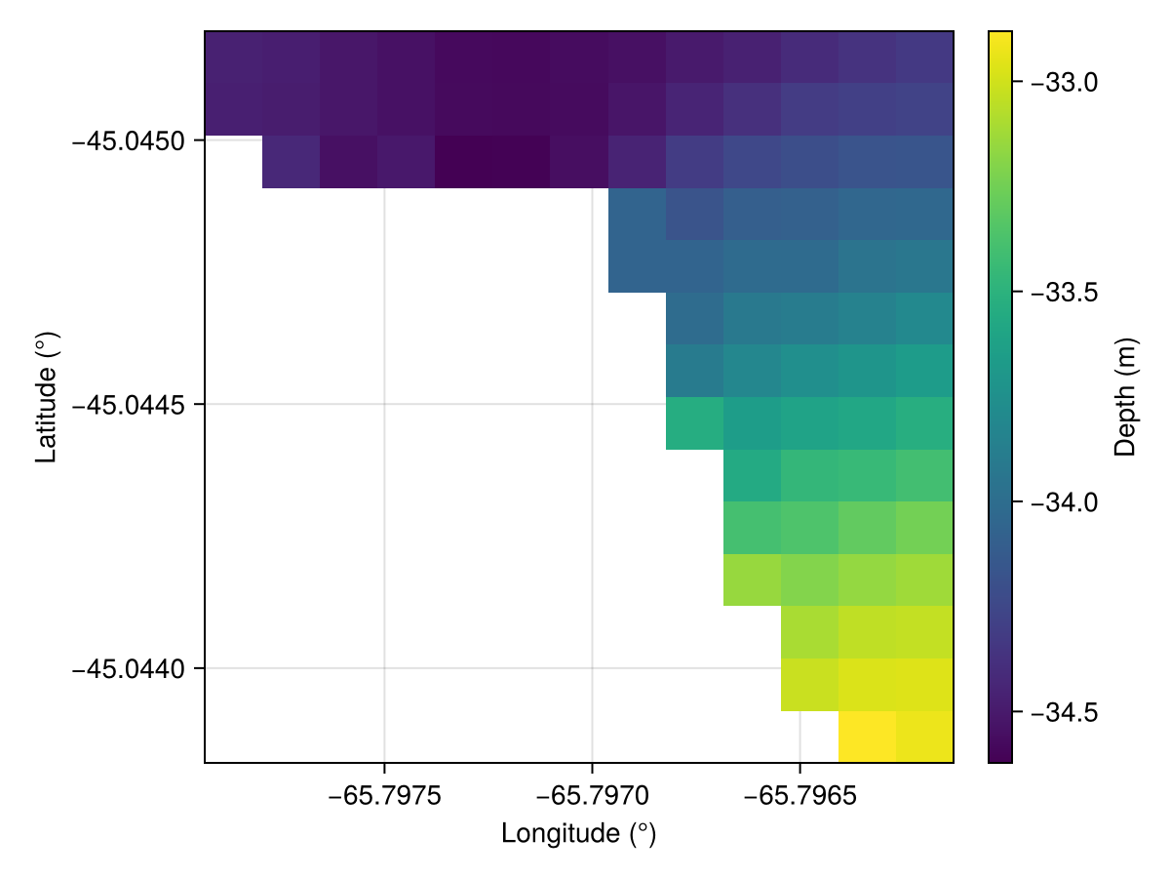

2. Test: xyz2img
- Synthetic X, Y, Z point data is generated to simulate terrain.
- The function xyz2img converts this scattered data into a gridded image using either mean or inverse-distance weighting (IDW).
- The result is visualized as a heatmap to verify the interpolation.
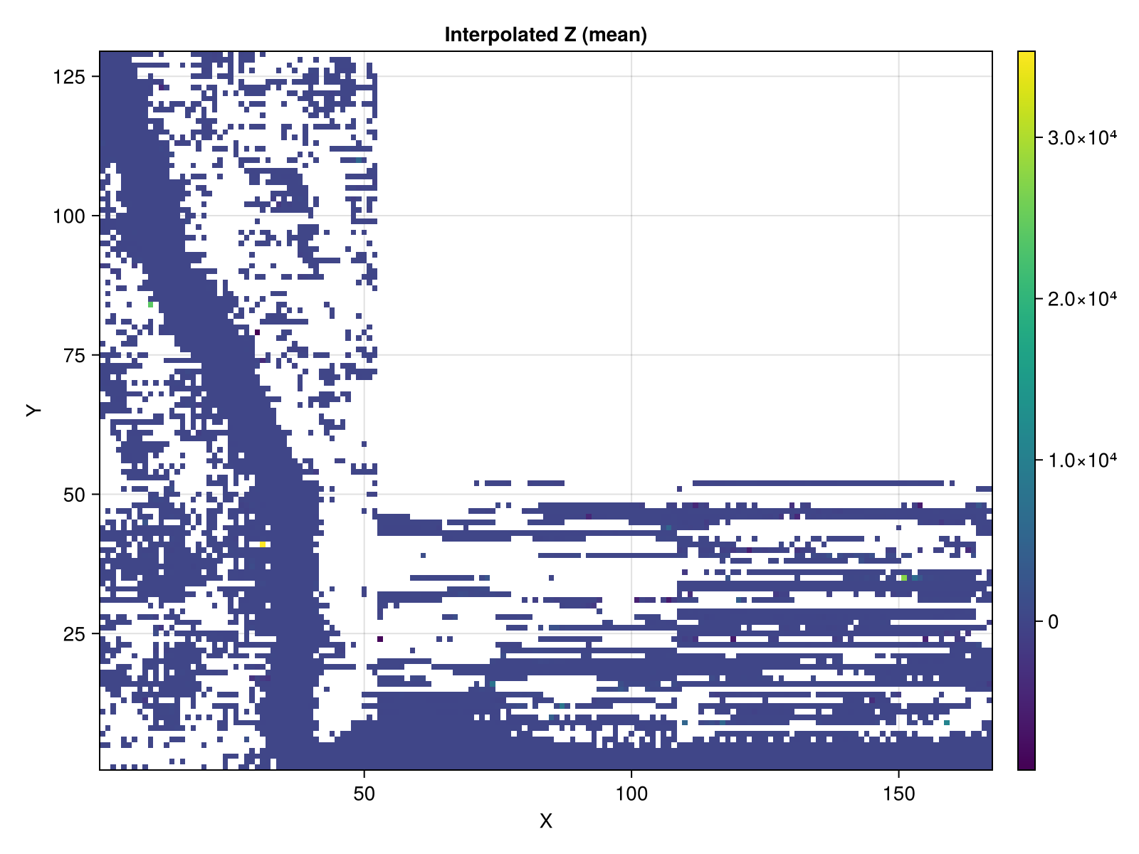

3. Test: intershapes
- This test checks interpolation between disjoint shapes (e.g., polylines).
- Points from two shapes are interpolated at fixed spacing.
- Original and interpolated points are plotted together for visual confirmation.

7. Test: interpPS!
- This tests GPS interpolation on partially missing GPS sequences.
- A small GPS list with missing entries is passed to interpPS!, which fills in the gaps linearly.
- The updated GPS coordinates are printed to validate correctness.

