Transects.jl

- Compute bathymetry data (see test_bathymetry)

- Preprocess Transects for Plotting and Export

ntr, utmCoords, xCoord, yCoord, znCoord, depth, _ = preproc_transects(
baths, data; sel = config["transects"]["sel"], use_utm = config["transects"]["use_utm"])
- Extracts and organizes transect data for selected sections (sel) with optional coordinate conversion to UTM.
- Returns multiple coordinate and depth arrays for downstream plotting and export.

- Plot Transects (2D Still Images)

transect_args = Dict(Symbol(k) => v for (k, v) in config["transects"]["plot"])
plot_transects(ntr, utmCoords, xCoord, yCoord; depth = depth, znCoord = znCoord, transect_args...)
- Converts plotting parameters to symbols for keyword splatting.
- Generates 2D plots of transect lines with depth overlays, configured by JSON options.
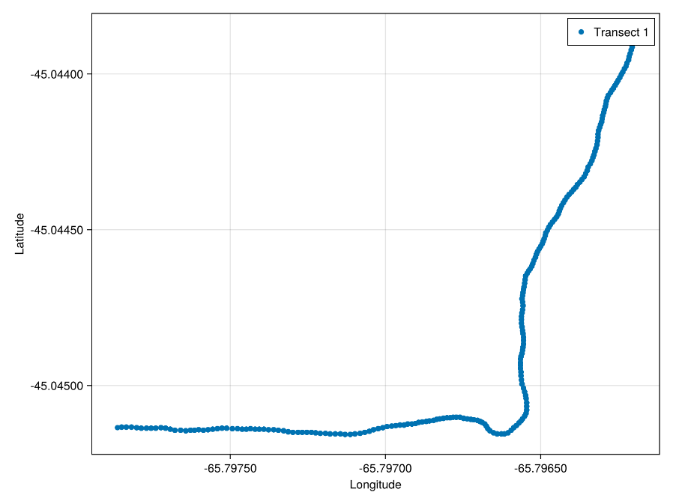

- Additional Plotting (Commented Out but fully functional)
- Several blocks for alternative plotting modes are included but commented out:
  - 2D transect GIF animation.
  - 3D transect plotting with still images or GIFs.

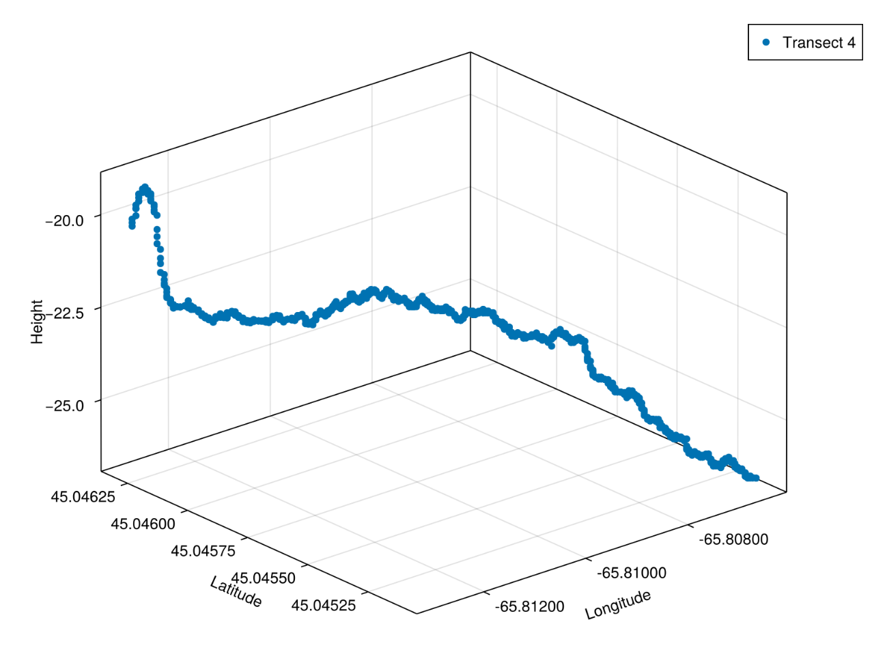

- Export Transect Data

export_dir = joinpath(@__DIR__, config["transects"]["export"]["file"])
n_step = config["transects"]["export"]["n_step"]
export_transects(ntr, utmCoords, xCoord, yCoord, znCoord, export_dir; n_step = n_step)
- Defines export file path and step size for subsampling.
- Saves transect coordinates and depths to disk for external use.

Summary
This script automates:
- Loading and parsing configuration parameters.
- Loading raw sonar files and detecting seafloor bottom returns.
- Computing bathymetry profiles.
- Preparing transect data with flexible coordinate systems.
- Visualizing transect lines and bathymetry in 2D plots.
- Exporting processed transect data for further analysis.

