**

**A PROJECT REPORT ON**

**AUTOMATION TESTING ON AMAZON**

**BY**

**NAMRATA SHINDE**

**BATCH: (2020-5343)**

**COURSE: SCHOOL OF CODING CERTIFIED SOFTWARE TEST ENGINEER**

**UNDER THE GUIDANCE OF,**

**PRIYANKA DESALE**

**(TECHNICAL TRAINER)**

**EDUBRIDGE**

**INTRODUCTION**

**THIS PROJECT AIMS TO DO OVERALL TESTING LIKE FUNCTIONAL TESTING, GUI TESTING ON WEBSITE TO CHECK QUALITY OF APPLICATION. IT HELPS TO IMPROVE QUALITY OF WEBSITE AND SAVES TIME FOR MANUALLY DOING THIS TESTING. IN THIS PROJECT OUR MAIN FOCUS IS TO CHECK FUNCTIONALITIES AVAILABLE ON WEBSITE. ALSO, IT INCLUDES TITLE CHECK AND ALL LINKS COUNT WITH THEIR WORKING STATUS.**

**SOFTWARE REQUIREMENTS**

* **OPERATING SYSTEM: WINDOWS 10**
* **BROWSER: CHROME VERSION 91.0.4472.124**
* **IDE: ECLIPSE IDE**
* **AUTOMATION TOOL: SELENIUM WEBDRIVER**
* **TESTNG FRAMEWORK**
* **FRONT-END: JAVA**

**Testcases**

**TC01 : Launch the browser and open Amazon Website.**

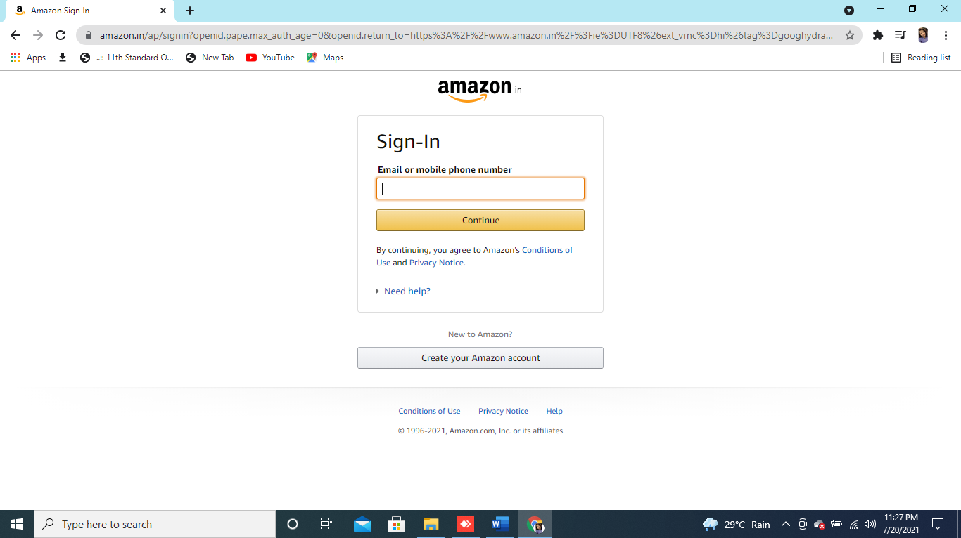

System.*setProperty*("webdriver.firefox.driver", "C:\\firefoxdriver.exe");

WebDriver w = **new** FirefoxDriver();

// To Open Url

w.get("http://amazon.in");

**TC02 :Verify if a user will be able to login with a valid username and valid password.**

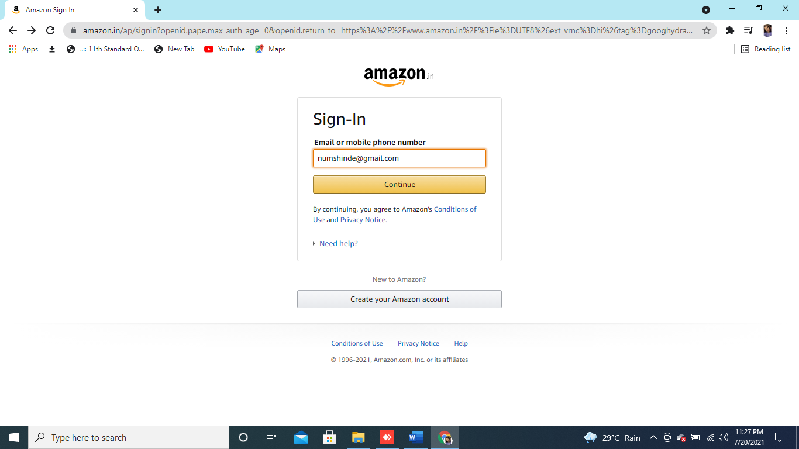

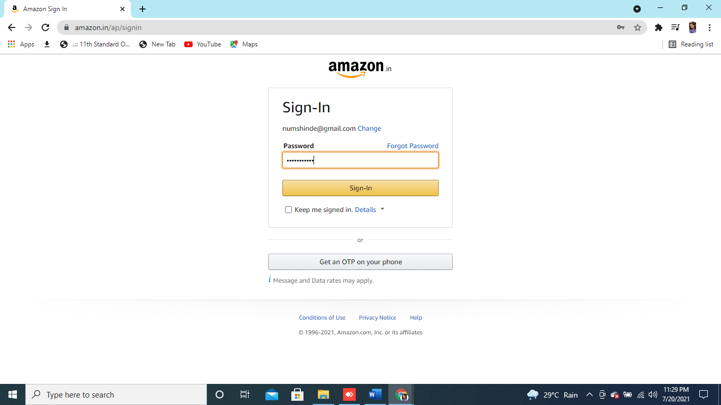

//SIGN IN with valid username And password

w.findElement(By.*xpath*("//*[@id=\"nav-link-accountList\"]/span")).click();

w.findElement(By.*id*("ap_email")).sendKeys("numshinde@gmail.com");

w.findElement(By.*id*("continue")).click();

w.findElement(By.*id*("ap_password")).sendKeys("Namrata@123");

w.findElement(By.*id*("signInSubmit")).click();

**TC03 :Verify the ‘Forgot Password’ functionality.**

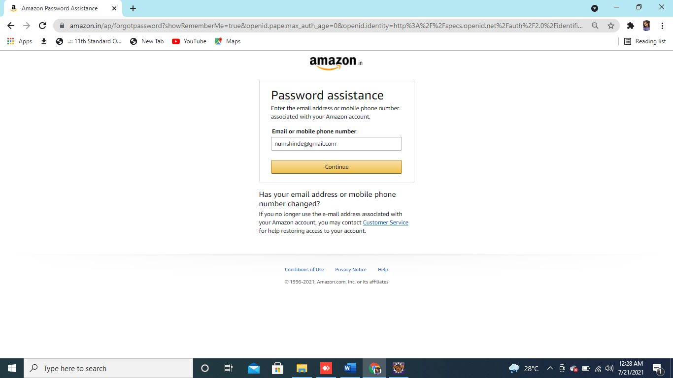

**TC04 :Verify the messages for invalid login.**

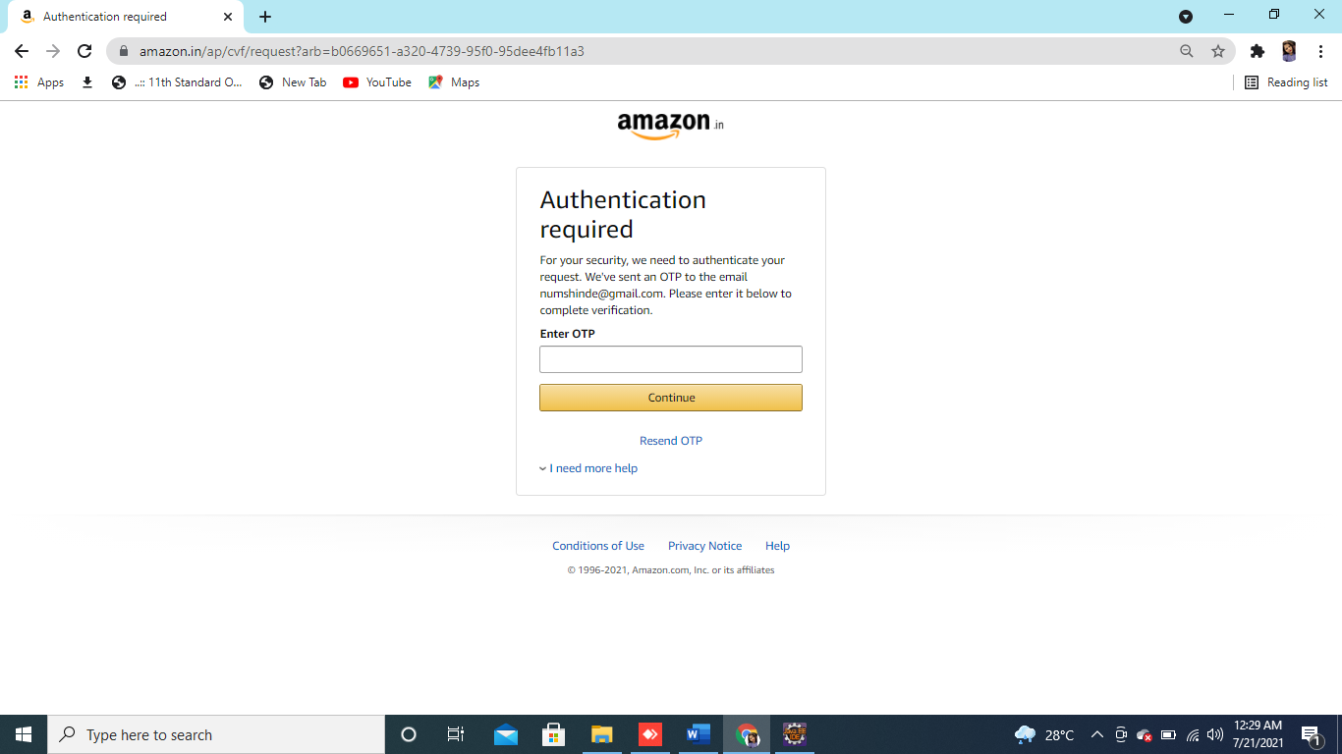

//SIGN IN with forget password

/w.findElement(By.xpath("//[@id=\"nav-link-accountList\"]/span")).click();

w.findElement(By.id("ap_email")).sendKeys("numshinde@gmail.com");

w.findElement(By.id("continue")).click();

w.findElement(By.linkText("Forgot Password")).click();

w.findElement(By.id("continue")).click();

w.findElement(By.id("cvf-input-code")).sendKeys("581234");

w.findElement(By.className("a-button-input")).click();

w.findElement(By.id("ap_fpp_password")).sendKeys("Namrata@123");

w.findElement(By.id("ap_fpp_password_check")).sendKeys("Namrata@123");

w.findElement(By.id("continue")).click(); */

**TC05 :Verify if a user is able to login with a new password only after he/she has changed the password.**

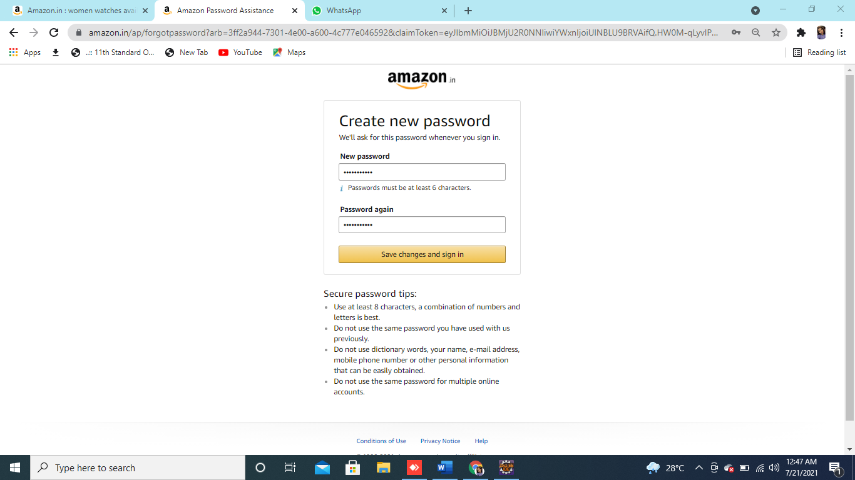

**TC07 :Add one item to the cart and verify.**

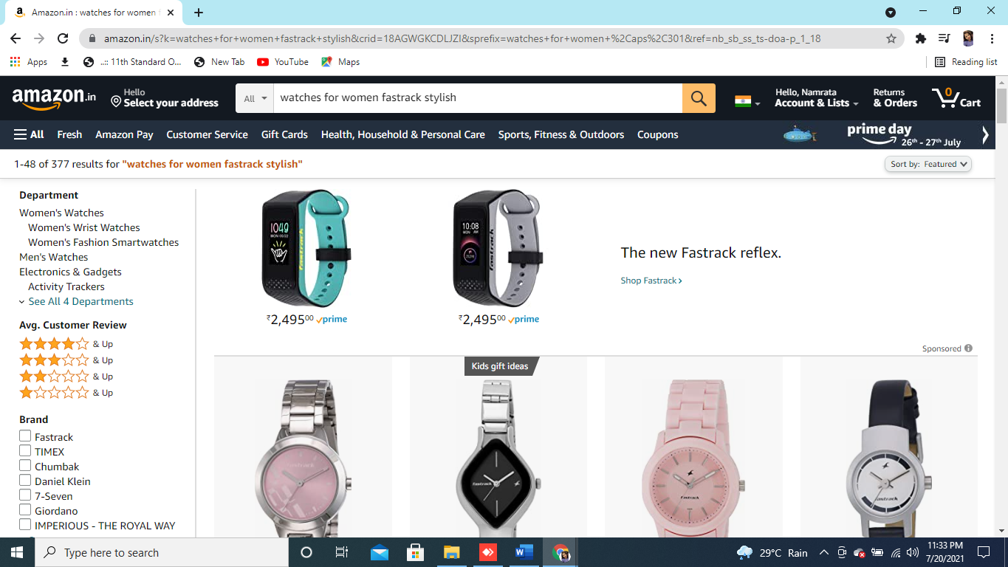

//search product

w.findElement(By.*id*("twotabsearchtextbox")).sendKeys("Fastrack watches for women");

w.findElement(By.*id*("nav-search-submit-button")).click();

JavascriptExecutor js = (JavascriptExecutor) w;

js.executeScript("window.scrollBy(0,1500)","");

**TC08 :Increase the quantity of the item from the cart and verify.**

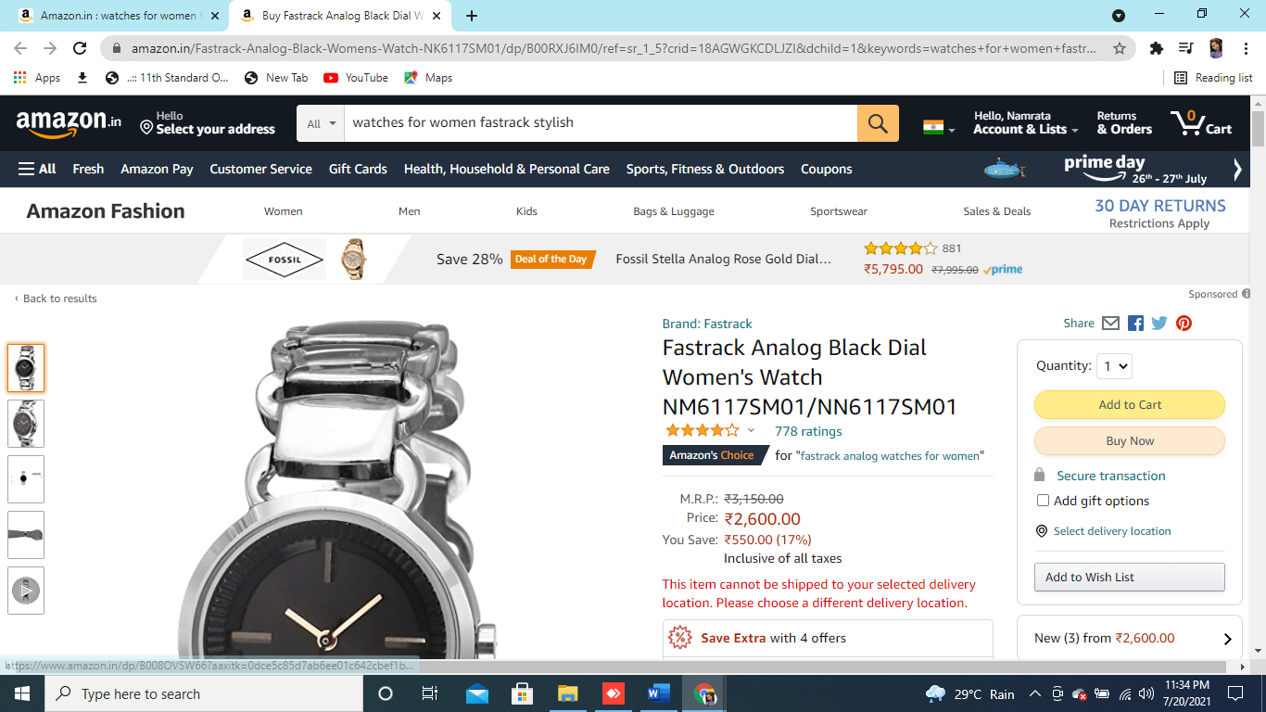

// ADD TO CART PRODUCT

Select quantity = **new** Select (w.findElement(By.*id*("quantity")));

quantity.selectByValue("2");

w.findElement(By.*id*("add-to-cart-button")).click();

w.findElement(By.*id*("nav-cart-count")).click();

Thread.*sleep*(5000);

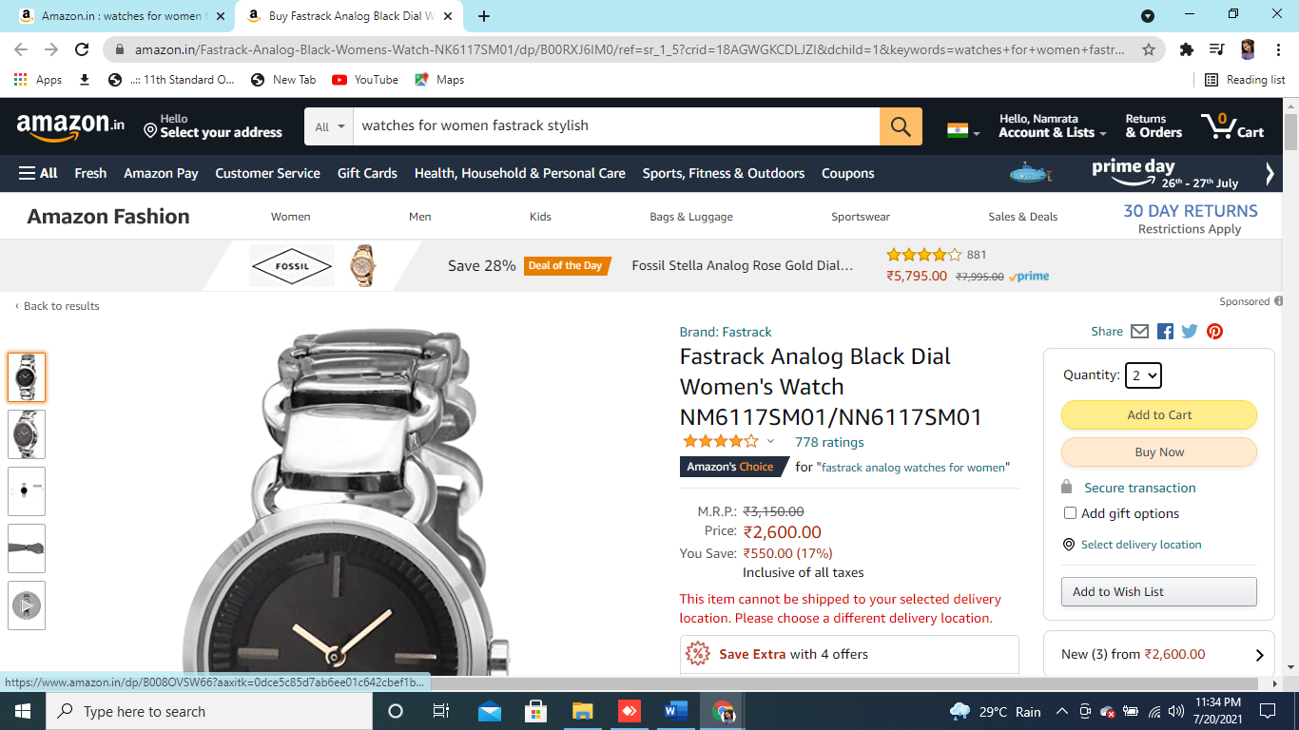

**TC11 :Remove item from the cart and then verify**

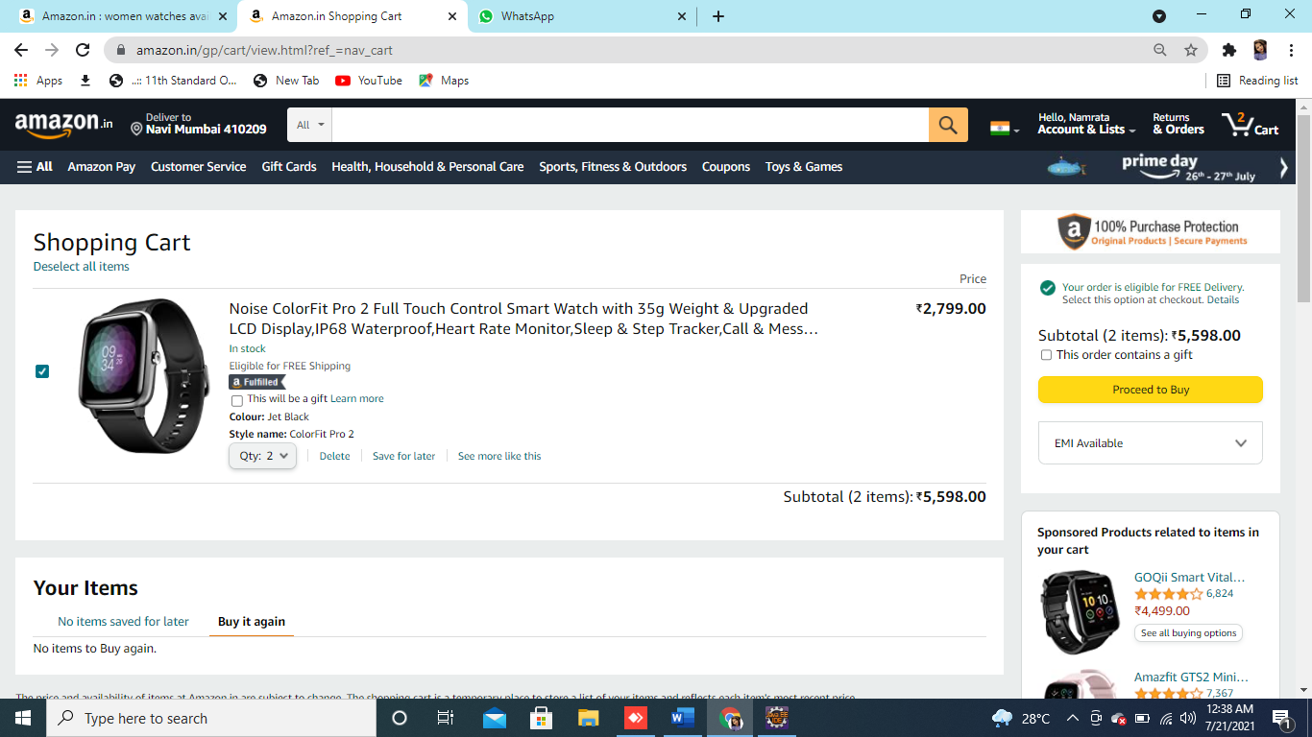

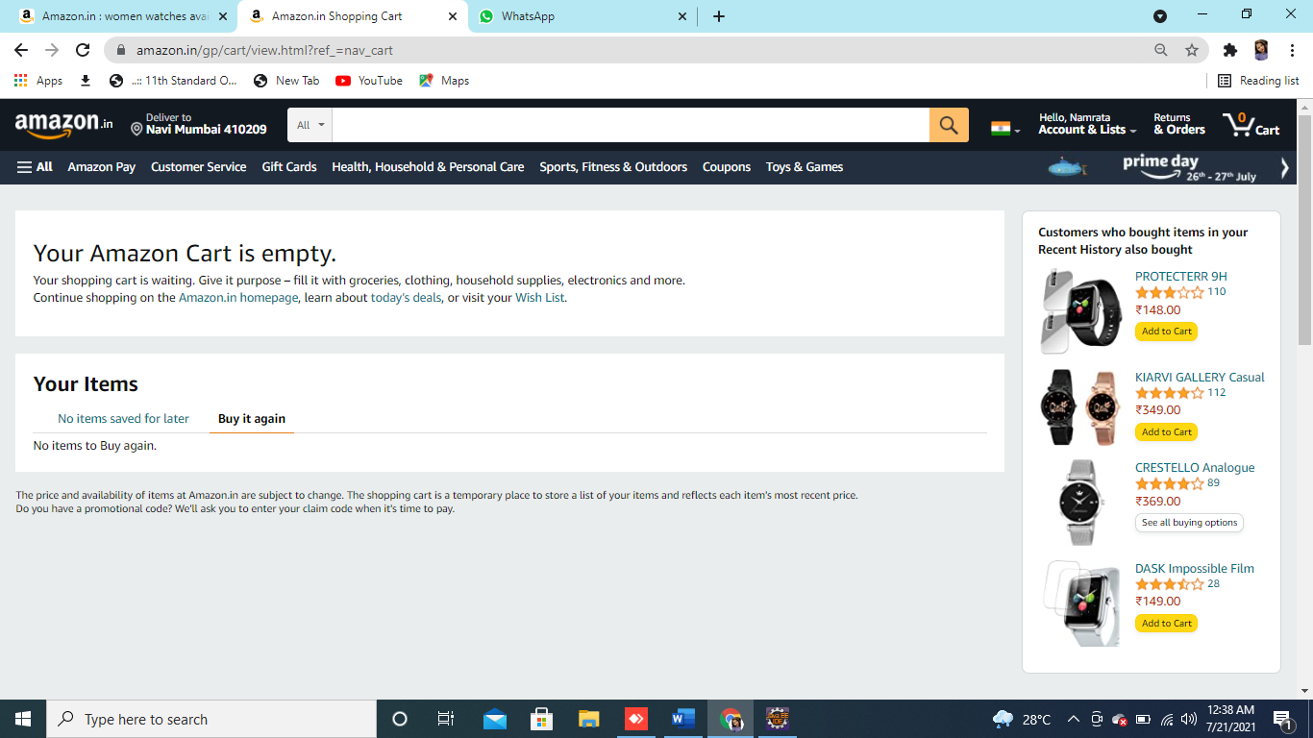

//Delete from Add To Cart

w.findElement(By.*xpath*("/html/body/div[1]/div[4]/div/div[3]/div/div[2]/div[2]/div/form/div[2]/div[3]/div[4]/div/div[1]/div/div/div[2]/div[1]/span[2]/span/input")).click();

Thread.*sleep*(3000);

**TC12: Sign Out From The Current Page**

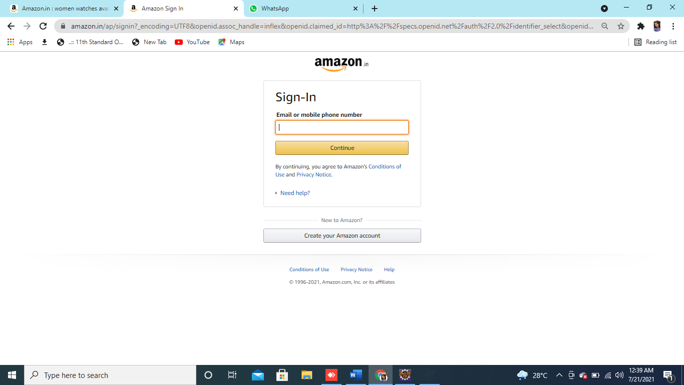

SIGN OUT

w.findElement(By.*xpath*("/html/body/div[1]/div[1]/header/div/div[3]/div[2]/div[2]/div/div[2]/a[13]/span")).click();

System.***out***.println("Done with sigh out");