AIPP LAB 18
MD. NUMAAN AHMED
221202055
Completed this Assignment using VS – Gemini Al Integration.
Task 1:
Translate a Simple Program (Python → JavaScript)
CODE:
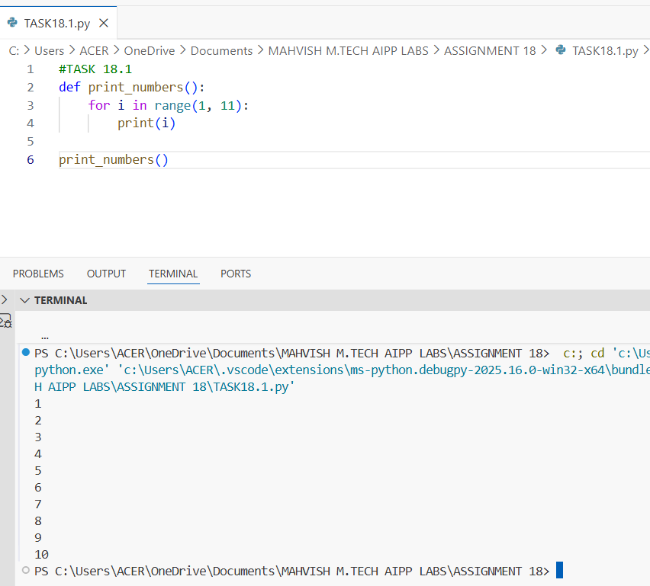
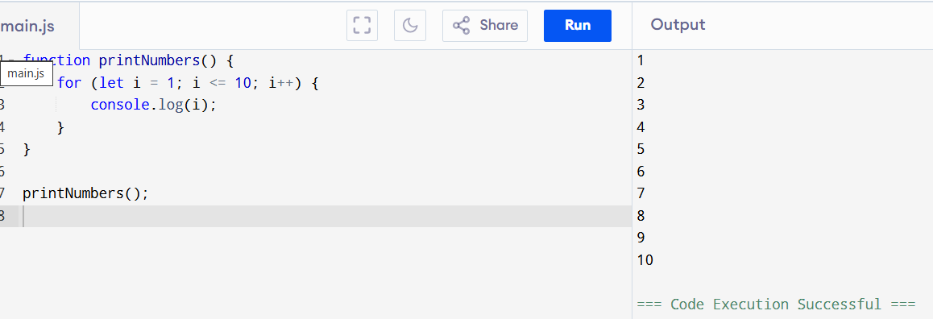
Task 2:
Convert Conditional Statements (Java → Python)
CODE:
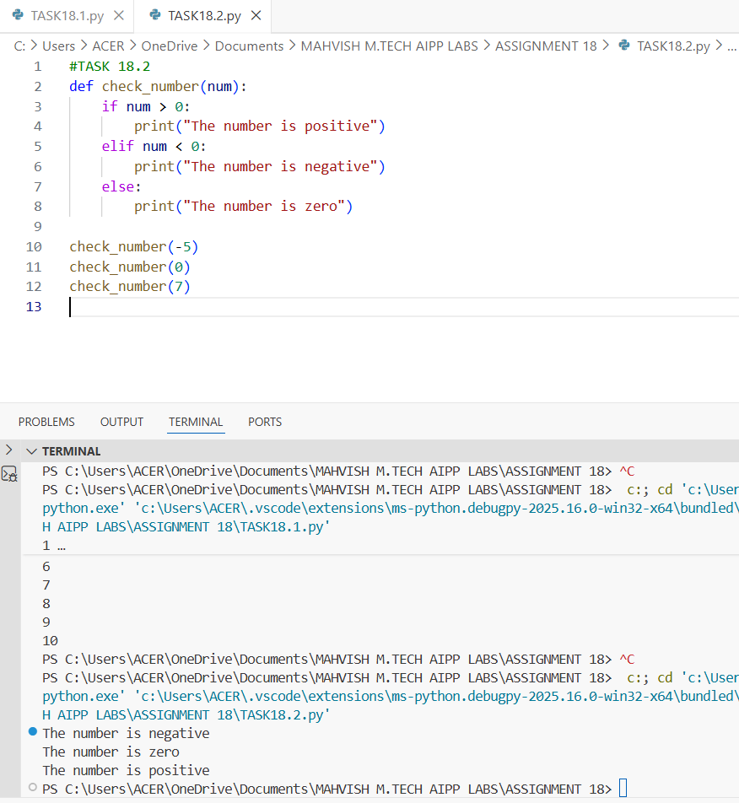

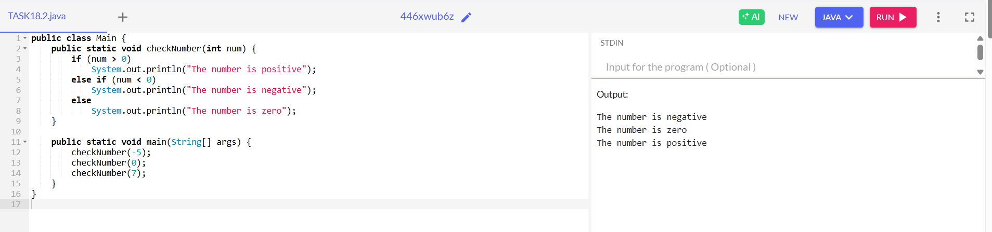
Task 3:
Translate Recursive Function (Python → C++)
CODE:
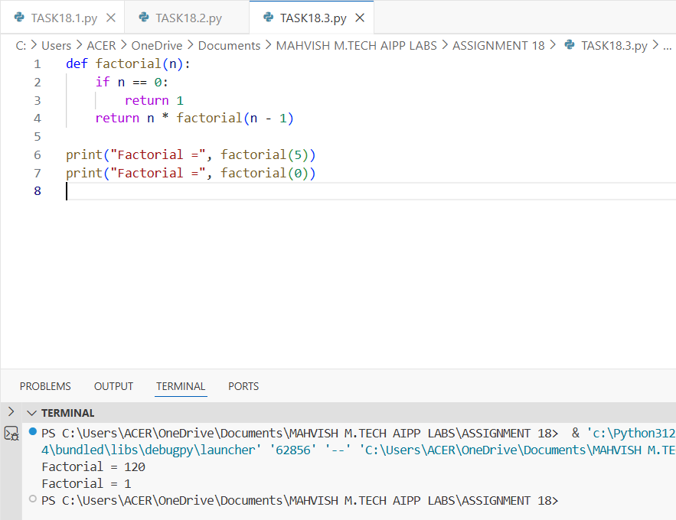
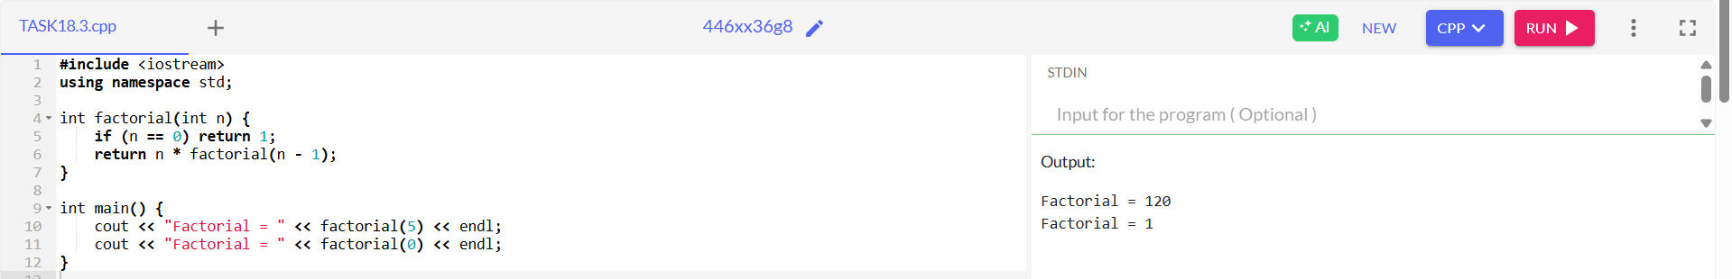
Task 4:
Data Structures with Functions (JavaScript → Python)
CODE:
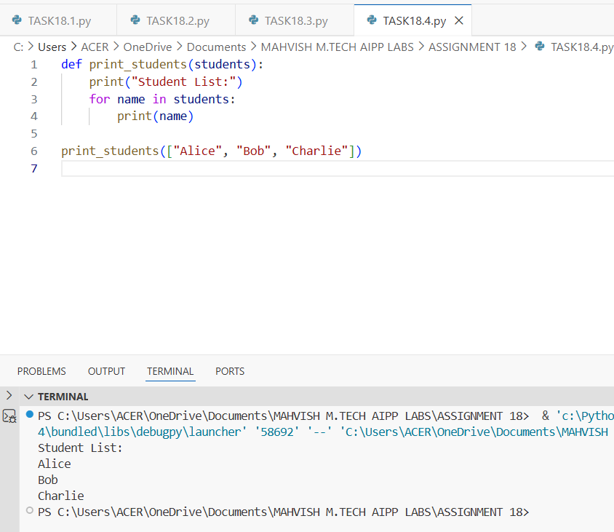
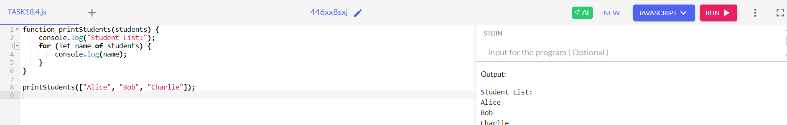
Task 5:
Class & Object Translation (Python → Java)
CODE:



