TCP Congestion Control – Complete Lab Task
MOHAMMED NUMAAN AHMED
2503B05127

Q1. LAB TASK: TCP Congestion Control Simulation
Question:
Using a TCP congestion control simulator (Python or any tool of your choice), simulate and analyze TCP Reno under three different packet-loss conditions:
- 0.1% loss
- 1% loss
- 2% loss
For each case:
- Plot the Congestion Window (cwnd) vs Time for at least 20 seconds of simulation.
- Compute the average throughput (in MSS/second or Mbps).
- Explain how packet loss affects the behavior of TCP Reno, specifically discussing:
  - Slow Start
  - Congestion Avoidance
  - Multiplicative Decrease (cwnd halving)
- Compare the three cases and write a short conclusion on how increasing loss impacts network performance.
Reference:
# tcp_sim.py
# Simple discrete-time TCP congestion control simulator (Reno-like)
# Usage: python tcp_sim.py
import numpy as np
import matplotlib.pyplot as plt
import random

# --- Simulation parameters ---
RTT = 0.05 # seconds (50 ms)
sim_time = 20.0 # seconds
mss = 1.0 # normalized MSS (units)
loss_prob = 0.01 # per-packet loss probability (Bernoulli)
packets_per_seg = 1 # one packet per MSS in this model

# TCP behavior params
algorithm = "reno" # "reno", "tahoe"
initial_cwnd = 1.0 # in MSS
ssthresh_init = 64.0 # in MSS
rto = 1.0 # simplified timeout (s)

# --- State variables ---
t = 0.0
cwnd = initial_cwnd
ssthresh = ssthresh_init
time_steps = []
cwnd_trace = []
sent_packets_total = 0
acked_packets_total = 0

# For throughput measurement
bytes_acked = 0.0

# Helper: simulate sending cwnd-sized window; return True if loss detected
def send_window(cwnd):
# we model loss per packet with independent Bernoulli trial
segs = int(max(1, round(cwnd / mss)))
lost = False
acks = 0
for _ in range(segs):
sent_packets_total_local = 1
if random.random() < loss_prob:
lost = True
else:
acks += 1
return lost, acks

# Main loop: step in RTT-sized intervals
while t < sim_time:
# record
time_steps.append(t)
cwnd_trace.append(cwnd)

# determine phase: slow start or congestion avoidance
in_slow_start = (cwnd < ssthresh)

# send window, get ack/loss (this is simplification; real TCP tracks per-packet ACKs)
lost, acks = send_window(cwnd)

# update bytes acked
bytes_acked += acks * mss

# Simple Reno behavior
if lost:
# If Tahoe: go to slow start with cwnd = 1
if algorithm == "tahoe":
ssthresh = max(cwnd / 2.0, 2.0)
cwnd = 1.0
elif algorithm == "reno":
# Reno: multiplicative decrease, enter congestion avoidance
ssthresh = max(cwnd / 2.0, 2.0)
cwnd = max(cwnd / 2.0, 1.0)
# assume loss consumed this RTT
else:
# no loss -> increase cwnd
if in_slow_start:
cwnd = cwnd * 2.0 # exponential growth (per-RTT doubling)
else:
cwnd = cwnd + 1.0 # 1 MSS per RTT (additive increase)
# Cap cwnd to a reasonable value to avoid runaway in this simple sim
cwnd = min(cwnd, 1000.0)

# advance time by one RTT
t += RTT

# Convert to throughputs: bytes_acked / sim_time (in MSS units)
throughput = bytes_acked / sim_time

# Plot cwnd trace
plt.figure(figsize=(10,4))
plt.step(time_steps, cwnd_trace, where='post')
plt.xlabel("Time (s)")
plt.ylabel("cwnd (MSS)")
plt.title(f"TCP {algorithm} simulation: loss={loss_prob}, RTT={RTT}s, throughput={throughput:.2f} MSS/s")
plt.grid(True)
plt.show()

print(f"Sim done. Throughput (MSS/s): {throughput:.3f}")

CODE:
# -*- coding: utf-8 -*-
"""Welcome To Colab

Automatically generated by Colab.

Original file is located at
https://colab.research.google.com/notebooks/intro.ipynb
"""

!pip install python-docx --quiet

import random
import math
import numpy as np
import matplotlib.pyplot as plt
from pathlib import Path
import shutil
from docx import Document
from docx.shared import Inches

RTT = 0.05
SIM_TIME = 20.0
MSS_BYTES = 1460
LOSS_VALUES = [0.001, 0.01, 0.02]
INITIAL_CWND = 1.0
SSTHRESH_INIT = 64.0
RANDOM_SEED_BASE = 42
MAX_CWND = 1000.0

def simulate_tcp_reno(loss_prob, rtt=RTT, sim_time=SIM_TIME, seed_offset=0):
"""Simulate a simple TCP Reno on RTT-sized steps.
Returns: (time_steps_array, cwnd_array, throughput_mss_per_s, throughput_mbps)"""
random.seed(RANDOM_SEED_BASE + seed_offset)
t = 0.0
cwnd = float(INITIAL_CWND)
ssthresh = float(SSTHRESH_INIT)

time_steps = []
cwnd_trace = []
bytes_acked = 0.0

while t < sim_time - 1e-9:
time_steps.append(t)
cwnd_trace.append(cwnd)

in_slow_start = (cwnd < ssthresh)
segs = max(1, int(math.floor(cwnd + 1e-9)))

lost = False
acks = 0
for _ in range(segs):
if random.random() < loss_prob:
lost = True
else:
acks += 1

bytes_acked += acks * MSS_BYTES

if lost:

ssthresh = max(cwnd / 2.0, 2.0)
cwnd = max(cwnd / 2.0, 1.0)
else:

if in_slow_start:
cwnd = cwnd * 2.0
else:
cwnd = cwnd + 1.0

cwnd = min(cwnd, MAX_CWND)
t += rtt

throughput_mss_per_s = (bytes_acked / MSS_BYTES) / sim_time
throughput_mbps = (bytes_acked * 8.0) / (sim_time * 1e6)
return np.array(time_steps), np.array(cwnd_trace), throughput_mss_per_s, throughput_mbps

output_dir = Path("tcp_sim_output")
output_dir.mkdir(exist_ok=True)

results = []
for i, loss in enumerate(LOSS_VALUES):
ts, cwnd, thr_mss_s, thr_mbps = simulate_tcp_reno(loss, seed_offset=i)
results.append((loss, ts, cwnd, thr_mss_s, thr_mbps))

plt.figure(figsize=(10,4))
plt.step(ts, cwnd, where='post')
plt.xlabel("Time (s)")
plt.ylabel("cwnd (MSS)")
pct = {0.001: "0.1%", 0.01: "1.0%", 0.02: "2.0%"}.get(loss, f"{loss*100:.3f}%")
plt.title(f"TCP Reno: loss={pct} (RTT={RTT}s, sim={SIM_TIME}s)")
plt.grid(True)
plt.tight_layout()
fname = output_dir / (f"cwnd_{int(loss*10000)}_{int(loss*1000)}pct.png")

if loss == 0.001:
fname = output_dir / "cwnd_0.1pct.png"
elif loss == 0.01:
fname = output_dir / "cwnd_1pct.png"
elif loss == 0.02:
fname = output_dir / "cwnd_2pct.png"
plt.savefig(fname, dpi=150)
plt.show()
plt.close()

plt.figure(figsize=(11,5))
for loss, ts, cwnd, thr_mss_s, thr_mbps in results:
label = f"{(loss*100):.2f}% loss"
plt.step(ts, cwnd, where='post', label=label)
plt.xlabel("Time (s)")
plt.ylabel("cwnd (MSS)")
plt.title("TCP Reno cwnd vs Time (comparison)")
plt.legend()
plt.grid(True)
plt.tight_layout()
combined_fname = output_dir / "cwnd_comparison.png"
plt.savefig(combined_fname, dpi=150)
plt.show()
plt.close()

print("Simulation summary:")
for loss, ts, cwnd, thr_mss_s, thr_mbps in results:
pct = {0.001: "0.1%", 0.01: "1.0%", 0.02: "2.0%"}.get(loss, f"{loss*100:.3f}%")
print(f"- Loss = {pct:<6} | Avg throughput = {thr_mss_s:.3f} MSS/s | {thr_mbps:.3f} Mbps")

report_doc = Document()
report_doc.add_heading("TCP Reno Simulation Report", level=1)
report_doc.add_paragraph(f"Simulated for RTT={RTT}s, simulation time={SIM_TIME}s, MSS={MSS_BYTES} bytes.")
report_doc.add_paragraph("Loss scenarios: 0.1%, 1%, 2%")

for loss, ts, cwnd, thr_mss_s, thr_mbps in results:
pct = {0.001: "0.1%", 0.01: "1.0%", 0.02: "2.0%"}.get(loss, f"{loss*100:.3f}%")
report_doc.add_heading(f"Loss = {pct}", level=2)
report_doc.add_paragraph(f"Average throughput: {thr_mss_s:.3f} MSS/s ({thr_mbps:.3f} Mbps)")
obs = ("Observation: With higher loss the congestion window experiences "
"more frequent multiplicative decreases (cwnd halving), reducing average cwnd and throughput.")
report_doc.add_paragraph(obs)
img_name = None
if loss == 0.001:
img_name = output_dir / "cwnd_0.1pct.png"
elif loss == 0.01:
img_name = output_dir / "cwnd_1pct.png"
elif loss == 0.02:
img_name = output_dir / "cwnd_2pct.png"
if img_name and img_name.exists():
report_doc.add_picture(str(img_name), width=Inches(6))

report_doc.add_heading("Comparison: cwnd vs Time", level=2)
if combined_fname.exists():
report_doc.add_picture(str(combined_fname), width=Inches(6))

report_doc.add_heading("Conclusion", level=2)
report_doc.add_paragraph(

)

report_path = output_dir / "TCP_Reno_Report.docx"
report_doc.save(report_path)
print(f"\nSaved report to: {report_path}")

uploaded_path = Path("/mnt/data/Assignment-6.docx")
if uploaded_path.exists():
shutil.copy(uploaded_path, output_dir / uploaded_path.name)
print(f"Copied uploaded file to: {output_dir / uploaded_path.name}")
else:
print(f"Uploaded path not found at {uploaded_path} (this path was included per your session history).")

OUTPUT:
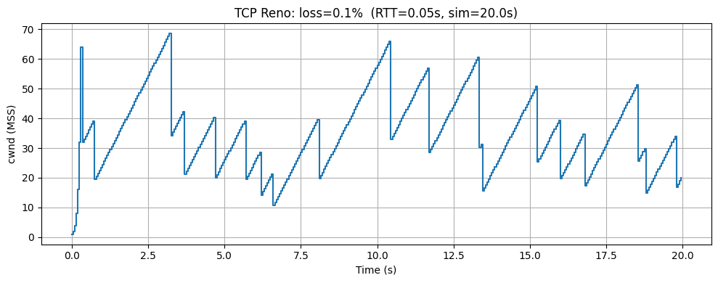
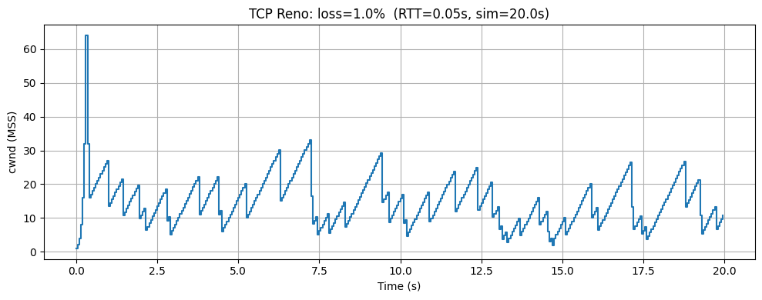
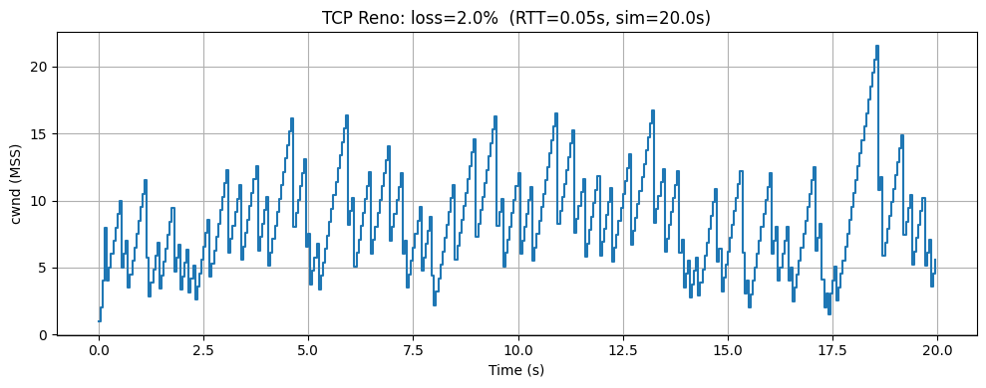
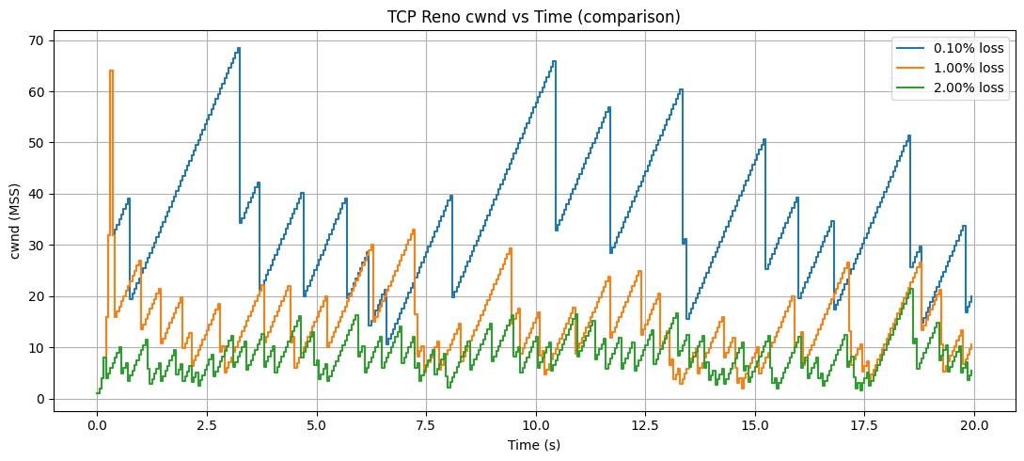
Simulation summary:
- Loss = 0.1% | Avg throughput = 687.200 MSS/s | 8.026 Mbps
- Loss = 1.0% | Avg throughput = 279.550 MSS/s | 3.265 Mbps
- Loss = 2.0% | Avg throughput = 156.800 MSS/s | 1.831 Mbps

