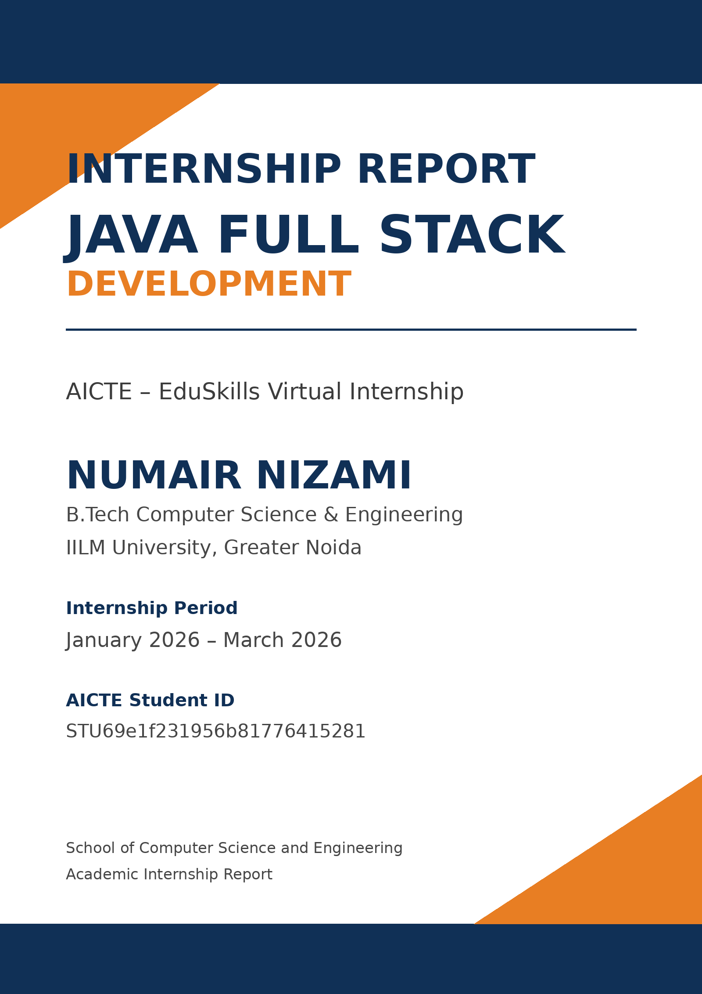

CANDIDATE’S DECLARATION
I, NUMAIR NIZAMI, hereby declare that this internship report on “Java Full Stack Development” has been prepared for the academic requirements of the Bachelor of Technology in Computer Science and Engineering. The report is compiled from the internship records, certificates, offer letter and learning material supplied for this submission. I confirm that the report presents the documented internship experience and that source material has been acknowledged appropriately.

Signature: ______________________________
Student Name: NUMAIR NIZAMI
Roll No.: 2410030155

ACKNOWLEDGEMENT
I sincerely thank AICTE and EduSkills for providing the opportunity to participate in the Java Full Stack Developer Virtual Internship. The program offered structured exposure to frontend technologies, Java programming, enterprise frameworks, persistence technologies and version control.
I am grateful to the mentors and the EduSkills team for their guidance and learning support. I also acknowledge the School of Computer Science and Engineering, IILM University, Greater Noida, for the academic encouragement provided during the internship and preparation of this report.
I also thank my parents for their encouragement and support throughout the internship and while compiling this academic report.

Signature: ______________________________
Student Name: NUMAIR NIZAMI
Roll No.: 2410030155

INTERNSHIP COMPLETION CERTIFICATE
Certificate of Virtual Internship – Java Full Stack Developer
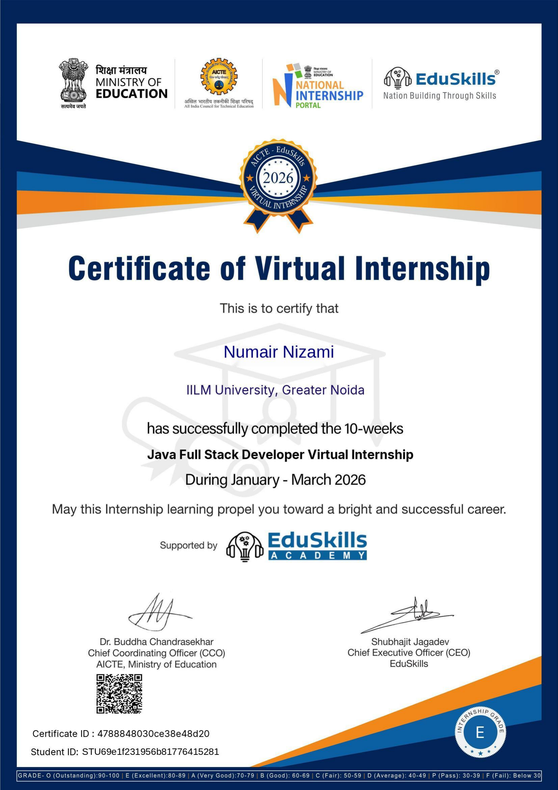

INTERNSHIP CREDENTIAL
Java Full Stack Internship Credential
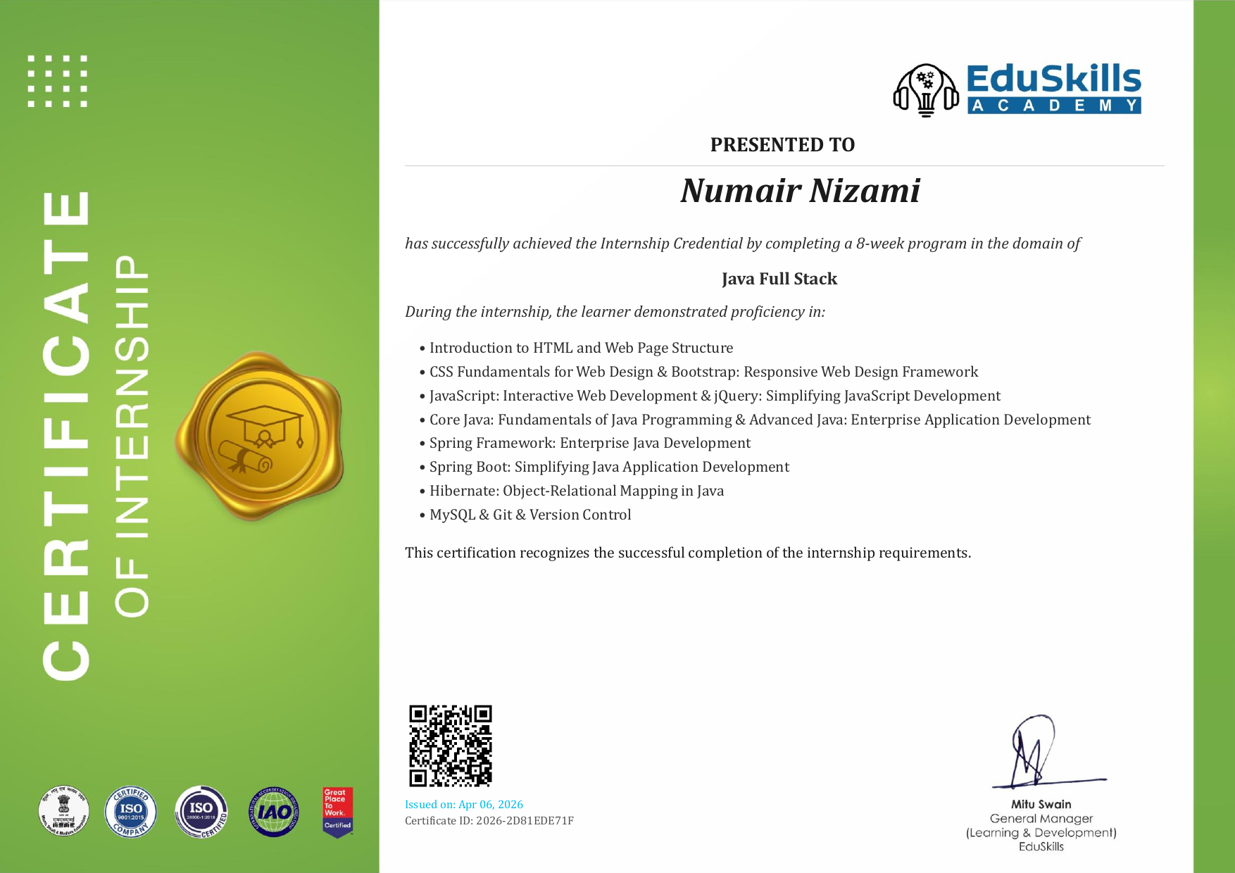

TABLE OF CONTENTS
Table of Contents
Chapter / Section | Chapter Name | Page Nos.
1 | Candidate’s Declaration | i
2 | Acknowledgement | ii
3 | Internship Completion Certificate | —
 | Table of Contents | iii
 | List of Tables | iv
 | List of Figures | v
4 | Project Description | 1
4.1 | Introduction | 1
4.2 | Organization Profile | 2
4.3 | Problem Statement | 2
4.4 | Project Objectives | 3
4.5 | Scope of the Project | 3
4.6 | Technologies and Tools Used | 4
4.7 | System Architecture | 5
4.8 | Methodology | 6
4.9 | Expected Outcomes | 8
4.10 | Certificates of Completion and Communication Proof | 9
5 | Bibliography / References | 10
A | Annexure A – Internship Offer Letter | 11
B | Annexure B – Official Communication Mail | 13

LIST OF TABLES
List of Tables
Table No. | Title | Page
Table 4.1 | Student and Internship Details | 2
Table 4.2 | Week-wise Internship Learning Structure | 3
Table 4.3 | Technologies and Tools Covered | 4
Table 4.4 | Scope Summary | 5

LIST OF FIGURES
List of Figures
Figure No. | Title | Page
Figure 4.1 | Java Full Stack Development Learning Workflow | 5

4. INTERNSHIP & PROJECT OVERVIEW

4.1 INTERNSHIP OVERVIEW
The AICTE–EduSkills Java Full Stack Developer Virtual Internship provided a structured pathway through frontend web development, Java programming, enterprise frameworks, database persistence and version-control practices. The supplied offer letter records the internship period as January 2026 to March 2026 and describes weekly learning, assessments and project documentation.
The learning sequence moved from HTML, CSS and Bootstrap into JavaScript and jQuery, then into Core Java and Advanced Java. The documented curriculum continued with Spring Framework, Spring Boot, Hibernate, MySQL and Git/GitHub. The supplied credentials also recognize these technology areas.
Table 4.1: Student and Internship Details
Particular | Details
Student Name | NUMAIR NIZAMI
Roll Number | 2410030155
Degree | B.Tech CSE
University | IILM University, Greater Noida, U.P.
School | School of Computer Science and Engineering
Batch | 2024-2028
Internship Domain | Java Full Stack Developer
Internship Period | January 2026 – March 2026
Mode | Virtual / Online
Supporting Organization | EduSkills Academy
Program | AICTE – EduSkills Virtual Internship
AICTE Student ID | STU69e1f231956b81776415281

4.2 PROGRAM & ORGANIZATION
EduSkills Academy is identified in the supplied records as the supporting organization for the virtual internship. The offer letter describes an AICTE–EduSkills learning framework combining structured weekly study, assessments, assignments and a final assessment.
The supplied offer letter states that the internship followed a week-wise learning structure, included weekly assessments, required project documentation and assignments for certain modules, and concluded with a final assessment. The completion certificate recognizes successful completion of the Java Full Stack Developer Virtual Internship.
The documents supplied for this report do not provide additional detailed corporate history, product portfolios, departmental structure or organizational financial information. Therefore, such information has not been added.

4.3 LEARNING CHALLENGE
The supplied evidence does not identify one specific deployed software product or a named capstone application. Instead, it documents a broad Java Full Stack learning program. The central learning challenge was therefore to build practical familiarity across the frontend, Java, enterprise-framework and persistence layers.
Project-specific problem statement: Not specified in the supplied internship evidence. This report therefore focuses on the documented internship learning journey rather than inventing an application-specific problem.

4.4 INTERNSHIP OBJECTIVES
- To develop foundational knowledge of web page structure and frontend styling.
- To strengthen JavaScript and jQuery skills for interactive web development.
- To understand Core Java programming concepts, including object-oriented programming, collections, exception handling and file handling.
- To learn Advanced Java concepts including JDBC, Servlets and multithreading.
- To understand enterprise application development using Spring Framework and Spring Boot.
- To learn object-relational mapping using Hibernate.
- To understand MySQL database integration, persistence and CRUD operations.
- To practice Git and GitHub-based version control and branching concepts.
- To complete the required internship assessments and demonstrate the skills covered by the program.

4.5 SCOPE OF LEARNING
The documented scope covers the progression from web fundamentals to Java-based enterprise development, relational data handling and source-code management. It is presented as an internship learning scope rather than as evidence of a separately deployed production application.
Table 4.2: Week-wise Internship Learning Structure
Week | Module | Documented Focus
1 | HTML | HTML fundamentals, page structure, semantic elements, forms and tables.
2 | CSS | Selectors, box model, positioning, Flexbox, Grid and responsive web design.
3 | Bootstrap | Responsive and mobile-first interfaces using Bootstrap components, grid system and utility classes.
4 | JavaScript & jQuery | JavaScript fundamentals, DOM manipulation, events and jQuery.
5 | Core Java | OOP concepts, data types, collections, exception handling and file handling.
6 | Advanced Java | JDBC, Servlets, multithreading and enterprise application development principles.
7 | Spring Framework & Spring Boot | Dependency injection, REST APIs and application configuration.
8 | Hibernate & MySQL | ORM concepts, MySQL integration, data persistence and CRUD operations.
9 | Git & Version Control | Git/GitHub usage and branching strategies.
10 | Assessment | Final assessment.

The supplied documents do not establish a particular deployed application, production database, API service or named capstone project for this Java internship. Such components are therefore not presented as completed project features.

4.6 TECHNOLOGY STACK
Table 4.3: Technologies and Tools Covered
Technology / Tool | Documented Role
HTML | Web-page structure and semantic elements.
CSS | Styling, layout and responsive design.
Bootstrap | Responsive and mobile-first interface development.
JavaScript | Interactive web development and DOM manipulation.
jQuery | Simplifying JavaScript development and interactive applications.
Core Java | Java programming fundamentals, OOP, collections, exceptions and file handling.
Advanced Java | JDBC, Servlets, multithreading and enterprise application concepts.
Spring Framework | Enterprise Java development and dependency injection.
Spring Boot | Java application development and application configuration.
Hibernate | Object-relational mapping in Java.
MySQL | Relational database integration and CRUD/data persistence.
Git / GitHub | Source-code version control and branching strategies.

4.7 LEARNING ARCHITECTURE
Because the supplied records do not define one completed production application, the architecture figure is treated as a learning workflow. It connects the documented interface technologies with Java application logic, enterprise frameworks, persistence and version-control concepts.
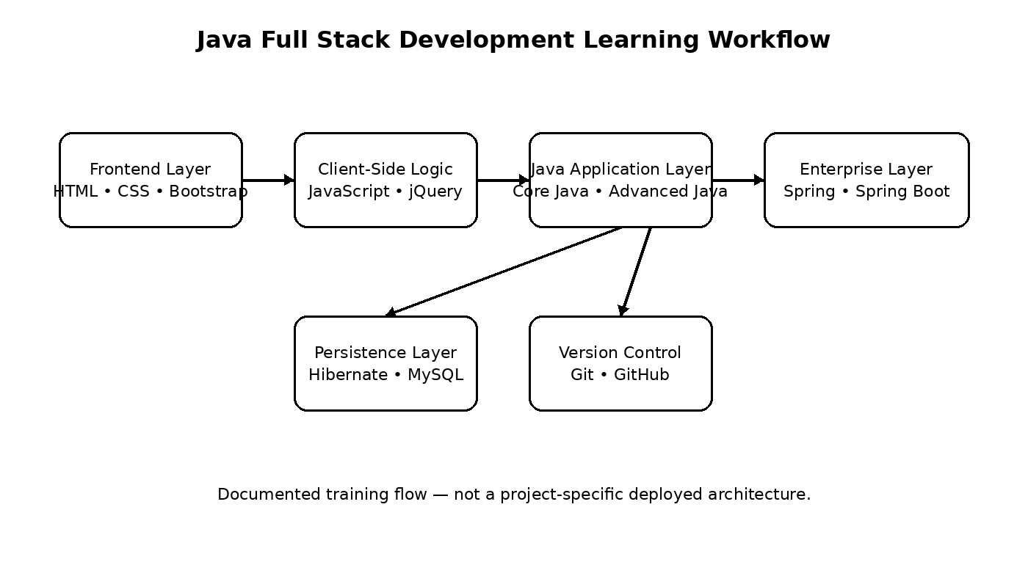
Figure 4.1: Java Full Stack Development Learning Workflow

4.8 LEARNING METHODOLOGY
The internship followed the week-wise sequence described in the offer letter. Learning progressed from frontend foundations through Java development, enterprise frameworks, database persistence and version control, with assessment used to consolidate the covered material.
1. Foundation setup: Learn HTML, CSS and Bootstrap to establish web-development fundamentals and responsive interface concepts.
2. Client-side development: Study JavaScript and jQuery for interactive web development, DOM manipulation and event handling.
3. Core Java development: Build understanding of Java fundamentals, object-oriented programming, collections, exception handling and file handling.
4. Advanced Java: Study JDBC, Servlets and multithreading together with enterprise-level application development principles.
5. Enterprise framework development: Learn Spring Framework and Spring Boot, including dependency injection, REST APIs and application configuration.
6. Database and persistence: Study Hibernate for ORM and integrate MySQL for data persistence and CRUD operations.
7. Version control: Use Git and GitHub concepts for source-code management and branching strategies.
8. Assessment: Complete the required assessments and final assessment associated with the internship program.

4.9 LEARNING OUTCOMES
The supplied Java Full Stack credential records proficiency across HTML, CSS, Bootstrap, JavaScript, jQuery, Core Java, Advanced Java, Spring Framework, Spring Boot, Hibernate, MySQL and Git/version control. These records support the following learning outcomes:
- Improved understanding of full-stack web-development fundamentals.
- Improved programming ability in Core Java and Advanced Java.
- Exposure to enterprise Java development through Spring Framework and Spring Boot.
- Understanding of object-relational mapping using Hibernate.
- Understanding of relational database integration using MySQL.
- Experience with source-code management and version-control practices using Git.
- Completion of the structured internship requirements and assessments, as evidenced by the supplied certificates.
The supplied documents do not provide quantitative performance scores, project-specific test results, deployment statistics or other measurable project outcomes. These have therefore not been added.

4.10 COMPLETION EVIDENCE
The supplied internship evidence is incorporated into the report as supporting documentation. The offer letter, virtual internship certificate, Java Full Stack credential and official communication together document the student's participation and completion records.
The Certificate of Virtual Internship confirms successful completion of the 10-week Java Full Stack Developer Virtual Internship during January–March 2026. A separate Java Full Stack internship credential issued on April 06, 2026 records completion of an 8-week program and lists the same core technology areas. Because the two official Java credentials state different program durations, both have been retained as supplied and no unsupported reconciliation has been made.
The supplied communication email is retained as documentary evidence in the annexure. The email confirms completion of the Java Full Stack Developer internship and provides instructions for accessing the certificate.

5. BIBLIOGRAPHY / REFERENCES
EduSkills. (2026). Internship Offer Letter: Java Full Stack Developer. Ref. No. C15Y2026M081356071.
EduSkills Academy. (2026). Certificate of Virtual Internship: Java Full Stack Developer Virtual Internship. Certificate ID: 4788848030ce38e48d20.
EduSkills Academy. (2026). Internship Credential: Java Full Stack. Certificate ID: 2026-2D81EDE71F. Issued April 06, 2026.
EduSkills Foundation. (2026). AICTE–EduSkills Internship Certificate download link – official communication email supplied for documentation.

ANNEXURE A
INTERNSHIP OFFER LETTER – JAVA FULL STACK DEVELOPER
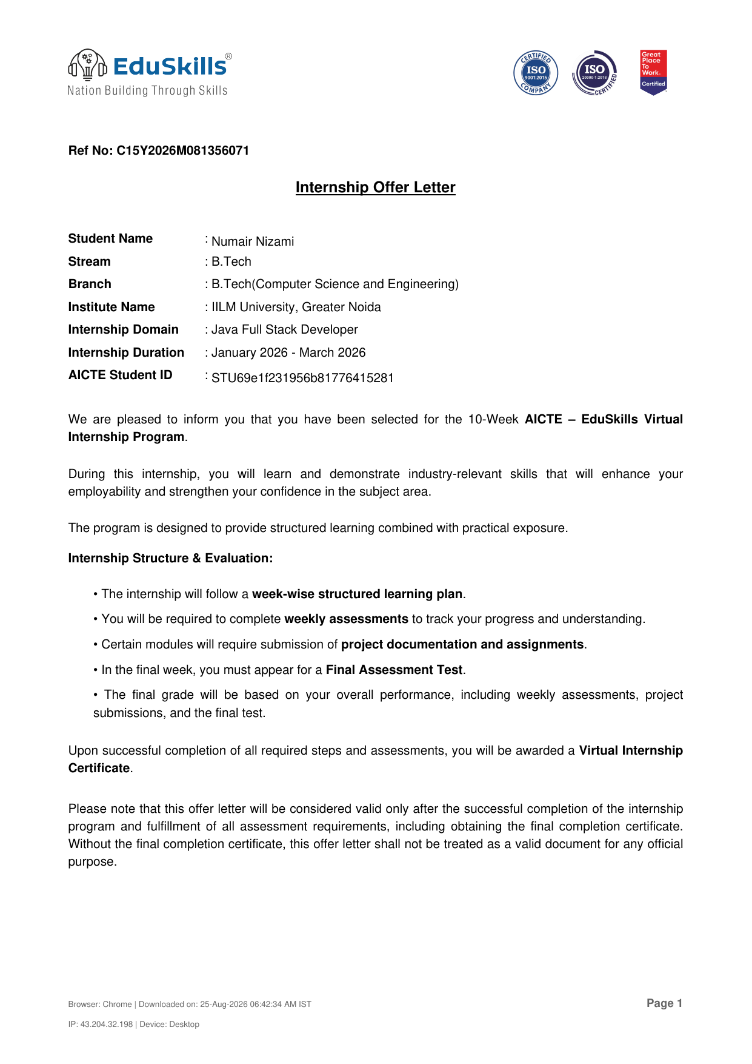

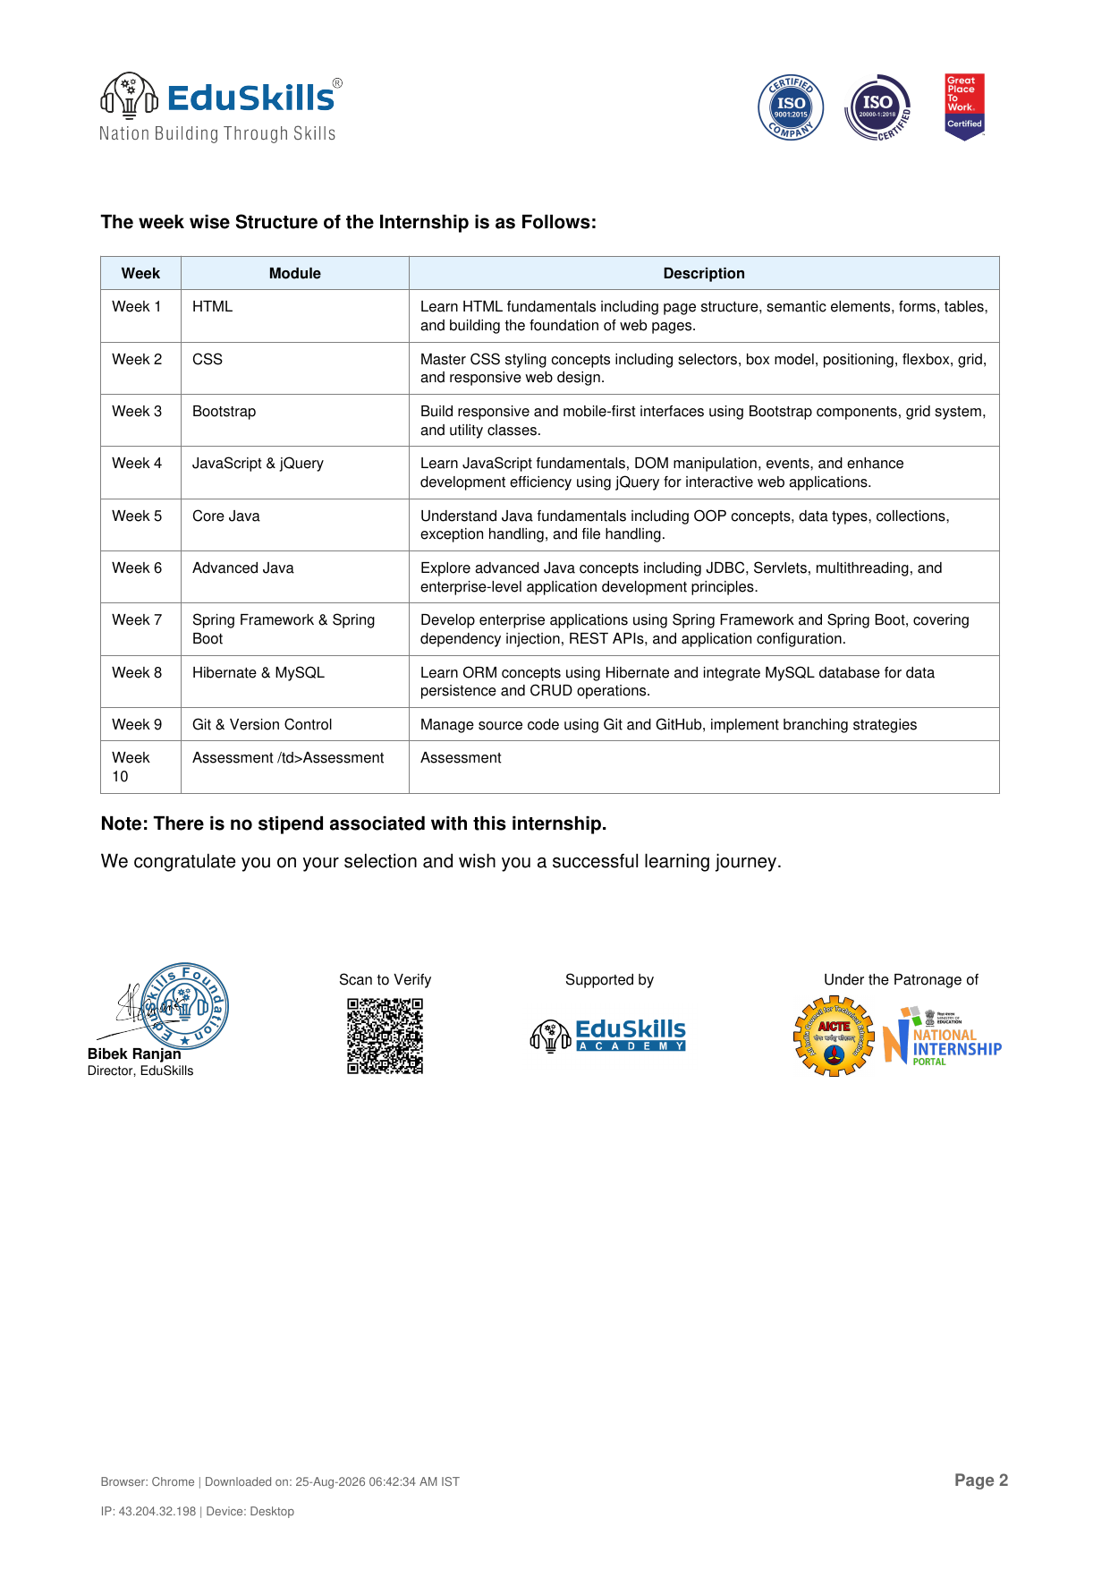

ANNEXURE B
OFFICIAL COMMUNICATION MAIL
