

## **LARSEN & TOUBRO EDUTECH**

## **QUANTUM UNIVERSITY**

## **BATCH NO. 5**

* **MD NUMAN RAZA**
* **MRINAL VISHWAKARMA**
* **AKSHAY KUMAR**
* **INDRONEEL KUMAR**

## **2nd MILESTONE OF PROJECT**

## Construct and simulate a NOR gate using MOS transistors, infer its behaviour, and explain its truth table with logical operation.

## **CIRCUIT:**

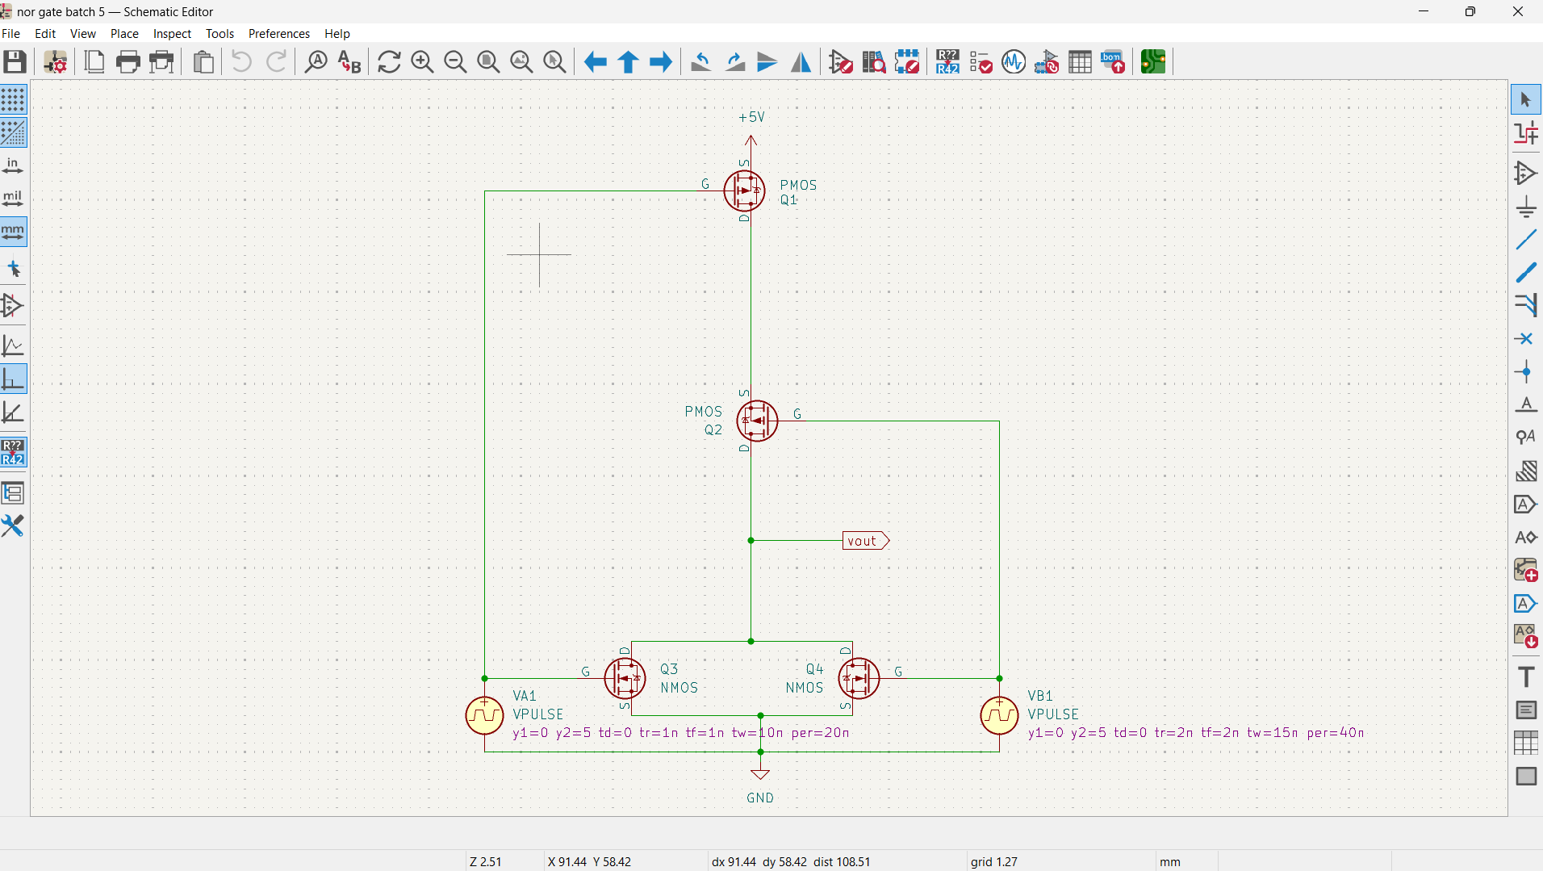

## **SIMULATION VALUES:**

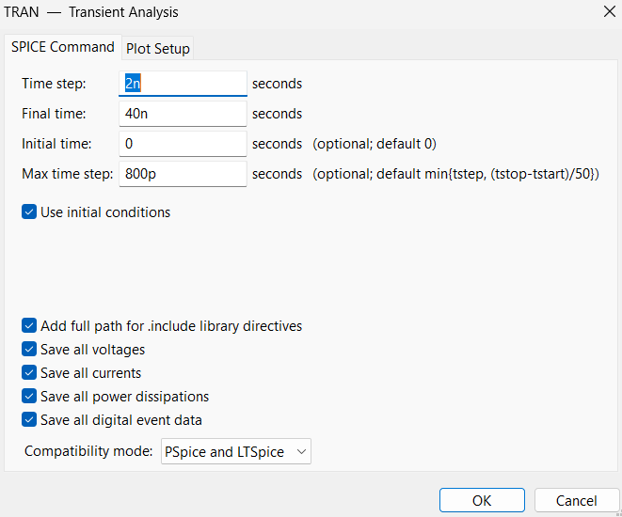

## **SIMULATION WAVES:**

