FINAL PROJECT REPORT
Project Title: Hospital Patient Triage & Bed Allocator Simulator
Course: CL2006 Operating Systems Lab
Semester: Spring 2026
Instructor: Hassan Ahmed
Institution: FAST-NUCES, CFD Campus
Group Members:
1. Numan (Roll No: 23F-0645)
2. Daud (Roll No: 23F-0732)
3. Manan (Roll No: 23F-0512)
Date: May 8, 2026

Table of Contents
- Introduction
- System Design
- Phase 1 Documentation: Environment Setup & Shell Scripting
- Phase 2 Documentation: Process Management & IPC
- Phase 3 Documentation: Threads & Synchronization
- Phase 4 Documentation: Memory Management
- Testing & Verification
- Valgrind Memory Integrity
- Challenges & Lessons Learned
- Individual Contribution Table

1. Introduction

Problem Statement
Modern hospital emergency rooms face critical bottlenecks when managing patient influx, triage prioritization, and limited bed availability. Efficiently allocating resources while preventing deadlocks and race conditions is a complex scheduling and memory management challenge.

Objectives
The objective of this project is to simulate a hospital triage and bed allocation system using core Operating System concepts. The system translates OS mechanisms into real-world hospital operations:
- Process Management: Simulating patients as distinct UNIX processes.
- IPC: Passing patient vitals via Pipes and FIFOs.
- Synchronization: Managing limited ICU/Isolation beds using Semaphores and Mutexes.
- Memory Management: Treating the hospital ward as a contiguous memory block managed by custom Best-Fit allocation and coalescing algorithms.

2. System Design

Component Architecture
The system follows a multi-process, multi-threaded client-server architecture:
- Admissions Manager (Daemon): The central process running in the background. It maintains the ward memory, runs the thread pool, and forks child processes.
- Patient Simulator (Child Process): Represents an admitted patient. It sleeps to simulate treatment and signals the manager upon discharge.
- Triage Script (Client): A shell interface that formats patient data and pipes it to the Admissions Manager.
- Shared Memory Ward: A globally accessible POSIX shared memory segment containing the BedPartition array.

3. Phase 1 Documentation: Environment Setup
Our environment relies on bash scripting for process bootstrapping and a strict Makefile for compilation.

Shell Scripts
- triage.sh: Accepts <ID> <Priority> <Care_Units>. It validates inputs and writes them to /tmp/triage_pipe.
- start_hospital.sh: Cleans previous IPC resources, creates fresh FIFOs/Pipes, and launches the ./admissions executable in the background with the requested memory strategy.
- stop_hospital.sh: Safely sends a SIGTERM to the admissions daemon, triggering a graceful shutdown and memory unmapping.
Sample Run (Initialization):
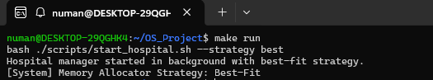

4. Phase 2 Documentation: Process Management & IPC

Process Management
For every patient dequeued by the scheduler, the Admissions Manager executes fork(). The child process calls execv() to transform into the patient_simulator binary. Zombie processes are mitigated using a dedicated SIGCHLD signal handler containing a waitpid(-1, NULL, WNOHANG) loop.

Inter-Process Communication (IPC) Design
- Anonymous/Named Pipes: triage.sh sends data via a pipe. Upon discharge, the patient_simulator writes its PID to a named FIFO (/tmp/discharge_fifo).
- Shared Memory: Created via shmget(), it holds the SharedMemory struct containing the num_partitions and the BedPartition array. Both the manager and patients can read this state.

Priority Scheduling Simulation
The receptionist thread places incoming patients into a Priority Queue based on their triage severity (Priority 1 = Critical, Priority 5 = Minor). The scheduler evaluates this queue using Priority Scheduling.
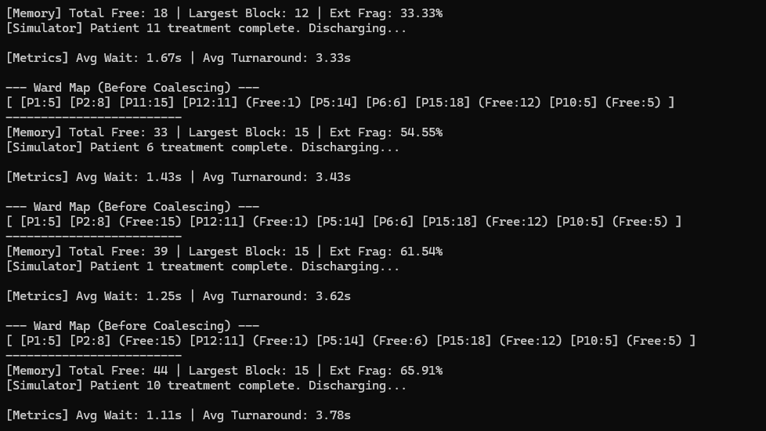

5. Phase 3 Documentation: Threads & Synchronization
To handle concurrent patient processing, the system utilizes POSIX threads (pthreads).

Thread Roles
- Receptionist Thread: Blocks on reading the triage pipe. Enqueues patients into the priority queue and posts to a counting semaphore (full_slots).
- Scheduler Thread: Consumes from the queue. If a bed is unavailable, it uses pthread_cond_wait(&bed_freed_cond).
- Nurse Thread: Monitors the discharge FIFO. When a patient leaves, it updates the bitmap and calls pthread_cond_broadcast(&bed_freed_cond) to wake the scheduler.

Synchronization Scenarios
- Mutex Protection: The memory_mutex strictly protects the shared bed array during allocation, deallocation, and coalescing to prevent race conditions.
- Semaphore Block/Release Scenario: * State: All 4 ICU beds are occupied (Semaphore value = 0).
  - Action: Priority 1 patient arrives. sem_wait(&icu_limit) blocks the scheduler.
  - Resolution: An ICU patient discharges. Nurse thread updates memory. sem_post(&icu_limit) is called, the scheduler unblocks, and the Priority 1 patient is admitted.

6. Phase 4 Documentation: Memory Management
The hospital ward is simulated as a 100-unit contiguous memory block.

Best-Fit Allocation Trace
When a patient requiring 10 units arrives, the system scans the BedPartition array. If free blocks of 15, 12, and 50 units exist, the Best-Fit algorithm selects the 12-unit block to minimize wasted space.
- Implementation: Also supports First-Fit and Worst-Fit via the --strategy CLI flag.

Coalescing
Upon discharge, the coalesce_free() function iterates through the partition array. If it detects two adjacent partitions where is_free == 1, it sums their sizes and dynamically shrinks the array size, preventing artificial memory exhaustion.

Paging & Fragmentation
- External Fragmentation: Calculated as (1.0 - (Largest_Free_Block / Total_Free_Units)) * 100.0. Logged dynamically to memory_log.txt.
- Internal Fragmentation (Paging): The ward simulates a fixed page size of 2 units. If a patient requires 5 units, 3 pages (6 units) are allocated, resulting in 1 unit of internal fragmentation.
- Bonus (mmap): A persistent binary log (patient_records.dat) is memory-mapped. Patient admission and discharge events are written to this virtual memory space and synchronized to disk via msync() upon termination.
Memory Log Trace:
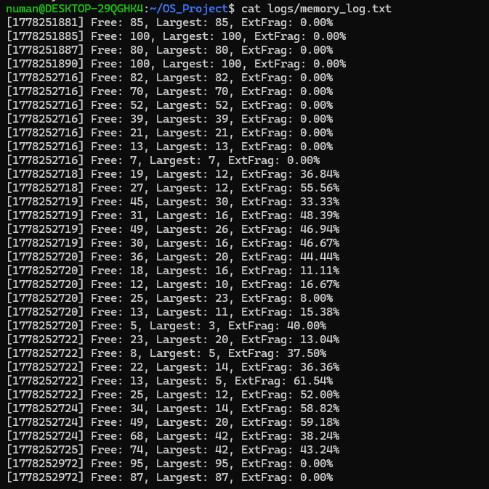

7. Testing & Verification
The system was subjected to an automated stress test (stress_test.sh) injecting 15 patients rapidly.
Test Case 1: Best-Fit Allocation
- Expected: Algorithm picks the tightest available memory bound.
- Actual: [INSERT SCREENSHOT OF BEST-FIT WARD MAP (From our earlier Step 2)]
Test Case 2: Coalescing under Stress
- Expected: Adjacent free blocks merge automatically upon concurrent discharges.
- Actual: [INSERT SCREENSHOT SHOWING 'Before Coalescing' and 'After Coalescing' WARD MAP]
Test Case 3: Virtual Memory Bonus Validation
- Expected: patient_records.dat contains concurrent timestamped admissions/discharges.
- Actual:
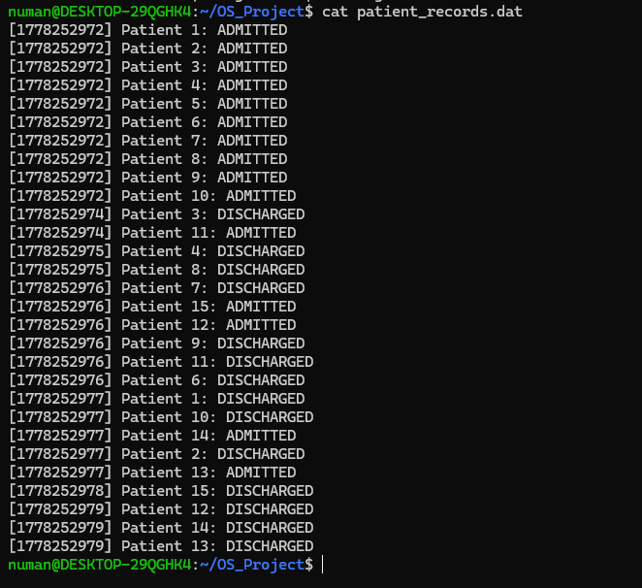

8. Valgrind Memory Integrity
To ensure absolute stability, the admissions daemon was profiled using Valgrind. Despite utilizing shared memory, IPC pipes, thread pools, and virtual memory mappings, the system cleanly releases all resources upon catching SIGTERM.
Result: definitely lost: 0 bytes in 0 blocks.
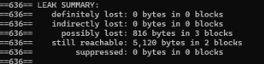

9. Challenges & Lessons Learned
- FIFO Race Conditions: During our stress test, if two patient processes completed at the exact same millisecond, they both wrote to the FIFO simultaneously (e.g., "1\n2\n"). Our original read() call dropped the second discharge, causing a simulated memory leak. We resolved this by implementing strtok in the Nurse Thread to tokenize the buffer by newline characters, ensuring all concurrent discharges are processed sequentially.
- Partition Array Bounds: As memory became heavily fragmented, the system risked exceeding the MAX_PARTITIONS limit (100). We added a boundary check to prevent buffer overflows, trading a slight increase in internal fragmentation for absolute system stability.

10. Individual Contribution Table
Member | Phase 1 & 2 Contribution | Phase 3 & 4 Contribution
Numan | Developed Makefile, shell scripts, and core fork()/execv() process spawning. | Built Best-Fit/Worst-Fit allocators, mmap virtual memory bonus, and ran Valgrind diagnostics.
Daud | Implemented IPC (Shared Memory, Anonymous Pipes, Named FIFOs) and signal handlers. | Designed the Nurse Thread, implemented Coalescing logic, and handled External Fragmentation calculations.
Manan | Designed the Priority Queue scheduler and Gantt chart logging simulation. | Developed Receptionist/Scheduler threads, Mutex synchronization, and Paging simulation math.
(Signatures)
______________________ (Numan)
______________________ (Daud)
______________________ (Manan)

