Assignment 4
Question 1:
Server.js
const express = require('express');
const dotenv = require('dotenv');
const connectDB = require('./config/db');

dotenv.config();

connectDB();

const app = express();

app.use(express.json());

app.get('/', (req, res) => {
res.send('Student Management API is running...');
});

app.use('/api/students', require('./routes/studentRoutes'));

const PORT = process.env.PORT || 5000;

app.listen(PORT, () => {
console.log(`Server running on port ${PORT}`);
});

studentController.js
const Student = require('../models/Student');

exports.createStudent = async (req, res) => {
try {
const student = new Student(req.body);
const savedStudent = await student.save();
res.status(201).json(savedStudent);
} catch (error) {
res.status(400).json({ message: error.message });
}
};

exports.getStudents = async (req, res) => {
try {
const { department, page = 1, limit = 10 } = req.query;

const query = {};
if (department) query.department = department;

const skip = (parseInt(page) - 1) * parseInt(limit);

const students = await Student.find(query)
.skip(skip)
.limit(parseInt(limit));

res.status(200).json(students);
} catch (error) {
res.status(500).json({ message: error.message });
}
};

exports.searchStudents = async (req, res) => {
try {
const { name } = req.query;
if (!name) {
return res.status(400).json({ message: "Search term 'name' is required" });
}

const students = await Student.find({
name: { $regex: name, $options: 'i' }
});
res.status(200).json(students);
} catch (error) {
res.status(500).json({ message: error.message });
}
};

exports.getStudentById = async (req, res) => {
try {
const student = await Student.findById(req.params.id);
if (!student) {
return res.status(404).json({ message: 'Student not found' });
}
res.status(200).json(student);
} catch (error) {
if (error.kind === 'ObjectId') {
return res.status(404).json({ message: 'Student not found' });
}
res.status(500).json({ message: error.message });
}
};

exports.updateStudent = async (req, res) => {
try {
const student = await Student.findByIdAndUpdate(req.params.id, req.body, {
new: true,
runValidators: true,
overwrite: true
});
if (!student) return res.status(404).json({ message: 'Student not found' });
res.status(200).json(student);
} catch (error) {
res.status(400).json({ message: error.message });
}
};

exports.patchStudent = async (req, res) => {
try {
const student = await Student.findByIdAndUpdate(req.params.id, req.body, {
new: true,
runValidators: true
});
if (!student) return res.status(404).json({ message: 'Student not found' });
res.status(200).json(student);
} catch (error) {
res.status(400).json({ message: error.message });
}
};

exports.deactivateStudent = async (req, res) => {
try {
const student = await Student.findByIdAndUpdate(
req.params.id,
{ isActive: false },
{ new: true }
);
if (!student) return res.status(404).json({ message: 'Student not found' });
res.status(200).json(student);
} catch (error) {
res.status(500).json({ message: error.message });
}
};

exports.deleteStudent = async (req, res) => {
try {
const student = await Student.findByIdAndDelete(req.params.id);
if (!student) return res.status(404).json({ message: 'Student not found' });
res.status(200).json({ message: 'Student permanently deleted' });
} catch (error) {
res.status(500).json({ message: error.message });
}
};
studentRoutes.js
const express = require('express');
const router = express.Router();
const studentController = require('../controllers/studentController');

router.post('/', studentController.createStudent);
router.get('/', studentController.getStudents);

router.get('/search', studentController.searchStudents);

router.get('/:id', studentController.getStudentById);
router.put('/:id', studentController.updateStudent);
router.patch('/:id', studentController.patchStudent);
router.delete('/:id', studentController.deleteStudent);

router.patch('/:id/deactivate', studentController.deactivateStudent);

module.exports = router;

db.js
const mongoose = require('mongoose');

const connectDB = async () => {
try {
const conn = await mongoose.connect(process.env.MONGO_URI);
console.log(`MongoDB Connected: ${conn.connection.host}`);
} catch (error) {
console.error(`Error connecting to MongoDB: ${error.message}`);
process.exit(1);
}
};

module.exports = connectDB;

student.js
// models/Student.js
const mongoose = require('mongoose');

const studentSchema = new mongoose.Schema({
rollNumber: {
type: String,
required: [true, 'Roll number is required'],
unique: true
},
name: {
type: String,
required: [true, 'Name is required']
},
email: {
type: String,
required: [true, 'Email is required'],
unique: true,
match: [
/^\w+([\.-]?\w+)*@\w+([\.-]?\w+)*(\.\w{2,3})+$/,
'Please provide a valid email format'
]
},
department: {
type: String,
required: [true, 'Department is required']
},
cgpa: {
type: Number,
min: [0.0, 'CGPA cannot be less than 0.0'],
max: [4.0, 'CGPA cannot exceed 4.0']
},
enrollmentYear: {
type: Number,
required: [true, 'Enrollment year is required']
},
isActive: {
type: Boolean,
default: true
}
}, {
timestamps: true
});

module.exports = mongoose.model('Student', studentSchema);

Output:
->Post
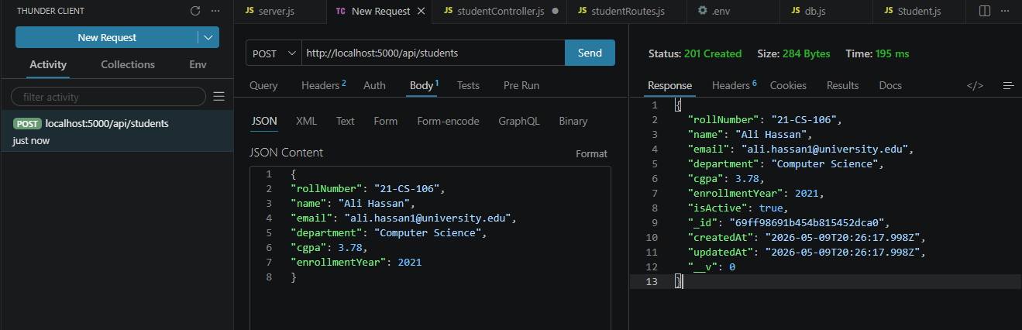
->Get
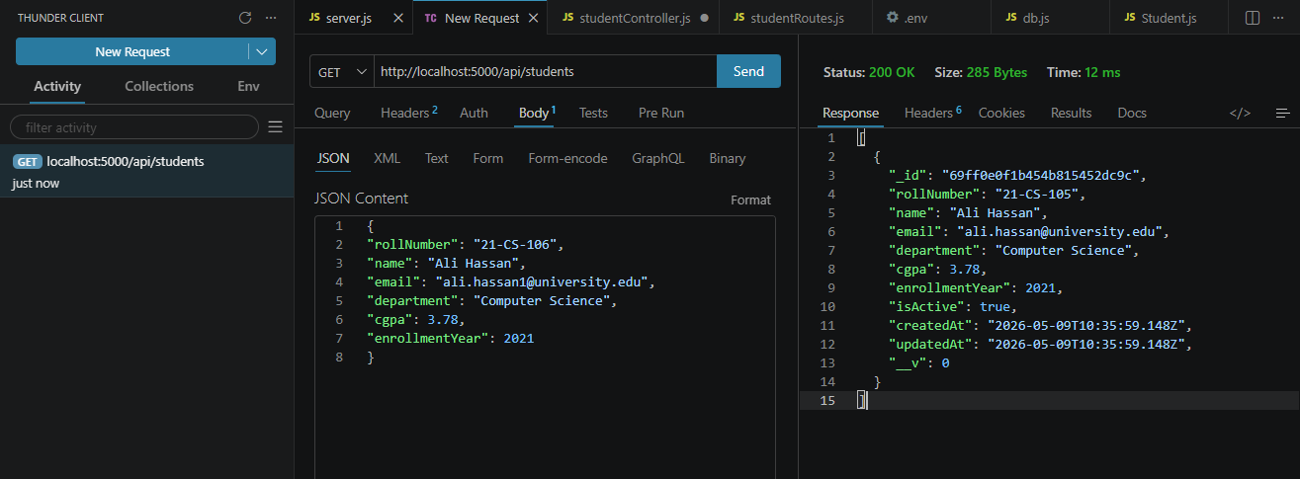
->Regex Search:
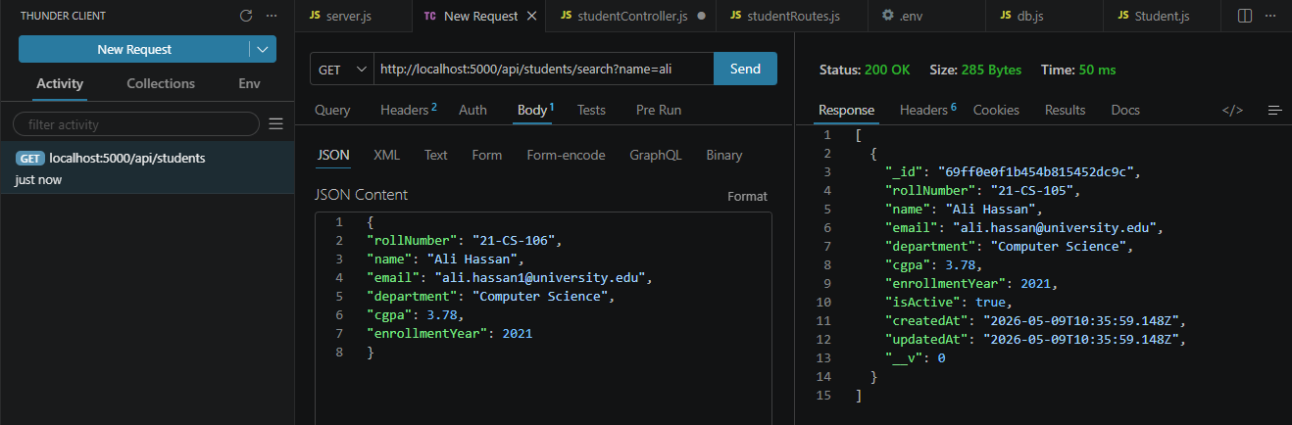
->Delete
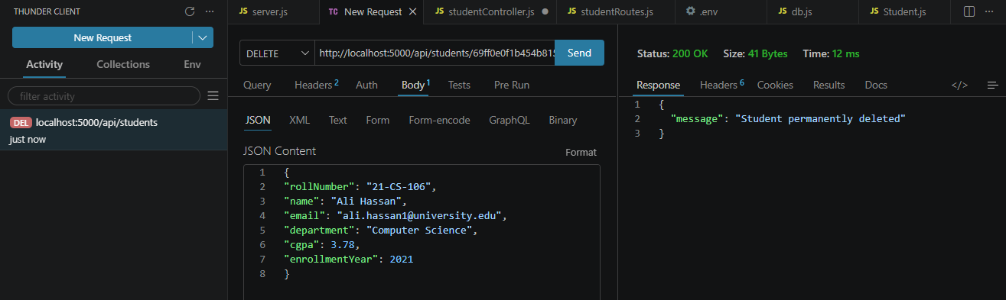
Question 2:
Server.js
const express = require('express');
const dotenv = require('dotenv');
const connectDB = require('./config/db');

dotenv.config();
connectDB();

const app = express();
app.use(express.json());

app.use('/api', require('./routes/apiRoutes'));

const PORT = process.env.PORT || 5001;

app.listen(PORT, () => {
console.log(`Blog Server running on port ${PORT}`);
});

User.js
const mongoose = require('mongoose');
const bcrypt = require('bcrypt');

const userSchema = new mongoose.Schema({
username: { type: String, required: true, unique: true },
email: { type: String, required: true, unique: true },
password: { type: String, required: true, minlength: 6 },
createdAt: { type: Date, default: Date.now }
});

userSchema.pre('save', async function() {
if (!this.isModified('password')) return;

const salt = await bcrypt.genSalt(10);
this.password = await bcrypt.hash(this.password, salt);
});

userSchema.virtual('posts', {
ref: 'Post',
localField: '_id',
foreignField: 'author'
});

userSchema.set('toJSON', { virtuals: true });
userSchema.set('toObject', { virtuals: true });

module.exports = mongoose.model('User', userSchema);

Post.js
const mongoose = require('mongoose');

const postSchema = new mongoose.Schema({
title: { type: String, required: true },
content: { type: String, required: true },
author: { type: mongoose.Schema.Types.ObjectId, ref: 'User', required: true },
tags: [{ type: String }],
createdAt: { type: Date, default: Date.now }
});

postSchema.virtual('comments', {
ref: 'Comment',
localField: '_id',
foreignField: 'post'
});

postSchema.set('toJSON', { virtuals: true });
postSchema.set('toObject', { virtuals: true });

module.exports = mongoose.model('Post', postSchema);

Comment.js
const mongoose = require('mongoose');

const commentSchema = new mongoose.Schema({
text: { type: String, required: true },
post: { type: mongoose.Schema.Types.ObjectId, ref: 'Post', required: true },
user: { type: mongoose.Schema.Types.ObjectId, ref: 'User', required: true },
createdAt: { type: Date, default: Date.now }
});

module.exports = mongoose.model('Comment', commentSchema);

userController.js
const User = require('../models/User');

exports.registerUser = async (req, res) => {
try {
const user = new User(req.body);
await user.save();
res.status(201).json({ message: 'User registered successfully', userId: user._id });
} catch (error) {
res.status(400).json({ message: error.message });
}
};

exports.getUsers = async (req, res) => {
try {
const users = await User.find().select('-password');
res.status(200).json(users);
} catch (error) {
res.status(500).json({ message: error.message });
}
};

exports.getUserById = async (req, res) => {
try {
const user = await User.findById(req.params.id)
.select('-password')
.populate('posts');

if (!user) return res.status(404).json({ message: 'User not found' });
res.status(200).json(user);
} catch (error) {
res.status(500).json({ message: error.message });
}
};

postController.js
const Post = require('../models/Post');
const Comment = require('../models/Comment');

exports.createPost = async (req, res) => {
try {
const post = new Post(req.body);
await post.save();
res.status(201).json(post);
} catch (error) {
res.status(400).json({ message: error.message });
}
};

exports.getPosts = async (req, res) => {
try {
const posts = await Post.find().populate('author', 'username email');
res.status(200).json(posts);
} catch (error) {
res.status(500).json({ message: error.message });
}
};

exports.getPostById = async (req, res) => {
try {
const post = await Post.findById(req.params.id)
.populate('author', 'username email')
.populate({
path: 'comments',
populate: { path: 'user', select: 'username email' }
});

if (!post) return res.status(404).json({ message: 'Post not found' });
res.status(200).json(post);
} catch (error) {
res.status(500).json({ message: error.message });
}
};

exports.getPostsByTag = async (req, res) => {
try {
const posts = await Post.find({ tags: req.params.tag }).populate('author', 'username email');
res.status(200).json(posts);
} catch (error) {
res.status(500).json({ message: error.message });
}
};

exports.updatePost = async (req, res) => {
try {
const post = await Post.findByIdAndUpdate(req.params.id, req.body, { new: true });
if (!post) return res.status(404).json({ message: 'Post not found' });
res.status(200).json(post);
} catch (error) {
res.status(400).json({ message: error.message });
}
};

exports.deletePost = async (req, res) => {
try {
const post = await Post.findByIdAndDelete(req.params.id);
if (!post) return res.status(404).json({ message: 'Post not found' });

await Comment.deleteMany({ post: post._id });
res.status(200).json({ message: 'Post and associated comments successfully deleted' });
} catch (error) {
res.status(500).json({ message: error.message });
}
};

apiRoutes.js
const express = require('express');
const router = express.Router();

const userController = require('../controllers/userController');
const postController = require('../controllers/postController');
const commentController = require('../controllers/commentController');

router.post('/users/register', userController.registerUser);
router.get('/users', userController.getUsers);
router.get('/users/:id', userController.getUserById);

router.post('/posts', postController.createPost);
router.get('/posts', postController.getPosts);
router.get('/posts/tag/:tag', postController.getPostsByTag);
router.get('/posts/:id', postController.getPostById);
router.put('/posts/:id', postController.updatePost);
router.delete('/posts/:id', postController.deletePost);

router.post('/posts/:postId/comments', commentController.addComment);
router.get('/posts/:postId/comments', commentController.getCommentsByPost);
router.delete('/comments/:id', commentController.deleteComment);

module.exports = router;

commentController.js
const Comment = require('../models/Comment');
const Post = require('../models/Post');
const User = require('../models/User');

exports.addComment = async (req, res) => {
try {
const { postId } = req.params;
const { text, user } = req.body;

const postExists = await Post.findById(postId);
const userExists = await User.findById(user);

if (!postExists || !userExists) {
return res.status(404).json({ message: 'Post or User not found' });
}

const comment = new Comment({ text, post: postId, user });
await comment.save();
res.status(201).json(comment);
} catch (error) {
res.status(400).json({ message: error.message });
}
};

exports.getCommentsByPost = async (req, res) => {
try {
const comments = await Comment.find({ post: req.params.postId }).populate('user', 'username email');
res.status(200).json(comments);
} catch (error) {
res.status(500).json({ message: error.message });
}
};

exports.deleteComment = async (req, res) => {
try {
const comment = await Comment.findByIdAndDelete(req.params.id);
if (!comment) return res.status(404).json({ message: 'Comment not found' });
res.status(200).json({ message: 'Comment deleted successfully' });
} catch (error) {
res.status(500).json({ message: error.message });
}
};

.env
PORT=5001
MONGO_URI=mongodb://localhost:27017/blog_db

db.js
const mongoose = require('mongoose');

const connectDB = async () => {
try {
const conn = await mongoose.connect(process.env.MONGO_URI);
console.log(`MongoDB Connected: ${conn.connection.host}`);
} catch (error) {
console.error(`Error connecting to MongoDB: ${error.message}`);
process.exit(1);
}
};

module.exports = connectDB;

Output:
-> Register a User
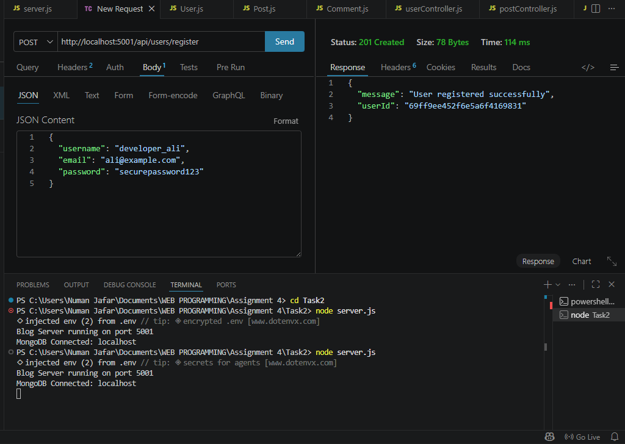
-> Create a Post
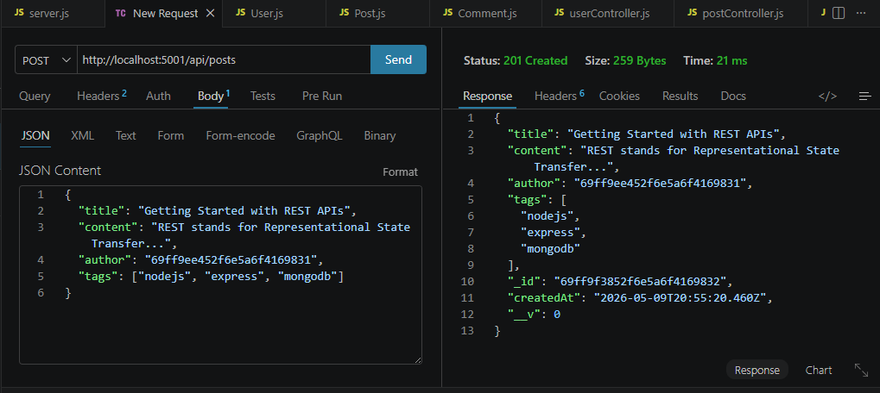
-> Add a comment
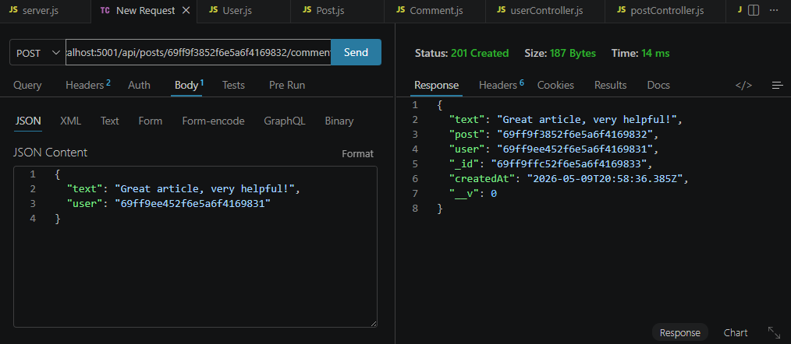
-> Population
