REPORT

1. Introduction
This project demonstrates the development of two RESTful APIs using Node.js, Express, and MongoDB (Mongoose). The first API manages student records, and the second implements a blogging platform with relationships between users, posts, and comments.

2. Project Setup

Technologies Used
- Node.js
- Express.js
- MongoDB & Mongoose
- bcrypt (for password hashing)
- Postman / Thunder Client (for API testing)

Folder Structure
Q1-Student-API/
├── models/
├── routes/
├── controllers/
├── config/
├── app.js
├── package.json

Q2-Blog-API/
├── models/
├── routes/
├── controllers/
├── config/
├── app.js
├── package.json

3. Task 1: Student Management System API

3.1 Student Schema
Fields:
- rollNumber (String, required, unique)
- name (String, required)
- email (String, required, unique)
- department (String, required)
- cgpa (Number, 0.0 – 4.0)
- enrollmentYear (Number, required)
- isActive (Boolean, default: true)

3.2 API Endpoints

Create Student
- POST /api/students
- Description: Add new student

Get All Students
- GET /api/students
- Supports: pagination (page, limit), filter by department

Get Student by ID
- GET /api/students/:id

Search Student
- GET /api/students/search?name=

Update Student (Full)
- PUT /api/students/:id

Partial Update
- PATCH /api/students/:id

Delete Student
- DELETE /api/students/:id

Soft Delete
- PATCH /api/students/:id/deactivate

3.3 Screenshots
POST:
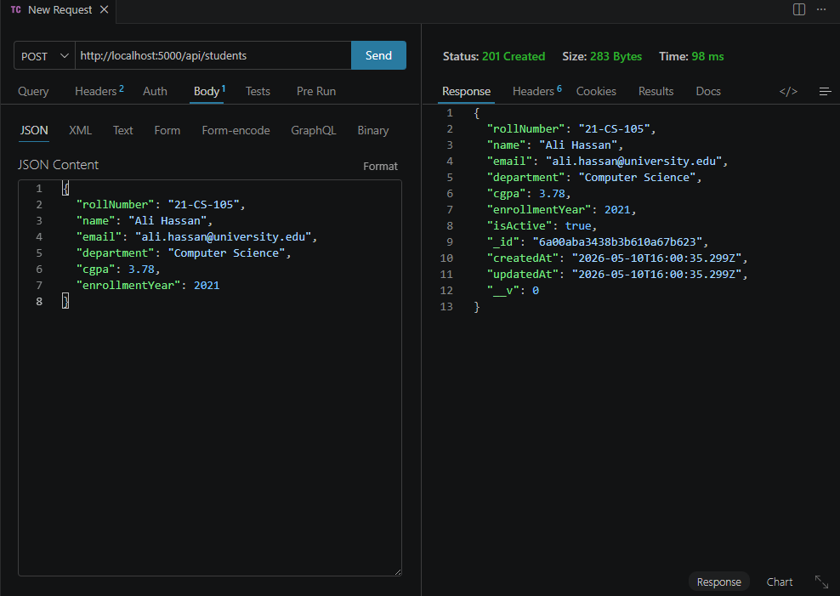
GET:
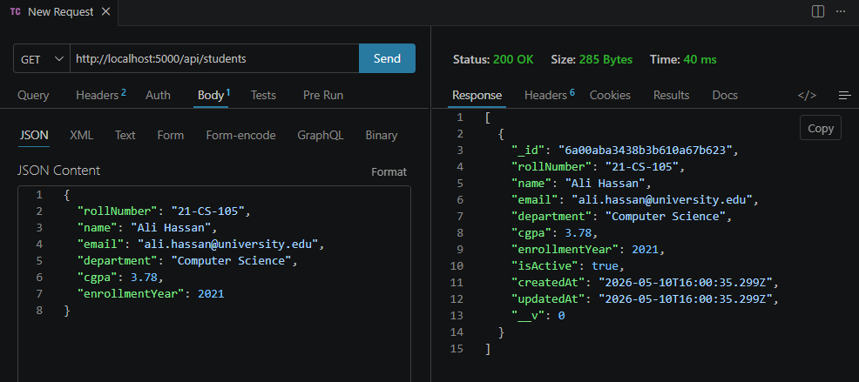
GET (by student_id):
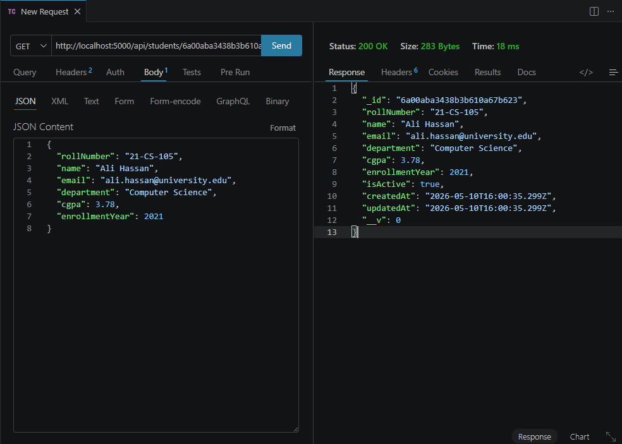
GET (by name):
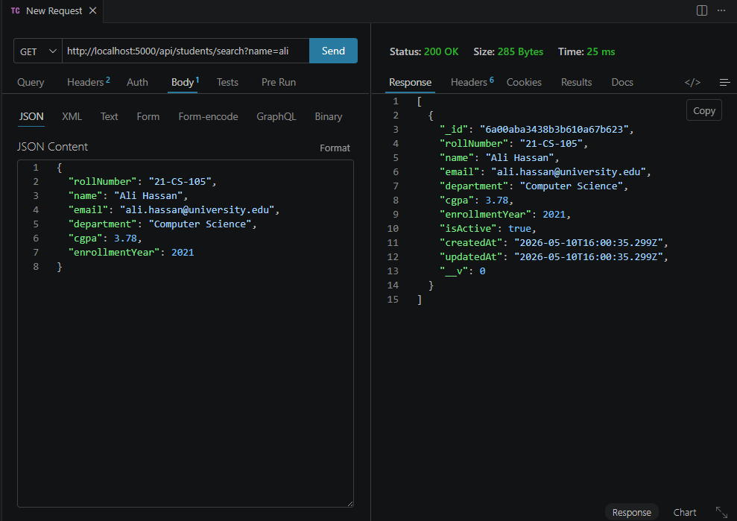
PUT (by id):
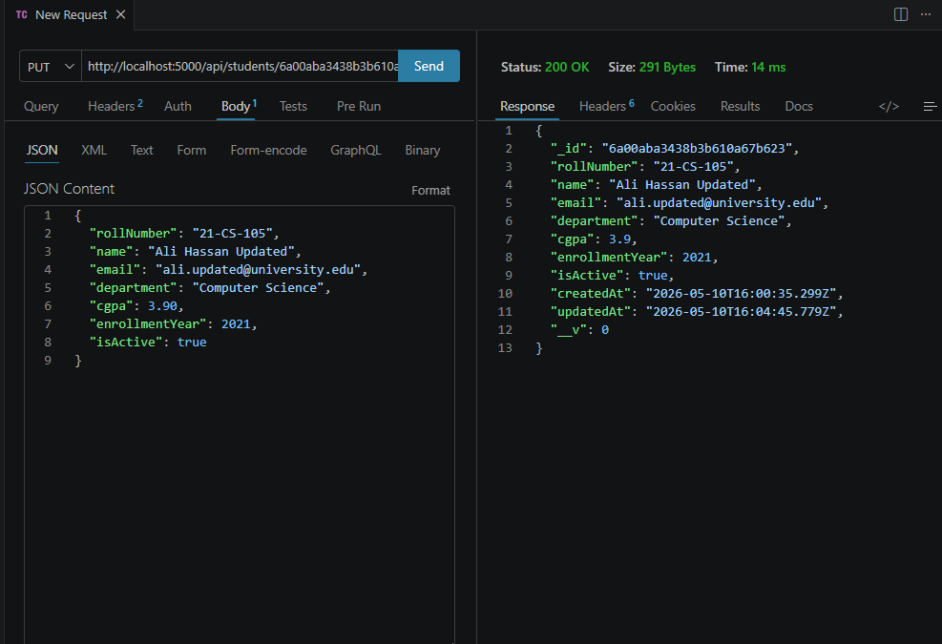
PATCH (by id):
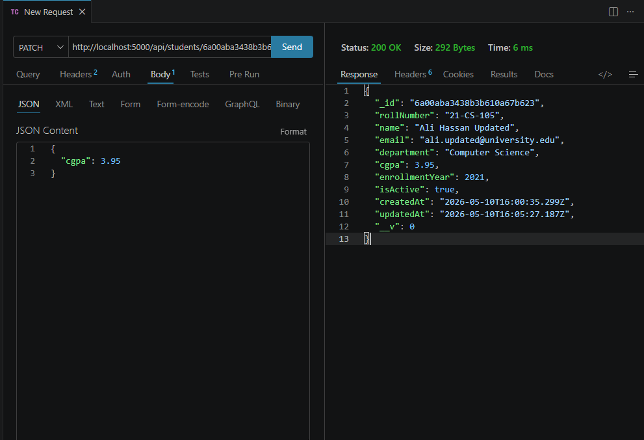
PATCH (deactivate):
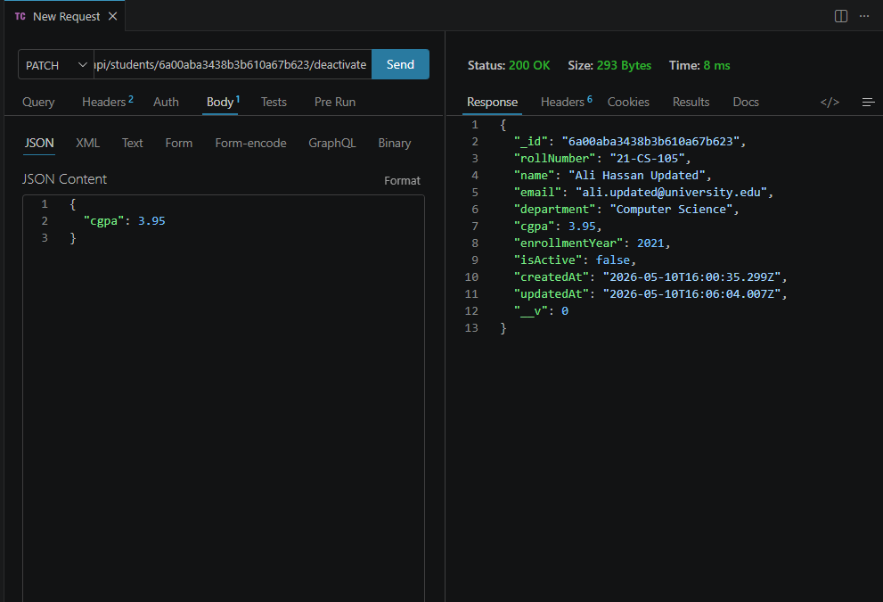
Delete:
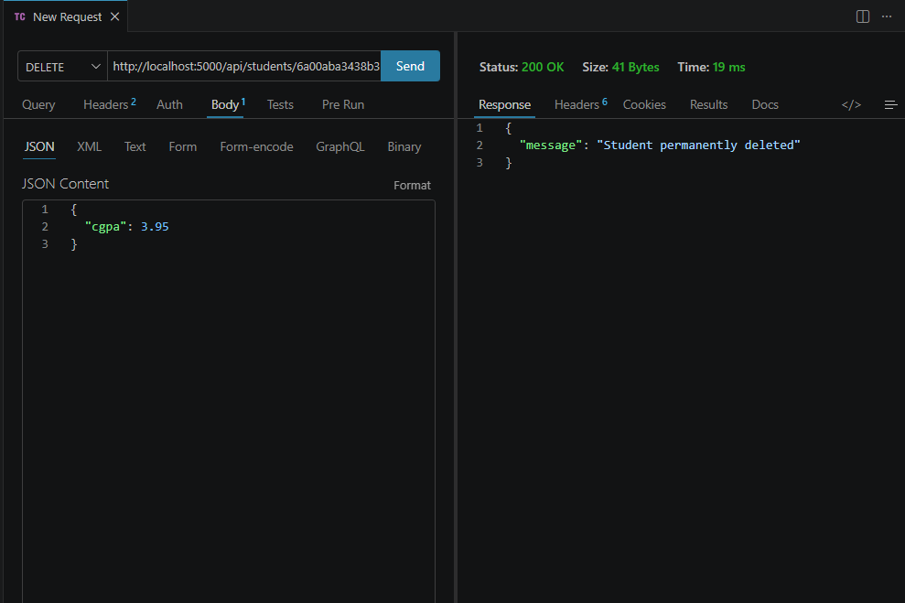

4. Task 2: Blog Application API

4.1 Schemas

User Schema
- username (String, unique)
- email (String, unique)
- password (String, hashed)
- createdAt (Date)

Post Schema
- title
- content
- author (ref: User)
- tags (Array)
- createdAt

Comment Schema
- text
- post (ref: Post)
- user (ref: User)
- createdAt

4.2 User APIs
- POST /api/users/register
- GET /api/users
- GET /api/users/:id (with posts populated)

4.3 Post APIs
- POST /api/posts
- GET /api/posts
- GET /api/posts/:id (author + comments populated)
- GET /api/posts/tag/:tag
- PUT /api/posts/:id
- DELETE /api/posts/:id (cascade delete comments)

4.4 Comment APIs
- POST /api/posts/:postId/comments
- GET /api/posts/:postId/comments
- DELETE /api/comments/:id

4.5 Screenshots
POST (registering a user):
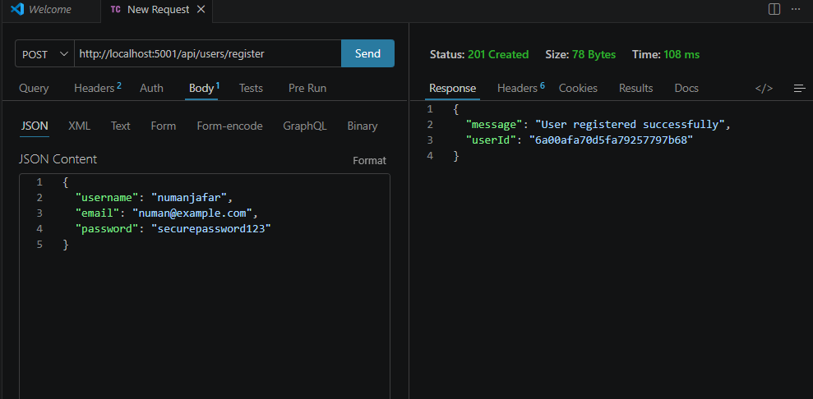

GET:
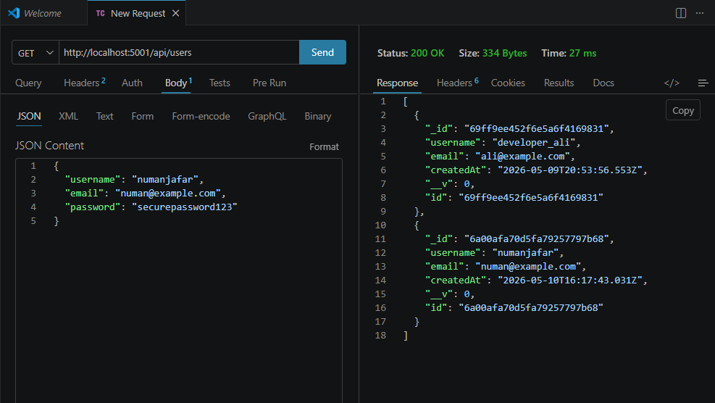
POST (adding a post):
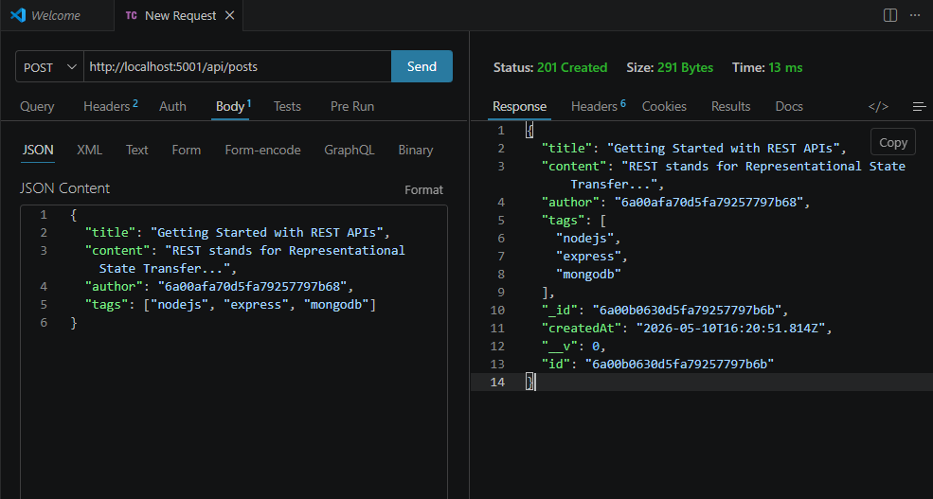
GET (by post-id):
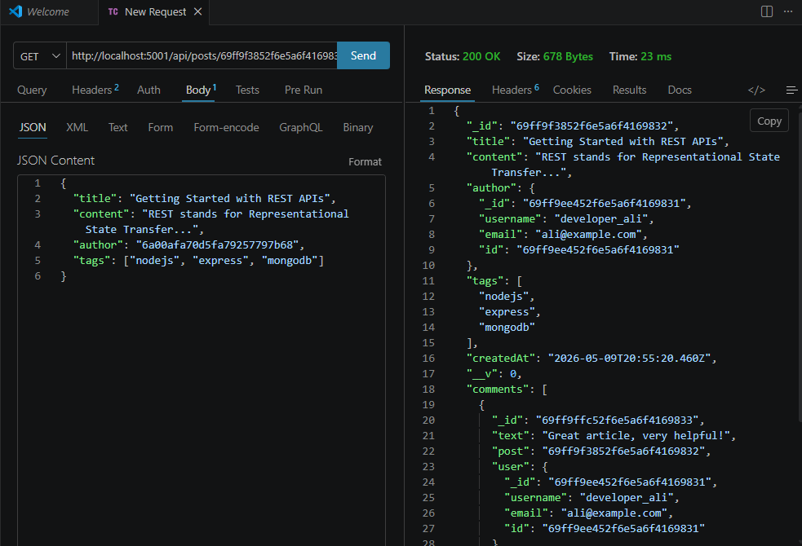
PUT (update a post):
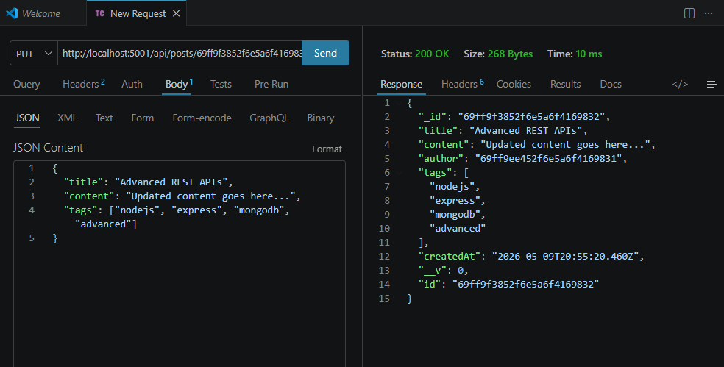

5. Database Design
- MongoDB used as NoSQL database
- Mongoose schemas define structure
- Relationships handled using ObjectId references
- populate() used for joining collections

6. Error Handling & Validation
Implemented:
- Required field validation
- Email format validation
- Unique constraints
- Proper HTTP status codes:
  - 200 OK
  - 201 Created
  - 400 Bad Request
  - 404 Not Found
  - 500 Server Error

