**Mobile Computing**

MC_Progress

**Submitted to:**

**Sir Haq Nawaz**

**Submitted by:**

**Numan Khalid (BSEF18A003)**

**Git hub Account:**

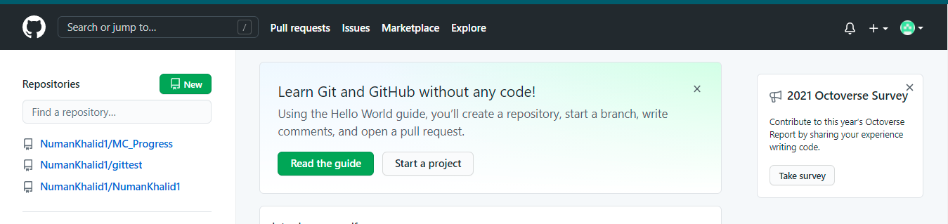

**Git Repositry:**

`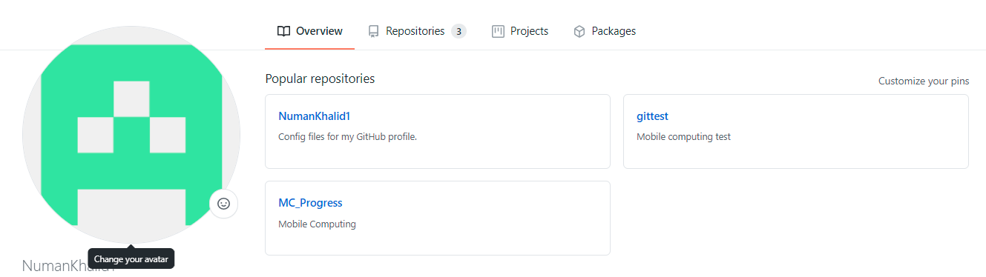

Git Add:



Git Commit:

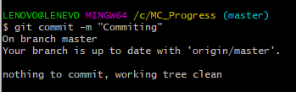

Git Push:

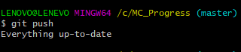

Git Status:

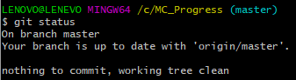

**Andriod Studio Installation**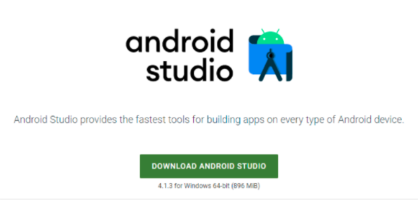

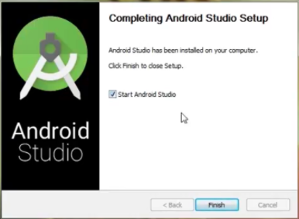

**Merge Conflicts**

Merge Coflicts occur when we try to change same line from local and central repository at the same time 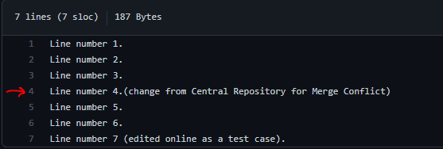Above are some changes from central repository.

Git log:

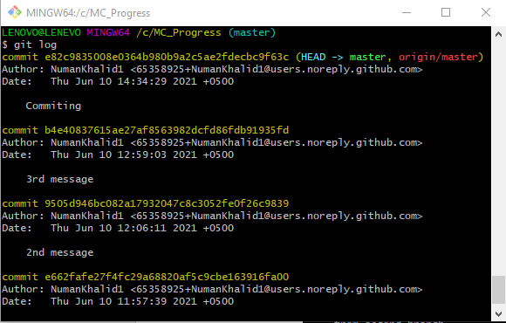

Views and Layouts:

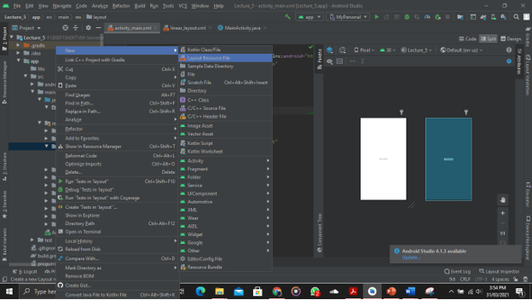

Layout View:

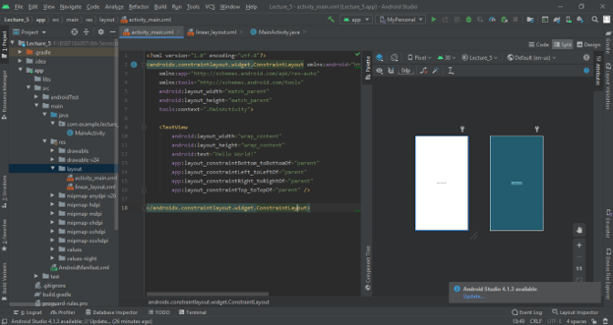

Animations:

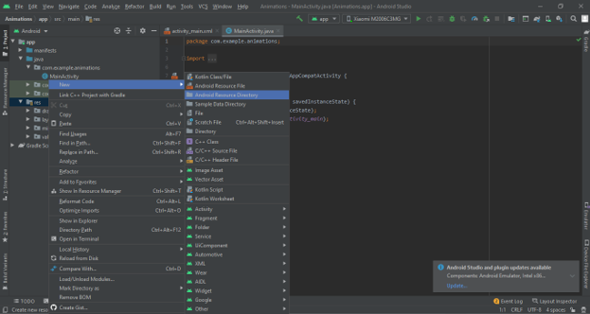

Navigation Drawer:

