Week 4 Report
Compare, Cross-Validate and Tune Models
Dataset: healthcare_data.csv | Target: patient status

1. Introduction
This report compares four classification models (KNN, Decision Tree, Random Forest, Gradient Boosting) using 5-fold cross-validation, tunes their hyper-parameters and checks them for overfitting. The goal is to predict the status of a hospital patient: Admitted, Discharged or Under Treatment.

2. Data preparation
The dataset has 17,498 patients and 14 columns. There were no missing values and no duplicate rows. The target is balanced (Admitted 5,883, Under Treatment 5,860, Discharged 5,755).
- Dropped identifier and contact columns (patient_id, first_name, last_name, phone, email): they are unique per patient and have no predictive meaning.
- Converted admission and discharge dates and created length_of_stay, admit_month and admit_year.
- 4,382 rows (25.0%) had a discharge date before the admission date. These impossible lengths of stay were set to missing and filled with the median.
- One-hot encoded gender, department, diagnosis and treatment (24 features in total); label-encoded the target.
- Split 80/20 with stratify=y and random_state=42: 13,998 training rows and 3,500 test rows. The test set was not used for any choice.

3. Comparison of four models (5-fold CV)
All models were evaluated with 5-fold stratified cross-validation on the training data only. KNN uses make_pipeline(StandardScaler(), KNeighborsClassifier()) so scaling is fitted inside every fold.
Model | Mean CV accuracy | Std
Gradient Boosting | 0.3348 | 0.0028
KNN | 0.3337 | 0.0064
Decision Tree | 0.3283 | 0.0074
Random Forest | 0.3275 | 0.0066

All four scores are close to 0.33, which is what random guessing gives for three balanced classes. The differences between models are smaller than the standard deviation.

4. Tuning KNN and Decision Tree

4.1 KNN: K = 1, 3, 5, ..., 15
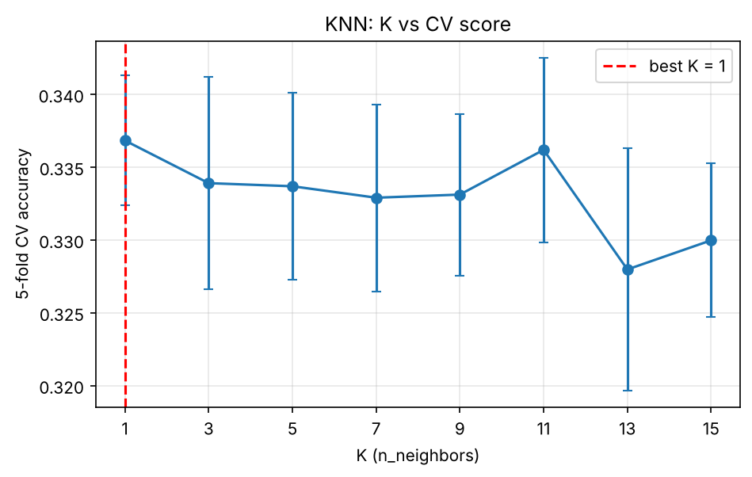
Figure 1: KNN, K vs 5-fold CV accuracy
The best K by CV mean is K = 1 (0.3368), but K = 11 is almost identical (0.3362) and the differences are smaller than the standard deviation (about 0.005 to 0.006). K = 1 memorises every training patient (train score 1.00), so in a real project a larger K such as 11 would be the safer choice. Odd values of K are used to avoid ties between the three classes.

4.2 Decision Tree: max_depth = 2, 3, 5, 10, None
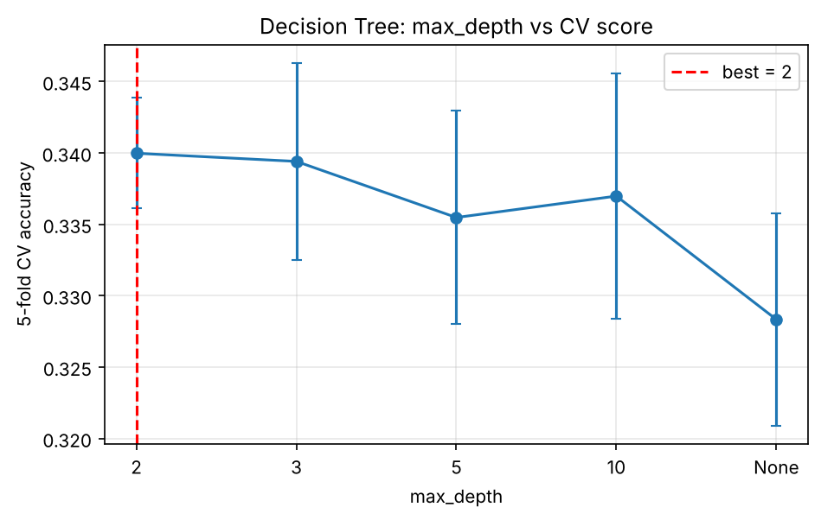
Figure 2: Decision Tree, max_depth vs 5-fold CV accuracy
max_depth | 2 | 3 | 5 | 10 | None
CV mean | 0.3400 | 0.3394 | 0.3355 | 0.3370 | 0.3283

max_depth = 2 gives the best CV score (0.3400). A fully grown tree (None) is the worst because it memorises noise in the training data. The shallow tree is also the simplest and most stable model.

5. Random Forest with GridSearchCV
Grid: n_estimators = [50, 100, 200] and max_depth = [3, 5, None], cv = 5.
- best_params_: {max_depth: 5, n_estimators: 100}
- best_score_: 0.3427
- Number of trainings: 3 x 3 = 9 combinations x 5 folds = 45 trainings (plus one final refit on the full training set).

6. Bonus: Gradient Boosting tuning
Grid: learning_rate = [0.01, 0.05, 0.1, 0.2] and n_estimators = [50, 100, 200], cv = 5 (12 combinations x 5 folds = 60 trainings).
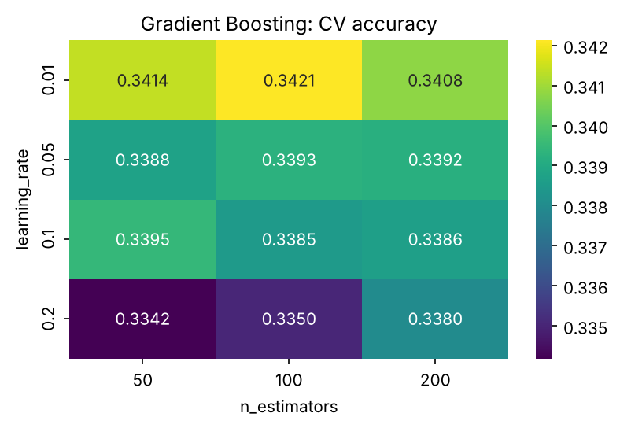
Figure 3: Gradient Boosting CV accuracy for each parameter pair
Best parameters: learning_rate = 0.01, n_estimators = 100, CV score 0.3421. This is practically the same as the tuned Random Forest (0.3427). A very small learning rate being best means the model prefers to learn almost nothing, which is a sign that the data contains no real signal.
Model | Best parameters | CV score
Random Forest | max_depth=5, n_estimators=100 | 0.3427
Gradient Boosting | learning_rate=0.01, n_estimators=100 | 0.3421

7. Overfitting check
Model | Train score | Test score | Gap
KNN (K=1) | 1.0000 | 0.3394 | 0.6606
Decision Tree (depth=2) | 0.3457 | 0.3337 | 0.0120
Random Forest (tuned) | 0.4369 | 0.3320 | 0.1049
Gradient Boosting (tuned) | 0.3762 | 0.3271 | 0.0491

Most overfit: KNN with K = 1. It reaches a perfect training score because each point is its own nearest neighbour, but falls to 0.34 on the test set.
Most stable: the Decision Tree with depth 2, with a gap of only 0.012. Its train and test scores are almost the same because the model is too simple to memorise anything.

8. Final test and decision
The final model was chosen from the cross-validation scores (not from the test set) and then evaluated once on the test set.
Final model: tuned Random Forest (max_depth=5, n_estimators=100). Test accuracy: 0.332.
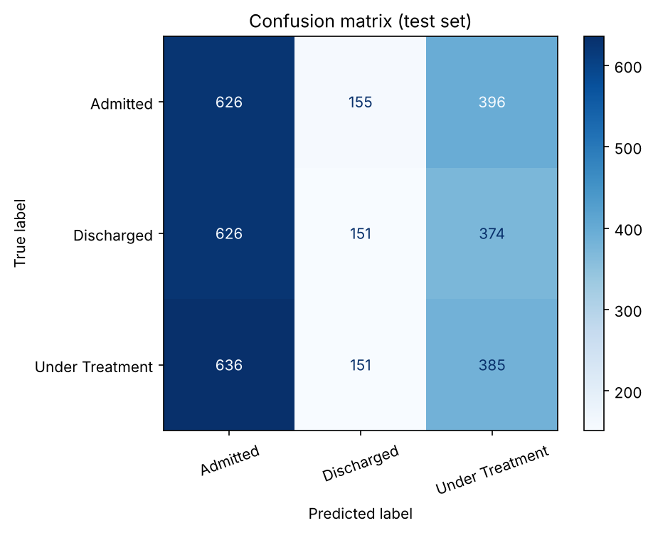
Figure 4: Confusion matrix on the test set
Class | Precision | Recall | F1-score | Support
Admitted | 0.33 | 0.53 | 0.41 | 1177
Discharged | 0.33 | 0.13 | 0.19 | 1151
Under Treatment | 0.33 | 0.33 | 0.33 | 1172
Accuracy |  |  | 0.33 | 3500

Why this model
- It has the highest CV accuracy (0.3427 against 0.3421 for Gradient Boosting). The difference is tiny, so the two are effectively tied.
- Ensembles of trees average many models, so they are more stable than KNN with K = 1.
- Its train/test gap (0.105) is larger than the Decision Tree (0.012) and Gradient Boosting (0.049). If the safest generalisation were the only goal, the shallow Gradient Boosting or Decision Tree would be the conservative choice.

Precision or recall?
For this hospital problem, recall matters more. Missing a patient who still needs care (for example predicting Discharged when the patient is really Admitted or Under Treatment) is a bigger risk than a false alarm, which only costs extra checking. Precision should still be acceptable so that staff are not flooded with false alerts, but recall comes first.

9. Conclusion and limitation
Every model scores about 0.33, the chance level for three balanced classes, and the confusion matrix is spread almost evenly. The final model predicts Admitted too often (recall 0.53) and Discharged rarely (recall 0.13), which is a bias and not real skill. The available features (age, gender, department, diagnosis, treatment, bill amount and dates) contain almost no information about status, and the dataset appears to be randomly generated. In a real project the data source should be checked, a more meaningful target (such as diagnosis or department) could be used, and real clinical features should be added. The main learning points are: use cross-validation on the training set only, tune with a grid search, compare train and test scores to detect overfitting, and keep the test set for one final evaluation.

