Week 3: Supervised Models on a Healthcare Dataset
YOUR NAME | DATE | KNN, Decision Tree, Logistic Regression
GitHub: https://github.com/YOUR-USERNAME/week3-supervised-models (replace with your real link)
1. Dataset
Source: healthcare_data.csv (hospital patient records; add the original download link here). It has 17,498 rows and 14 columns, with no missing values and no duplicate rows. Only 2 columns are numeric (age, bill_amount); the rest are text. The target is status, with three classes: Admitted, Under Treatment and Discharged.
Cleaning: I dropped patient_id, names, phone, email and the two date columns, because they are identifiers or contact details and would only add noise. The 4 text columns (gender, department, diagnosis, treatment) were one-hot encoded, giving 21 features. The data is balanced: Admitted 5,883 (33.6%), Under Treatment 5,860 (33.5%), Discharged 5,755 (32.9%). I used an 80/20 stratified split (13,998 train, 3,500 test, random_state=42) and fitted StandardScaler on the training set only.
Data quality warning: 4,382 rows (25%) have a discharge date before the admission date. Pediatrics has 2,056 patients older than 18 out of 2,550, and 420 patients with diagnosis “Healthy” had surgery. These problems suggest the values were generated randomly rather than collected from real patients.
2. Results
Model | Accuracy | Precision | Recall | F1
KNN (K=1) | 0.3403 | 0.3403 | 0.3403 | 0.3403
Decision Tree (max_depth=5) | 0.3374 | 0.3431 | 0.3374 | 0.2692
Logistic Regression | 0.3311 | 0.3292 | 0.3311 | 0.3230
Precision, recall and F1 are weighted averages over the 3 classes. Random guessing on 3 balanced classes gives about 33.3%, so all three models are at chance level.
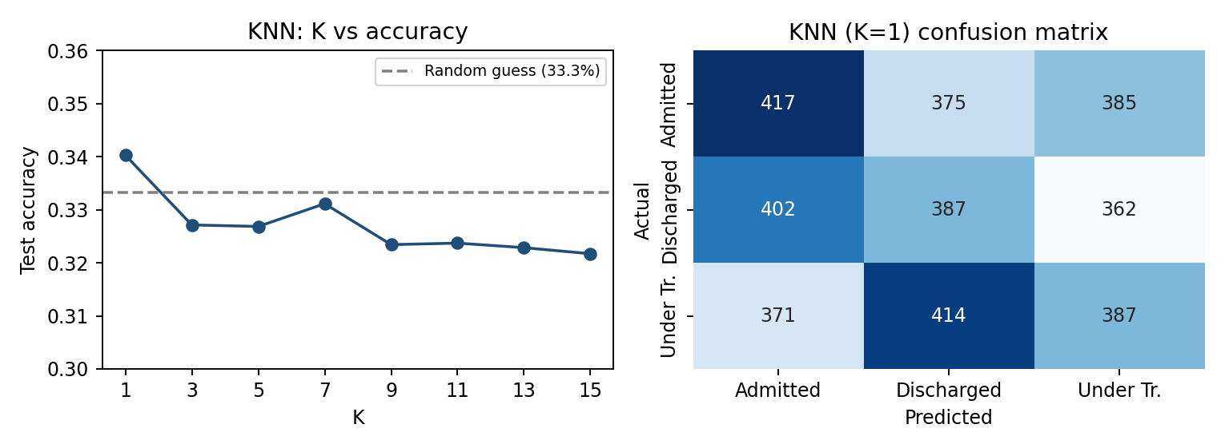
3. Confusion matrix of the best model (KNN, K=1)
Each row is the true status and each column is what the model predicted. A good model would have large numbers on the diagonal (417, 387, 387) and small numbers elsewhere. Here every cell is between 362 and 417, so the model gets about as many patients wrong as right: for example, of 1,151 truly Discharged patients, only 387 were found, while 402 were called Admitted and 362 Under Treatment. The model is basically guessing.
4. Best K and best max_depth
- Best K = 1 (accuracy 0.3403). K=3 to 15 gave 0.322 to 0.331. The K=1 win is only about 1 percentage point, which is within random variation (the standard error on 3,500 test rows is about 0.8 points), so I do not trust it as a real signal.
- Best max_depth = 5 (test 0.3374). Depths 2 and 3 gave 0.334 and 0.333. At depth 10 train accuracy rose to 0.402, and with max_depth=None it reached 1.000, while test accuracy stayed near 0.33. A very deep tree memorises the training rows (overfitting) but learns nothing that works on new patients.
5. Which metric matters most
In a hospital, the worse mistake is a false “Discharged” prediction: telling staff a patient is ready to leave when they still need care could harm them. A false “Admitted” only costs extra bed time. So precision of the Discharged class matters most (when the model says Discharged, it must be right), together with recall for the patients who still need treatment. The KNN precision for Discharged is only about 0.33, far too low for real use. Accuracy alone is also unreliable here: the Decision Tree has accuracy 0.337 but F1 0.269, because it almost never predicts Discharged (recall 0.01) and mostly predicts Admitted. A dummy model that always says Admitted gets 0.336 accuracy, almost the same as all three models.
6. What I learned and problems faced
- The workflow (clean, encode, stratified split, scale on train only, compare models with accuracy, confusion matrix and F1) works, but good scores need data with real patterns. I also checked diagnosis, department, treatment and gender as targets with a random forest, and none beat guessing.
- Problems: the dataset has mostly text columns instead of numbers, many identifier columns, impossible dates, and no relationship between features and status. Because of this I cannot honestly say any model is useful. KNN is only “best” by a tiny, unreliable margin.
- Next time I would pick a dataset with real medical measurements (for example heart disease or diabetes), and use cross-validation to choose K and depth instead of the test set.

