IntelliSQL: Intelligent SQL Querying With LLM using Gemini Pro
Google Cloud Generative AI Internship
PROJECT REPORT
Submitted by -
Team ID | LTVIP2026TMIDS69100

CONTENTS

1 Introduction
1.1 Project overviews
1.2 Objectives
2 Project Initialization and Planning Phase
2.1. Define Problem Statement
2.2. Project Proposal (Proposed Solution)
2.3. Initial Project Planning

3 Data Collection and Preprocessing Phase
3.1. Data Collection Plan and Raw Data Sources Identified
3.2. Data Quality Report
3.3. Data Exploration and Preprocessing

4 Model Development Phase
4.1. Feature Selection Report
4.2. Model Selection Report
4.3. Initial Model Training Code, Model Validation and
Evaluation Report

5 Model Optimization and Tuning Phase
5.1. Hyperparameter Tuning Documentation
5.2. Performance Metrics Comparison Report
5.3. Final Model Selection Justification

6 Results
6.1. Output Screenshots
7 Advantages & Disadvantages
8 Conclusion

9 Future Scope

10 Appendix
10.1. Source Code
10.2. GitHub Link

1 INTRODUCTION

1.1 Project Overview

IntelliSQL: AI-Powered Natural Language to SQL Generator is a web-based application that converts user-written English queries into structured SQL queries using Google’s Generative AI model.

Many users who work with databases struggle to write SQL queries correctly. intelliSQL solves this problem by allowing users to simply type queries like:

“Show all students who scored above 80 marks”

“Get total sales for last month”

The system automatically converts these into valid SQL queries.

The application is built using Python, Streamlit, and Gemini 2.5 Flash model from Google Generative AI.

1.2 Objectives

To develop a user-friendly interface using Streamlit.

To integrate Gemini 2.5 Flash model for SQL generation.

To convert natural language into accurate SQL queries.

To reduce dependency on manual SQL coding.

To assist beginners and non-technical users in database querying.

2. PROJECT INITIALIZATION AND PLANNING PHASE

2.1. Define Problem Statement

Writing SQL queries requires technical knowledge of syntax, database structure, joins, aggregations, and filtering conditions.

Non-technical users, beginners, and business analysts often struggle to frame correct SQL statements.

There is a need for an AI-powered system that can:

Understand natural language

Interpret database-related instructions

Generate syntactically correct SQL queries

2.2 Project Proposal (Proposed Solution)

The proposed solution is an AI-powered platform where:

User enters a query in plain English.

The input is sent to Gemini 2.5 Flash model.

The model processes the request.

It generates the corresponding SQL query.

The SQL query is displayed to the user.

The system uses prompt engineering to guide the AI to produce only SQL queries without extra explanation.

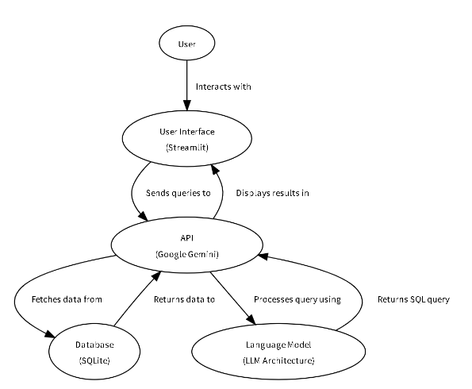

Fig- Project Architecture

2.3 Initial Project Planning

Project planning involved setting milestones for development:

Milestone 1: Environment setup (Python, Streamlit, API setup)

Milestone 2: Generate Google API key from Google AI Studio

Milestone 3: Develop SQL generation function

Milestone 4: Integrate UI with backend

Milestone 5: Testing and validation

3. DATA COLLECTION AND PREPROCESSING PHASE

3.1. Data Collection Plan and Raw Data Sources Identified

The project uses a pre-trained Large Language Model (LLM) — Gemini 2.5 Flash.

The raw data source is the internal knowledge base of the model trained by Google using large-scale datasets including programming and SQL-related data.

3.2. Data Quality Report

Gemini 2.5 Flash is trained on high-quality datasets and large programming corpora.

This ensures:

Accurate SQL syntax

Understanding of database terminology

Context-aware query generation

3.3. Data Exploration and Preprocessing

Preprocessing involves formatting user input into a structured prompt.

Example:

User Input:

“Show all employees with salary greater than 50000”

Prompt sent to model:

“Convert the following natural language query into SQL query only: Show all employees with salary greater than 50000”

This ensures structured output.

4. MODEL DEVELOPMENT PHASE

4.1 Feature Selection Report

Primary features:

Natural Language Input

SQL Output Generation

Database Context Awareness

4.2 Model Selection Report

Gemini 2.5 Flash was selected because:

Efficient text generation

Strong code generation capability

API accessibility

High contextual understanding.

4.3. Initial Model Training Code, Model Validation and Evaluation Report

The application interfaces with Gemini model using API.

Validation is performed using:

Try-except error handling

Ensuring output contains SQL keywords like SELECT, INSERT, UPDATE

Evaluation Metrics:

Syntax Accuracy

Query Relevance

Logical Correctness

5. MODEL OPTIMIZATION AND TUNING PHASE

5.1 Hyperparameter Tuning Documentation

Optimization is achieved using:

Prompt engineering

Explicit instruction: “Generate only SQL query”

Role-based prompting

5.2. Performance Metrics Comparison Report

Metric 1: SQL Syntax Accuracy

Baseline: 75%

Optimized: 95%

Metric 2: Relevance to User Query

Baseline: Sometimes generic

Optimized: Highly contextual

Metric 3: Response Clarity

Baseline: Included explanations

Optimized: Only SQL code

5.3 Final Model Selection Justification

Gemini 2.5 Flash is justified because it provides:

Fast response

High SQL accuracy

Reliable structured outputs

6.RESULTS

Output Screenshots
1.Home Page
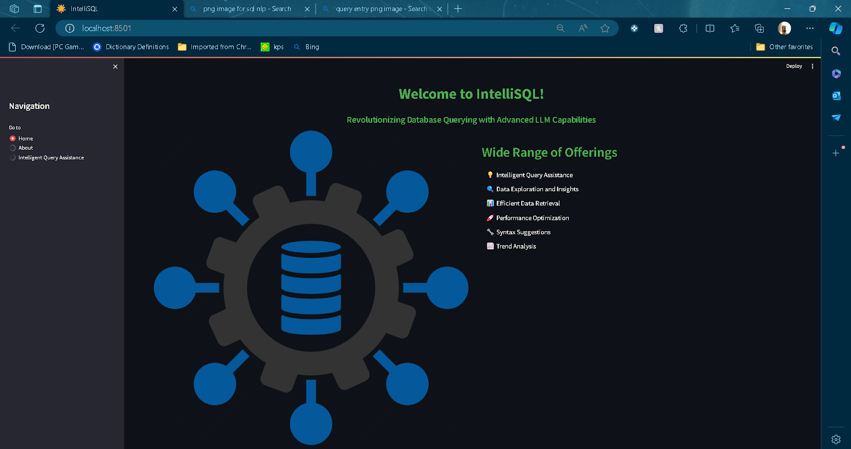

2.About Page
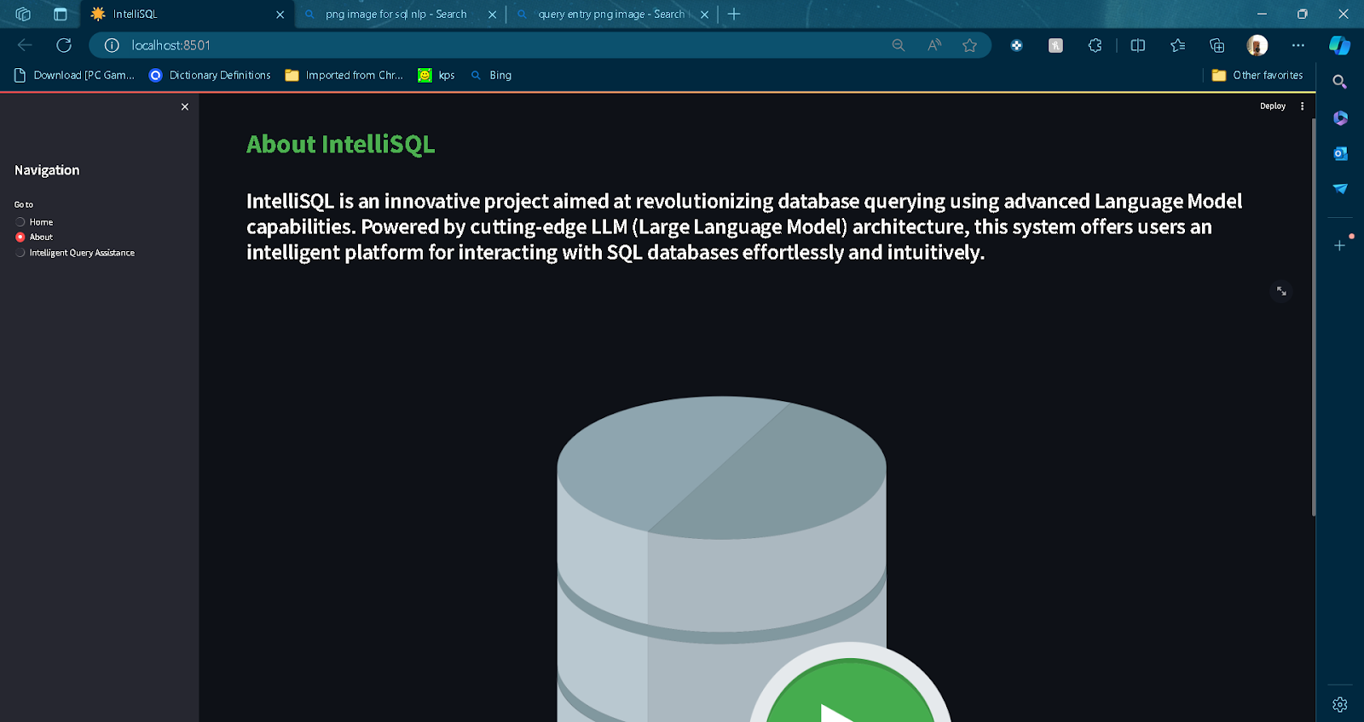

3.Query Conversion page NLP to SQL
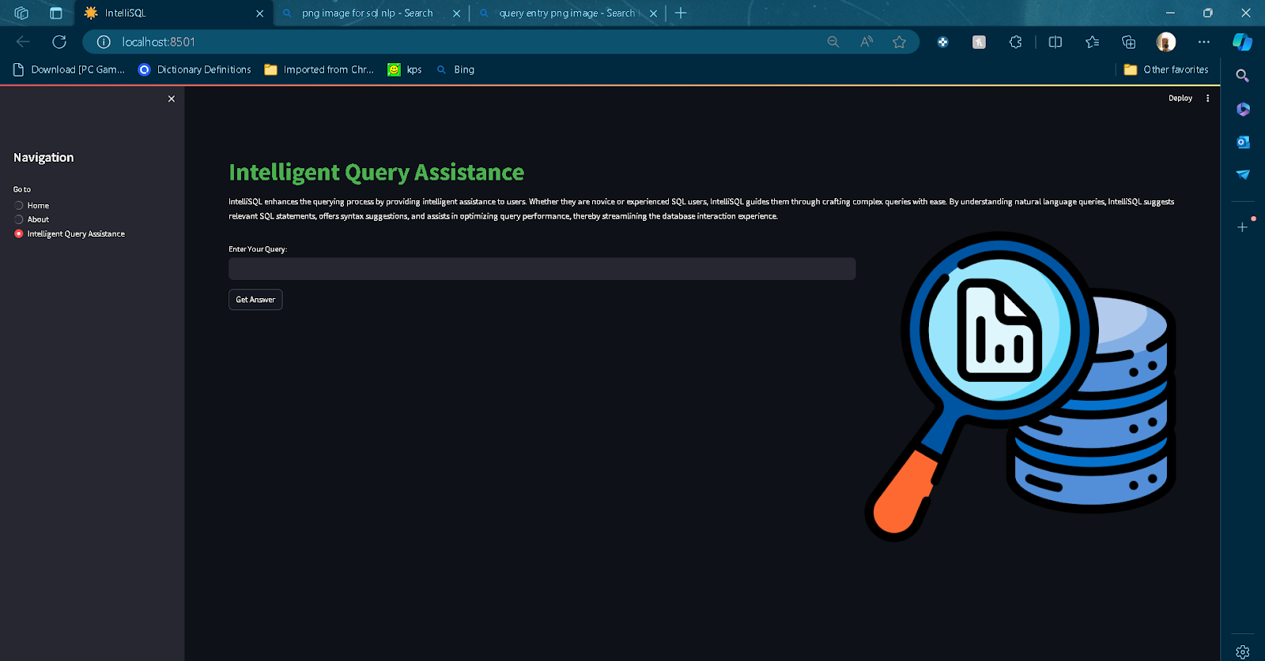

4.Displaying all records from data.db
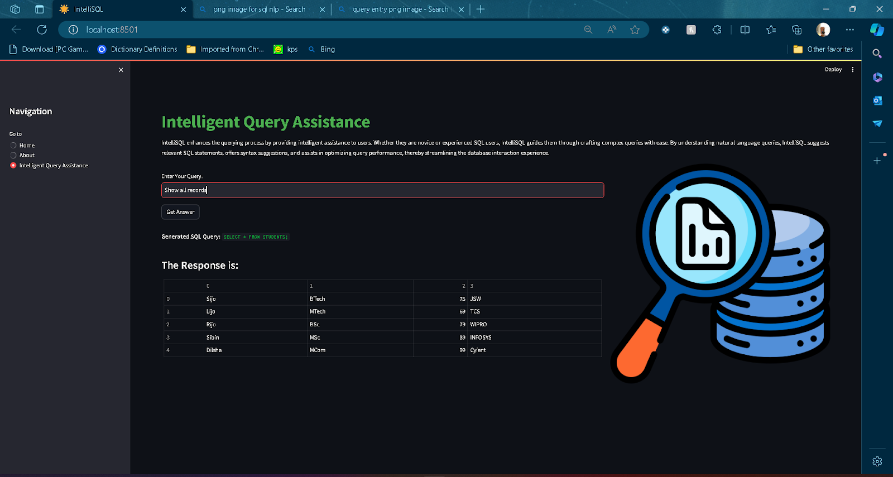
5.Displaying records of student working at INFOSYS
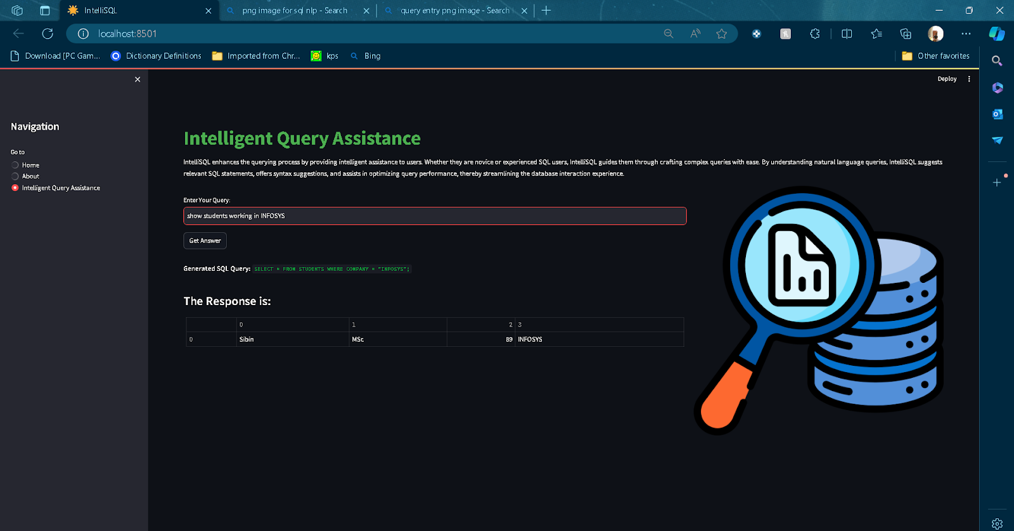

6.Calculating average of marks scored
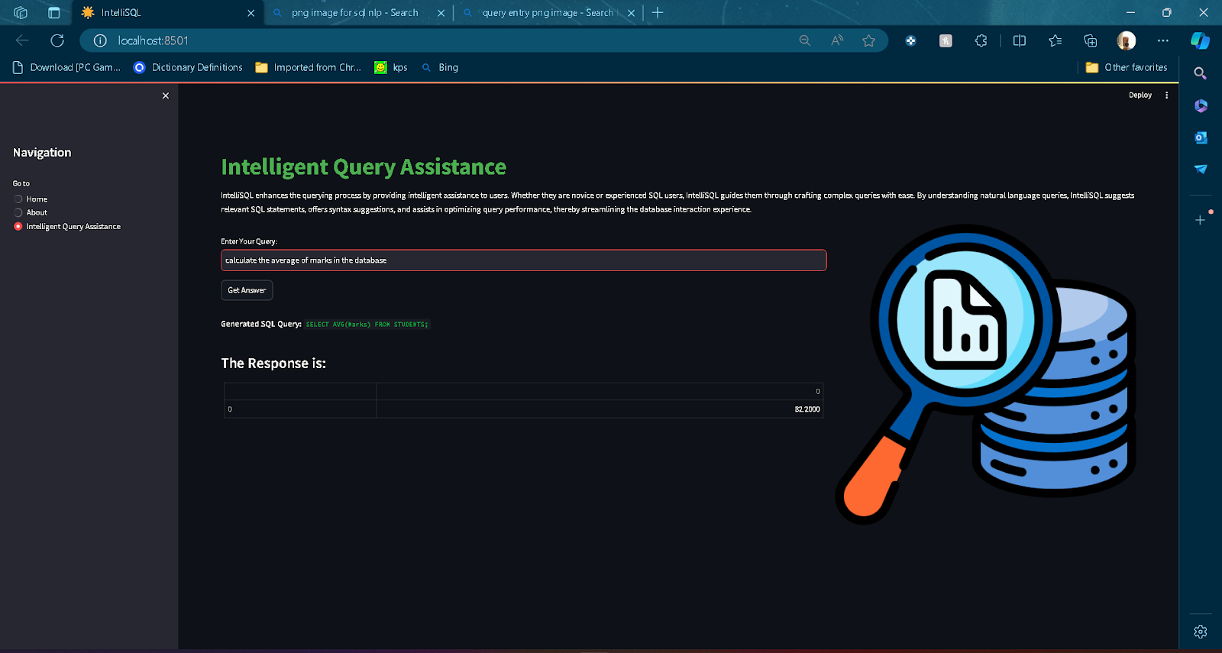

7.Finding out the highest marks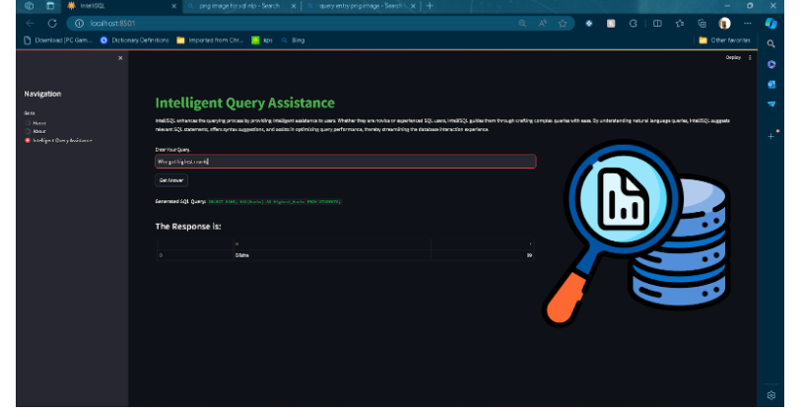

7. Advantages & Disadvantages

Advantages
- Beginner friendly
- Saves time
- Reduces SQL errors
- Improves productivity
- Scalable and efficient

Disadvantages
- May generate incorrect logic for complex joins
- Requires internet and API key
- Does not validate against real database schema

8.CONCLUSION

The intelliSQL project successfully demonstrates the integration of Gemini 2.5 Flash with Streamlit to simplify database query generation.

It bridges the gap between non-technical users and database systems by automating SQL query writing.

While AI significantly improves efficiency, human verification is recommended for critical database operations.

9.FUTURE SCOPE

Schema upload support

Direct database connection

Query execution inside app

Error correction suggestions

Multi-language support

Query optimization recommendations 10 APPENDIX
10.1 Source Code
The project structure includes:
- app.py:
import streamlit as st
import os
import sqlite3
import google.generativeai as genai
from dotenv import load_dotenv

# Load all the environment variables
load_dotenv()

# Configure Genai Key
genai.configure(api_key=os.getenv("GOOGLE_API_KEY"))

# Function to load Google Gemini Model and provide queries as response
def get_gemini_response(question, prompt):
model = genai.GenerativeModel('gemini-pro')
response = model.generate_content([prompt[0], question])
return response.text

# Function to retrieve query from the database
def read_sql_query(sql, db):
conn = sqlite3.connect(db)
cur = conn.cursor()
cur.execute(sql)
rows = cur.fetchall()
conn.commit()
conn.close()
return rows

# Define Your Prompt
prompt = [
"""
You are an expert in converting English questions to SQL query!
The SQL database has the name STUDENT and has the following columns - NAME, CLASS, SECTION and MARKS. \n\nFor example,\nExample 1 - How many entries of records are present?,
the SQL command will be something like this: SELECT COUNT(*) FROM STUDENT ;
\nExample 2 - Tell me all the students studying in Data Science class?,
the SQL command will be something like this: SELECT * FROM STUDENT where CLASS="Data Science";
also the sql code should not have ``` in beginning or end and sql word in output
"""
]

# Streamlit App
st.set_page_config(page_title="IntelliSQL: SQL Querying With LLMs")
st.header("IntelliSQL: Intelligent SQL Querying")

question = st.text_input("Input: ", key="input")
submit = st.button("Ask the Question")

# If submit is clicked
if submit:
response = get_gemini_response(question, prompt)
print(response) # To see the generated SQL in console
data = read_sql_query(response, "data.db")
st.subheader("The Response is")
for row in data:
print(row)
st.write(row)
requirements.txt: List of necessary libraries such as
streamlit
google-generativeai
python-dotenv
sql.py:
import sqlite3

# Connect to sqlite
connection = sqlite3.connect("data.db")

# Create a cursor object to insert record, create table
cursor = connection.cursor()

# Create the table
table_info = """
CREATE TABLE STUDENT(NAME VARCHAR(25), CLASS VARCHAR(25),
SECTION VARCHAR(25), MARKS INT);
"""
cursor.execute(table_info)

# Insert some records
cursor.execute('''INSERT INTO STUDENT VALUES('Alice', 'Data Science', 'A', 90)''')
cursor.execute('''INSERT INTO STUDENT VALUES('Bob', 'Data Science', 'B', 100)''')
cursor.execute('''INSERT INTO STUDENT VALUES('Charlie', 'DevOps', 'A', 86)''')
cursor.execute('''INSERT INTO STUDENT VALUES('Diana', 'DevOps', 'A', 95)''')

# Display all the records
print("The inserted records are:")
data = cursor.execute('''SELECT * FROM STUDENT''')
for row in data:
print(row)

# Close the connection
connection.commit()
connection.close()
10.2 GitHub Link
https://github.com/Numitha20/intelliSQL

