BIT 4107 – Mobile Application Development
ENHANCED PROFESSIONAL STUDENT LOGBOOK
Student Name: Agnes Nungari Mwangi
Admission Number: BIT/2024/54977
School/Faculty: School of Computing and Informatics
Program: Information Technology
Academic Year: Third
Semester: Two
Lecturer: Nyoro Micheal
Phone Number: 0792042475

Instructions
This logbook is used to document weekly learning activities, practical exercises, skills acquired, challenges encountered, solutions applied, and reflections. Students should complete all sections every week.
Each week to follow remarks in week 1 section.

Autogenerated Table of content

Week 1: Introduction to Mobile Application Development

Practical Activities Undertaken
only screenshots needed and labeling
Screenshots/Evidence Attached (Yes/No)

Tools/Software Used

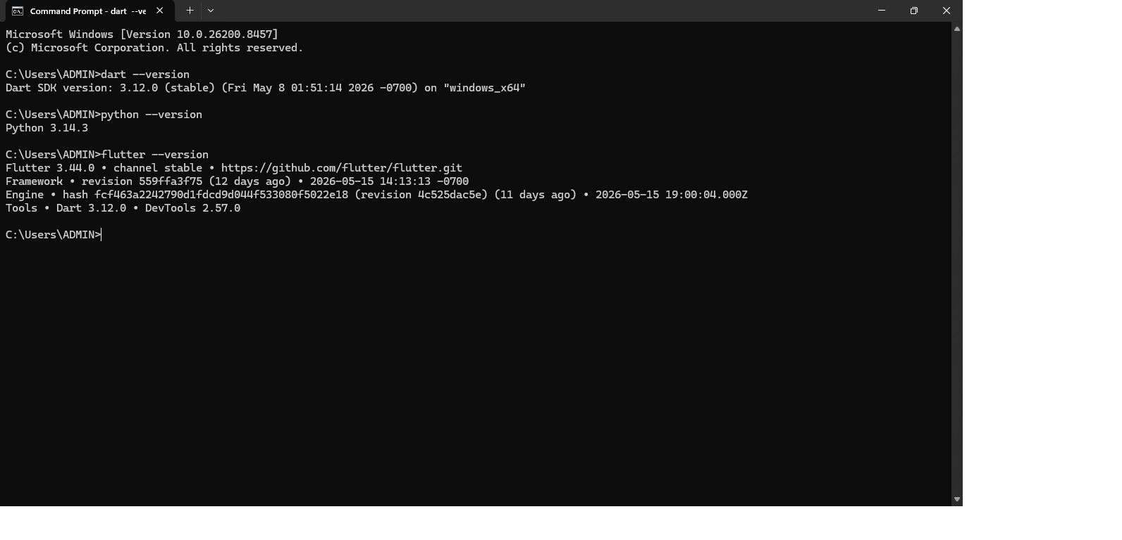

Personal Reflection
not more than 50 words
This week I learned the fundamentals of mobile application development, including the different types of mobile applications and their importance in solving real-world problems. I gained an understanding of the mobile application development lifecycle and the tools commonly used to create mobile apps. This knowledge provided a strong foundation for the development of the AI CyberShield project.

Week 2: Mobile Development Environment
Same as week 1
This week focused on setting up the mobile development environment. I installed and configured Flutter, Dart, Android Studio, and the required SDKs. I learned how to create, run, and test mobile applications using an emulator and web browser. This environment enabled me to begin developing my AI CyberShield application efficiently.
Student Management 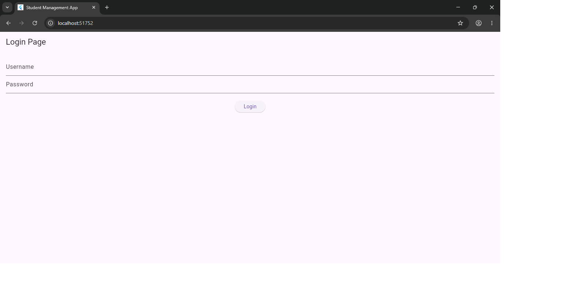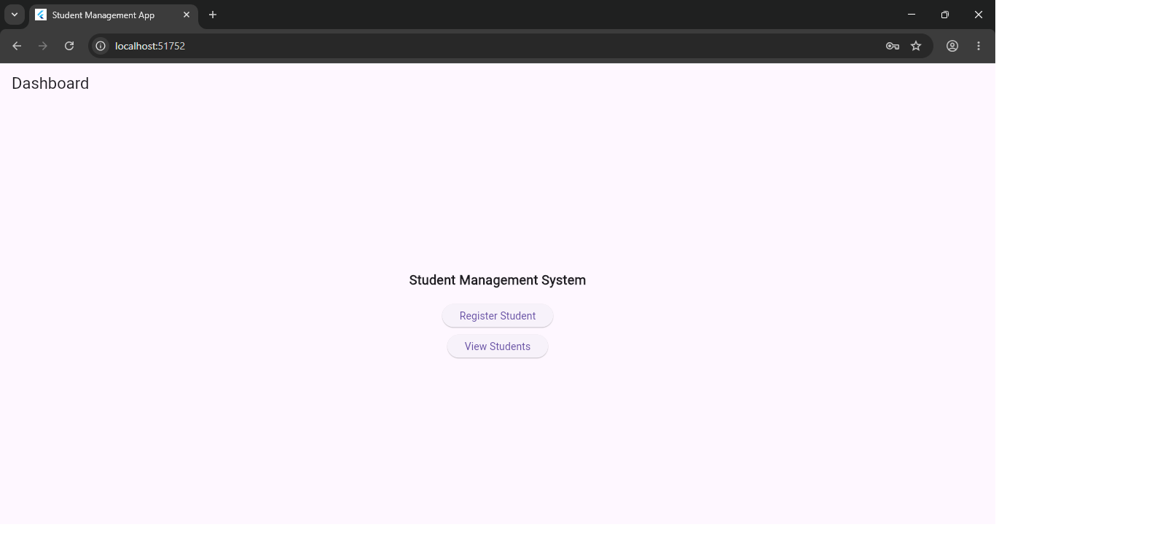

Week 3: User Interface Design

Same as week 1
During this week, I learned how to design user-friendly mobile interfaces. I used Flutter widgets such as Text Field, Button, Row, and Column to create application screens. I designed the login page, dashboard, and navigation interfaces for the AI CyberShield system while focusing on usability and appearance.
Figma UI
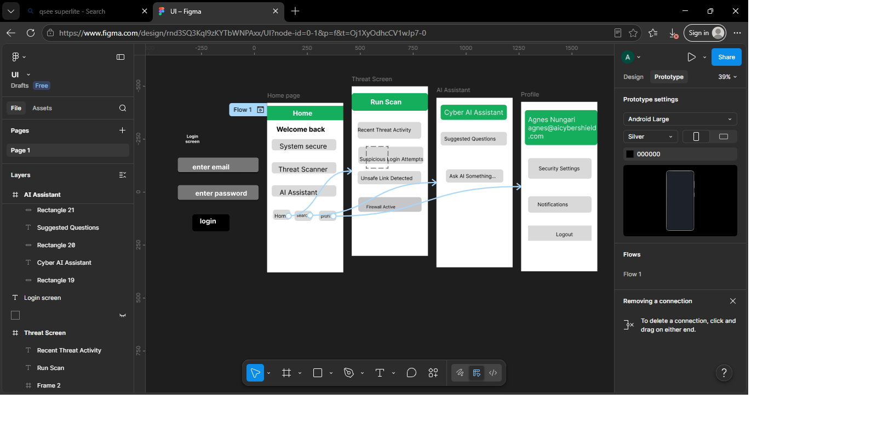
Login screen
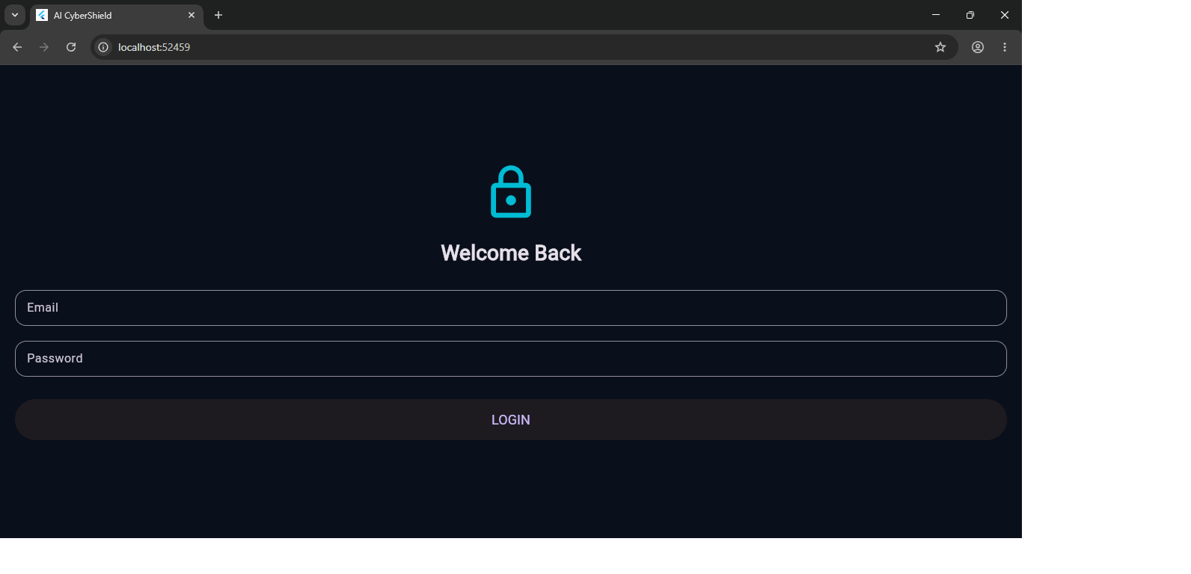
Profile Screen
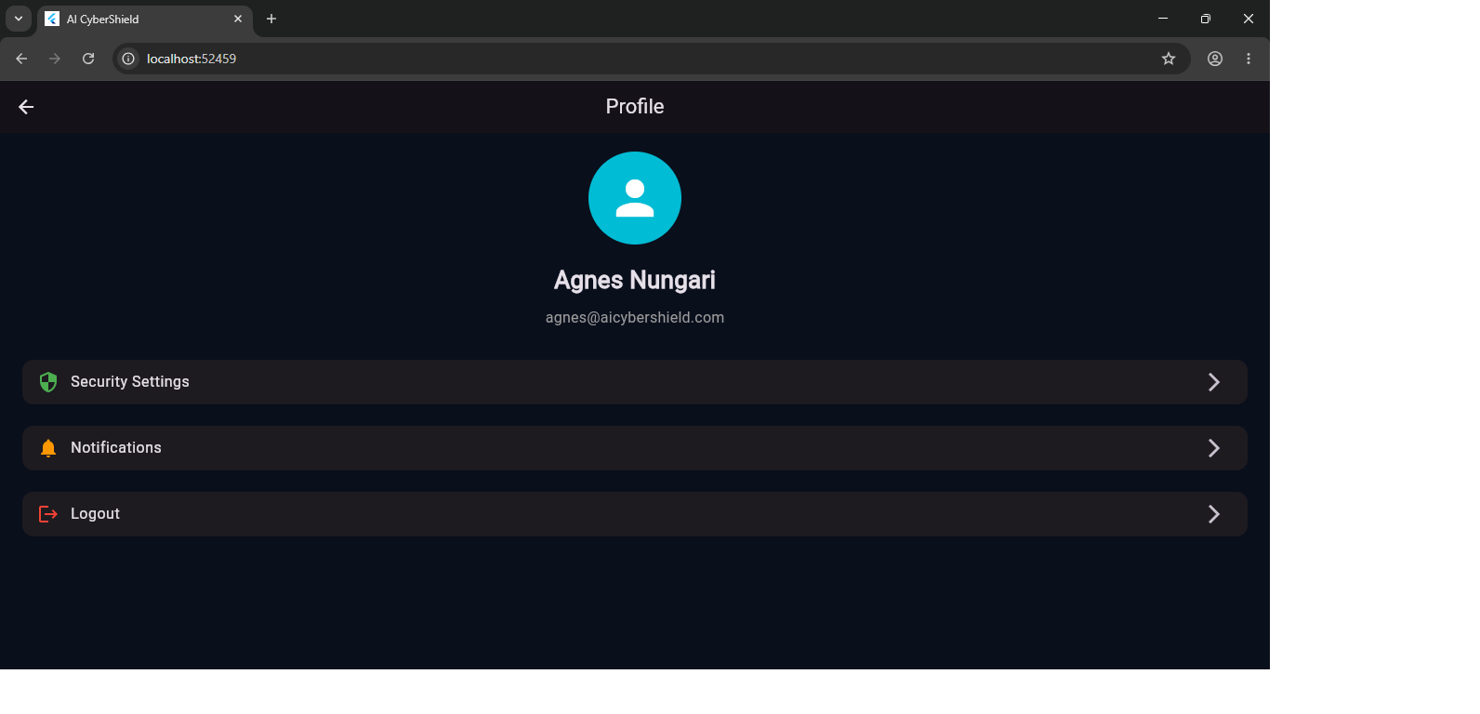

Threat Screen
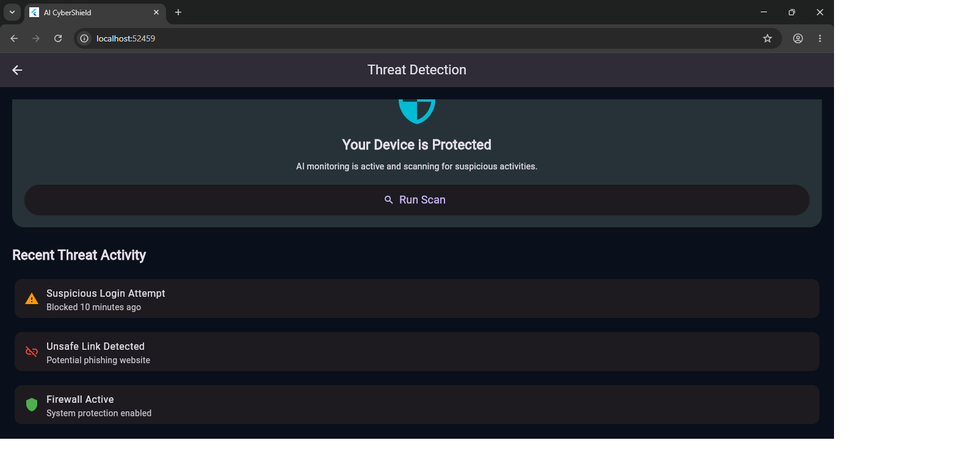

AI Assistant screen
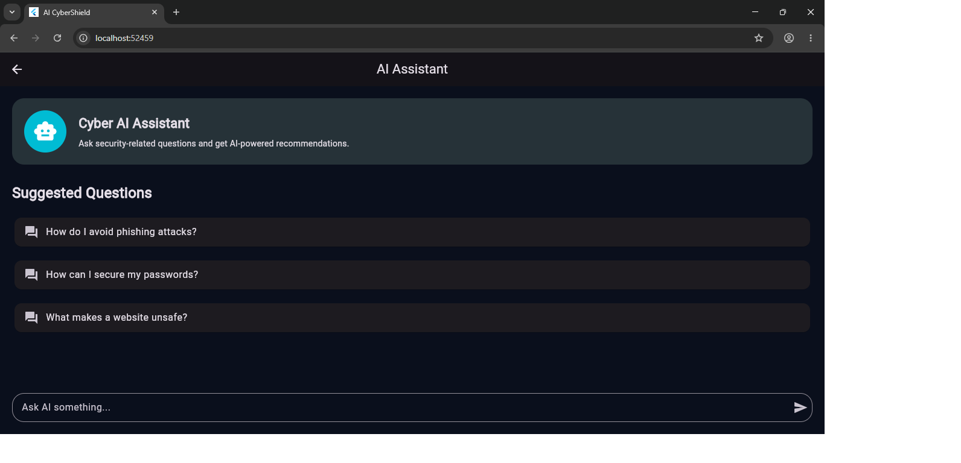

Week 4: Event Handling and User Interaction

Same as week 1
This week introduced event handling and user interaction in Flutter. I learned how to use buttons, event listeners, and navigation to respond to user actions. I implemented login actions, screen transitions, and user feedback through messages and loading indicators in the AI CyberShield application.
Dashboard
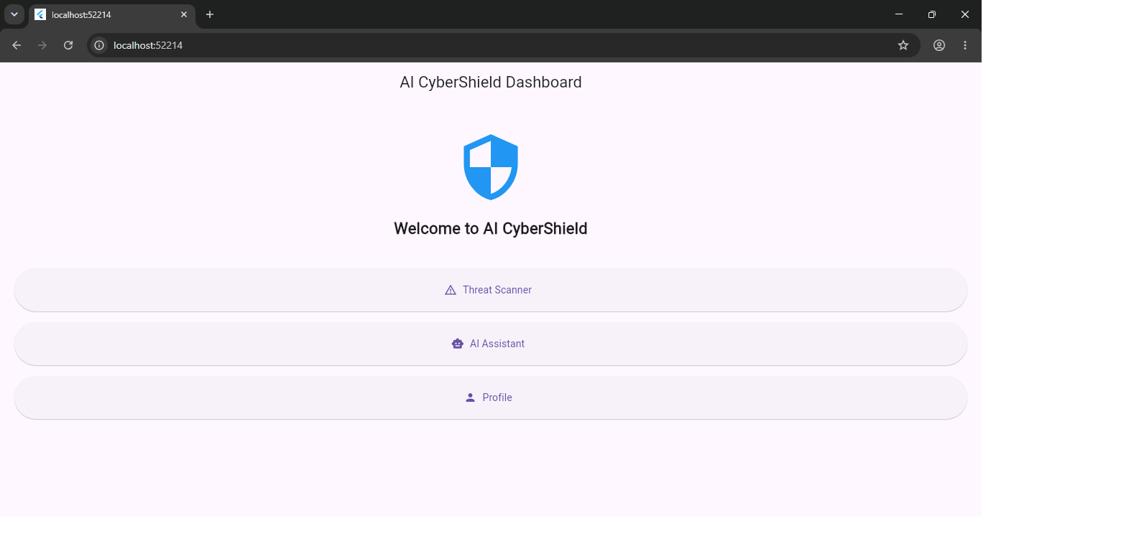
AI-assistant screen
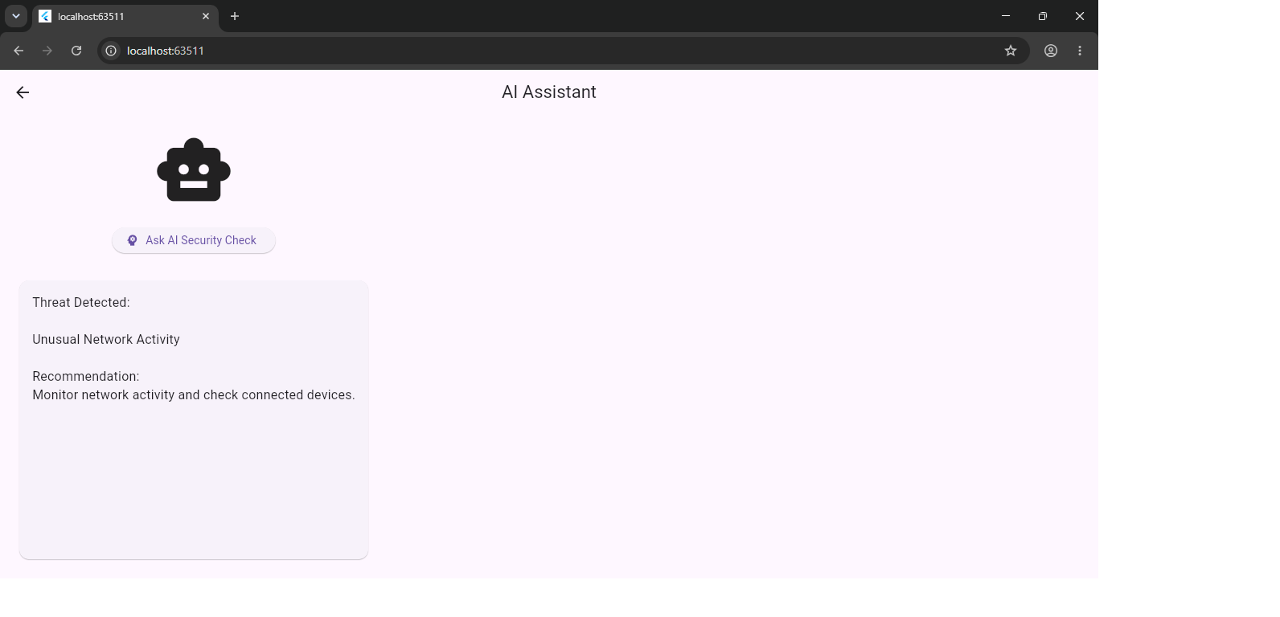

Threat screen
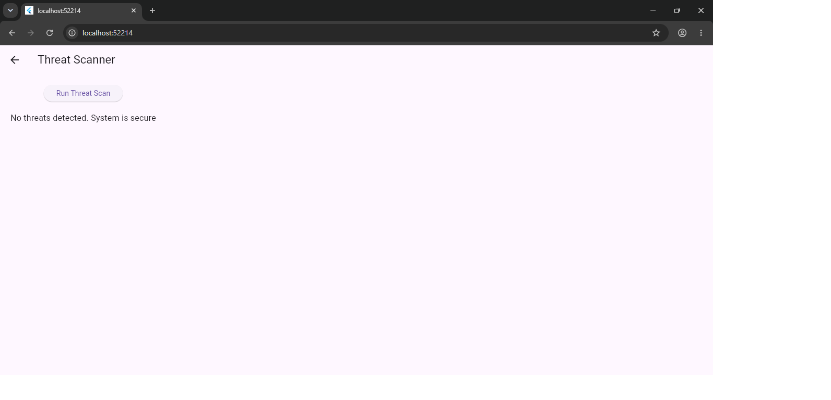
Profile screen
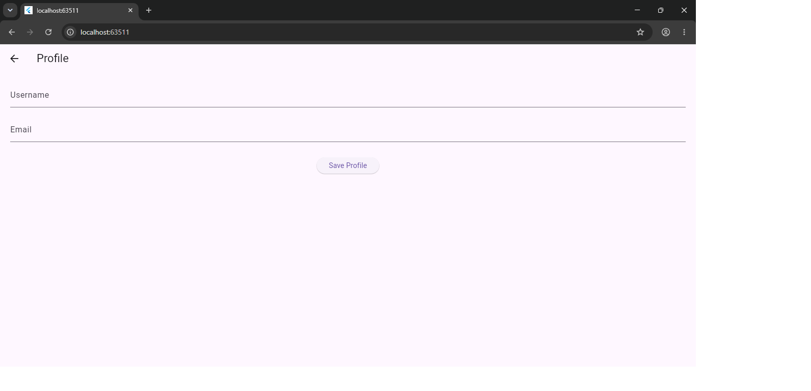
Week 5: Data Management

Same as week 1
This week focused on storing and managing data within a mobile application. I learned how to use variables, lists, controllers, and state management techniques to handle user input and application data. These concepts helped me manage login information, scan results, and dashboard content in the AI CyberShield project.

Week 6: Networking and APIs

Same as week 1
This week covered networking concepts and API integration. I learned how mobile applications communicate with online services using HTTP requests and JSON data. I implemented API service classes and explored how external data can be retrieved and displayed within an application. This knowledge is essential for connecting AI CyberShield to online threat intelligence and AI services.
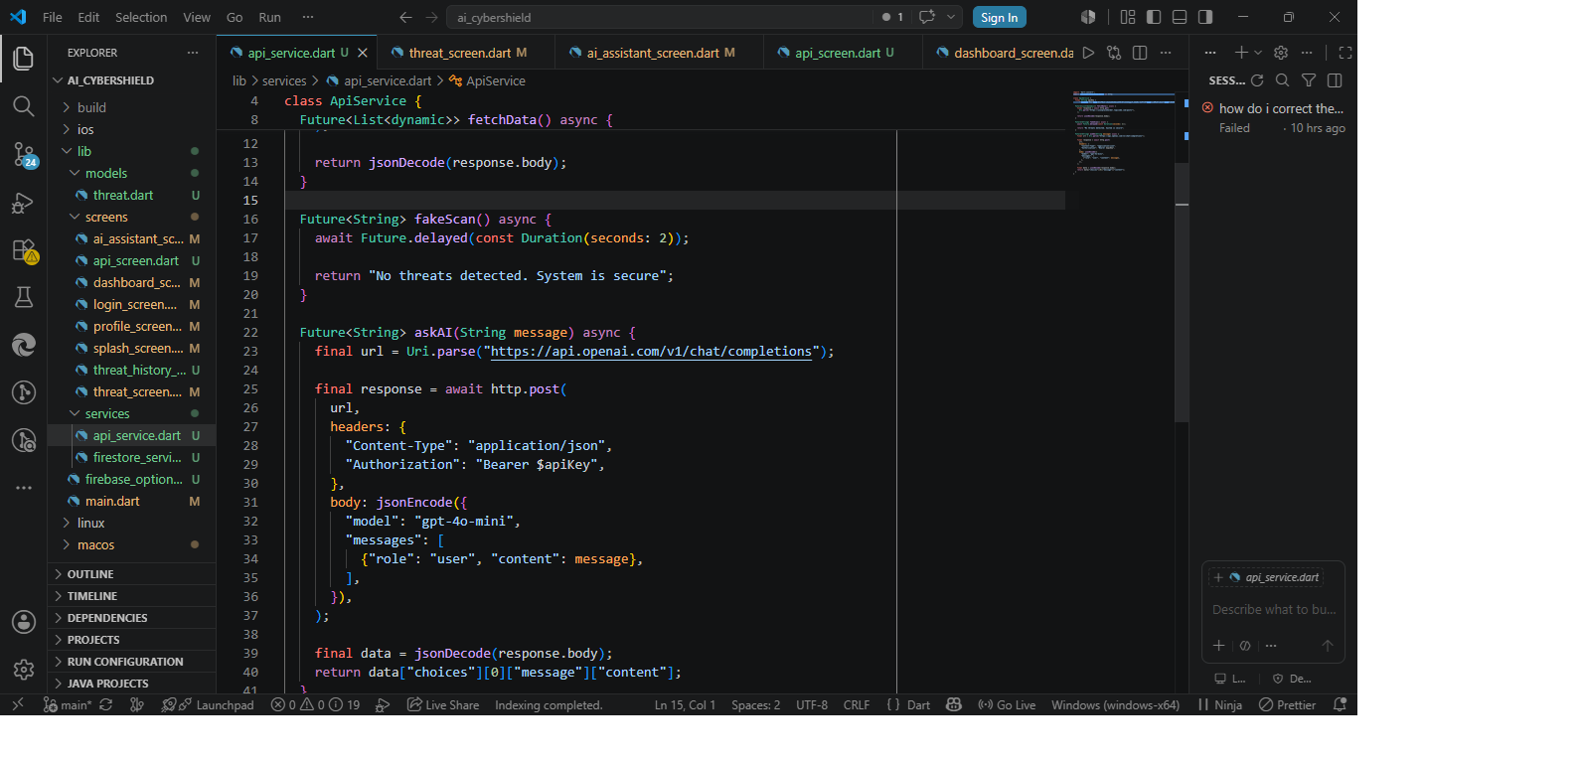
Why my AI CyberShield app needs networking:
Networking enables the AI CyberShield application to communicate with online servers, retrieve threat intelligence data, access AI services, and provide real-time cybersecurity analysis and updates to users.

Week 7: Application Architecture

Same as week 1

Week 8: Project Planning

Week 9: Device Features and Sensors

Same as week 1

Week 10: Notifications and Background Services

Same as week 1

Week 11: Mobile Security

Same as week 1

Week 12: Testing and Debugging

Same as week 1

Week 13: Application Deployment

Same as week 1

Week 14: Final Project Presentation

Same as week 1

Semester Project Tracking

Project Title

Project Objectives

Project Requirements

Development Milestones

Testing Results

Lessons Learned

Future Improvements

End of Semester Reflection

Summary of Skills Acquired

Most Interesting Topic

Major Challenges Faced

How Challenges Were Overcome

Professional Growth Achieved

Overall Course Experience

Final Approval
Student Name: __________________________
Student Signature: ______________________
Date: _________________________________
Lecturer Name: _________________________
Lecturer Remarks: _____________________
Date: _________________________________

