A Comparative Analysis of Linguistic Errors in Kazakh Language Text Generated by Large Language Models
  - Assignment 4 Experiment execution results and discussion
Nurbekova Nuray · Kadirbay Tolganay · Kairkulova Dilnaz
Group SE 2418 · 8 November 2026
This study compares grammatical, morphological and lexical errors in 600 saved Kazakh responses to 200 shared prompts. The primary comparison uses 160 open-ended prompts. Under the recorded annotations and user-reported human confirmation, the GPT-labelled group has the lowest observed error rate. Differences between Gemini and Claude do not survive the specified pairwise comparison. These findings concern the archived response groups, whose exact hosted model versions remain unverified.

Research question and expected comparisons
The primary research question is “What types of grammatical, morphological, and lexical errors occur most frequently in free-form Kazakh-language text generated by selected Large Language Models?” The aim is to identify, classify and compare these errors using identical prompts. Objectives are comparable collection, consistent annotation, frequency estimation and identification of shared error patterns. The revised freeze specifies no directional winner. EC1 predicts differences in primary error rates, EC2 predicts differences in category profiles, and EC3 predicts a negative association between evaluator quality scores and human-verified error rates.

Deviations from the frozen protocol
The revised Protocol Freeze fixes 200 prompts and one response per prompt and condition. It records 3 November 2026 as the upload date and main / 901833f as the freeze reference. A Moodle receipt with an exact upload time is absent from this workspace. The 200-prompt revision followed the earlier 500-prompt plan because of API budget and quota constraints. This report uses the revised design throughout.
Assignment 3 proposed 60 open-ended prompts and 180 responses, preceded by an 18-response pilot. The revised freeze expands that design to 160 open-ended prompts plus 40 secondary translation prompts, selected from the later 500-prompt candidate pool. The pilot’s 2360 words and four primary errors are reported in Assignment 3 as initial implementation evidence. The current report analyses the separately archived 600-response final dataset. Its research question, paired prompt design and three primary error categories follow Assignment 3.
The final evaluation differs materially from the frozen Gemini API procedure. Four responses were evaluated through the API, sixteen through the Gemini web interface, and 580 by Codex using the existing rubric. The API output limit increased from 4096 to 16384 after truncation. The study team reported that human review confirmed the same errors. Candidate confirmations and the 150-response agreement file record that statement as user-reported evidence. Original independent annotations, reviewer identities and review times were not supplied. Instructor approval of these deviations is not documented.

Final experimental setup
The dataset A4_KK200_v1.0 contains 160 open-ended prompts and 40 custom English-to-Kazakh translation prompts with fixed references. The complete prompt set has 50 items at each difficulty level. The open-ended subset contains 40 prompts per difficulty and six task categories with 26 or 27 prompts each. The same Prompt_ID values occur once in each source group. All 600 responses are non-empty. The revised prompt SHA-256 matches the freeze, although the repository filename is selected_200_prompts.csv.
Assignment 3 requested approximately 120–150 words per response. The final open-ended prompts use difficulty-specific ranges of 80–120 words for Basic, 120–160 for Intermediate, 160–220 for Advanced and 220–300 for Expert. Translation prompts specify source fidelity without a word range. These revised length instructions are assessed using the same frozen word-count rule for all source groups.
The planned conditions were Gemini 3.6 Flash as the efficient baseline, GPT-6 Astra as the strong baseline, and Claude Sonnet 5.5 as the main comparison condition. The workbook records the source labels GPT, Gemini and Claude without verifiable snapshot identifiers. Consequently, tables retain those source labels. Prompts and responses are archived verbatim. Collection controls such as fresh chats and disabled tools were intended, but the workbook cannot verify their execution for every response. Source dates are missing for 541 responses.
Table 1 Final setup and analysis settings
Component | Recorded setting
Dataset | 200 matched prompts × 3 groups × 1 run = 600 responses
Primary analysis | 160 open-ended prompts and 480 responses
Secondary analysis | 40 translation prompts and 120 responses
Evaluation | 4 Gemini API + 16 manual Gemini + 580 Codex evaluations
Word rule | Whitespace tokens containing a Unicode letter or digit
Uncertainty | 10 000 prompt bootstrap samples with seed 20261030
Inference | Friedman, gated Wilcoxon tests, Holm correction, Kendall W and rank-biserial effects
Human evidence | Candidate confirmations and 150 rows reconstructed from reported agreement

Each distinct span contributes at most one primary error. Orthographic, script, factual and instruction issues are supplementary unless a separate primary category is assigned. The aggregate rate equals 100 times confirmed primary errors divided by all generated words. Prompt-level rates supply the paired Friedman blocks. Bootstrap samples resample prompts with replacement and preserve model pairing. Confidence intervals describe variation across these prompts under fixed labels. They do not include annotation uncertainty or stochastic variation across repeated generations.

Main results
The complete corpus contains 78,220 words and 140 confirmed primary candidates. In the primary open-ended subset, GPT contributes 27,126 words and 4 errors, Gemini 23,471 words and 69 errors, and Claude 24,167 words and 56 errors. The corresponding aggregate rates are 0.015, 0.294 and 0.232 errors per 100 words. Table 2 reports prompt bootstrap intervals and response-level prevalence. Translation outputs are excluded from these primary estimates.
Table 2 Primary open-ended linguistic results
Group | Words | G / M / L | Total | Rate and 95% CI | With errors
GPT | 27,126 | 1 / 0 / 3 | 4 | 0.015  [0.004, 0.030] | 4/160  2.5%
Gemini | 23,471 | 21 / 10 / 38 | 69 | 0.294  [0.228, 0.364] | 56/160  35.0%
Claude | 24,167 | 16 / 18 / 22 | 56 | 0.232  [0.167, 0.305] | 43/160  26.9%

All three prompt-level medians are zero. The interquartile ranges are 0.000–0.000 for GPT, 0.000–0.575 for Gemini and 0.000–0.437 for Claude. Every bootstrap interval for the median is also 0.000–0.000. This follows from the concentration of zero-count responses. Aggregate rates and the percentage of responses containing an error therefore convey differences that the median alone obscures. A zero count indicates that the evaluation found no confirmed primary span in that response.
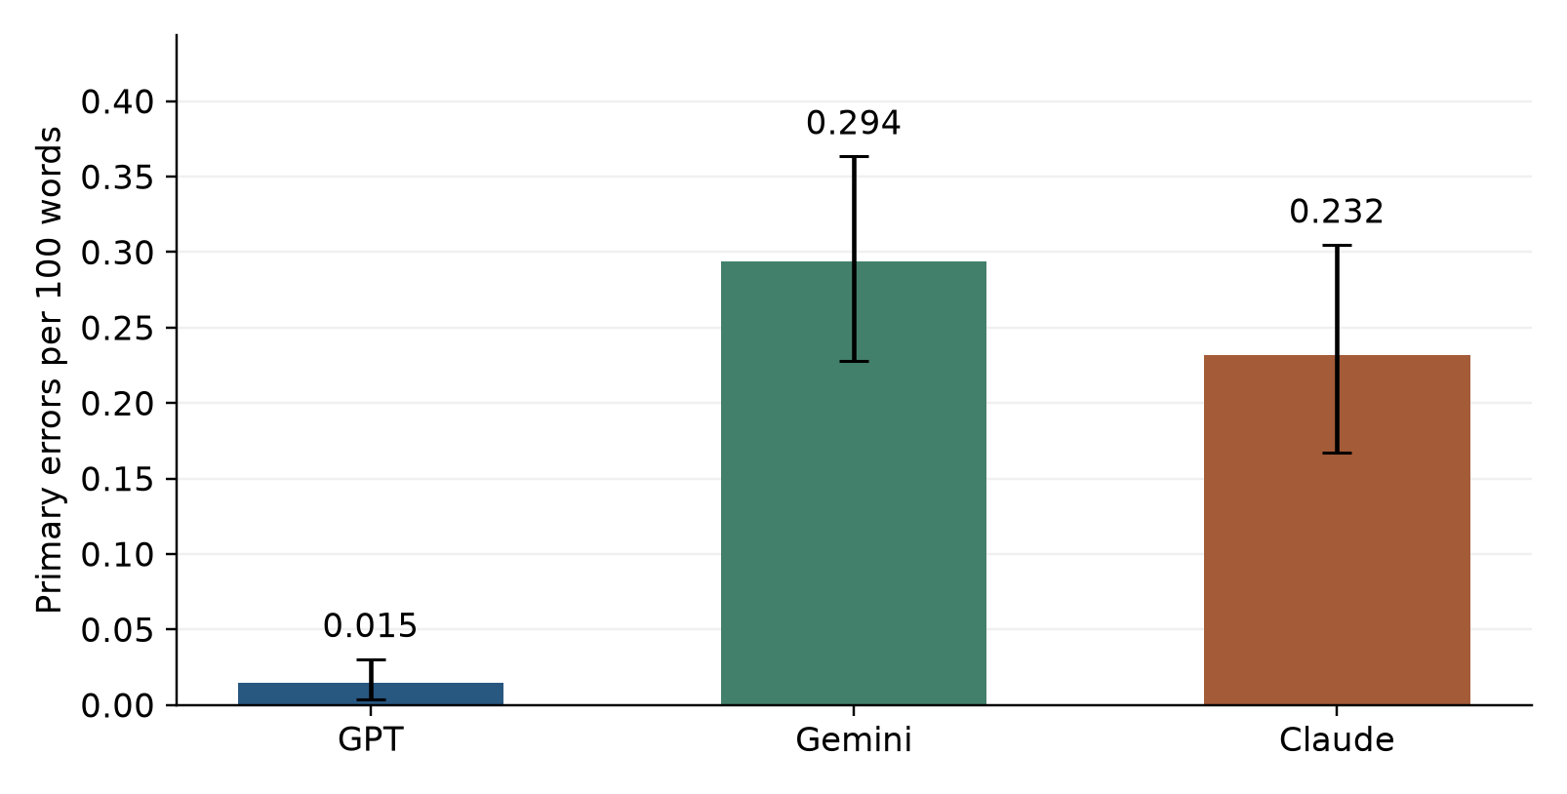
Figure 1 Aggregate primary errors per 100 words on 160 open-ended prompts per group. Whiskers show 95% percentile intervals from 10 000 paired prompt bootstrap samples. Labels use archived source groups.
The tie-corrected Friedman test yields χ²(2) = 52.182, p = 4.66e-12, with Kendall’s W = 0.163. Of 160 blocks, 74 tie across all groups. Gated two-sided Wilcoxon tests use nonzero paired differences and average ranks for ties. Holm correction covers the three model pairs. GPT differs from both comparison groups, whereas Gemini versus Claude remains inconclusive. Effect signs in Table 3 refer to the first group minus the second, with negative values favouring the first group on errors.
Table 3 Paired comparisons for the primary outcome
Pair | Nonzero n | W | Holm p | Rank biserial | Mean difference and CI
GPT vs Gemini | 58 | 41.5 | 8.78e-10 | -0.951 | -0.277  [-0.348, -0.209]
GPT vs Claude | 45 | 27.0 | 6.17e-08 | -0.948 | -0.215  [-0.286, -0.149]
Gemini vs Claude | 85 | 1497.5 | 0.148 | 0.181 | 0.063  [-0.042, 0.166]

The paired mean differences are averages of response-level rates, while Table 2 divides pooled errors by pooled words. These estimands can differ. Rank-biserial magnitudes near 0.95 for GPT comparisons reflect strongly directional differences among nonzero pairs. Kendall’s W summarises agreement across all prompt blocks and is smaller because many blocks tie. Neither statistic establishes a universal ranking across unobserved tasks or hosted model versions.

Secondary outcomes and translation
Median grammar, morphology and lexical-naturalness scores are 5 for every source group. Open-ended overall-quality medians are 5, 4 and 5 for GPT, Gemini and Claude. Evaluator-reported instruction compliance is 98.75%, 65.00% and 75.63%, respectively. A separate deterministic word-range check yields 99.38%, 66.25% and 75.00%. Evaluator compliance and the range check measure different recorded decisions, so they are retained as separate variables. Instruction or spelling failures do not automatically increase primary linguistic counts.
Table 4 Secondary metrics on all 40 translation prompts per group
Group | BLEU | ChrF | ROUGE 1 | ROUGE 2 | ROUGE L | BERTScore
GPT | 17.06 | 62.74 | 0.588 | 0.310 | 0.512 | 0.858
Gemini | 16.08 | 62.67 | 0.568 | 0.297 | 0.488 | 0.855
Claude | 5.87 | 52.16 | 0.402 | 0.218 | 0.330 | 0.773

BLEU uses SacreBLEU 13a tokenization and the corpus estimator. ChrF uses character orders one to six with beta two. ROUGE reports mean response-level F1 with a Unicode letter-and-digit tokenizer, lowercase conversion and no stemming, preserving Kazakh characters. All metrics use the entire saved response, including extra glossaries or commentary. These choices were documented during final analysis because the freeze names metrics without fixing these implementations.
BERTScore uses bert-base-multilingual-cased, layer 9, without IDF weighting or baseline rescaling, on CPU. The number of hypotheses exceeding the model input limit is 0. Contextual similarity supplies a complementary reference measure. Its score remains conditional on one custom reference per prompt and the multilingual encoder’s representation of Kazakh.
Translation contains 0, 6 and 5 primary errors for GPT, Gemini and Claude, respectively. The translation-rate Friedman test is χ²(2) = 5.429, p = 0.066, W = 0.068. The significance gate therefore does not trigger pairwise tests. Claude’s lower reference overlap accompanies frequent additions of terminology notes, which increase output length. These metrics assess resemblance to fixed references and cannot by themselves decide whether a different fluent paraphrase is incorrect.

Error profiles and subgroup analysis
The open-ended subset contains 129 primary errors. Lexical errors are most frequent at 63 (48.8%), followed by 38 grammatical errors (29.5%) and 28 morphological errors (21.7%). Gemini’s profile is primarily lexical, whereas Claude’s grammatical and morphological counts are closer together. Across the complete corpus, 61 orthographic/script flags and 39 instruction/format flags are recorded separately. Supplementary labels can overlap and their sum is not the primary-error total.
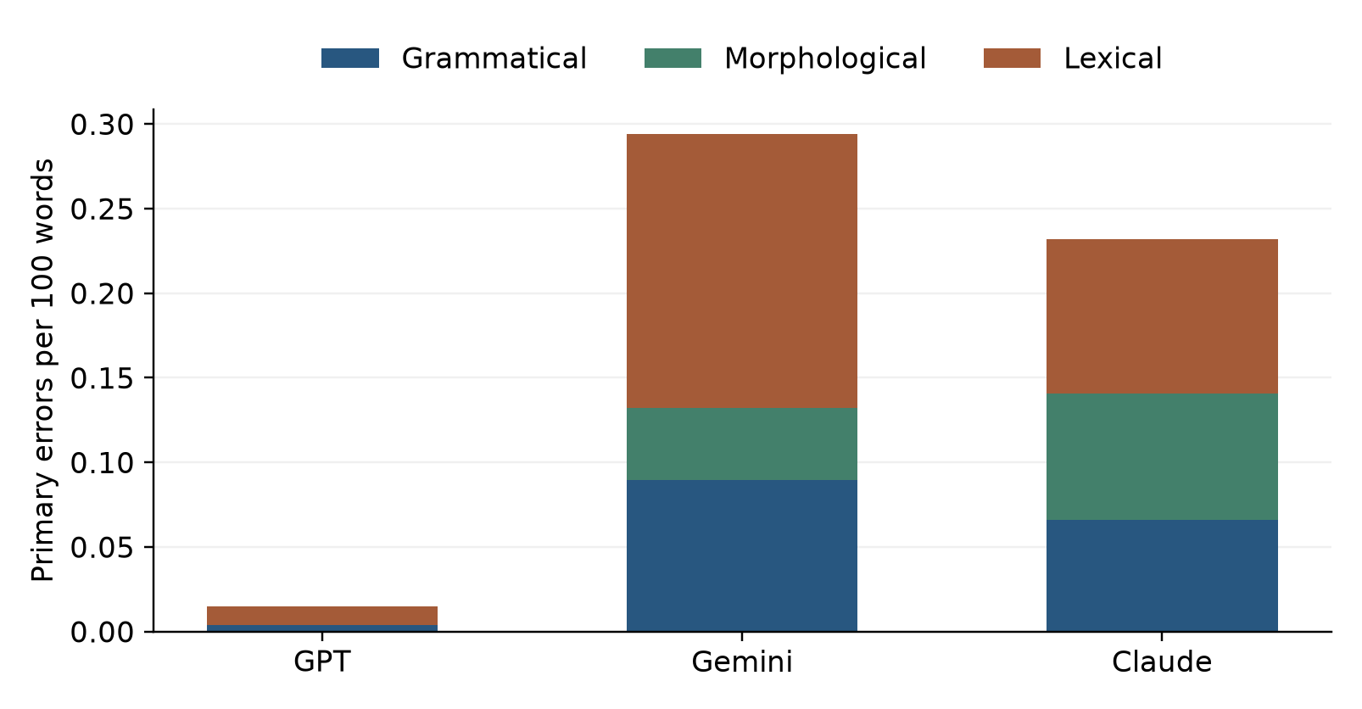
Figure 2 Contributions of grammatical, morphological and lexical errors to each open-ended aggregate rate. Stacked segments use the same word denominator within each group.
Category-level Friedman tests remain significant after Holm correction across three categories. The corrected p-values are 0.000157 for grammar, 0.000157 for morphology and 8.97 × 10⁻⁸ for lexical errors. Each category also has a significant corrected GPT comparison. Gemini–Claude category comparisons do not reach the corrected threshold. Category tests support differences in the archived profiles, while subgroup tables describe where those counts accumulate.
Difficulty does not show a uniform monotonic increase. Gemini’s rates across Basic, Intermediate, Advanced and Expert prompts are 0.255, 0.250, 0.343 and 0.298. Claude’s corresponding rates are 0.227, 0.177, 0.222 and 0.273. Expert tasks create more raw errors partly because their responses are longer. Normalization changes that interpretation. Each difficulty subgroup contains 40 matched open-ended prompts per group, which supports descriptive comparison but leaves uncertainty for fine distinctions.
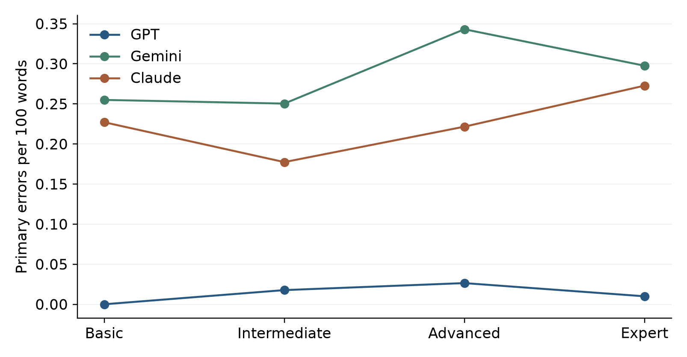
Figure 3 Open-ended error rates by difficulty. Each point aggregates 40 responses per source group. Lines connect the ordered task levels and do not imply a causal difficulty effect.
Task profiles identify a more specific contrast. Claude’s highest rate occurs in Narrative/Scenario tasks at 0.442, compared with Gemini’s 0.348. In Formal/Functional tasks, Claude records 0.104 and Gemini 0.294. These exploratory comparisons receive no separate significance claims. A post hoc sensitivity analysis retaining the 140 open-ended prompt blocks evaluated entirely by Codex still yields Friedman χ²(2) = 45.932, p = 1.06 × 10⁻¹⁰ and W = 0.164. It reduces evaluator mixture while preserving the limitations of a common automated evaluator.
Appendix B gives 30 distinct error-bearing responses, ten examples per primary category, selected deterministically by blind ID with no repeated response. The selection illustrates categories and does not estimate their prevalence. Observed patterns include case selection, malformed affixes, misattached modifiers and inappropriate technical word choices. Proposed explanations include transfer from English or Russian and lexical uncertainty. Those mechanisms remain hypotheses because the dataset contains outputs rather than model training traces or controlled causal interventions.

Human confirmation and evaluator agreement
The team reported that human review found the same errors and quantities. All 275 candidate observations, including 140 primary spans and 135 supplementary-only observations, carry that confirmation basis. The 150-response file was subsequently populated from the reported agreement. Its labels therefore reproduce the evaluator labels. Table 5 shows the arithmetic consequences of that assertion. The absence of original independent records prevents these values from establishing blind inter-annotator reliability or ruling out missed errors.
Table 5 Concordance implied by reported agreement on 150 responses
Category | Positive responses | Agreement | Kappa | Evidence
Grammatical | 14 | 100% | 1.000 | Reconstructed from user report
Morphological | 7 | 100% | 1.000 | Reconstructed from user report
Lexical | 22 | 100% | 1.000 | Reconstructed from user report

The reconstructed sample contains 46 primary spans, all matched by the saved evaluation, giving asserted span recall of 1.000. It contains 50 responses per source group, but difficulty allocation is uneven at 35 Basic, 28 Intermediate, 51 Advanced and 36 Expert responses. This differs from explicit difficulty stratification in the freeze. The reported agreement cannot independently justify the recall threshold used to decide whether another validation sample is needed.
Within these 150 responses, the overall-quality score and primary error rate have Spearman ρ = -0.671, with a prompt-cluster bootstrap 95% interval [-0.757, -0.583]. The association is negative as expected. However, scores and candidate errors come from the same evaluation procedure, and the human labels were reconstructed from agreement. The result demonstrates internal consistency of the saved scoring system while leaving independent validation unresolved.

Answers to the research question
Table 6 Expected comparisons and supporting evidence
Question or comparison | Evidence | Assessment
RQ Most frequent primary type | Open-ended lexical 63/129, grammar 38/129, morphology 28/129 | Lexical errors are most frequent in the recorded data
EC1 Group error rates differ | Friedman p = 4.66e-12 and two significant Holm pairs | Supported within the recorded annotations
EC2 Category profiles differ | Three corrected category tests and corresponding pairwise tests | Supported within the recorded annotations
EC3 Quality and error rate correlate negatively | Sample rho = -0.671 with CI [-0.757, -0.583] | Descriptively supported; independent confirmation remains unresolved

The primary question is answered by a predominance of lexical errors in the open-ended corpus. Grammatical construction and morphological form errors also occur, particularly in the Gemini- and Claude-labelled groups. GPT has the lowest observed rate and differs from both groups in paired comparisons. Gemini and Claude cannot be reliably ordered by the specified primary test. The data therefore identify error patterns and conditional group differences for this prompt set. They provide limited evidence about exact commercial model versions, future model releases, or all Kazakh writing. Agreement and recall values require the additional qualification that the original independent human labels were not preserved in the supplied materials.

Discussion
The central finding is that low aggregate error rates coexist with identifiable local weaknesses. Many responses have no primary candidate, yet technical word choice, case government and sentence construction produce recurring problems. The normalized ranking and the response prevalence tell a consistent story for GPT comparisons. The Gemini–Claude contrast is more dependent on task type. A small difference in pooled rates should therefore be interpreted alongside the non-significant paired result and the subgroup reversals.
Lexical errors account for nearly half of open-ended primary spans. This pattern is compatible with uncertainty when models select specialized Kazakh terminology or translate a technical concept too literally. For example, a term referring to authority can be used where statistical representativeness is intended, or an ordinary physical sense can replace the technical meaning of a word. These errors can remain hidden inside otherwise fluent prose. Their detection requires contextual reading rather than checking suffixes or surface fluency alone.
Morphological examples involve case endings and vowel harmony, while grammatical examples involve the organization of complements and modifiers. The boundary between those categories requires careful adjudication. Kazakh permits flexible word order and omitted subjects, so borderline stylistic judgments can inflate grammatical counts. The available human confirmation expresses acceptance of the candidates but offers no separate adjudication notes. Rechecking ambiguous spans with a linguist would clarify whether the present category proportions are stable under a more conservative interpretation.
Maxutov, Myrzakhmet and Braslavski (2024) evaluated seven LLMs on several Kazakh tasks and found weaker Kazakh performance than parallel English performance, with particular difficulties in generation. Our remaining local errors are compatible with their concern about generation quality. The present experiment does not include parallel English responses and therefore cannot estimate the language gap they measured. Differences in model generations, task sets and error definitions also prevent direct numerical comparison. https://aclanthology.org/2024.sigturk-1.8/
Togmanov et al. (2025) introduced KazMMLU to evaluate Kazakh, Russian and Kazakhstan-related knowledge with educational questions. Their benchmark demonstrates the value of native-language evaluation and substantial remaining limitations. Our evidence adds a linguistic-error perspective on free-form outputs. A model can produce a grammatically acceptable response while making an incorrect factual claim, so our low primary rate cannot be read as high knowledge accuracy on KazMMLU. The supplementary factual flags illustrate this distinction. https://aclanthology.org/2025.acl-long.701/
Toleu, Tolegen and Ualiyeva (2025) studied Kazakh simplification and reported remaining tone, tense and semantic-drift errors. That work provides a relevant comparison for our lexical and morphological observations, although simplification requires preserving a source meaning under a different task objective. Our narrative and technical prompts create broader opportunities for error. Their combination of automatic metrics and native-speaker evaluation also highlights why reference overlap and internally consistent evaluator scores cannot replace recoverable independent human judgments. https://doi.org/10.3390/app15158344
Translation results illustrate a construct limitation of reference metrics. Several Claude responses add glossaries, alternatives or commentary after the requested sentence. Preserving that raw material gives a faithful evaluation of the submitted output, but it can reduce precision-based overlap even when the first sentence is reasonable. Conversely, a translation that closely resembles one reference can still misuse a domain term. BLEU, ChrF, ROUGE and contextual similarity should be read together with the linguistic examples and compliance indicators.
The practical use of these findings is targeted review of generated Kazakh. Domain terminology, case selection and formal constructions deserve attention even when an answer sounds fluent. The subgroup results suggest that the review burden depends on task type. This dataset does not measure the time, financial cost or user benefit of adopting a particular service. It therefore supports a description of observed weaknesses and a workflow for checking them, without establishing a cost-effective deployment choice.

Threats to validity and limitations
Internal validity is limited by collection through different interfaces, missing timestamps and unverified model identities. Evaluation also mixes Gemini and Codex. Because GPT workbook notes mention Codex and the majority evaluator is Codex, shared-system familiarity or preference is a possible confound. The same-evaluator sensitivity check addresses mixture but cannot remove that concern. The 580 rubric evaluations were produced in this assistant session, which also prepared the report, creating additional dependence between annotation and interpretation.
Construct validity depends on the taxonomy and conservative span decisions. Supplementary-only spelling and factual problems are excluded from the primary outcome, so primary rates measure a specific linguistic construct. They do not represent all failures. Evaluator scores are subjective ordinal judgments, and their correlation with counts is partly built into the common evaluation process. The perfect agreement figures are reconstructed from a team report and must not be presented as independently observed reliability estimates.
External validity is limited by 200 custom prompts, a selected commercial-model comparison and one generation per prompt. Bootstrap intervals capture prompt sampling variation conditional on the supplied annotations. They do not quantify uncertainty over model runs, annotators or collection settings. Statistical conclusion validity is affected by many zeros and ties. The primary family and category families use the specified Holm correction, while difficulty and task analyses remain descriptive. The single-run design cannot establish temporal or stochastic stability.
A repeat study should preserve original independent labels, adjudication reasons, exact visible model identities, collection dates and generation controls. A balanced validation sample should explicitly include difficulty strata. Repeated runs would quantify stochastic variation. A separate blinded evaluator with no role in response generation would test the stability of the observed group ordering. Translation references should also receive linguistic review, since several custom source sentences and references are formulaic or awkward.

Reproducibility statement
The repository is https://github.com/Nuni-nn/kazakh-llm-assignment4. scripts/analyze_results.py regenerates the final response dataset, summaries, statistical results, 30 cases and figures from archived data. scripts/build_report.py regenerates this document. analysis_manifest.json records software versions, file hashes, seeds and runtime. The current repository HEAD is 901833f with local additions, and an assignment-4 release tag is not yet present. Appendix C records local checks. Independent clean-environment reproduction remains unrecorded.

References
Maxutov, A., Myrzakhmet, A., & Braslavski, P. (2024). Do LLMs Speak Kazakh? A Pilot Evaluation of Seven Models. Proceedings of SIGTURK 2024, 81–91. https://aclanthology.org/2024.sigturk-1.8/
Togmanov, M., et al. (2025). KazMMLU: Evaluating Language Models on Kazakh, Russian, and Regional Knowledge of Kazakhstan. Proceedings of ACL 2025, 14403–14416. https://aclanthology.org/2025.acl-long.701/
Toleu, A., Tolegen, G., & Ualiyeva, I. (2025). Fine-Tuning Large Language Models for Kazakh Text Simplification. Applied Sciences, 15(15), 8344. https://doi.org/10.3390/app15158344
Zhang, T., Kishore, V., Wu, F., Weinberger, K. Q., & Artzi, Y. (2020). BERTScore: Evaluating Text Generation with BERT. ICLR. https://arxiv.org/abs/1904.09675
Study team. (2026). Assignment 4 Part 1 Protocol Freeze, revised 200-prompt version, and frozen annotation guideline. Local course materials.

Appendix A Protocol and complete result tables
The supplied revised Protocol Freeze remains the authoritative protocol document. Its 200-prompt SHA-256 is 4cafdca6761f106e4469394cb5cf65622cc2614ddef7dee7954adf4a95bc7691. The source PDF records 3 November 2026 as the upload date. The exact Moodle timestamp and approval evidence should accompany the submission.
Table A1 Complete 600-response descriptive results
Group | Words | G / M / L | Total | Rate and 95% CI | Affected
GPT | 27,907 | 1 / 0 / 3 | 4 | 0.014 [0.003, 0.030] | 4/200
Gemini | 24,208 | 21 / 11 / 43 | 75 | 0.310 [0.242, 0.382] | 61/200
Claude | 26,105 | 17 / 18 / 26 | 61 | 0.234 [0.171, 0.305] | 48/200

Table A2 Open-ended task subgroup rates per 100 words
Task group | Prompts per group | GPT | Gemini | Claude
Argumentative / Opinion | 27 | 0.000 | 0.350 | 0.239
Description / Analysis | 27 | 0.000 | 0.201 | 0.190
Explanation / Educational | 27 | 0.000 | 0.298 | 0.146
Formal / Functional | 26 | 0.023 | 0.294 | 0.104
Instructional / Procedural | 26 | 0.023 | 0.270 | 0.269
Narrative / Scenario | 27 | 0.044 | 0.348 | 0.442

The complete subgroup CSV also includes counts, word totals, confidence intervals and medians. Supplementary label occurrences across all 600 responses are Calque 18, Orthographic / script 61, Instruction / format 39, Factual 32, Code-switching 7, Hallucinated word 8, Singarmonism 3, Other 3, Politeness consistency 1. Labels can overlap on a span.

Appendix B Thirty illustrative primary error cases
Each row identifies an archived response and an exact original fragment. Corrections are evaluator proposals accepted through user-reported confirmation. Possible causes describe plausible linguistic mechanisms, not measured internal model behavior. Ten distinct responses per category were selected in blind-ID order. These illustrative counts do not represent category prevalence.

Grammatical
Case and source | Original fragment and proposed correction | Linguistic interpretation
1 B0003  Claude OE201 | Тәуекелді портфельде кластарды үйлестіру арқылы басқарады  → Тәуекел портфельде актив кластарын үйлестіру арқылы басқарылады | Бастауышы жоқ белгісіз субъектілі сөйлемде сабақтас ыссыз етістік («басқарылады») қолданылуы керек немесе бастауыш айқын көрсетілуі тиіс.  Possible modifier, agreement or construction mismatch.
2 B0042  Gemini OE247 | нақты іс-қимыл жоспарын әзірлеп, оларды  → нақты іс-қимыл жоспарын әзірлеп, оны | The plural object pronoun does not agree with the explicitly singular plan antecedent.  Possible modifier, agreement or construction mismatch.
3 B0056  Gemini OE384 | қалалық қызметтердің халыққа көрсетілетін сапасын  → халыққа көрсетілетін қалалық қызметтердің сапасын | The relative modifier is attached to quality instead of the services being provided.  Possible modifier, agreement or construction mismatch.
4 B0059  Gemini OE358 | ақпаратты сапалы **интерпретация** жасап  → ақпаратты сапалы интерпретациялап | The accusative ақпаратты is not licensed by the light-verb construction интерпретация жасау in this form.  Possible modifier, agreement or construction mismatch.
5 B0076  Claude OE302 | қысқа қашықтан курс  → қысқа мерзімді қашықтан оқыту курсы | The adverbial қашықтан requires an activity complement such as оқыту to modify the course naturally.  Possible modifier, agreement or construction mismatch.
6 B0082  Claude OE013 | өз жұмысын басқа оқушымен  → өз жұмысын басқа оқушының жұмысымен | The comparison pairs a piece of work with a person, rather than equivalent work or performance.  Possible modifier, agreement or construction mismatch.
7 B0093  Gemini OE039 | оған алдын ала берілген  → оның алдын ала берген | Informed consent is given by the participant, not to the participant.  Possible modifier, agreement or construction mismatch.
8 B0102  Gemini OE015 | бұрыс қойылмаған  → дұрыс қойылмаған | The negative form reverses the intended meaning of an incorrectly presented quotation.  Possible modifier, agreement or construction mismatch.
9 B0109  Gemini OE049 | Ал **аллель** – осы геннің әртүрлі нұсқалары.  → Ал аллель – осы геннің әртүрлі нұсқаларының бірі. | The singular defined term is equated to plural variants rather than one variant.  Possible modifier, agreement or construction mismatch.
10 B0119  Gemini OE110 | жоғары деректер сапасын  → деректердің жоғары сапасын | The adjective is placed before деректер rather than modifying сапасы in the intended genitive-possessive construction.  Possible modifier, agreement or construction mismatch.

Morphological
Case and source | Original fragment and proposed correction | Linguistic interpretation
11 B0006  Gemini OE010 | жақтаушылар көзқарасы  → жақтаушылардың көзқарасы | Missing genitive case suffix (-дың) on 'жақтаушылар' required to mark possession with 'көзқарасы'.  Possible case, suffix or word-form selection error.
12 B0012  Claude OE297 | образды емес, функцияны  → образдылықты емес, функцияны | «Функцияны» сөзі табыс септігіндегі зат есім түрінде қолданылған, ал онымен жарыса айтылған «образды» сөзі сын есім қалпында тұр. Синтаксистік және морфологиялық параллелизмді сақтау үшін бұл жерде табыс септікті зат есім («обр…  Possible case, suffix or word-form selection error.
13 B0018  Gemini OE379 | жүйесіндегі техникалық журналын  → жүйесіндегі техникалық журналды | The adjectival modifier 'жүйесіндегі' (-дегі suffix) does not establish a possessive relation, making the 3rd person possessive suffix (-ын) on 'журналын' morphologically mismatched; it should either be accusative without posse…  Possible case, suffix or word-form selection error.
14 B0027  Claude OE379 | 0,3 %-нан  → 0,3 %-дан | The ablative suffix after пайыз should be -дан, rather than -нан.  Possible case, suffix or word-form selection error.
15 B0044  Claude OE225 | сізден келген SMS-кодты  → сізге келген SMS-кодты | The code was sent to the recipient, requiring the dative сізге instead of the ablative сізден.  Possible case, suffix or word-form selection error.
16 B0058  Claude OE110 | С балама  → С баламасы | The letter-designated option requires the possessive construction С баламасы.  Possible case, suffix or word-form selection error.
17 B0070  Claude OE238 | түрлерін өзін де  → түрлерінің өзін де | The reflexive possessive construction requires the genitive түрлерінің before өзін.  Possible case, suffix or word-form selection error.
18 B0133  Claude OE243 | аймақпен  → аймақтар бойынша | The instrumental case is inappropriate for grouping orders by region.  Possible case, suffix or word-form selection error.
19 B0151  Claude OE220 | одан не үшін керек екенін  → олардың не үшін керек екенін | The pronoun needs a genitive form referring to the data, rather than the ablative одан.  Possible case, suffix or word-form selection error.
20 B0188  Claude OE347 | әр сұранысты ықпалын  → әр сұраныстың ықпалын | The possessive ықпалын requires a genitive сұраныстың.  Possible case, suffix or word-form selection error.

Lexical
Case and source | Original fragment and proposed correction | Linguistic interpretation
21 B0016  Claude OE111 | үлгі ішінде  → таңдама ішінде | In statistical contexts, the term 'sample' (выборка) is standardly rendered as 'таңдама' in Kazakh. 'Үлгі' refers to a specimen, pattern, or template.  Possible literal transfer, terminology confusion or malformed lexical selection.
22 B0020  Claude OE038 | Қорытындыда  → Қорытындылай келе, | «Қорытындыда» сөзі орыс тіліндегі «В заключение» тіркесінің лексикалық калькасы болып табылады. Академиялық қазақ тілінде бұл орайда «Қорытындылай келе» немесе «Қорыта айтқанда» сөз тіркестері қолданылады.  Possible literal transfer, terminology confusion or malformed lexical selection.
23 B0022  Gemini RB411 | Кедергі  → Төзімділік | In this antibiotic context resistance means biological resistance, rather than an obstacle.  Possible literal transfer, terminology confusion or malformed lexical selection.
24 B0023  Gemini OE297 | Пұсық  → Астарлы | The adjective meaning astute/efficient does not naturally characterize implicit context.  Possible literal transfer, terminology confusion or malformed lexical selection.
25 B0024  Gemini OE069 | қайталанбас  → қайтымсыз | Irreversibility is intended, rather than uniqueness or unrepeatability.  Possible literal transfer, terminology confusion or malformed lexical selection.
26 B0026  Gemini OE055 | статистикалық тұрғыда бекітіңіз  → статистикалық тұрғыда растаңыз | Statistical verification is intended. The verb meaning approve/fix is an unnatural collocation here.  Possible literal transfer, terminology confusion or malformed lexical selection.
27 B0035  Gemini OE352 | субъектілікке  → субъективтілікке | Subjectivity, rather than subjecthood, is intended in describing qualitative assessment.  Possible literal transfer, terminology confusion or malformed lexical selection.
28 B0039  GPT OE198 | әртүрлі әсерленетіндіктен  → әртүрлі әсерге ұшырайтындықтан | For financial assets this verb choice is less natural than being affected differently by economic changes.  Possible literal transfer, terminology confusion or malformed lexical selection.
29 B0057  Gemini OE347 | маңызды жол  → сыни жол | Important path is an imprecise technical rendering of the critical-path project-management concept.  Possible literal transfer, terminology confusion or malformed lexical selection.
30 B0060  Gemini OE267 | жүк көтергіш монолитті арқалардың  → жүк көтергіш монолитті арқалықтардың | The structural elements are beams, арқалықтар. Арқалар refers to backs/arches in other contexts.  Possible literal transfer, terminology confusion or malformed lexical selection.

Appendix C Reproduction record and evidence status
Item | Recorded evidence
Local execution | Codex executed analysis and document generation in the current workspace.
Independent reproducer | Not recorded. A classmate or team member must execute the README commands in a clean environment.
Repository state | HEAD 901833f with local additions. assignment-4 tag not yet created.
Machine | Windows-11-10.0.26200-SP0
Python | 3.12.14 (main, Aug 25 2026, 14:01:42) [MSC v.1944 64 bit (AMD64)]
Software | numpy 2.5.4, scipy 1.18.1, matplotlib 3.11.2, sacrebleu 2.6.0, rouge-score 0.1.2, python-docx 1.2.0, bert-score 0.3.13, torch 2.15.0, transformers 5.22.2
Seed and resampling | 20261030 with 10 000 prompt bootstrap samples and 2000 correlation cluster samples.
Analysis runtime | 11.8 seconds for tables and figures using cached BERTScore. The initial --bert execution also downloaded the model and computed embeddings.
Model generation runtime | Unavailable in the imported workbook. Analysis runtime is not generation latency.
Main commands | python scripts/analyze_results.py --bert  python scripts/analyze_results.py  python scripts/build_report.py
Local consistency checks | 600 unique prompt-group pairs, matching response hashes and word counts, 275 confirmed candidates, 30 distinct error cases.
Human evidence | 150 labels transcribed from reported full agreement. Original independent label files, reviewer identity and review time unavailable.

Saved data and table locations
results/selected200_analysis/combined_600.csv contains the imported raw responses and source metadata.
results/selected200_judge_16k/attempts.jsonl preserves evaluation events and their provenance.
results/selected200_judge_16k/candidate_errors_for_review.jsonl contains candidate-level user-reported confirmations.
results/final_analysis/final_dataset_600.csv joins responses, labels, word counts and scores.
results/final_analysis/statistics.json contains the tests and all report-level numeric summaries.
results/final_analysis/model_summary.csv, pairwise_comparisons.csv and subgroup_summary.csv support Tables 2, 3 and A2.
results/final_analysis/translation_metrics.csv and translation_per_response.csv preserve reference metrics.
results/final_analysis/error_analysis_30.csv supplies Appendix B.
results/final_analysis/analysis_manifest.json records versions and checksums for reproduction.

