Better to create references to objects in blueprint or code to be faster, instead of creating a lot of components.
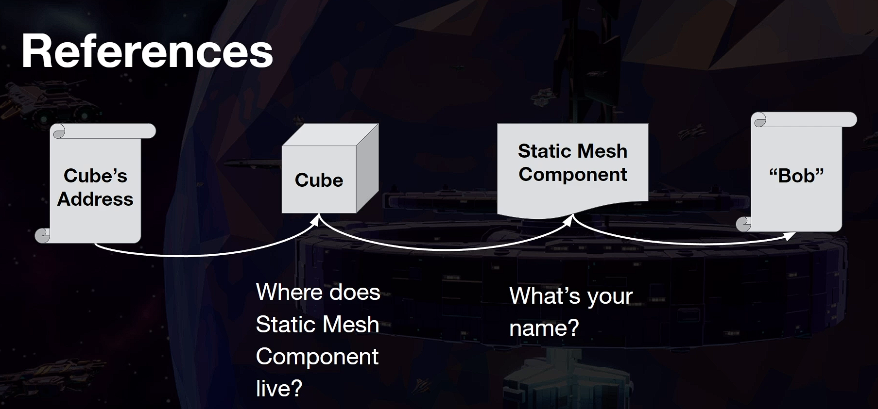



Reference to cube actor

