4/4

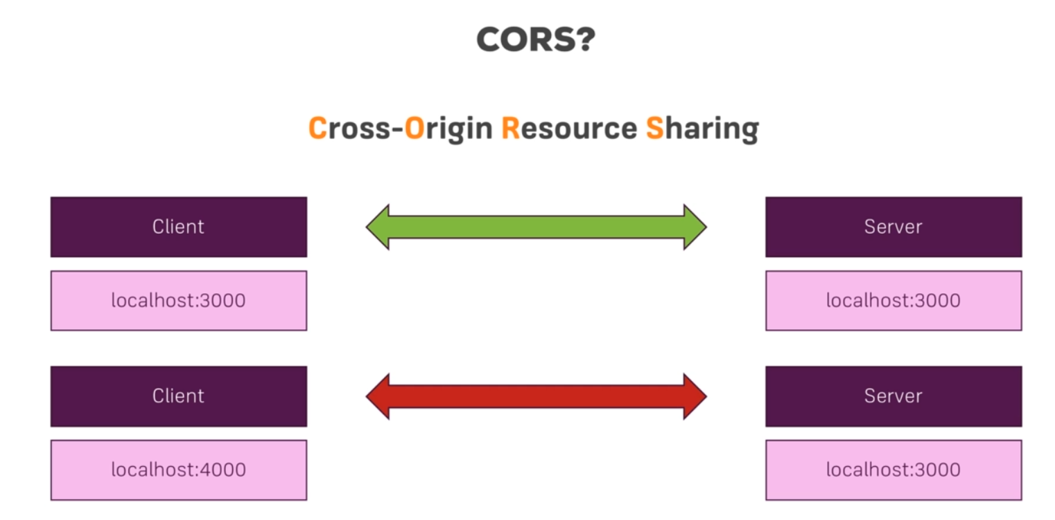

Communicating with different hosts, client to server will fail, will give us a cors error, is a security mechanism. But in modern web apps is not a security issue , we wanna expose our server api, to all possible clients. We need to disable this mechanism. We need to write the correct headers in the server side.

