2/4 9:10

Class

A building block of an application.

The class was two parts.
- Data represented by fields.
- Behaviors represented by functions.

Object is an instance of an class that resides on the memory.

Why use static members?

To represent concepts that are singleton. That means that we have only one instance of that concept into memory.

Constructor

Is a method that is called when an instance of a class is created. The constructor serve to put an object on the earlier state, to initialize the fields in the class. No return type.

Constructor Overloading

Method with the same name but with different signature (Return type; types and names of parameters).

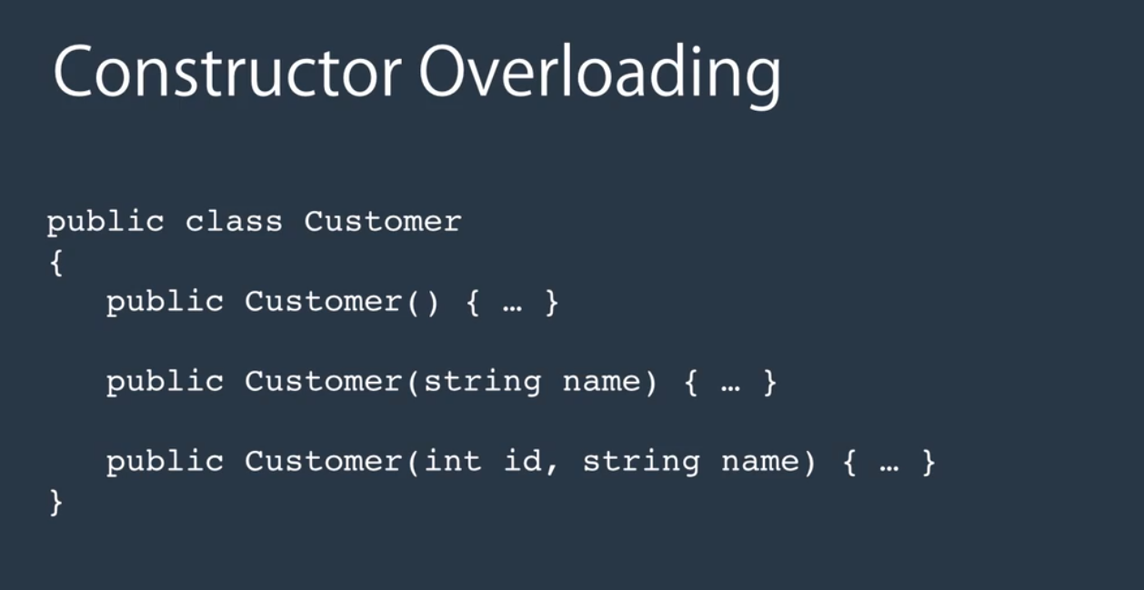

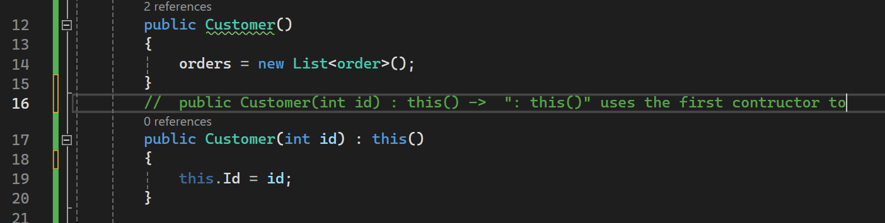

But we can choose what constructor is call in other constructors.

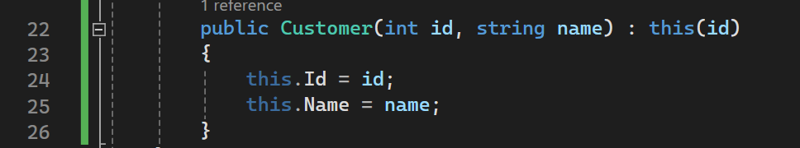

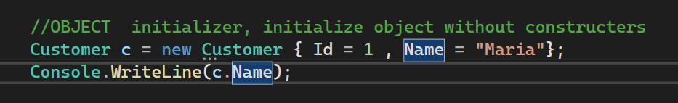

Methods

Signature methods – Consist in the name and the number of the type parameters.
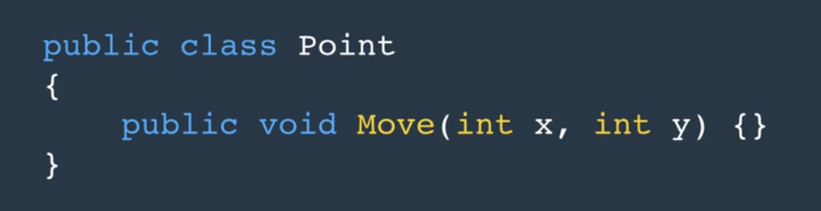

Signature

Overload is method with the same name but different signatures.

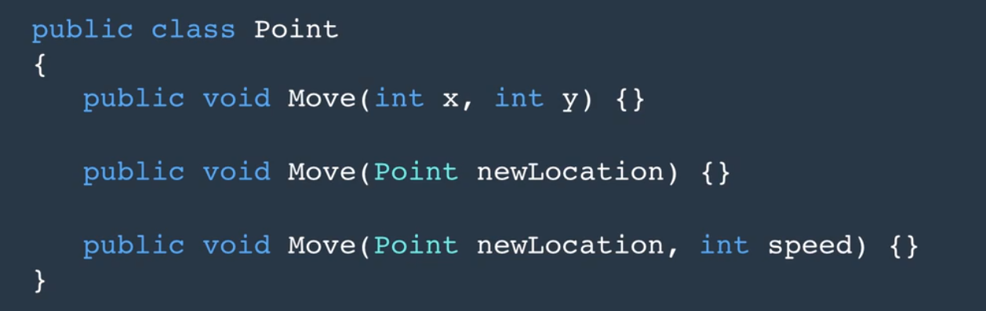

Params modifier - no need to initialize the array when the function is called.

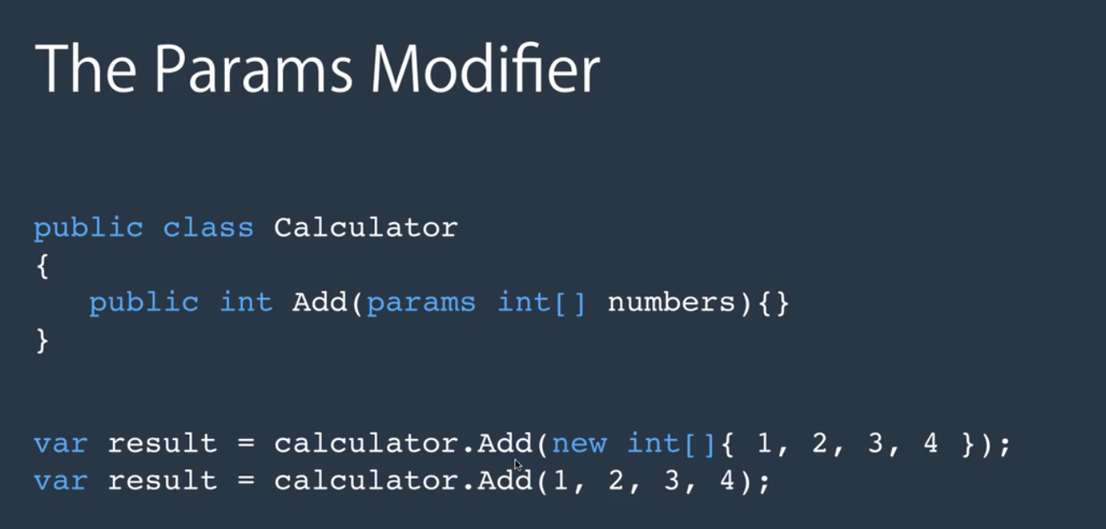

Ref modifier – change var a.

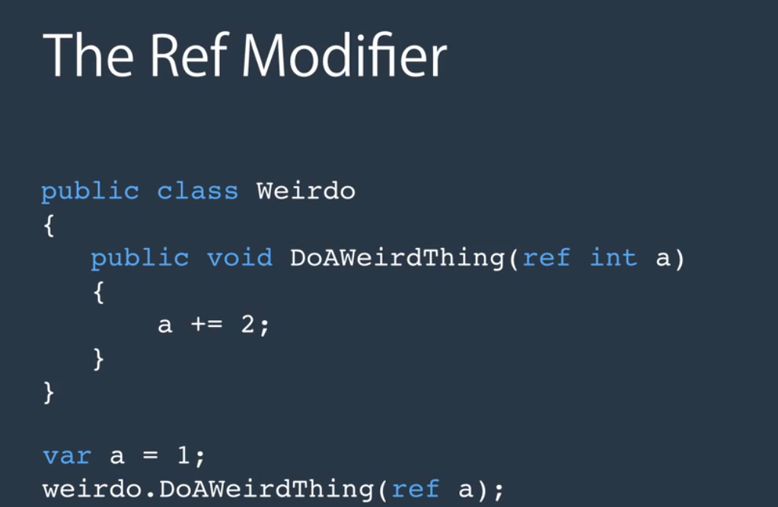

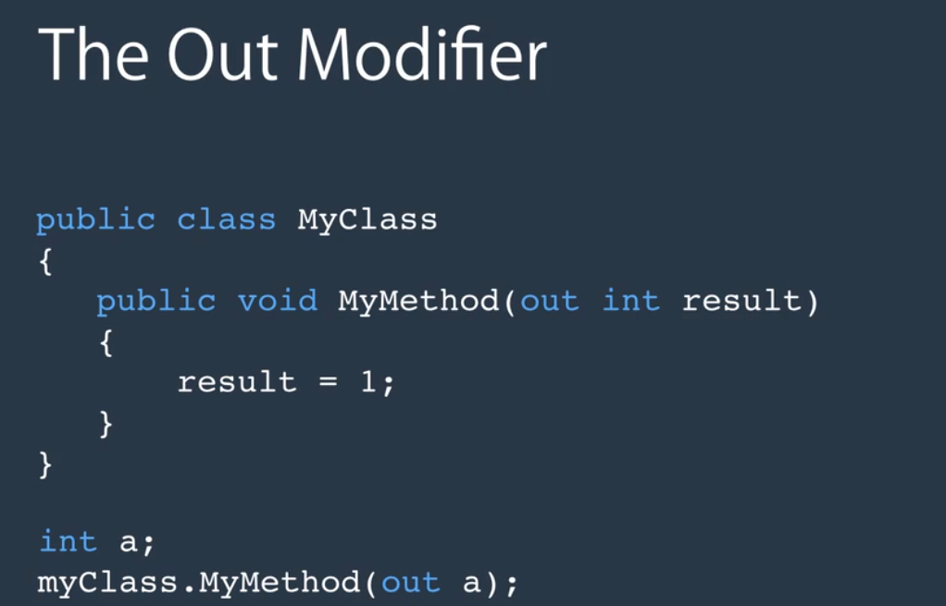
Out modifier - returns value to the caller

In C#, both ref and out are used as parameter modifiers, but they have different purposes:
- ref Modifier:
  - The ref keyword is used to pass arguments by reference.
  - It allows a method to modify the parameter value passed to it.
  - The parameter must be initialized before being passed to the method.
  - It's useful when you need to pass a value to a method and have that method modify the original value.
  - Example:

void ModifyValue(ref int x)
{
x = x * 2;
}

int value = 5;
ModifyValue(ref value);
// value is now 10
- out Modifier:
  - The out keyword is similar to ref, but it doesn't require the parameter to be initialized before being passed to the method.
  - It's typically used when the method needs to return multiple values.
  - The method is required to assign a value to the out parameter before it returns.
  - Example:

void GetValues(out int x, out int y)
{
x = 10;
y = 20;
}

int a, b;
GetValues(out a, out b);
// a is 10, b is 20
In summary:
- ref is used when you want to pass a value by reference and modify it within the method.
- out is used when you want the method to return multiple values or modify the parameter without requiring it to be initialized before the method call.

