Alchemist’s Arsenal
Game design document
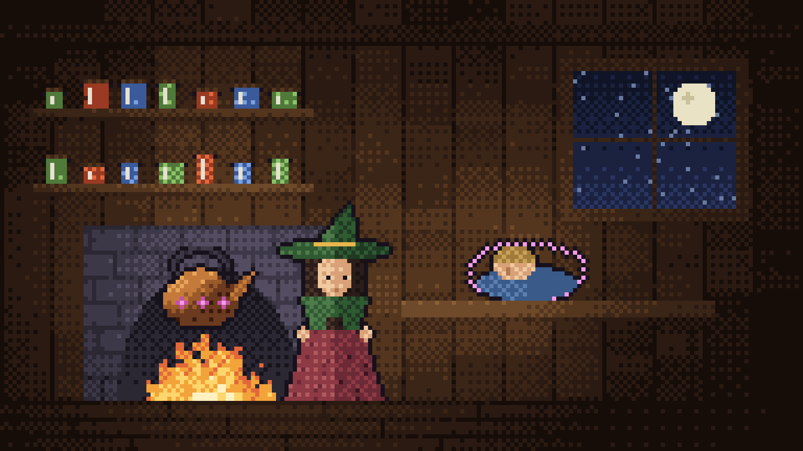
Intended systems | Windows PC
Target age of players | 10+
Intended ESRB / PEGI rating | E10+ / PEGI 7
Projected ship date | 18 December 2026

Nuno Gonçalves
Version 2.2
23 September 2026

Outline

Game story summary
Nell Ashgrove runs a small potion shop at the edge of a forest. The night before her younger sibling Tam leaves for the Coven’s school on the mountain, the two of them have a fight. Nell reaches for the kettle-charm her grandmother taught her, a little spell for calming a room, and says it wrong because she is angry. Tam puts their head down on the table and doesn’t wake up.
In the morning Sister Veil, an envoy from the Coven, is at the door. She calls it a sleep-curse. Only the Coven’s Matriarch can lift it, and the ingredients for the cure are spread along five roads through the forest. Nell can’t walk those roads herself, so she does what she’s good at. She brews bombs for the heroes who can.
Each road the heroes clear brings back a clue. The trees in the Whispering Woods say her grandmother’s name. A burned page from the Cinder Peaks describes a ward “for when they come for the child”. At the top of the Coven’s Peak the Matriarch’s mask cracks, and under it is Grandmother Ysolde, who went up the mountain years ago to stop the Coven and was made into its weapon. Nell’s crooked charm never cursed Tam. It woke a ward Ysolde had hidden in the kettle, one that put Tam to sleep where the Coven couldn’t reach them, and the “cure” is the key that breaks it. Nell pours it into the fire and Tam wakes up. When Veil comes back for the child, every hero Nell ever armed is standing in the doorway.

Description of gameflow (what is the player’s experience)
Alchemist’s Arsenal is a shop game joined to an auto-battler. In most shop games the story ends when the customer leaves.
Here you follow the potion out of the door.
Each day has three parts. In the morning you run the shop. Every hero going out comes to the counter and picks a job, and then you have a few minutes of real time to brew each of them a bomb: malt the grain, grind the herbs, stir the cauldron and bottle it.
In the afternoon you stop and watch. The heroes carry those exact bombs into one of five regions and fight on their own. You can speed the fight up or pause it, but you can’t play it for them. In the evening you get paid, spend the money on upgrades or new heroes, and pick tomorrow’s road.
Every bomb gets a quality score from 0 to 100 while it’s being brewed, and that score becomes damage, ammunition and pay in the afternoon. A careless morning shows up a few hours later as a hero running out of bombs halfway down the road.

Character
Main antagonists: Sister Veil and the Coven Matriarch
Sister Veil is the Coven’s envoy. She comes to the counter like any other customer, and she’s the one who sends Nell after the cure. The closer Nell gets to the truth, the sharper Veil gets: “You’re asking questions about your grandmother. Don’t. Ask about the cure.”
The Matriarch waits at the top of the Coven’s Peak, with six arms, a crown of spires and a cracked porcelain mask. Under the mask is Nell’s grandmother. The real enemy is the Coven, and the Coven is bigger than one Matriarch.

Main character: Nell Ashgrove
Nell learned her craft at her grandmother’s kitchen table. She has steady hands and a short temper, which is a bad combination for someone who casts spells. She never leaves the shop: the player is Nell, working the counter and the benches.  We get to know her through her diary, which she writes at the end of each day. It starts out guilty and stubborn. By the last page it’s closer to forgiveness.  The heroes she arms are her customers first. Each fights best with one element and has a way of fighting (up close, from a distance, or holding on while hurt). Once hired, they come to the counter each morning to order the bomb they’ll carry. | 

Gameplay

Progression
The forest road runs through five regions: the Whispering Woods, the Cinder Peaks, the Frostbite Caverns, the Venom Swamp and the Coven’s Peak. Each one is built around a single element, and each is harder than the last. One star on a region opens the next.
A single hero with nothing bought can clear the first two roads. From the Caverns on, that stops working. The waves are bigger, the monsters have more health and they hit harder, so one hero runs out of bombs long before the road runs out of monsters.
So the shop has to grow.
You can hire more heroes, up to four on the road at once, each with their own bomb. You can buy road upgrades that give the party more damage, more bombs and more health. And you can rebuild the benches: a clockwork paddle that stirs the cauldron while you work somewhere else, a kiln that keeps its own fire, a brass mortar that forgives a clumsy strike. The map says what tomorrow’s road expects before you set off.
Heroes level up too, but only a little. Picking the right hero for the right bomb matters more than grinding.

Replayability
Any region you’ve cleared can be played again for half the fee, which is the usual way to save up for a hire or an upgrade. Each run is graded out of three stars, and a messy win on day four is worth redoing on day nine with a better party. Since the heroes, the jobs on offer and the monsters’ elements keep changing which bomb is the right one, no two mornings plan out quite the same.

Game world
The game happens in two places that feel nothing alike. The shop is warm: candlelight, jars on every shelf, herbs hung up to dry, and a cauldron bubbling in the middle of the room. The forest is cold. Each region has its own ground and sky and weather, from falling leaves in the Woods to embers in the Cinder Peaks and snow in the Caverns, and some of it changes the fight. Heroes slide on the Caverns’ ice and wade slowly through the Swamp’s bog pools.
All of it is pixel art drawn from one palette of about thirty colours, so the shop and the forest still look like the same world.

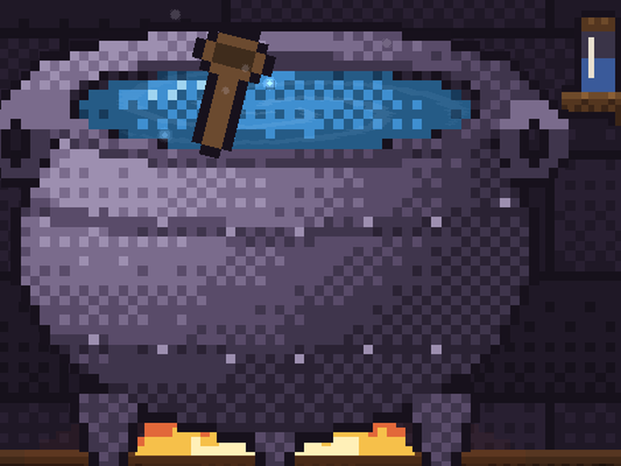 | 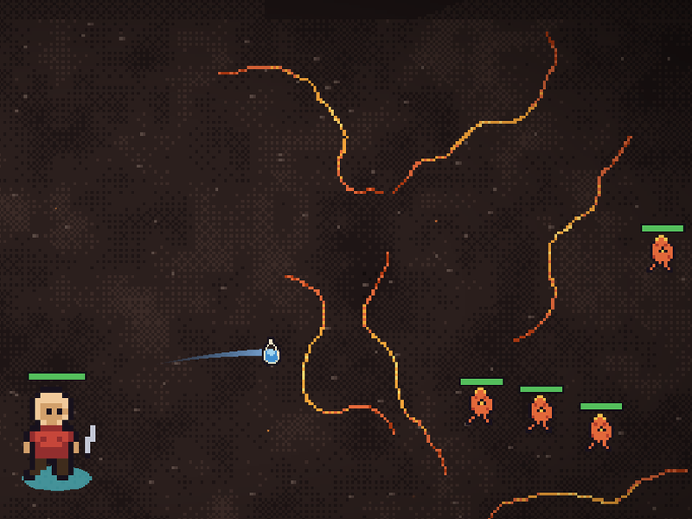

Gestalt
Alchemist’s Arsenal is three small games in one day, and the point is how different they feel. The morning is busy. The clock is running, one hero’s grain is in the kiln, the next hero’s herbs are in the mortar, and the stir keeps drifting out of the band. The afternoon is calm. You take your hands off and watch the heroes use exactly what you made. A clean bomb lands for double damage. A sloppy one barely scratches. A hero who ran out pulls back. Then the evening is quiet: coins, a page of the diary, a decision about tomorrow.
The story is told in small pieces too. Short animated scenes play one line at a time, and the diary fills up with pages that turn out to be clues. The tone is warm and a bit sad, but it never gets grim. Characters talk in an Animalese-style babble, the shop and the forest each have their own music, and none of it is recorded. The game makes every sound as it plays.
The first day only uses four benches and two-herb recipes, and the screen dims around the one thing to touch next. Each new road adds a step or two, and the same spotlight teaches each one the first time it turns up. By the third day everything is in play, and the roads keep getting harder until the Coven’s Peak and the mask.

Gameplay mechanics

Core mechanics
- Quality: each bomb starts at 25 out of 100 and goes up or down with every step you take. The final grade (Perfect, Great, Okay or Poor) sets its damage, how many the hero carries and how much you’re paid
- Elements: Nature, Fire, Water, Poison and Arcane. The right element for a monster does double damage and the wrong one does half
- One bomb per hero: each hero orders their own bomb, and the benches work on several at once
- A growing morning: each new road adds a bench step, a longer recipe and another wave. Replaying a road keeps it exactly as hard as it was
- Every bomb finished: the heroes only leave once every bomb is sealed and labelled, or when the clock runs out
- Auto-battle: heroes choose their own targets by scoring every throw they could make

Benches
- Counter: the jobs hang on the board as paper tags: a safe one, a better-paid one that pays half for sloppy work, or the hero’s own element. Drag one onto the order book to take it
- Malting: pour grain from the sack, carry the lid onto the jar, skim off the husks that float, turn the sprouting bed, then carry the malt to the kiln and feed the fire log by log
- Prep: toss the herbs into the mortar, then lift the pestle and let it drop. How fast it lands decides the strike
- Cauldron: stir the way the recipe turns and keep the speed inside a band. Too slow and it burns, too fast and it spills
- Bottling: drag the ladle down to pour to the line, carry the cork from its dish into the neck, and drag the right label onto the glass

Hazards
- Waves: monsters walk at the heroes and bite on contact. Further up the road they bite harder
- Off-element waves: most roads mix in a wave that shrugs off the obvious bomb
- Guardians: they mark each attack on the ground before it lands, and ward themselves against an element that’s used too much
- Running dry: a party with no bombs left retreats, and the road is lost

Enemies
The forest is full of elemental creatures, and each region’s monsters mostly share its element, which is why the right bomb matters so much. The counter shows the waves before the heroes leave, so you always know what’s coming and have to decide what to brew for it. Most monsters just walk at the heroes and bite. The ones further up the road bite harder, and most roads slip in one wave of a different element to catch out a party that only brought one kind of bomb.
Two roads end with a guardian. The Elder Woodwose, a giant of bark and moss, waits at the end of the Woods once they’ve been cleared, and the Coven Matriarch waits at the top of the Peak. Guardians aren’t scripted. They move between four states (calm, enraged, warded and recovering) depending on how the fight is going.

  Elder Woodwose  Guardian of the Whispering Woods |   Coven Matriarch  Guardian of the Coven’s Peak

  Treantkin  Nature |   Emberlings  Fire |   Frostkin  Water |   Miremaws  Poison |   Acolytes  Arcane

Bonus
Every expedition is graded out of three stars: one for clearing the road, one for bringing every hero home, and one for a Great bomb or better. Filling them all in means going back to the early roads with a better party and a steadier hand. | 

Monsters sometimes drop rare herbs: Emberleaf, Frostmoss, Cinder Heart, Venom Sac and the Coven Sigil. Bring one home and it turns up on the prep bench the next morning, stronger than anything Nell can buy.
The diary has eleven illustrated pages that unlock as the story moves along. Read them in order and you can guess the twist before the Peak says it out loud.
A Perfect bomb also earns a tip on top of the fee. It’s a small thing, but it gives good brewers a reason to keep sharpening their hands long after the story is over.

Money
Alchemist’s Arsenal will be free on itch.io. That’s the whole game, with no ads, no microtransactions and nothing locked behind a payment. Players who like it can leave a pay-what-you-want tip on the itch.io page. The tip doesn’t unlock anything, so someone who pays nothing plays exactly the same game as someone who pays.
It ships as a Windows installer and as a portable zip. Updates come through itch.io and the itch app, and saves stay on the player’s computer from one version to the next.
We may add new regions, heroes and diary pages later as free updates. The ending leaves room for that: the Coven is bigger than one Matriarch, and Sister Veil will be back.
Why free? Because this is a first release, and we want players and honest feedback more than we want money. Keeping pay-to-win out of it also keeps the game about what it should be about, which is brewing well and choosing who to send down the road.

