TigerChat
Setup & Architecture Guide

An enterprise RAG (Retrieval-Augmented Generation) system that crawls your Azure DevOps Wiki, indexes it with Azure AI Search, and lets your team ask natural-language questions answered by GPT-4o with source citations.

1. What Is TigerChat?
TigerChat is a web application that lets your team ask natural-language questions about your internal Azure DevOps Wiki and get accurate, sourced answers — powered by Azure OpenAI GPT-4o and Azure AI Search.

The system works in two phases:
- Ingestion — the wiki is crawled directly from Azure DevOps, chunked, embedded, and indexed into Azure AI Search in a single integrated pipeline.
- Query — questions are matched against the index using hybrid search, then answered by GPT-4o with source citations and a confidence signal.

2. Application Components

Ingestion Pipeline (ingest.py)
The core of TigerChat. A 5-step integrated pipeline: (1) Crawl — connects to Azure DevOps via REST API, lists all wiki pages, fetches their Markdown content, and saves a JSONL snapshot to Azure Blob Storage; (2) Chunk — splits changed pages using LangChain's RecursiveCharacterTextSplitter with MD5 hash change detection to skip unchanged content; (3) Embed — generates 3072-dim vectors with text-embedding-3-large; (4) Index — ensures the Azure AI Search HNSW index exists; (5) Upload — upserts all chunks + vectors into the index and saves the updated hash manifest.

Query Engine (query.py)
Handles the full RAG query loop: embed the user question, run hybrid search (vector + BM25 RRF), build context (rank, deduplicate, 12k char token budget), call GPT-4o, return answer + sources + confidence signal.

Web Server (app.py)
FastAPI server. Serves all HTML pages and exposes two key endpoints: GET /ingest/stream (Server-Sent Events for real-time ingestion progress) and POST /api/chat (JSON endpoint for RAG queries).

Standalone Crawler (optional) (crawler.py)
The crawling logic is now fully integrated into ingest.py. crawler.py still exists as a standalone script if you ever need to run a crawl separately without triggering the full indexing pipeline — for example to inspect or archive wiki snapshots.

Frontend UI (static/)
Vanilla HTML/CSS pages. Dark-themed, responsive. Landing page at / lets users navigate to: Ingestion (/ingest), Chat (/chat), Synergies (/synergies), and three documentation pages (/about, /chat/about, /chat/about/scoring).

Ingestion Pipeline — End to End
Pressing 'Start Ingestion' in the UI (or running ingest.py directly) triggers all 5 steps in sequence:

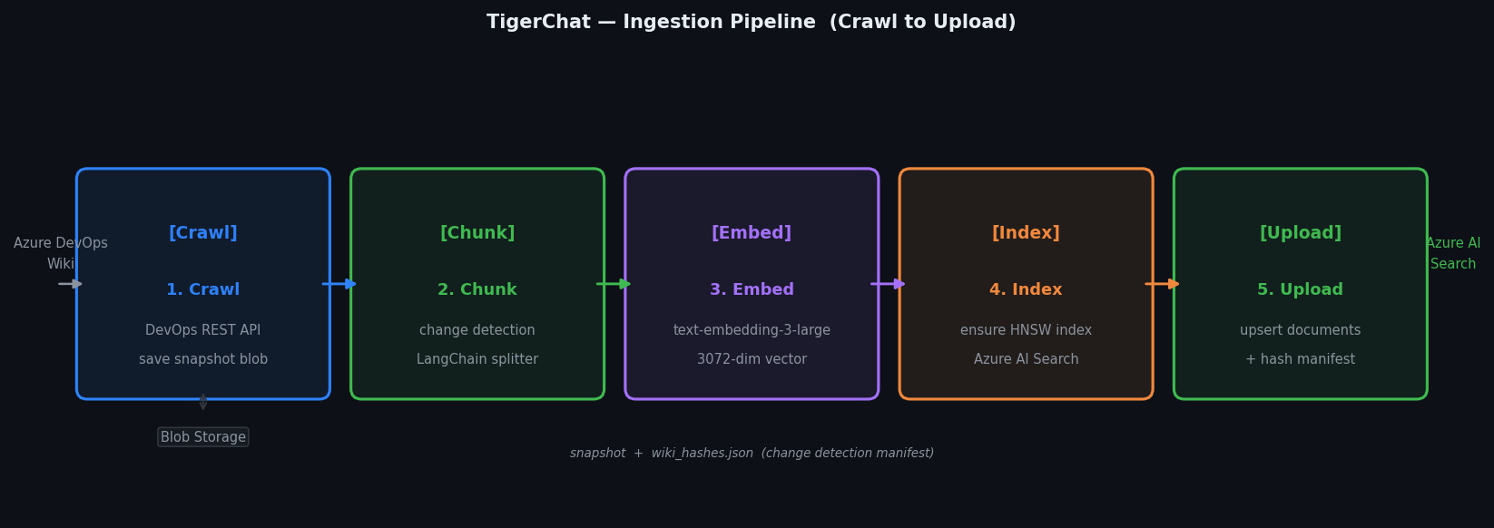
Figure 1 — Ingestion Pipeline (Crawl to Upload)

Note: The JSONL snapshot is always saved to the same blob (wiki_ORG_PROJECT.jsonl), overwriting the previous one — no accumulation of timestamped files.

RAG Query Pipeline — End to End
Every question a user asks in the chat goes through these 5 steps:

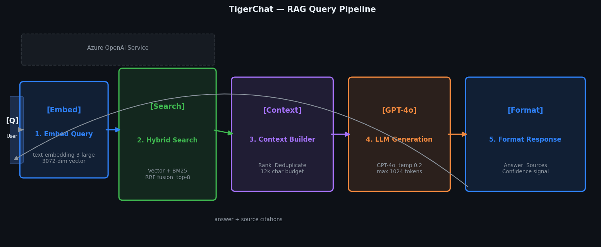
Figure 2 — RAG Query Pipeline

GPT-4o is instructed to answer only from the retrieved context chunks, cite sources, and say so clearly if the context is insufficient. Temperature is 0.2 for deterministic, factual answers.

3. Azure Resources to Create
Before running TigerChat you need to provision four Azure services. Each section below lists exactly what to create and which value to copy into your .env file.

3.1 Azure OpenAI Service
Used for both embedding (converting text to vectors during ingestion and at query time) and chat completion (generating answers). You need two model deployments inside the same resource.

Steps:
- Go to portal.azure.com → Create a resource → search "Azure OpenAI".
- Choose a region that supports gpt-4o and text-embedding-3-large (e.g. East US, Sweden Central).
- After creation, open the resource → "Model deployments" → Deploy model.
- Deploy 1: model = text-embedding-3-large, deployment name = text-embedding-3-large
- Deploy 2: model = gpt-4o, deployment name = gpt-4o
- Go to "Keys and Endpoint" → copy the Endpoint URL and Key 1.

Variable / Parameter | Required | Description
AZURE_OPENAI_ENDPOINT | Yes | Endpoint URL — e.g. https://my-aoai.openai.azure.com/
AZURE_OPENAI_API_KEY | Yes | Key 1 from Keys and Endpoint
AZURE_OPENAI_EMBEDDING_DEPLOYMENT | Yes | Deployment name for text-embedding-3-large
AZURE_OPENAI_CHAT_DEPLOYMENT | Yes | Deployment name for gpt-4o
AZURE_OPENAI_API_VERSION | Yes | API version — use 2024-02-01

3.2 Azure AI Search
Stores the indexed wiki chunks and handles hybrid search (vector similarity + keyword BM25). The application creates the index automatically on first ingest.

Steps:
- Go to portal.azure.com → Create a resource → search "Azure AI Search".
- Pricing tier: Basic or Standard S1 (Free tier does not support vector search).
- After creation, go to the resource → "Keys" → copy the Primary admin key.
- Copy the Search service URL from the Overview page.
- No index needs to be created manually — ingest.py creates it on first run.

Variable / Parameter | Required | Description
AZURE_SEARCH_ENDPOINT | Yes | Search service URL — e.g. https://my-search.search.windows.net
AZURE_SEARCH_API_KEY | Yes | Primary admin key from the Keys page
AZURE_SEARCH_INDEX_NAME | No | Index name — defaults to wiki-index if not set

3.3 Azure Blob Storage
Used for two purposes: storing the JSONL wiki snapshot produced by the Crawl step, and storing the wiki_hashes.json change detection manifest between runs.

Steps:
- Go to portal.azure.com → Create a resource → "Storage account".
- Redundancy: LRS is fine for this use case.
- After creation → "Containers" → create a new container (e.g. wiki-data). Set access to "Private".
- Go to "Access keys" → copy the Connection string for key1.

Variable / Parameter | Required | Description
AZURE_STORAGE_CONNECTION_STRING | Yes | Connection string from Access keys
AZURE_STORAGE_CONTAINER | Yes | Container name you created — e.g. wiki-data

3.4 Azure DevOps — Personal Access Token (PAT)
TigerChat's Crawl step authenticates to your Azure DevOps organization using a PAT. This is created inside Azure DevOps, not the Azure portal.

Steps:
- Go to your Azure DevOps organization (e.g. https://dev.azure.com/your-org).
- Click your profile icon (top right) → "Personal access tokens".
- Click "New Token". Give it a descriptive name like "TigerChat Wiki Reader".
- Expiration: set to your preference (max 1 year).
- Scopes: select "Custom defined" → under Wiki → tick Read.
- Click "Create" and COPY THE TOKEN IMMEDIATELY — you cannot see it again.

Note: The token only needs Wiki Read scope. Do not grant broader permissions than necessary.

Variable / Parameter | Required | Description
AZURE_DEVOPS_PAT | Yes | Personal Access Token — the value copied after creation
DEVOPS_ORG | Yes | Organization name — e.g. my-company (from https://dev.azure.com/my-company)
DEVOPS_PROJECT | Yes | Project name — e.g. MyProject
DEVOPS_WIKI | Yes | Wiki identifier — usually ProjectName.wiki, visible in the Wiki URL

Note: To find DEVOPS_WIKI: open your wiki in Azure DevOps — the URL contains _wiki/wikis/<wiki-id>.

4. Full .env File Reference
Create a file named .env in the project root (same folder as app.py). The .gitignore already excludes .env from source control.

# Azure DevOps
AZURE_DEVOPS_PAT=your-pat-token-here
DEVOPS_ORG=your-org-name
DEVOPS_PROJECT=your-project-name
DEVOPS_WIKI=your-project.wiki
# Azure Blob Storage
AZURE_STORAGE_CONNECTION_STRING=DefaultEndpointsProtocol=https;AccountName=...
AZURE_STORAGE_CONTAINER=wiki-data
# Azure OpenAI
AZURE_OPENAI_ENDPOINT=https://your-aoai-resource.openai.azure.com/
AZURE_OPENAI_API_KEY=your-key-here
AZURE_OPENAI_EMBEDDING_DEPLOYMENT=text-embedding-3-large
AZURE_OPENAI_CHAT_DEPLOYMENT=gpt-4o
AZURE_OPENAI_API_VERSION=2024-02-01
# Azure AI Search
AZURE_SEARCH_ENDPOINT=https://your-search-service.search.windows.net
AZURE_SEARCH_API_KEY=your-search-key-here
AZURE_SEARCH_INDEX_NAME=wiki-index

5. Running Locally

5.1 Install Dependencies
pip install -r requirements.txt

5.2 Run the Ingestion Pipeline
Crawling is now Step 1 of the ingestion pipeline — there is no separate crawl step. Starting ingestion will automatically connect to Azure DevOps, crawl all wiki pages, and proceed through chunk, embed, index, and upload.

Option A — via the web UI (recommended):
- Start the server (step 5.3), then open http://localhost:8000/ingest.
- Click Start Ingestion — progress streams in real time for all 5 steps.

Option B — directly from the terminal:
python -c "from ingest import run_pipeline; list(run_pipeline())"

Note: The JSONL snapshot is always saved to wiki_ORG_PROJECT.jsonl, overwriting the previous one. On subsequent runs only changed pages are re-embedded (change detection via MD5 hashes).

5.3 Start the Web Server
uvicorn app:app --reload
Then open http://localhost:8000 — the landing page shows links to all sections of the app.

Note: --reload watches for file changes and restarts automatically — useful during development.

6. Scoring & Confidence Explained

6.1 How Search Results Are Scored
Each search result carries a @search.score — a small float (typically 0.01–0.06) produced by Azure AI Search's Reciprocal Rank Fusion (RRF) algorithm, which merges two ranked lists:
- Vector similarity — cosine distance in 3072-dim embedding space (semantic meaning).
- BM25 full-text — keyword frequency/IDF scoring (exact term matching).

The formula:
score(doc) = 1 / (rank_vector + 60) + 1 / (rank_bm25 + 60)

A document ranking #1 in both lists scores ~0.032. A document appearing in only one list scores roughly half. The constant 60 softens rank differences.

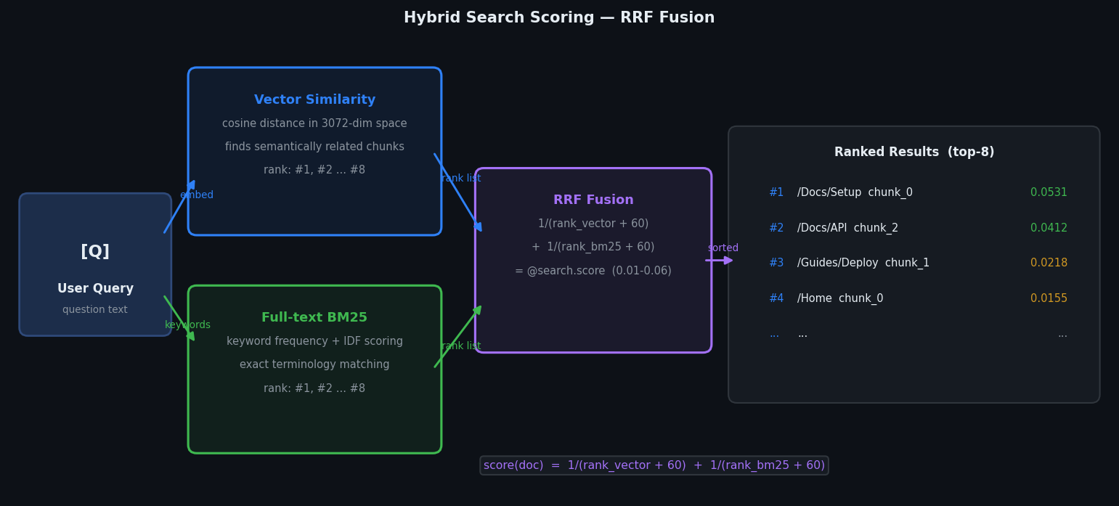
Figure 3 — RRF Hybrid Scoring

6.2 Confidence Signal
Three gates evaluated in order — the first that fires wins:

Gate | Condition | Signal | Notes
Gate 1 | No chunks returned | LOW | No content to base an answer on.
Gate 2 | Answer contains uncertainty phrases | LOW | "i don't know", "not enough information", "cannot find", "not mentioned", "unclear"
Gate 3 | score > 0.03 AND chunks >= 4 | HIGH | Strong relevance, 4+ corroborating chunks.
Gate 3 | score > 0.01 AND chunks >= 2 | MEDIUM | Moderate relevance, partial coverage.
Gate 3 | Anything else | LOW | Weakly matched or single chunk.

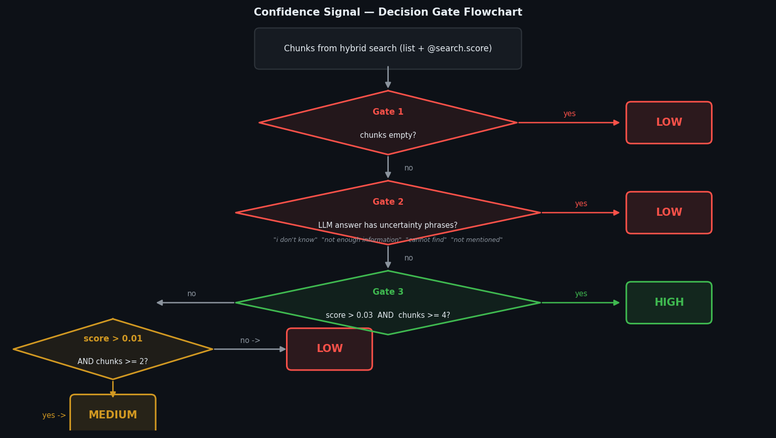
Figure 4 — Confidence Decision Gates

Note: Gate 2 always overrides Gate 3 — even with high scores, uncertainty language drops to LOW.

7. Cost Optimisation — Change Detection
Embedding tokens are the main ongoing cost. TigerChat avoids re-embedding unchanged content using a hash manifest stored in blob storage (wiki_hashes.json).

- Each wiki page's Markdown is MD5-hashed and compared to the stored hash.
- Pages whose hash hasn't changed are skipped — zero embedding API calls.
- Only new or changed pages are chunked, embedded, and upserted.
- The manifest is saved back to blob only after a fully successful upload.

Note: On a 300-page wiki where only 5 pages changed, only those 5 pages incur embedding cost.

8. Key Tuning Parameters
These constants are hardcoded in ingest.py and query.py. Adjust them to change trade-offs.

Variable / Parameter | Required | Description
CHUNK_SIZE | ingest.py | Characters per chunk — default 1000
CHUNK_OVERLAP | ingest.py | Overlap between chunks — default 150 chars
EMBED_BATCH_SIZE | ingest.py | Chunks sent per embedding API call — default 100
UPLOAD_BATCH_SIZE | ingest.py | Chunks per Azure AI Search upsert batch — default 100
VECTOR_DIM | ingest.py | Embedding dimensions — 3072 for text-embedding-3-large
TOP_K | query.py | Chunks retrieved per query — default 8
MAX_CONTEXT_CHARS | query.py | Token budget for LLM context — default 12000 chars (~3000 tokens)

