**Description**

* For students who do not have enough finance and want to learn new knowledge in participating, and in the Internet in general. Every day, they use laptops so they want to interact easily.
* Online Learning has a few following benefits: Saving time because they don’t go to Academy or still have enough information from courses when learning courses. Saving more money than going to Academy.

**Preview Screenshot**

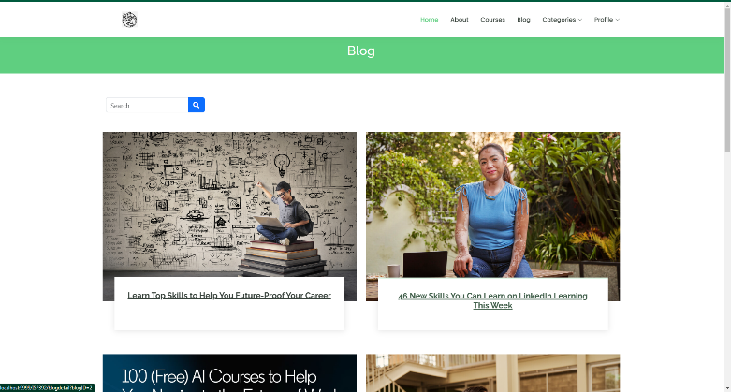

**Technology**

**1. Frontend**

* HTML, CSS, JS, Bootstrap, jQuery
* JSP - JavaServer Pages
* JSTL - JSP Standard Tag Library
* Axios - Promise based HTTP client for the browser and node.js

**2. Backend**

* Servlets - a Java programming language class that is used to extend the capabilities of servers that host applications accessed by means of a request-response programming model
* JDBC - Java Database Connectivity - a Java API to connect and execute the query with the database

**3. Database**

* Microsoft SQL Server - a relational model database server produced by Microsoft

**4. Tool**

* Netbeans 8.2
* Java JDK 8
* Apache Tomcat 8.5.29
* Visual Studio Code
* Microsoft SQL Server Management Studio 18

**5.Libraries**

* Lombok
* JSTL
* sqljdbc4
* javax.mail
* javax.activation-1.2.0
* jakarta.servlet.jsp.jstl-2.0.0