Spatial patterns in Pinus pinea regeneration transects

# Recovering transects data

## Warning: package 'googlesheets' was built under R version 3.3.3

## Warning: package 'dplyr' was built under R version 3.3.3

## # A tibble: 2 x 10  
## sheet_title author perm version updated  
## <chr> <chr> <chr> <chr> <dttm>  
## 1 TransectPinusPinea scotti rw old 2017-09-09 11:12:18  
## 2 TransectPinusPinea_v2 scotti rw old 2016-12-09 10:33:58  
## # ... with 5 more variables: sheet_key <chr>, ws_feed <chr>,  
## # alternate <chr>, self <chr>, alt_key <chr>

## Sheet successfully identified: "TransectPinusPinea"

## Sheet ' PointPatternWithMarks ' found.

## Accessing worksheet titled 'PointPatternWithMarks'.

## Parsed with column specification:  
## cols(  
## Area = col_character(),  
## IdPoint = col_character(),  
## X = col_double(),  
## Y = col_double(),  
## `H [m]` = col_double(),  
## `N palchi` = col_integer(),  
## AreaInsid = col_double(),  
## Note = col_character(),  
## Note_cod = col_character(),  
## KEY = col_character(),  
## n_el_gruppo = col_integer(),  
## sum_d_coll_sq = col_integer(),  
## n_fusti = col_integer(),  
## sum_d130sq = col_integer()  
## )

## Classes 'tbl_df', 'tbl' and 'data.frame': 102 obs. of 15 variables:  
## $ Area : chr "3" "3" "3" "3" ...  
## $ IdPoint : chr "C1" "C2" "C3" "C4" ...  
## $ X : num 5.4 14.6 23 26.1 26.8 29.2 26.6 29.2 32.4 33.3 ...  
## $ Y : num 9.3 4.8 5.5 9.9 4.3 4 4.4 4.4 0.7 4.3 ...  
## $ H [m] : num 7.5 2.4 6 3.6 3.4 6.7 3.6 3.2 3.3 8 ...  
## $ N palchi : int 13 8 10 8 7 11 8 9 6 13 ...  
## $ AreaInsid : num 63.65 4.95 23.01 4.81 2.88 ...  
## $ Note : chr NA NA NA NA ...  
## $ Note_cod : chr "A" "A" "A" "A" ...  
## $ KEY : chr "3C1" "3C2" "3C3" "3C4" ...  
## $ n_el_gruppo : int 1 1 1 1 1 1 2 1 1 1 ...  
## $ sum_d_coll_sq: int 7396 169 1600 100 49 1600 148 169 36 1444 ...  
## $ n_fusti : int 3 1 3 1 1 2 2 1 1 2 ...  
## $ sum_d130sq : int 1785 9 509 49 16 845 49 25 4 1025 ...  
## $ nPf : Factor w/ 13 levels "2","3","4","5",..: 12 7 9 7 6 10 7 8 5 12 ...  
## - attr(*, "spec")=List of 2  
## ..$ cols :List of 14  
## .. ..$ Area : list()  
## .. .. ..- attr(*, "class")= chr "collector_character" "collector"  
## .. ..$ IdPoint : list()  
## .. .. ..- attr(*, "class")= chr "collector_character" "collector"  
## .. ..$ X : list()  
## .. .. ..- attr(*, "class")= chr "collector_double" "collector"  
## .. ..$ Y : list()  
## .. .. ..- attr(*, "class")= chr "collector_double" "collector"  
## .. ..$ H [m] : list()  
## .. .. ..- attr(*, "class")= chr "collector_double" "collector"  
## .. ..$ N palchi : list()  
## .. .. ..- attr(*, "class")= chr "collector_integer" "collector"  
## .. ..$ AreaInsid : list()  
## .. .. ..- attr(*, "class")= chr "collector_double" "collector"  
## .. ..$ Note : list()  
## .. .. ..- attr(*, "class")= chr "collector_character" "collector"  
## .. ..$ Note_cod : list()  
## .. .. ..- attr(*, "class")= chr "collector_character" "collector"  
## .. ..$ KEY : list()  
## .. .. ..- attr(*, "class")= chr "collector_character" "collector"  
## .. ..$ n_el_gruppo : list()  
## .. .. ..- attr(*, "class")= chr "collector_integer" "collector"  
## .. ..$ sum_d_coll_sq: list()  
## .. .. ..- attr(*, "class")= chr "collector_integer" "collector"  
## .. ..$ n_fusti : list()  
## .. .. ..- attr(*, "class")= chr "collector_integer" "collector"  
## .. ..$ sum_d130sq : list()  
## .. .. ..- attr(*, "class")= chr "collector_integer" "collector"  
## ..$ default: list()  
## .. ..- attr(*, "class")= chr "collector_guess" "collector"  
## ..- attr(*, "class")= chr "col_spec"

# Initializing PPP and SO list

Spatial patterns windows are, partially, undefined. The width is fixed to 10m while the length is open and has to be estimated!!

library(spatstat)

## Warning: package 'spatstat' was built under R version 3.3.3

## Loading required package: nlme

##   
## Attaching package: 'nlme'

## The following object is masked from 'package:dplyr':  
##   
## collapse

## Loading required package: rpart

##   
## spatstat 1.52-1 (nickname: 'Apophenia')   
## For an introduction to spatstat, type 'beginner'

##   
## Note: R version 3.3.2 (2016-10-31) is more than 9 months old; we strongly recommend upgrading to the latest version

Areas <- unique(ppwm$Area)  
t_windows <- list()  
for(tid in Areas) t_windows[[tid]] <- ripras(ppwm$X[ppwm$Area==tid],ppwm$Y[ppwm$Area==tid], shape = "rectangle")  
# ripras(): Estimate window from points alone  
reduced <- c(1, 2, 3, 4, 6, 5, 7)  
ppwm0 <- ppwm  
ppwm <- ppwm[, reduced]  
names(ppwm)[5:7] <- c("#whorls", "height [m]", "crown [m^2]")  
trss <- solist()  
# To display transects as seen from the see  
# exchange x and y  
# mirror on the negative side the y ==> K=-1  
K <- -1  
for(tid in Areas) {  
 trs <- ppp(ppwm$Y[ppwm$Area==tid],K*c(ppwm$X[ppwm$Area==tid])  
 , yrange = range(K*t_windows[[tid]]$xrange), xrange = c(-10, 10)  
 , marks = ppwm[ppwm$Area==tid, c(5:7)])  
 unitname(trs) <- "m"  
# print(paste(tid,class(trs)))  
 trss[[length(trss)+1]] <- trs  
}  
names(trss)=paste("Trs-",Areas,sep="")

# Transects density distribution analysis

plot(as.solist(lapply(trss, density)), nrows=1, equal.scales=T, valign=T, main = "", hsep=2, cex.main=.7  
 , par(mar=c(0,0,2,0)), equal.ribbon=TRUE,  
 panel.end=function(i,y,...){contour(y, ...)})  
title(main="Density distribution", line =-1)  
Axis(trss, side=4, cex.axis=.6, at=seq(100,20,-20), labels = seq(0,80,20), line = -3)  
text(150,70,"distance [m]", srt = 90)

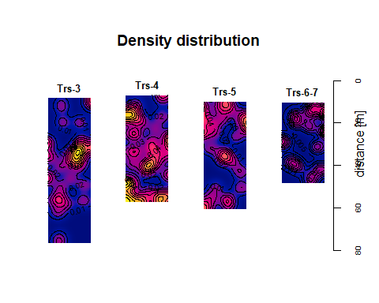

# Correlations among marks

library("PerformanceAnalytics", lib.loc="~/R/win-library/3.3")

## Loading required package: xts

## Loading required package: zoo

##   
## Attaching package: 'zoo'

## The following objects are masked from 'package:base':  
##   
## as.Date, as.Date.numeric

##   
## Attaching package: 'xts'

## The following objects are masked from 'package:dplyr':  
##   
## first, last

##   
## Attaching package: 'PerformanceAnalytics'

## The following object is masked from 'package:graphics':  
##   
## legend

ow <- options("warn")[[1]]  
options(warn = -1)  
for(i in 1:4) chart.Correlation(marks(trss[[i]])  
 , histogram=TRUE, pch=19  
 , main=names(trss)[i])

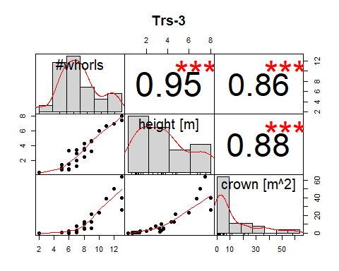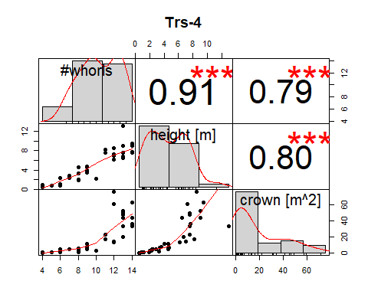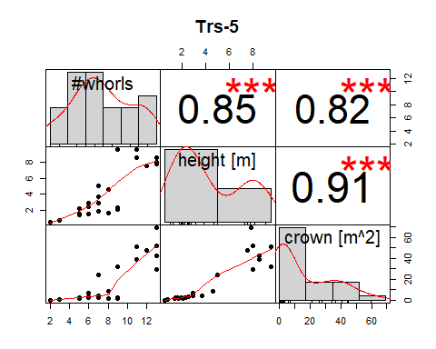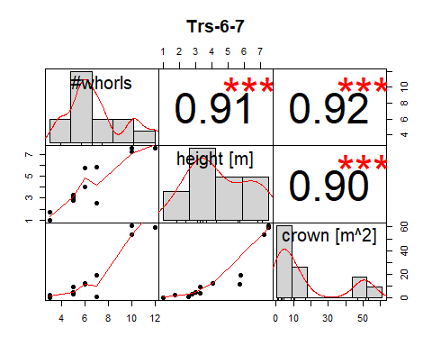

options(warn = ow)

# Distribution of mark values

for(i in 1:length(trss)) {  
 tid <- names(trss)[i]  
 trs <- trss[[tid]]  
 plot(trs, cex.main=1.1, main="",   
 hsep=0, par(mar=c(0,0.5,0,0), cex=.6), mar.panel=c(0,0,0,.9))  
 title(main = paste("Marks in",tid), line = -2)  
}

## Warning: Interpretation of arguments maxsize and markscale has changed (in  
## spatstat version 1.37-0 and later). Size of a circle is now measured by its  
## diameter.

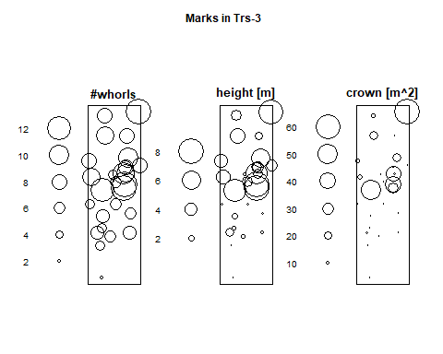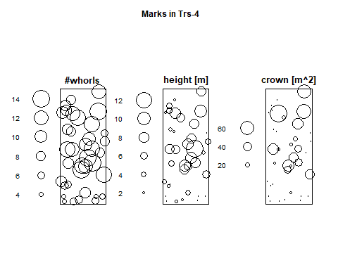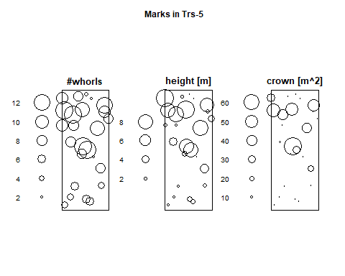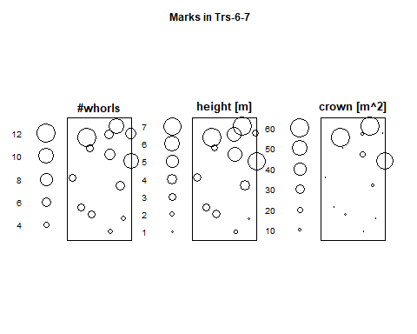

# which.marks = c(9, 1, 3),   
# main.panel=c("#whorls", "height [m]", "crown [m^2]"),

# Analysis of spatial characters

Kl <- as.anylist(lapply(trss, Kest))  
for(i in 1:length(Kl)) {  
 leg <- plot(Kl[[i]], legend = F, main=names(Kl)[[i]])  
 legend("topleft",legend = leg$key, lty=leg$lty, col=leg$col)  
}

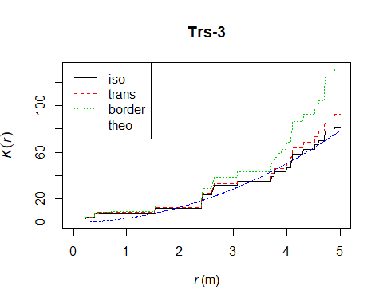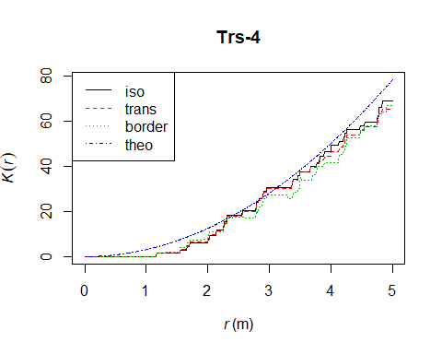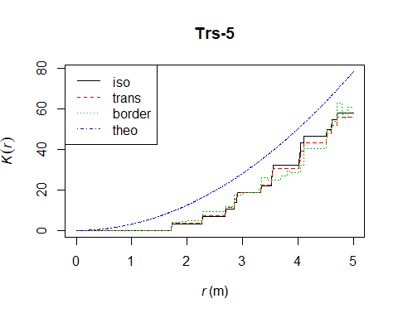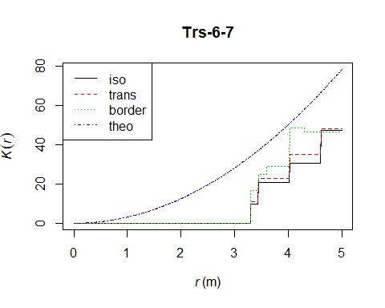

# Analysis of the spatial behaviour of each mark

pmkc <- function(x, m) plot(main=paste(names(trss)[x],":"  
 ,names(trss[[1]]$marks)[m])  
 ,markcorr(setmarks(unmark(trss[[x]])  
 ,marks(trss[[x]])[[m]])))  
  
for(m in 1:length(marks(trs))) {  
 for(i in 1:length(trss)) pmkc(i, m)  
}

