

Cinema Data Management Portal
(Red Curtain)

NIT3003 IT Capstone Project 1

Submitted By: | Submitted To:
Group 5:  Arpan Ghimire  Student ID: s8138683  Sulav Silwal  Student ID: s8139858  Nupjan Koirala  Student ID: s8132249  Isha .  Student ID: s8087877 | Fakhra Jabeen  Fakhra.Jabeen@vu.edu.au  Tutor: NIT3003) IT Capstone Project  VU Sydney

Table of Contents

Introduction 4
Red Curtain: New era of cinema engagement through user empowerment 4
Project Objectives: 5
Functional Requirements 6
I. User Authentication (Isha .) 6
II. Feed Page (Isha.): 8
III. Dynamic Homepage (NUPJAN) 10
IV. Systematic Ticket Booking System (SULAV SILWAL) 12
V. Reliable Payment and Ticket Delivery System (Arpan Ghimire) 15
Non- Functional Requirement 19
I. Seamless User Authentication (Isha) 19
II. Engaging Home Page Experience (Nupjan) 19
III. Systematic Ticket Booking System (Sulav Silwal) 19
IV. Reliable Payment & Ticket Delivery (Arpan Ghimire) 20
Use Case Diagram 20
Use Case Descriptions: 21
Sequence Diagrams 31
I. Authentication, Polls & Loyalty (ISHA) 31
II. Movie list and Details (Nupjan) 35
III. Systematic Ticket Booking System (Sulav) 37
IV. Payment & Ticket Delivery System (Arpan Ghimire) 38
PSEUDOCODES 41
User Authentication, Feed and Rewards 41
Movie HomePage (Nupjan) 44
Systematic Ticket Booking System (Sulav) 46
Payment and Ticket Generation Pseudocode (Arpan) 48
UI Design 50
User Authentication and Polling System 50
Movie list and Details (Nupjan) 54
Payment, Tickets and Loyalty Rewards (Arpan) 58
58
Resource Management 60
Introduction 60
Human Resources 60
Financial Resources 60
Material Resources 61
Technology 61
Allocation of Resources 62
Monitoring & Evaluation: 62
Timeframe & WBS 63
Timeline 64
Risk management plan 65
ISHA 65
Nupjan 65
Sulav 66
Arpan 67
ER Diagram 68
Components of ER diagram 68
Conclusion: 69
References 70

Introduction

Red Curtain: New era of cinema engagement through user empowerment
The global entertainment industry is currently going through rapid transformation while Australia's movie industry shows signs of revival. Viewers are getting back to the theaters after the massive pandemic of COVID-19 due to the improved viewing experience and the quality of movies. The pandemic shifted consumer habits dramatically toward streaming services, creating an increasingly competitive environment for traditional cinema. However, recent trends suggest that audiences crave the communal and immersive experiences that theaters provide as it is something that on-demand streaming cannot replicate. Cinemas are now compelled to adapt to evolving user expectations for personalized and interactive experiences to stay relevant. This creates an opportunity to bridge the gap between technology-driven user empowerment with the traditional movie-going experience intact.
Surveys show that 63% of Australian consumers plan to visit cinemas more often after the pandemic which indicates a strong consumer interest in unique and interactive experiences. This market trend matches Red Curtain's user-focused platform because it seeks to use this renewed interest by improving audience involvement in film selection and social interaction. Using this upward market sentiment, Red Curtain is well-positioned to capitalize on a market that demands both innovative solutions and personalized experiences.
Major Australian cinema chains HOYTS and Event Cinemas dominate the current market (Screen Australia, n.d.) through their top-down operational model which provides standardized showtimes with limited customization possibilities. These chains deliver dependable movie experiences through their wide theater networks and loyalty programs with an extensive selection of their mainstream movies. Their platforms do not offer flexible user-driven features including movie selection or dynamic pricing. The loyalty programs operate independently, which forces users to use a single cinema chain instead of allowing them to combine rewards across different chains. Their platforms also lack social interaction features which prevent users from experiencing modern community-based experiences and group planning capabilities. The Red Curtain platform addresses these gaps through user showtime voting and social features that create an interactive communal experience for cinema lovers.
Red Curtain aims to redefine cinematic experience by letting users somewhat be the center of decision-making. Unlike traditional cinema platforms that dictate showtimes and film selections, Red Curtain empowers its users through a polling system to actively choose what films they are willing to see, when, and where. This level of interactivity transforms passive audiences into engaged participants setting the project apart from existing offerings. Additionally, Red Curtain, with its dynamic pricing and loyalty rewards across different cinema chains, creates an ecosystem where users can maximize their movie experience without being tied to a single brand. The platform’s emphasis on social features such as group planning, shared experiences, and user reviews distinguishes it by transforming the cinema from a lonely outing into a community driven event. By addressing key industry gaps in flexibility, accessibility, and social integration, Red Curtain positions itself as a unique and compelling solution that modernizes and personalizes the cinema industry for Australian audiences.

To summarize, Red Curtain has the following key features for uplifting viewer’s experience:
- User Driven Poll System (Isha): The system allows users to select what movies should be played during specific time periods through its user-driven polling feature.
- Dynamic Pricing & Rewards Benefits (Arpan): The system provides real-time data about ongoing promotional activities across different chains and loyalty point usage along with dynamic price adjustments according to users.

- User reviews and social chain (Nupjan): The system includes social features which enable group planning and user reviews and accessibility filters.
- Seamless Booking Experience (Sulav): The system provides a smooth booking process through its user-friendly interface which displays real-time updates.

By combining the power of collective user input with smart and flexible services, RedCurtain aims to redefine what a cinema platform can be and not just a place to watch movies but making it a social hub powered by the viewers.

Project Objectives:
- Ideal User Authentication & feed page(Isha.)
- A login/signup system that is safe and straightforward and linked to the global database will make it easy for users to start using your app.
- Dynamic Homepage (Nupjan Koirala)
- Present new releases sorted movies and rich details on engaging homepage experience to keep users engaged.
- Systematic Ticket Booking System (Sulav Silwal)
- Allow users to select the movies showtimes, the seats they would like and set the ticket type (child, adult or disable ...) with real time updates.
- Reliable Payment and Ticket Delivery System (Arpan Ghimire)
- Use a secure gateway for payments and produce QR-based tickets through automation whenever a booking is confirmed, to make checkout easy for all.

Functional Requirements

User Authentication (Isha .)
1. User Registration (Sign-Up) Flow:
Front-End:
- Sign-Up Form: Users must enter Email, Password, Full Name, and optionally Phone. They can also select their Preferred Cinemas from a drop-down list.
Descriptions of buttons on sign-up page:
- Sign Up: Validates inputs (e.g., email format, password strength) and sends data to the server if valid.
- Google Login: Allows users to sign up using Google OAuth for quicker access.
- Real-time Validation: Provides instant feedback, like “Email already in use” or “Password too weak”, guiding users during input.

Back-End:
- Data Validation: The system checks if the email is unique and whether the password meets security requirements (e.g., minimum length, mixed characters).
- Password Hashing: The server securely hashes the password before storing it.
- Account Creation: Once validated, the user’s data is stored in the database, and a verification email with a token is sent to confirm the account.

2. User Login Flow:
Front-End:
- Login Form: Users enter their Email and Password. There is also an optional “Remember Me” checkbox for staying logged in.

Descriptions of buttons on login page:
- Login: Sends credentials to the server for authentication. If the authentication credentials are matched, the user is then redirected to their dashboard.
- Forgot Password: The button allows users to reset their password if they are unable to recall their login details.

Back-End:
- Authentication: User’s email and password are checked using the stored data from the database, and a login log is recorded for security.
- Session Management: After a successful login, the server generates a secure session token for maintaining the user’s session across requests.
- Security: Login attempts from users are rate-limited to prevent any brute-force attacks, and the server ensures that data is transmitted securely using secure protocols like HTTPS.

3. Password Recovery
Front-End:
- Forgot Password Flow: Users input their email to receive a password reset link or token.
Back-End:
- Reset Token Generation: The system generates a secure and time-sensitive token for the user to reset their password.
- Password Update: Once the token is validated, users can set up a new password which is then securely encrypted and stored in the database.

Database
User Data: The system stores essential user information including user’s email, hashed passwords, full name, phone number, preferred cinemas, and verification status in a secure database.

Field | Description
user_id | Unique identifier for each user.
email | The user’s email address (unique).
full name | The user’s full name.
password | The hashed password for the user.
phone | The user’s phone number (optional).
preferred cinemas | The users' preferred cinemas.
is verified | Boolean flag indicating if the user has verified their email.
created at | Timestamp of when the user registered.

Feed Page (Isha.):
Front-End
- Post Display Polls: The feed will feature weekly polls such as “Vote for the next classic movie!” or similar fun and engaging content. This encourages user participation and keeps the feed dynamic.

- Winners: Once a poll concludes, the feed will also show the results and announce the winning choice. For example, “And the winner is… Jurassic Park!” This keeps users engaged by sharing the outcome and creating a sense of excitement.

- Media: Posts may include media elements like images, videos, or links related to the poll or the winner announcement. This could be a poster for the classic movie poll or a clip celebrating the winning movie.

- Content Layout: Each post will clearly display the poll question, the related media, and the poll status (whether the poll is Active or Closed). The layout will be visually appealing and easy to follow for a better user experience.

- User Interaction Voting: Users will be able to vote directly within the feed for active polls. The process will be simple and quick to encourage participation.

- Vote Confirmation: After casting their vote, users will immediately see a message like “Your vote has been submitted!” This gives them confirmation and reassurance that their choice was recorded successfully.

- Winner Notification: Once the poll ends, the feed will automatically update to show the winner. A message such as “Winner: Jurassic Park!” will be displayed, making it clear which option was the most popular. This keeps users informed and adds a sense of closure and excitement.
Server-End
- Post Creation: Only admin users will be authorized to create posts, including polls and announcements. The system will verify the user's role before granting access to the post creation feature ensuring that only those with the correct permissions can generate content.

- Post Management: Admins will have the ability to both create and update posts related to polls, winners, and other relevant content. They can also control the poll status (Active, Closed, Pending) to manage when users can participate. Additionally, admins will be able to attach media, such as images or videos, to posts.

Database:
Post id | Admin id | Content | Media URL | Poll Status | Timestamp
554 | red55 | "Poll: Jurassic Park!" | redCurtain.com/posts/554 | Active | 18:20 08-02-2024

Dynamic Homepage (NUPJAN)
Fetch Movies:
- Front-end: Display of a scrollable list of "Now Showing" movies fetched from an external API. Each movie card shows:
- Poster image (clickable)
- Title
- Average rating (★★★★☆)
- Short description

- Server-end: The API is called to retrieve the real-time data and responses are cached to reduce latency.

- Database: Store movie IDs and metadata for offline fallback.
Movie_id | Title | Poster_URL | Rating | Description | Last_Updated
102 | Inception | redCurtin.com | 4.5 | A mindbending... | 18-07-2024

Movie Details Page
- Front-end: Show expanded movie details (synopsis, cast, showtimes) and user-generated content:
- Discussions: Threaded comments with replies (newest first).
- Ratings: Star ratings and written reviews.

- Server-end:
- Fetch movie details from API.
- Retrieve discussions/reviews from the database.

- Database Tables:
- Discussion Table:
Discussion_id | Movie_id | User_id | Comment | Timestamp
xxx | 123 | user@xx | "Great film!" | 18:20 08-02-2024

- Ratings Table:
Rating_id | Movie_id | User_id | Stars | Review | Timestamp
xxx | 123 | user@xx | 5 | "Masterpiece!" | 18:20 08-02-2024

Threads (User Discussions and Ratings)
- Front-end:
- Display a separate section under the movie details where users can create new threads related to the movie.
- Each thread includes:
- Title of the thread
- User comments and replies (nested discussions)
- Personal user rating out of 10 (optional but visible next to each comment)
- Timestamp of each comment/reply
- Allow users to create new threads, comment on existing ones, and reply to comments.
- Users can discuss theories, reviews, and share opinions about the movie.
- Server-end:
- Handle creation, retrieval, updating, and deletion of threads and comments.
- Fetch all threads related to the movie and order them by creation date or popularity.
- Store user ratings associated with each comment.
- Database Tables:
- Threads Table:
Thread_id | Movie_id | User_id | Title | Created_At
xxx | 123 | user@xx | "Ending Explained" | 18:20 08-02-2024

Systematic Ticket Booking System (SULAV SILWAL)
Using the Ticket Booking System, users pick the movie, choose when to watch it, the seat, and the ticket category. It lets you lock in your seats, incorporate dynamic pricing into your booking experience and connect payments without issues.
Front-End:
Following are the lists of user interface action used for Ticket Booking System:
- Showtime Selection
- Action:
- Users are allowed to pick a desired date through a calendar widget.
- Pick a theater from the list of available locations.
- Select a movie from a collection of posters.

- Data Bandying:
- Provide a GET request to server including filters((movie_id, date, cinema_id) .
- Based on that it will clearly show opening movie times
- Seat Mapping
- Action
- People use the interactive grid (based on SVG or color-code Green: Available, Red : Booked, blue with symbol :disable).
- Select seats by clicking on them; blue highlights let you know the seats you choose.
- Gives the option to set the seat as Adult, Child or Senior after selecting number of seats.
- Data Bandying:
- Send designated seat IDs and details of any ticket types selected to the server to check real time availability.

- Confirmation and Payment
- Action
- The user presses the “payment” button to finish the booking
- .The Views summary model displays seat numbers, the ticket types and a changing total price.

Server-End:
Following are the lists of server-end logic used for Ticket Booking System:
- Request Validation logic
- Validate
- Check that there is an upcoming showtime_id in the database.
- Be sure the seats are for the right theater screen
- Don’t have the same seat number selected twice.

- Seat Availability Workflow logic
- Real Time seat locking
- Locking seat using query database with SELECT ... FOR UPDATE
- If all seat are available
- for 10 minutes reserve the seat selected by user.
- write reserve to the seat which is in booking process by user

- Ticket Pricing logic
- Collect base price from the ticket_type table.
- Total price : sum of ( ticket_type x number of seat per ticket type price)
- Process to press payment button.

Database:
Following are the lists of database table used for Ticket Booking System:
- Showtimes
Column | Type | Description | Example Data
id | INT (PK) | Unique showtime ID | 789
movie_id | INT | References movies table | hit
cinema_id | INT | References cinemas table | 8 (Newton Redcurtin)
screen | TINYINT | Theater screen number | 5
start_time | DATETIME | Show start time | 2025-06-15 18:00:00
seats_left | SMALLINT | Available seats counter | 124

- Seats
Column | Type | Description | Example Data
id | VARCHAR(5) | Seat ID (e.g., "A1") | "B7"
cinema_id | INT | Theater location | 8
screen | TINYINT | Screen number | 5
type | ENUM | Standard/Premium/Wheelchair | "premium"
is_booked | BOOLEAN | Booking status | FALSE
lock_expiry | TIMESTAMP | Temporary reservation expiry | NULL

- Ticket_types

Column | Type | Description | Example Data
id | TINYINT(PK) | Ticket type ID | 2
name | VARCHAR(20) | Display name | "Child"
base_price | DECIMAL(5,2) | Default price | 15.00
access_rule | VARCHAR(50) | Restrictions (if any) | "age < 12"

Reliable Payment and Ticket Delivery System (Arpan Ghimire)
User Interactions (Frontend)
- Browse Movies Page: The user can browse through the movie titles of all sorts of movies on the Movies Page.
- Select Movie: The user can select the movies to view showtimes after clicking on it.
- Choose Showtime: The users can use calendar interface for movie showtimes and locations for selection.
- Select Seats: The real-time interactive seat map lets users pick their desired seats.
- Add to Cart & Checkout: The users then advance to checkout where they can use promo codes or loyalty points (if available).
- Payment: The user completes payment interacting with the paywall system by entering their payment information.
- Confirmation & E-ticket: Once the payment is successful, a confirmation page along with a digital ticket (QR code) with all the details will be shown to the user. The digital ticket will also be sent to the user via email.

UI Components:
- Movie Thumbnails
- Calander
- Interactive seat selection widget
- Summary of selected tickets
- Paywall
- Confirmation modal with ticket and QR code

Data Sent to Server:
- User Details (if logged in)
- Selected movie ID, location ID, date, and showtime ID
- Selected seat numbers
- Applied discount codes or loyalty points
- Payment method and payment token
- Total price

Server-End Logic
Backend Workflow:
- Receive Ticket Request:
- The system accepts all front-end information which it receives.
- The system checks the validity of movie ID and seat availability and user session and payment information.

- Seat Availability Check:
- Queries databases to ensure selected seats for specific showtime are still available.
- Locks seats temporarily to prevent other users from selecting same seats

- Apply Discounts or Points:
- Validates discount codes or loyalty points.
- Recalculates total payable amount if applicable.

- Process Payment:
- Encrypts and securely transmit payment data to payment processor
- Waits for a confirmation response.

- Generate Ticket:
- Upon successful payment:
- Finalizes seat booking (changes status to "booked").
- Creates ticket records with a unique QR code.
- Sends details of tickets and confirmation via email and SMS.

- Error Handling:
- If any step fails, the user is notified and prompted to retry.

Database Tables
Movies Table
MovieID | Title | Duration | Rating | Language | Genre
100 | Inception | 148 min | PG-13 | English | Sci-Fi

Showtimes Table
ShowtimeID | MovieID | CinemaID | Date | Time
500 | 100 | 1 | 2025-06-10 | 18:30

Seats Table
SeatID | ShowtimeID | SeatNumber | Status
1 | 500 | A1 | Available
2 | 500 | A2 | Booked
3 | 500 | A3 | Reserved

Users Table
UserID | Name | Email | LoyaltyPoints
101 | Rose Khatiwada | Rose.kh@protonmail.com | 10500
Ticket Table
TicketID | UserID | ShowtimeID | SeatNumber | Price | QRCode | Status
T1 | 101 | 500 | A1 | 16.50 | usr101_ticket.png | Booked

Payment Table
PaymentID | TicketID | Amount | Status | PaymentDate
P1 | T1 | 16.50 | Success | 2025-06-01 12:30:10

LoyalityPoints
Code | DiscountAmount | ExpiryDate
REDCUR10 | 10.00 | 2025-07-01

Non- Functional Requirement

Seamless User Authentication (Isha)
- The system must respond to login/signup requests within ≤1 second when handling 10,000 concurrent users.
- The system must implement OWASP Top 10 safeguards through rate limiting and password encryption.
- The system must support multi-factor authentication (MFA) for high-risk actions including password reset.

Engaging Home Page Experience (Nupjan)
- The homepage needs to load in less than 2 seconds with a Lighthouse score of 90 or higher.
- The initial payload should be reduced by implementing lazy loading for movie posters and carousels.
- Providing assistance to, over 10.000 users each day by utilizing cached movie information (CDNs and Redis).

Systematic Ticket Booking System (Sulav Silwal)
- The seat availability status needs to update within 500 milliseconds delay) to avoid overbooking.
- The interface, for selecting seats should be accessible using the keyboard to comply with WCAG AA standards.

Reliable Payment & Ticket Delivery (Arpan Ghimire)
- Ensuring compliance with global payment regulations for payment processing without storing any data.
- Ensuring that the payment gateway remains operational all the time and prioritizing a backup plan for any unsuccessful transactions.
- QR codes on tickets are made to be readable without an internet connection with an error correction level of 30% or more.

Use Case Diagram
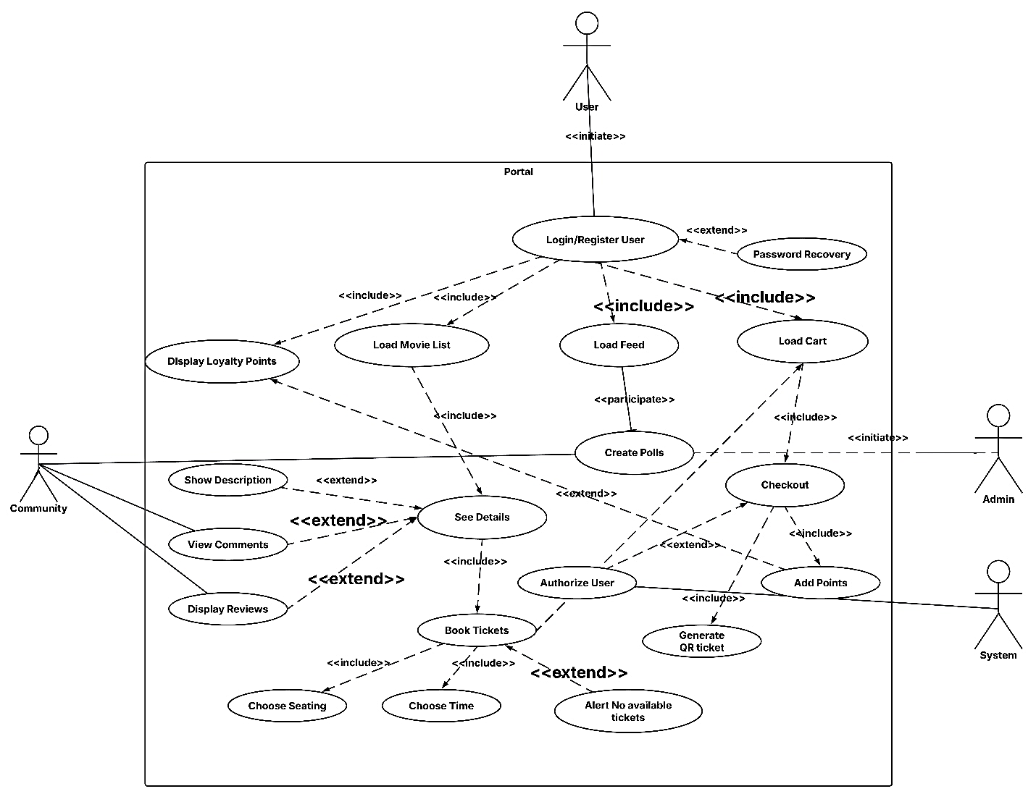

Use Case Descriptions:
1. Register
Field | Description
Use Case Name | Registration
Participating Actor | User
Goal | Establish a fresh account within the system.
Flow of Events | -The user enters their Email, Full Name, password, and re-enters the password for confirmation.  -Optionally select preferred cinemas.  -Click the "Register" button.  -System validates inputs and creates accounts.  -A verification email was sent.
Entry Condition | Visits the registration page through a web browser.
Exit Condition | Redirected to login page upon success, or error message shown if registration fails (e.g., duplicate email, weak password).

2. Login

Field | Description
Use Case Name | Login
Participating Actor | User
Goal | Access to the system using valid credentials.
Flow of Events | - User enters Email and Password.  - Clicks "Login".  - System authenticates credentials.  - If valid, redirects to dashboard.
Entry Condition | The user has an existing, verified account and accesses the login page.
Exit Condition | Redirected to dashboard success; error message shown if credentials are invalid.

3. Password Recovery
Field | Description
Use Case Name | Password Recovery
Participating Actor | User
Goal | Reset access credentials when the original password is forgotten.
Flow of Events | - User clicks "Forgot Password".  - Enters registered Email.  - Receives a reset link.  - Follows the link and sets a new password.
Entry Condition | User is not logged in and accesses password recovery page.
Exit Condition | Redirected to login page after reset, or error shown if email is unrecognized or token is expired.

4. Load Movie List
Field | Description
Use Case Name | Load Movie List
Participating Actor | Logged-In User / Guest User
Goal | Discover movies currently showing in cinemas.
Flow of Events | - User logs in and lands on the homepage.  - System fetches movie list from external API.  - Movies are displayed as scrollable cards.
Entry Condition | User is logged in and accesses the homepage.
Exit Condition | Movie list displayed, or an error message shown if the data fetch fails.

5. See Details
Field | Description
Use Case Name | See Details
Participating Actor | Logged-In User
Goal | Access comprehensive details about a specific movie.
Flow of Events | - User selects a movie from the homepage.  - System fetches details (synopsis, cast, showtimes, reviews).  - Details are rendered.
Entry Condition | User clicks on a movie from the homepage or search results.
Exit Condition | Movie detail page is displayed, or an error is shown if the data load fails.
6. Display Loyalty points
Field | Description
Use Case Name | Display Loyalty Points
Participating Actor | Logged-In User
Goal | View loyalty points and/or view rewards
Flow of Events | - User logs in and lands on the homepage.  - User finds Loyalty points at the top right of his home page  - points are displayed  -User clicks on the points
Entry Condition | User is logged in and accesses the homepage.
Exit Condition | Closes the loyalty tab/activity or network errors

7. View Comments
Field | Description
Use Case Name | View Comments
Participating Actor | Logged-In User
Goal | Share or respond to comments about a movie in a threaded discussion format.
Flow of Events | - User opens a movie’s discussion section.  - Creates a thread or replies to an existing one.  - System stores the post in the database.
Entry Condition | User is on the movie details page and has an active session.
Exit Condition | Comment is posted, or user receives an error message on failure.

8. Display Review
Field | Description
Use Case Name | Display Reviews
Participating Actor | Logged-In User
Goal | Submit a review and star rating for a movie.
Flow of Events | - User selects a movie.  - Clicks “Add Review”.  - Enters review text and select a star rating.  - Submits.  - System saves it.
Entry Condition | User has watched or selected a movie and is logged in.
Exit Condition | Review saved and displayed on the platform, or error shown on failure.

9. Load Feed
Field | Description
Use Case Name | Load Feed
Participating Actor | Logged-In User
Goal | Browse available community polls posted by admins.
Flow of Events | - User opens the feed section.  - System displays active and closed polls.  - Each poll includes media and status.
Entry Condition | User is logged in and opens the poll feed.
Exit Condition | Polls are displayed, or errors are shown if data load fails.

10. Create Poll
Field | Description
Use Case Name | Create Poll
Participating Actor | Admin
Goal | Creates a poll for users to participate
Flow of Events | - admin creates a poll  -users participate  -after deadline poll is locked
Entry Condition | Admin clicks on the button to create poll
Exit Condition | Creation completed or Uncomplete form resolution and receives an error message.

11. Book Ticket (Sulav)
Field | Description
Use Case Name | Book Ticket
Participating Actor | Logged-In User
Goal | The booking process ends with the selection of chosen seats and ticket options.
Flow of Events | -The user verifies their choices.  -The system places selected seats under temporary lockout.  Proceeds to payment.
Entry Condition | The user has chosen appropriate seating options and ticket categories.
Exit Condition | The checkout process locks seats until the user completes payment or the system times out or payment fails.

12. Choose Time (Sulav)
Field | Description
Use Case Name | Choose Time
Participating Actor | Logged-In User
Goal | The system displays available showtimes after the user chooses a movie and specifies both date and location.
Flow of Events | -The user picks a movie as their first step.  -The user chooses both cinema and date.  -The system displays showtimes that match the selected criteria after filtering them.
Entry Condition | The user is logged in and selects filters on the showtime page.
Exit Condition | The system shows appropriate showtimes or displays an error message when no matches exist or data retrieval fails.

13. Choose Seats (Sulav)
Field | Description
Use Case Name | Select Seats
Participating Actor | Logged-In User
Goal | The interactive seat map allows users to select their preferred seating options.
Flow of Events | -The user picks a showtime.  -The system displays the seating arrangement together with the current availability status.  -The user selects the seats they want to purchase.
Entry Condition | The user remains on the showtime screen after selecting a valid session.
Exit Condition | The system either reserves the selected seats temporarily or displays an error message when seats are already occupied.

14. Checkout
Field | Description
Use Case Name | Checkout
Participating Actor | Logged-In User
Goal | Review booking summary and apply discounts or points.
Flow of Events | -User views booking summary.  -Optionally applies promo codes or loyalty points.  -Clicks “Proceed to Pay”.
Entry Condition | User completes ticket and seat selection.
Exit Condition | Redirected to payment gateway or error if inputs are invalid.
15. Authorize User
Field | Description
Use Case Name | Authorize User
Participating Actor | Logged-In User /
Goal | Securely complete the transaction for the booking.
Flow of Events | -User enters payment details.  -The system sends encrypted data to gateway.  -Waits for confirmation.  -Marks booking as paid.
Entry Condition | User proceeds from the checkout page.
Exit Condition | Payment confirmed and booking finalized, or failure message if declined.

16. Generate QR Ticket
Field | Description
Use Case Name | Generate QR Ticket
Participating Actor | Logged-In User
Goal | Issue a scannable digital ticket for entry.
Flow of Events | -Upon successful payment, system generates unique QR code.  -Associates code with showtime, seat, and user.
Entry Condition | Payment is successful and seats are confirmed.
Exit Condition | QR ticket is created and ready for delivery and scanning.

17. Add points
Field | Description
Use Case Name | Add points
Participating Actor | System
Goal | Add points to user database after Checkout
Flow of Events | -User completes transaction  -Based on the money spent system analyses the rewards  -sytem adds the reward to the user profile
Entry Condition | User proceeds after transaction
Exit Condition | Points successfully added, view ticket QR

Sequence Diagrams

Authentication, Polls & Loyalty (ISHA)
REGISTRATION SEQUENCE DIAGRAM: (ISHA.)
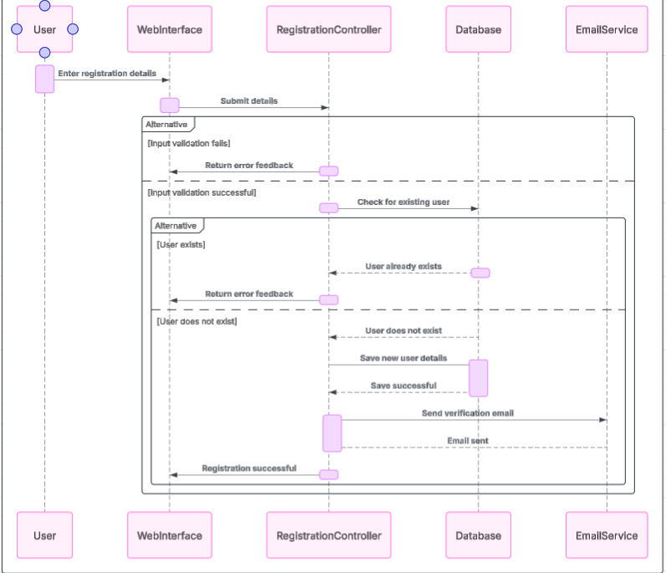
LOGIN SEQUENCE DIAGRAM: (ISHA.)
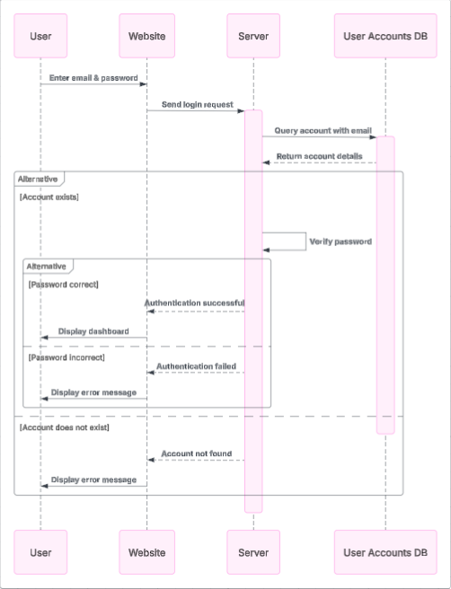
POLLING SEQUENCE DIAGRAM: (ISHA.)
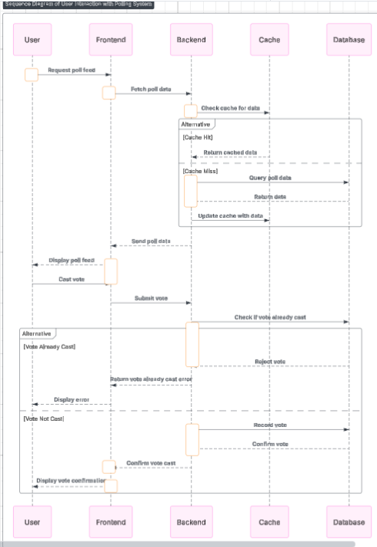

REWARDS SEQUENCE DIAGRAM: (ISHA.)
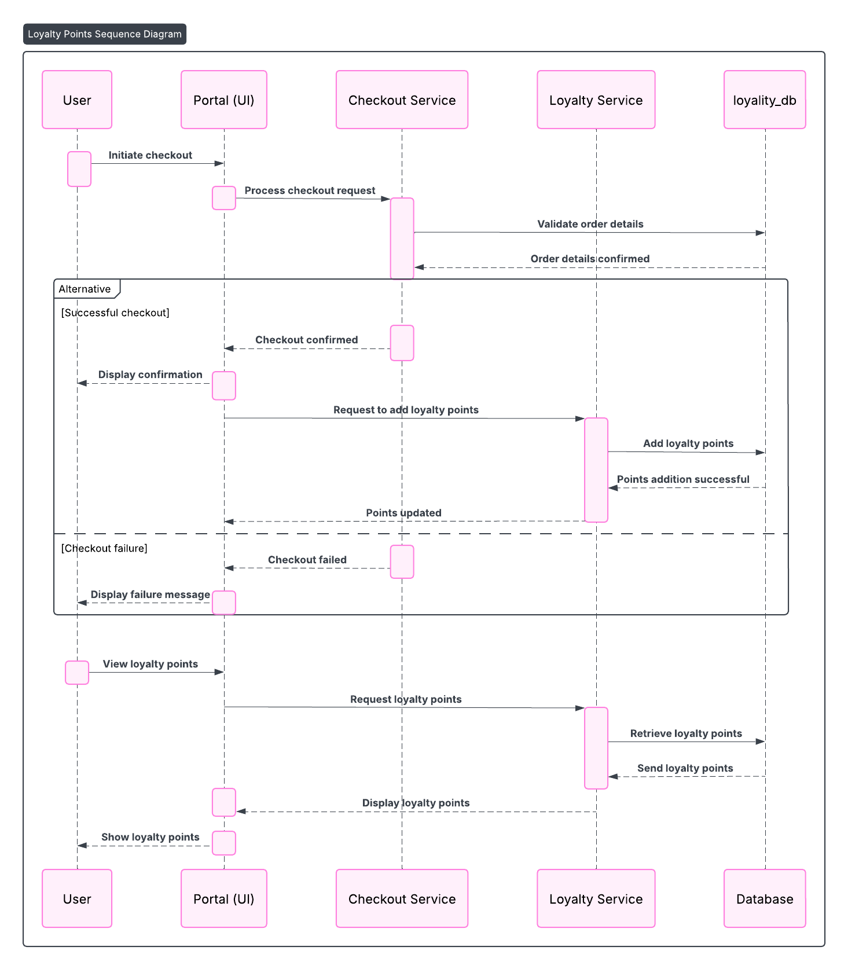

Movie list and Details (Nupjan)
Home Page
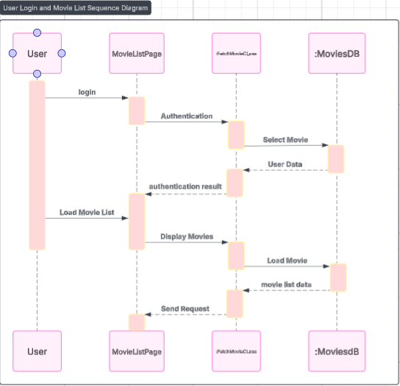
Details Page
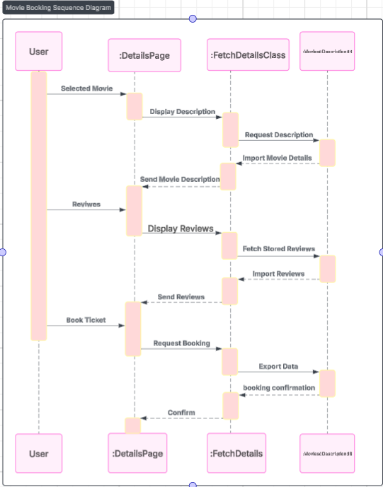

Systematic Ticket Booking System (Sulav)
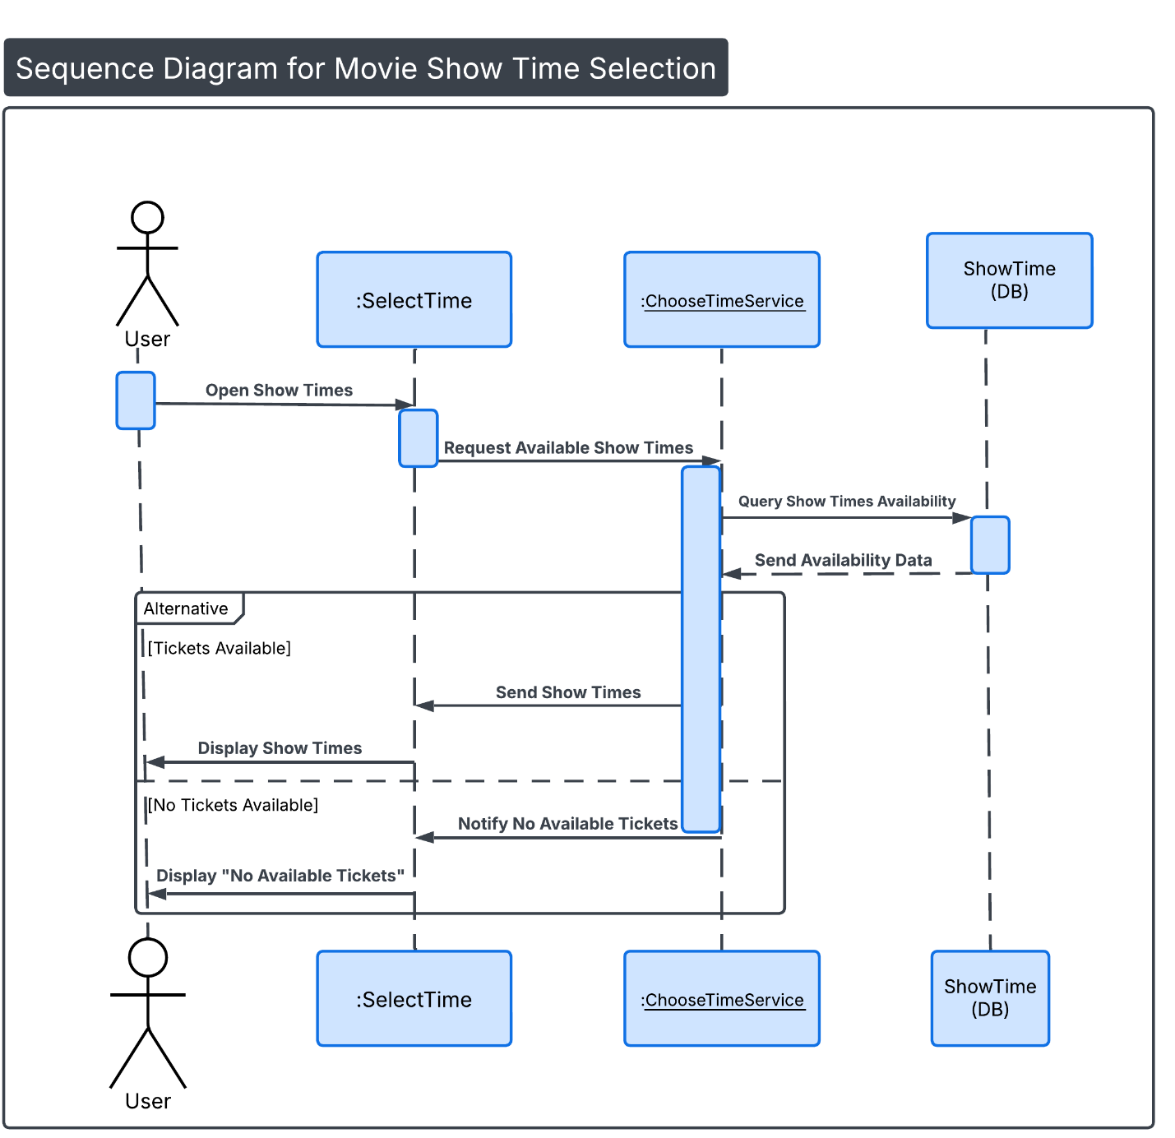
Movie Show Time Selection Sequence Diagram

Seat Selection Sequence Diagram
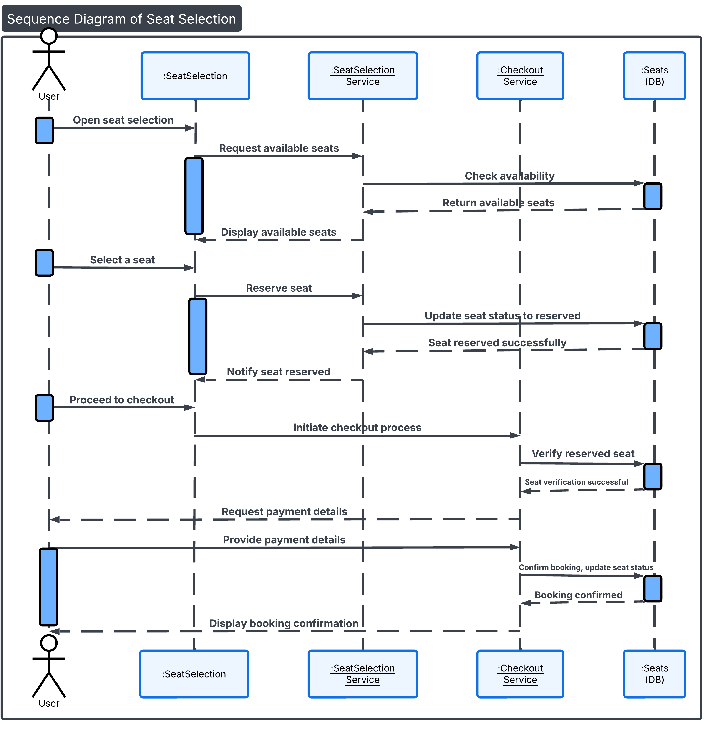

- Payment & Ticket Delivery System (Arpan Ghimire)
Payment
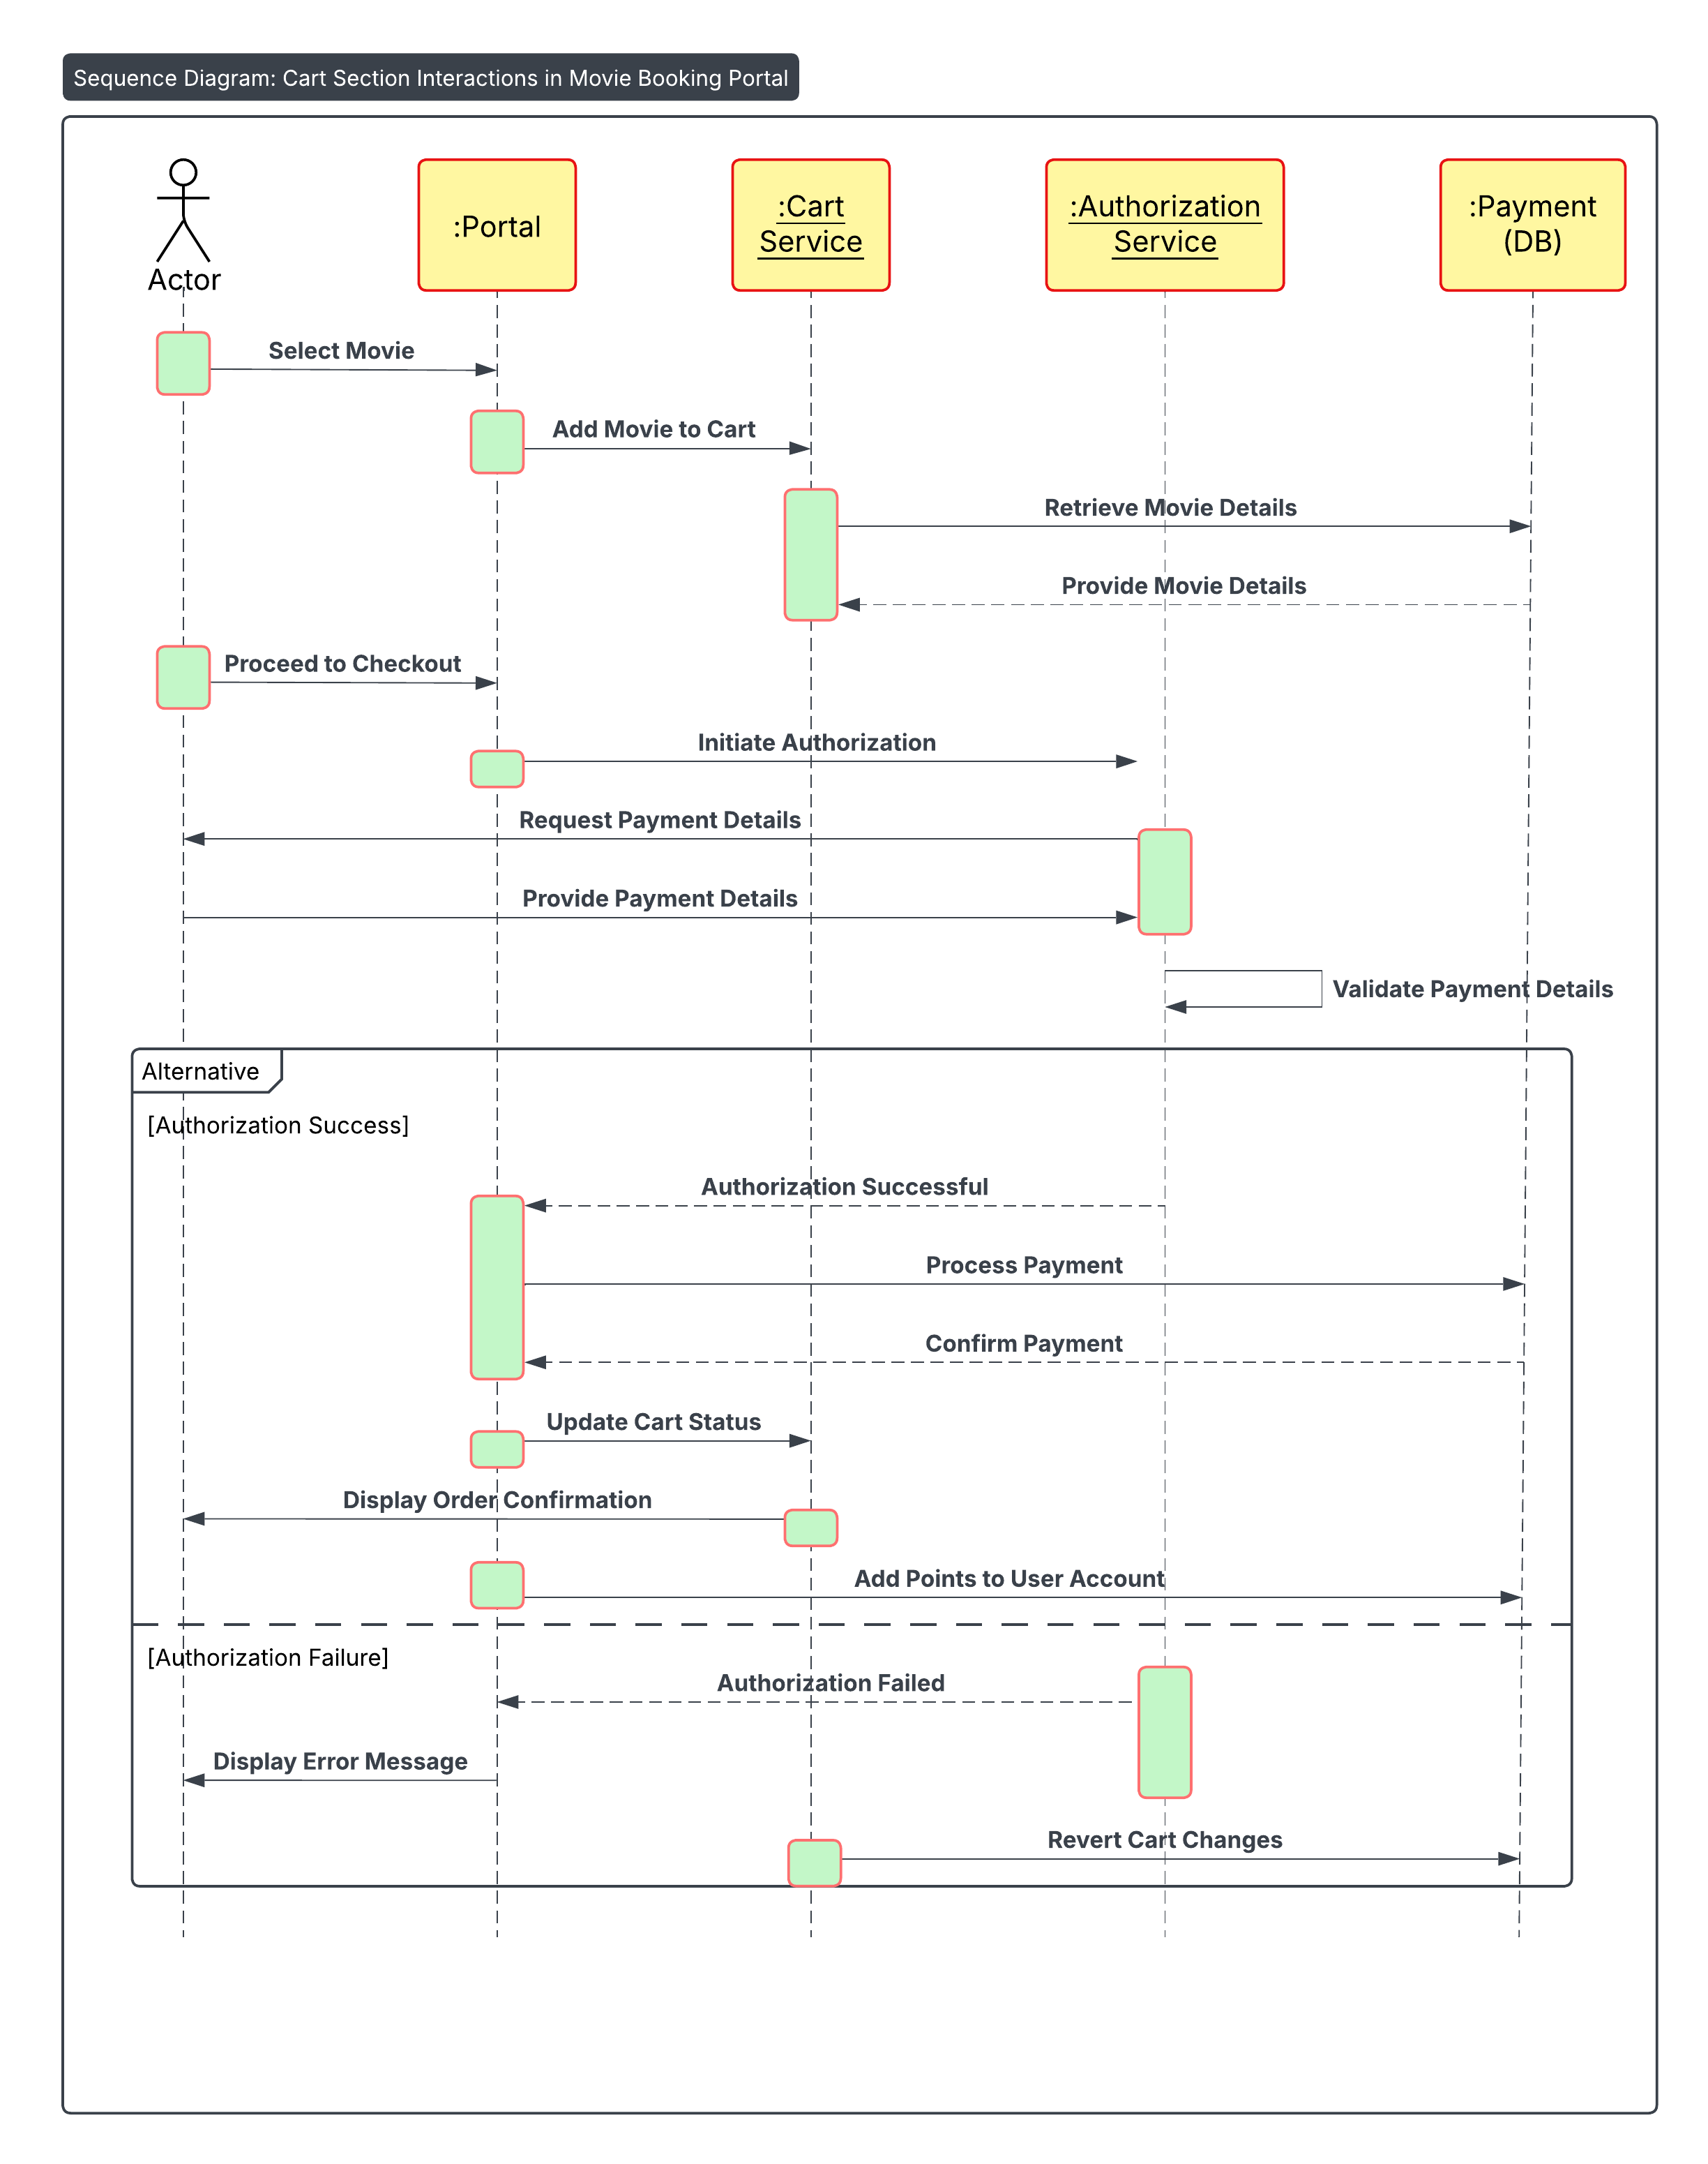

QR Ticket Generation
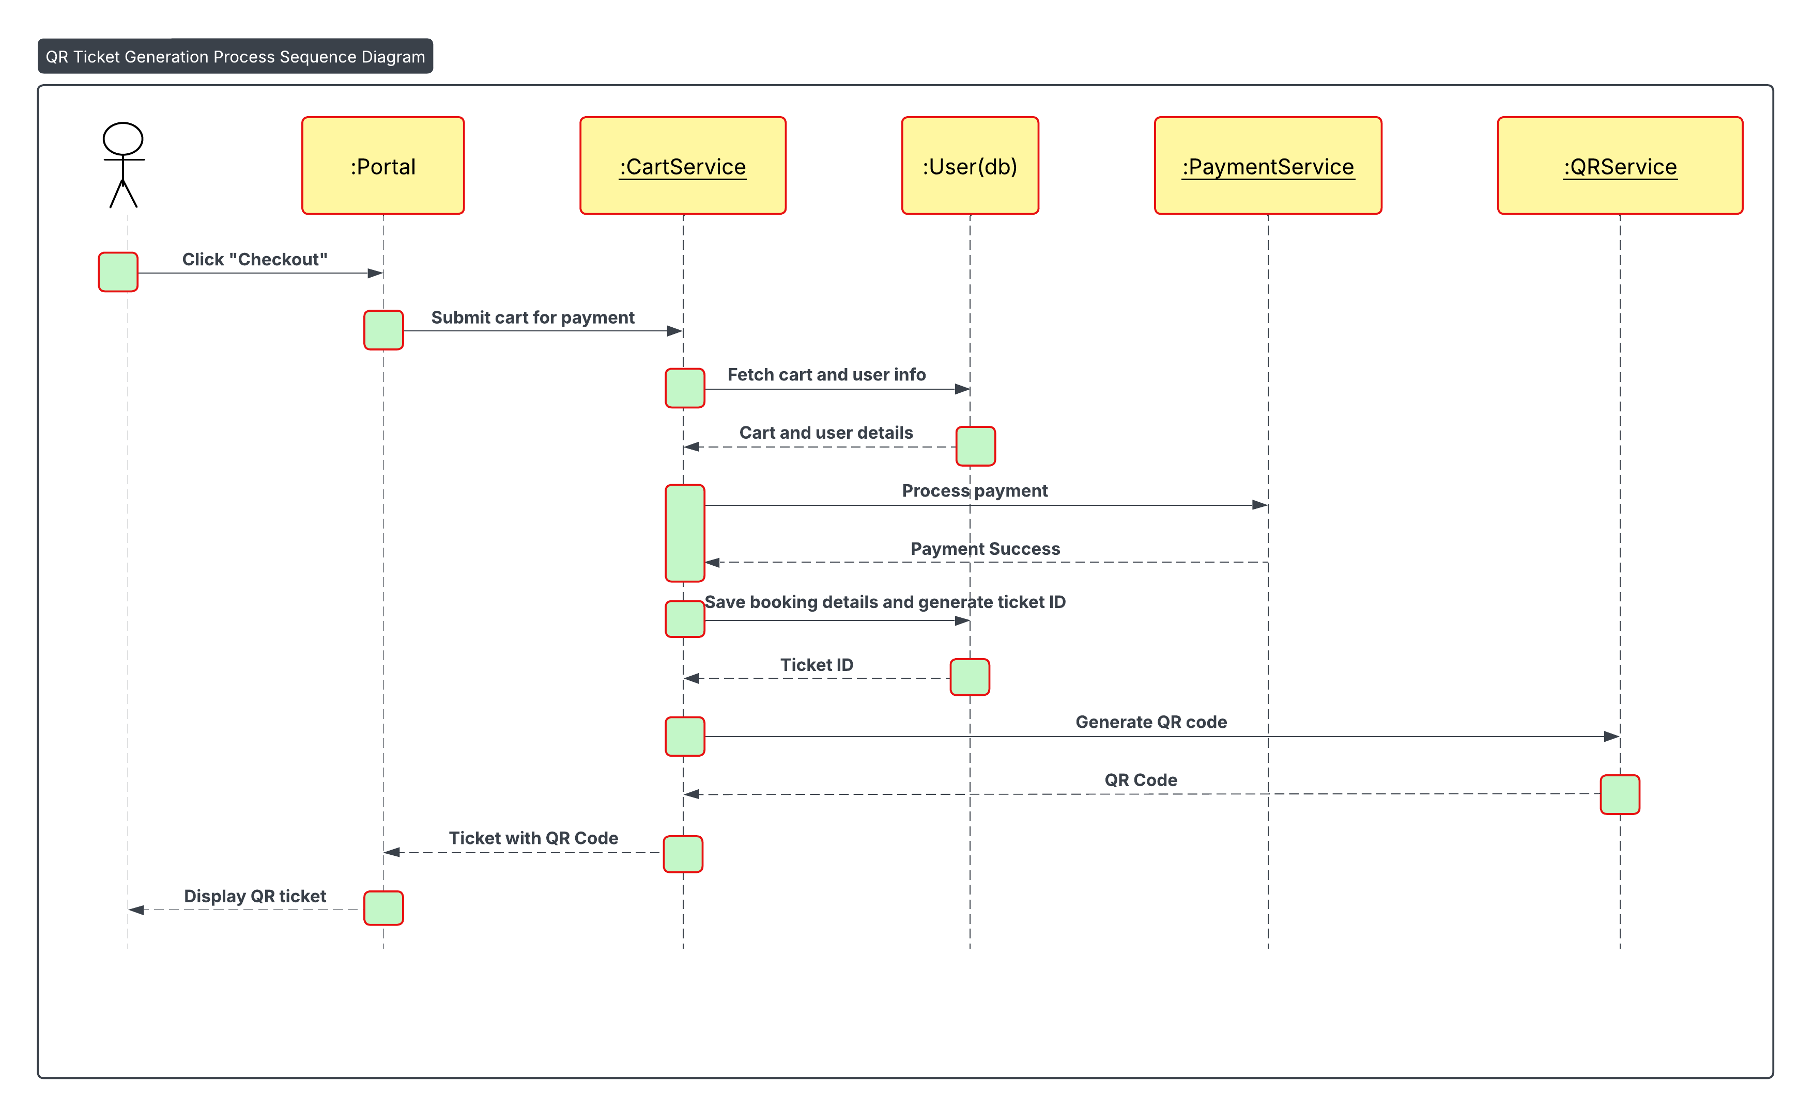

PSEUDOCODES

User Authentication, Feed and Rewards

User Registration Page (ISHA)
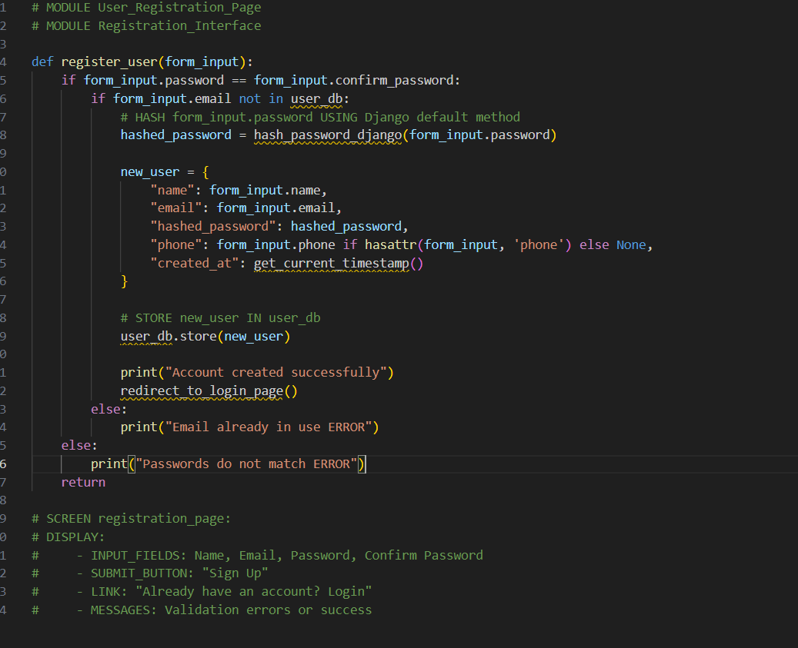
MODULE: User Login Page (ISHA)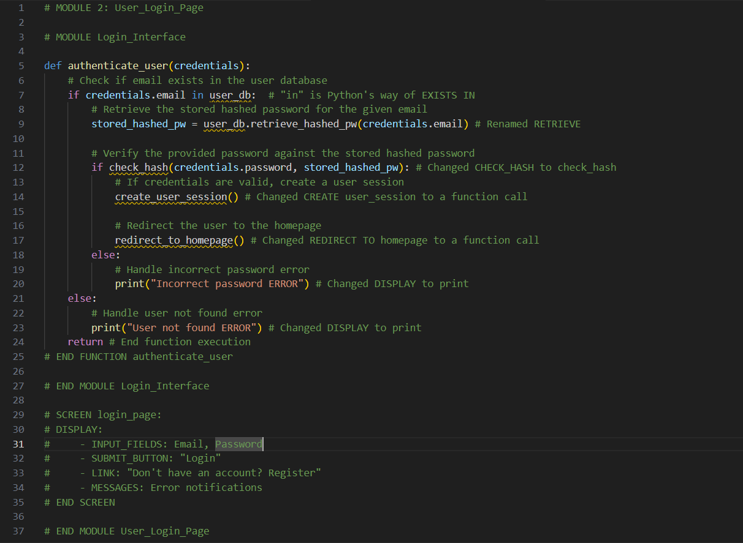

MODULE: Polling Interface (ISHA)

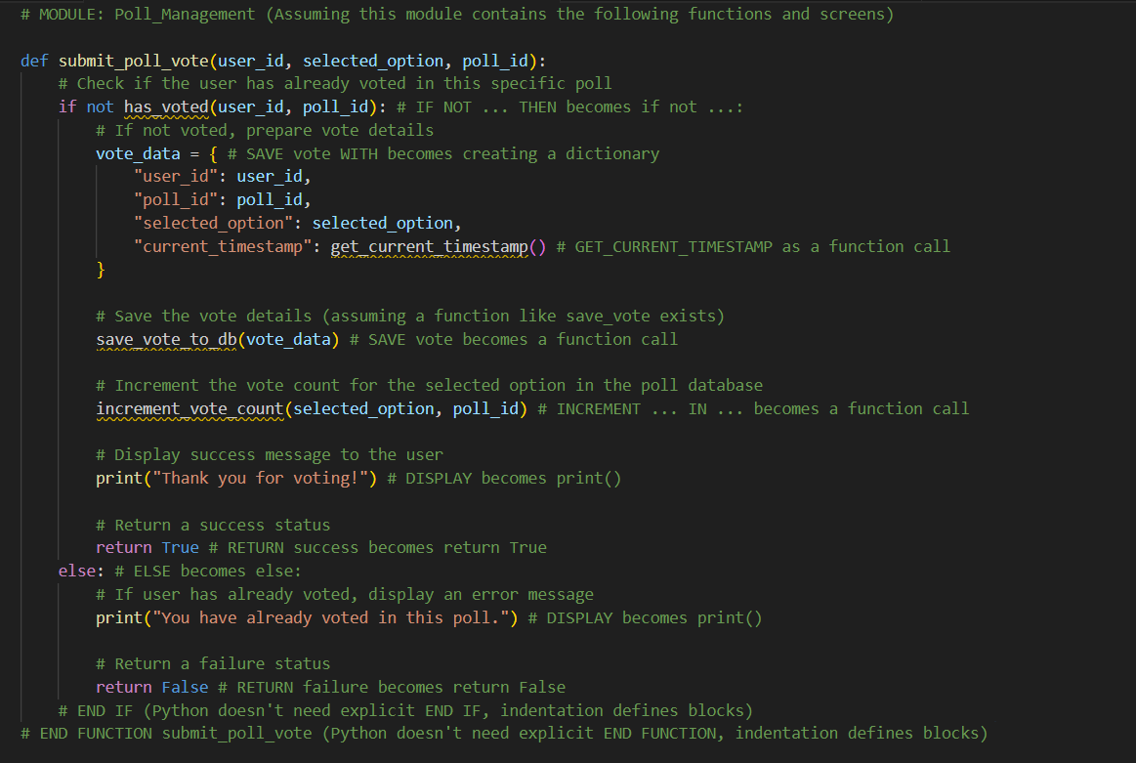
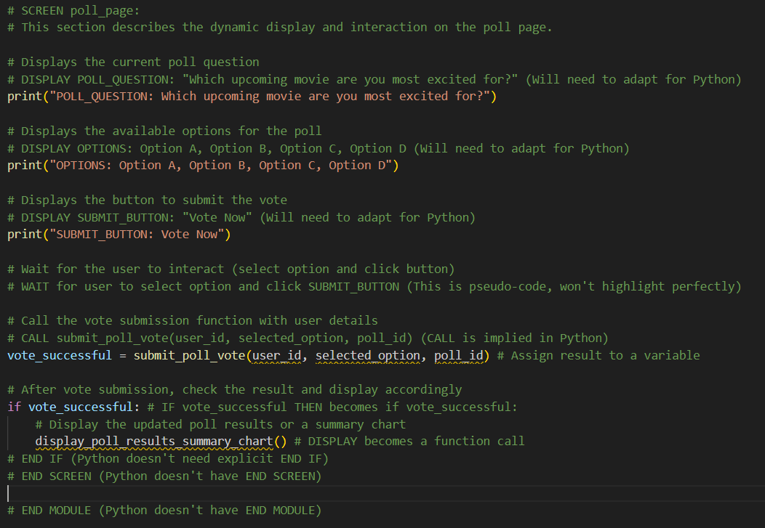
MODULE REWARD PAGE (ISHA)

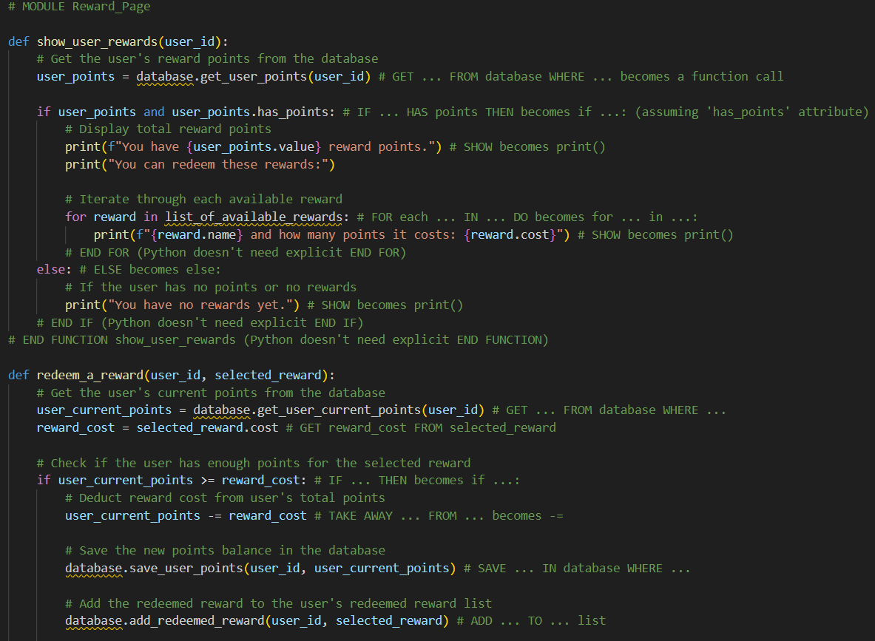

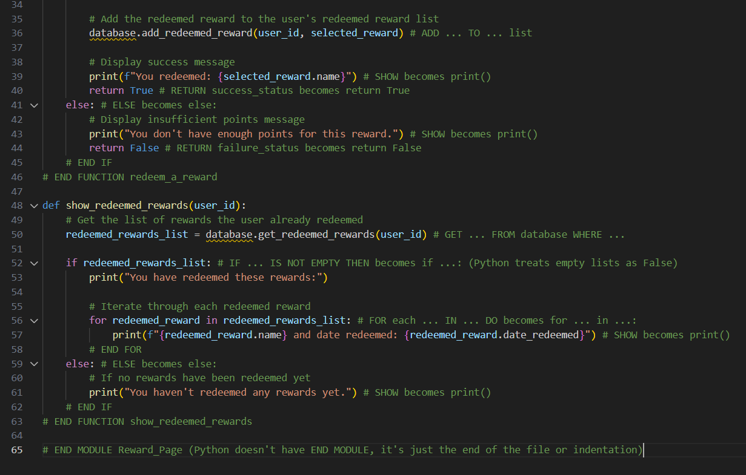

Movie HomePage (Nupjan)
Movie List (Nupjan)

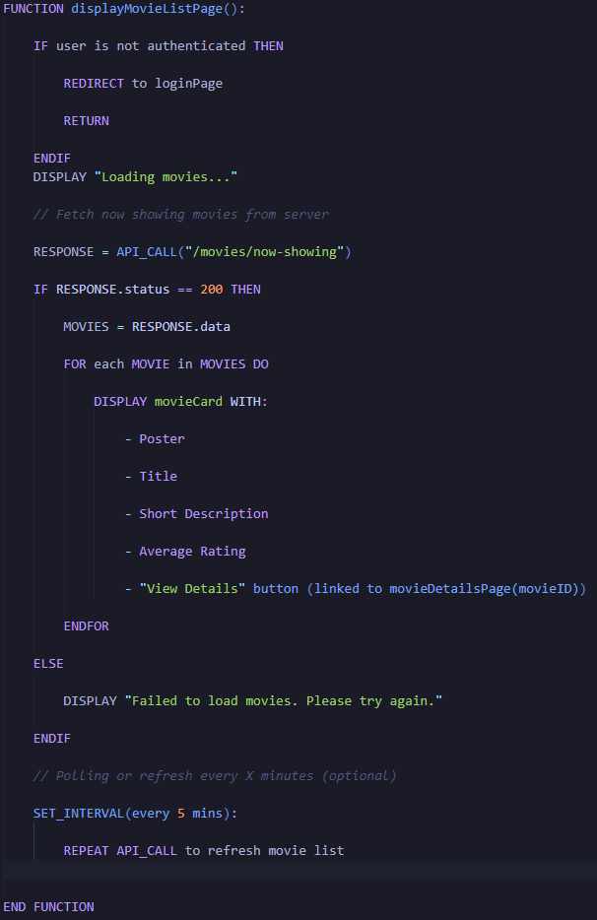

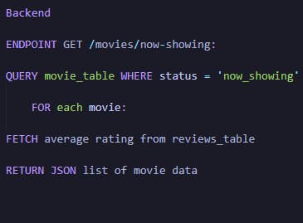

Movie Description (Nupjan)

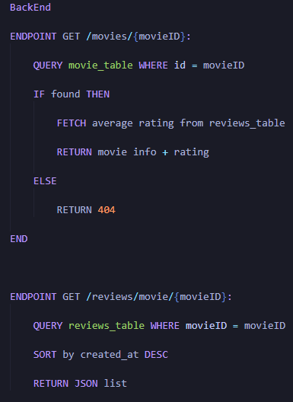
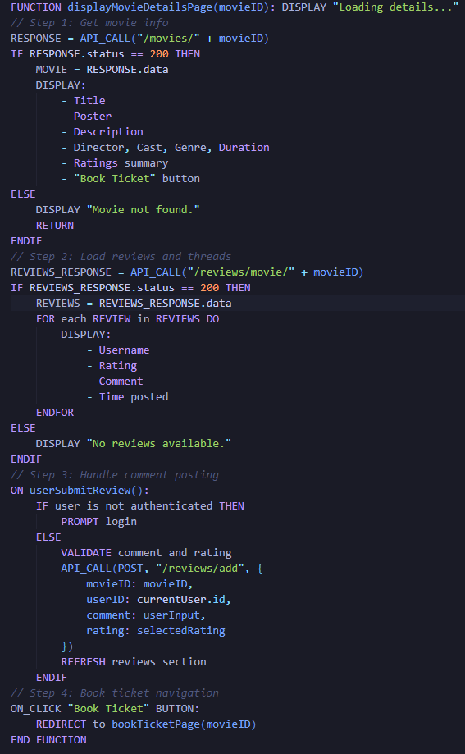

Systematic Ticket Booking System (Sulav)
Movie Show Time (Sulav)
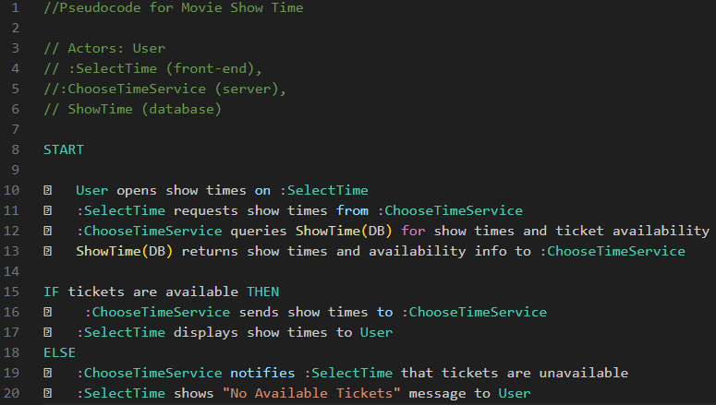

Seat Selection (Sulav)
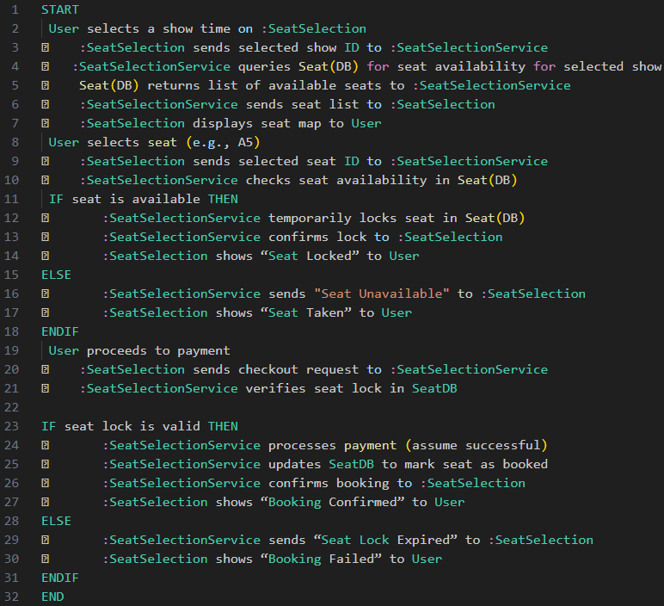

Payment and Ticket Generation Pseudocode (Arpan)
Payment Pseudocode
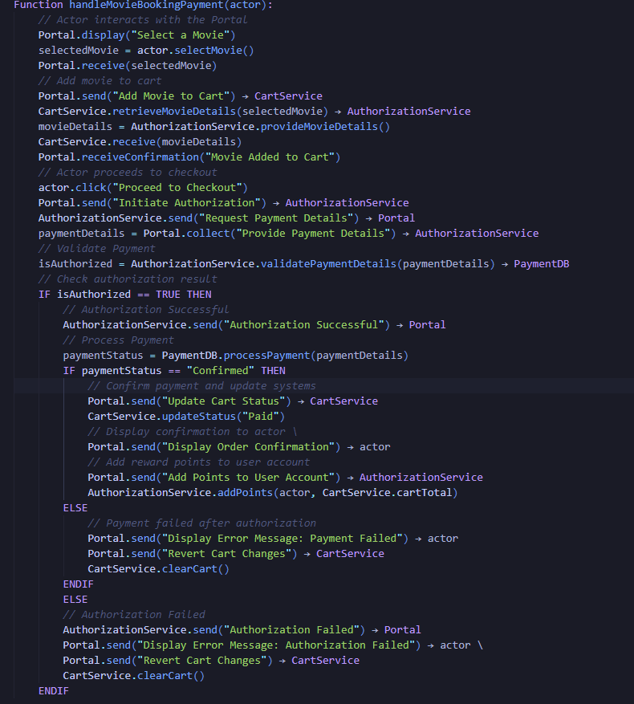

QR Ticket Pseudocode (Arpan)
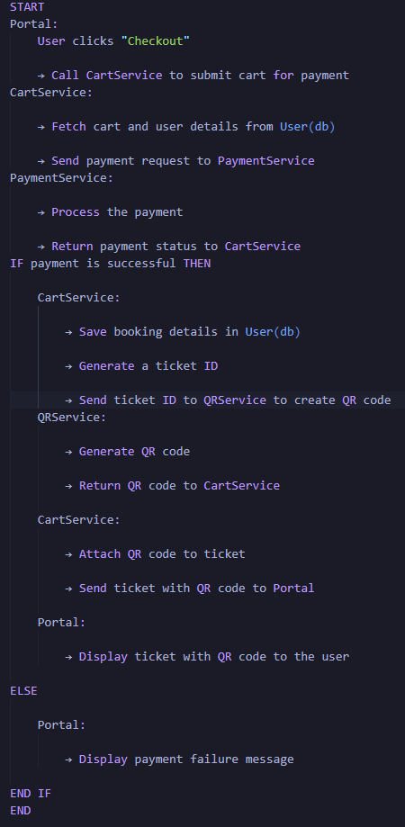

UI Design


User Authentication and Polling System
RED CURTAIN: LOGIN PAGE (ISHA)
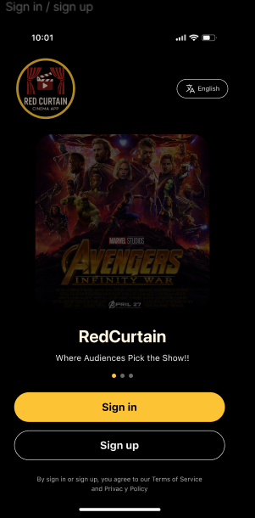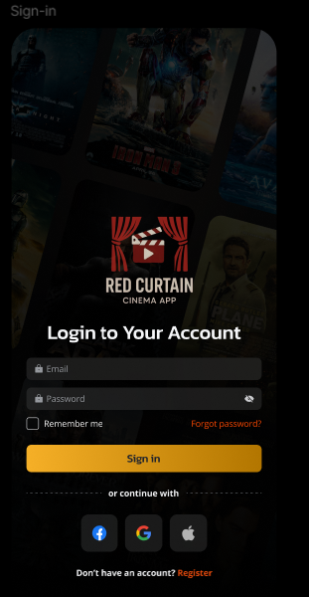
RED CURTAIN: REGISTRATION PAGE (ISHA)
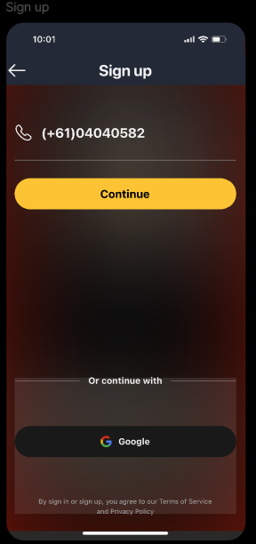

RED CURTAIN: POLLING DASHBOARD PAGE (ISHA)
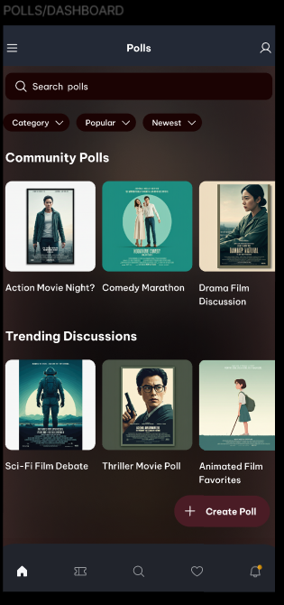 .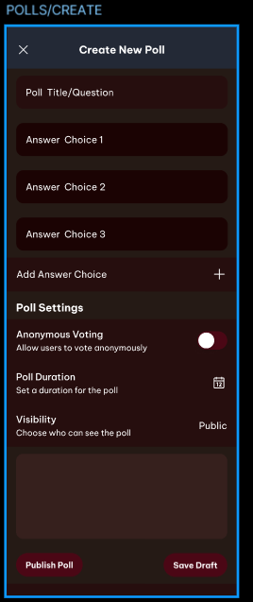

RED CURTAIN: POLL SUBMISSION & RESULT (ISHA)

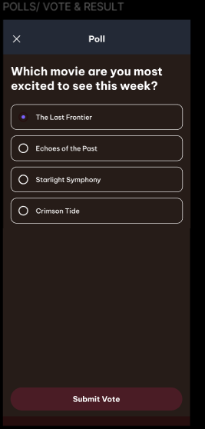

Movie list and Details (Nupjan)
Movie List page (Nupjan)
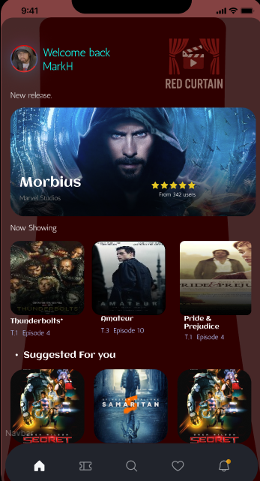

Movie Details Page (Nupjan)
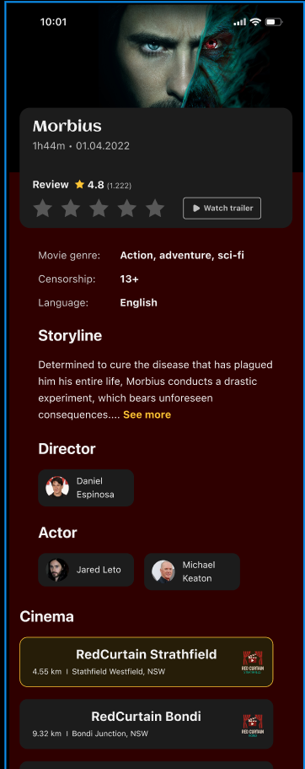

Ticket Booking System (Sulav)
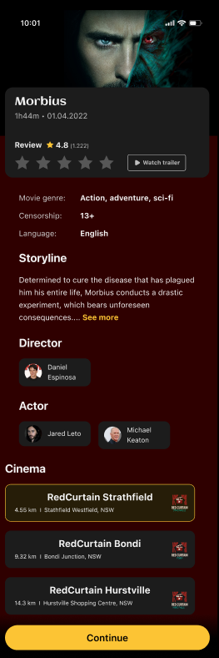
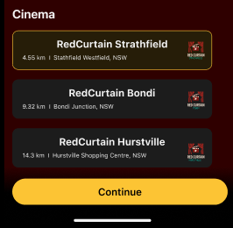

Location Selection

Movie Selection Page

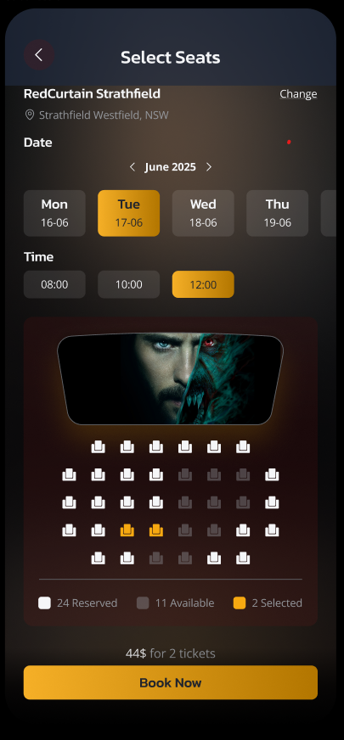

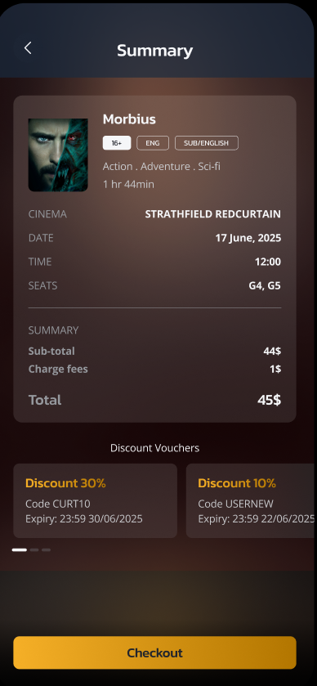

Showtime and Seat Selection page

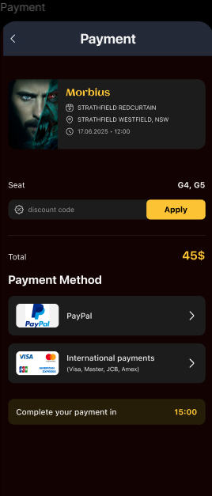
Payment, Tickets and Loyalty Rewards (Arpan)
Summary

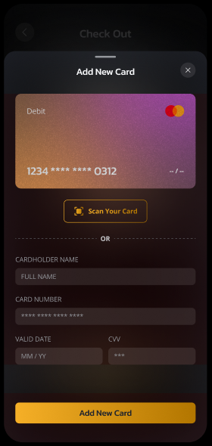

Payment

Card Checkout

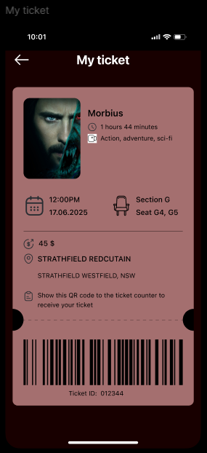

Resource Management

Introduction
Effective resource planning and management play a vital role in the execution of a successful project, so that is the case for Red Curtain. As we plan to create a system which is dynamic and user focused, we need to carefully plan and efficiently utilize our available resources to deliver a high-quality output within our designated budget and timeline.

Human Resources
RESOURCE | ROLES & JUSTIFICATION | CONTRIBUTION TO PROJECT SUCCESS
Arpan Ghimire | Handling ticket booking and payment gateways | Providing user the seamless online payment functions.
ISHA | Handling Feed page and authentication | Delivering user interface, handling polls & rewards
Sulav Silwal | Database design and seat selections | Developing a real-time booking system & enhancing user experience.
Nupjan Koirala | Designing and implementing the homepage interface | providing detailed, engaging movie information and reviews on the homepage
Mentor: Fakhra Jabeen- Provided advice, validation and assessment of progress.

Financial Resources
Resource | Roles | Contribution
Free Development Tools | Open-source platforms  (django/mysql/java etc) | It helps to develop the website fully.
Designing tools | For designing UI (Figma) | Helps in UI designing to get better ideas.
Domain name | Registering the address of the website | Redcurtain.mov

Material Resources
Resources | Roles | Contribution
Laptops | For developing and testing | To test codes run the server managing the docs
API for movie listings | Provides over-to-date movie data and showtimes. | Provide accurate, dynamic content on the platform
Testing tools | Tools to check compliance with availability norms | Tools to check compliance with availability norms  Improves usability for evey users , icing inclusivity and compliance with guidelines

Technology
- Development Tools:
  - Visual Studio Code (Web Application Development)
  - Android Studio (Mobile Application Development)
  - Kotlin
  - Python, Django, Django Frameworks
  - GitHub for shared workflow
  - MySQL (Database management)
- Frontend Tools:
  - HTML/JavaScript
  - CSS (for styling)

- Communication & Management Tools:
  - WhatsApp (Team Communication)
  - Google Meet (Team Meetings)
  - OneDrive (Documentation & file sharing)

Allocation of Resources
- The Human Resources department distributes work based on team members’ expertise. The team members maintain responsibility for their assigned modules while working together to achieve integration.
- The mentor will monitor shared budget sheets to prevent financial overruns through budget tracking.
- The team will use GitHub, OneDrive and Visual Studio's LiveShare Extension to manage shared access.
- The team will purchase any required Materials & Supplies during Weeks 1–2 to prevent development delays.

Monitoring & Evaluation:
Throughout the project, we monitor the progress of tasks by using GitHub to track the code changes and activities of each member. So, everyone will know what has been done and who is responsible. The project mentor will also evaluate the budget every month to ensure we don't go over our allocated spending. All progress reports and important papers will be stored on OneDrive so that any team member can easily find and review the most recent updates as needed.

Timeframe & WBS
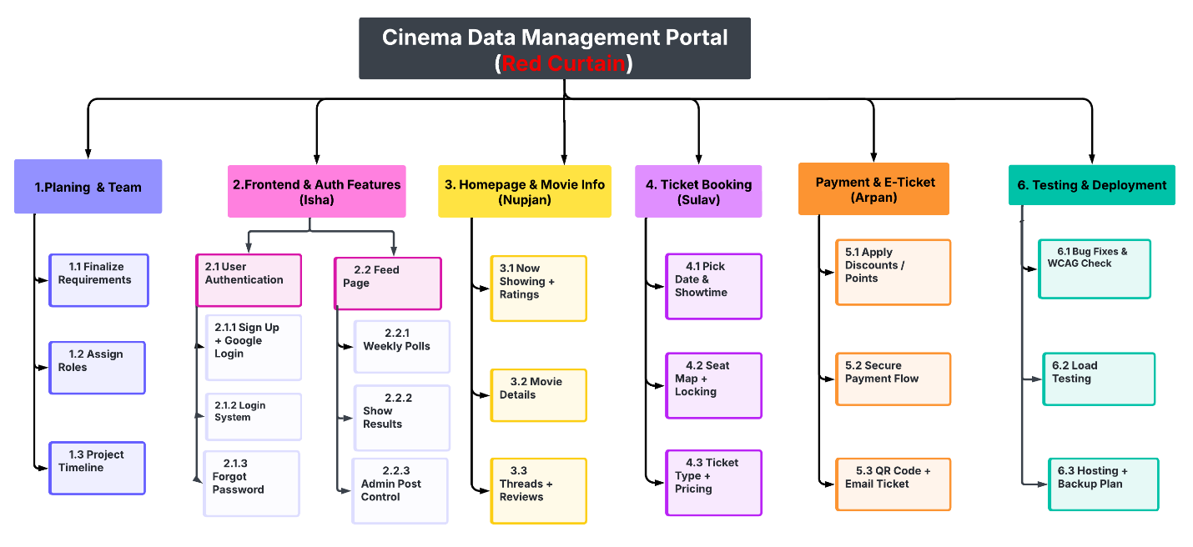
LINK FOR WORK BREAKDOWN STRUCTURE: WBS (SULAV)
- Estimated project duration: 12 weeks
TIMEFRAME | MILESTONE | DESCRIPTION
WEEK 1-3 | GATHERING & PLANNING | DEFINING SCOPE, SYSTEM REQUIREMENTS & PLANNING
WEEK 3-6 | BACKEND & FRONTEND DEV | SETTING UP BACKEND& DATABASE, IMPLEMENTATION OF FRONTEND ETC.
WEEK 7-8 | INTEGRATION & TESTING | RESOLVING BUGS AND TESTING THE FUNCTIONS
WEEK 9-10 | UI & SECURITY REFINEMENT | IMPROVING DESIGN & WORKING ON SECURITY LIKE HASHING VALIDATION ETC.
WEEK 11-12 | DEPLOYMENT, FEEDBACK & FINAL DOCUMENTATION | WE WILL BE DEPLOY THE SYSTEM AND COLLECT THE FEEDBACK TO SUBMIT THE FINAL DOCUMENTATIONS

Materials Procurement: Any software or APIs required will be researched and acquired in the early stages (Weeks 1–2) to prevent development delays.

Timeline
To make sure that we are proficiently utilizing our resources throughout the project, we created a Gantt chart for proper and clear visualizations. The chart will also display the days required to accomplish each task.
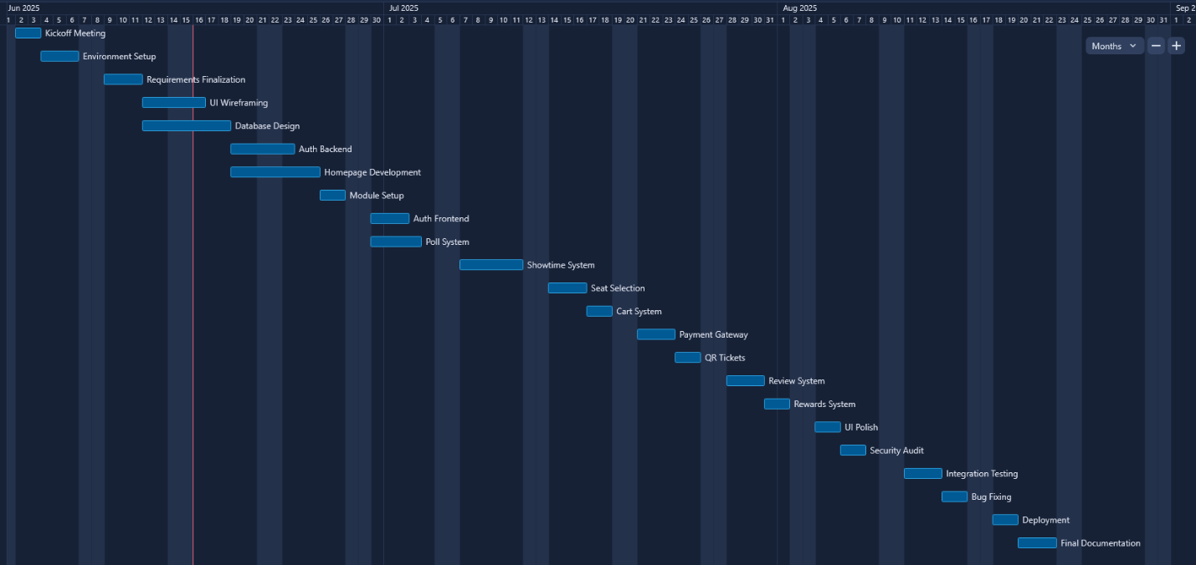
Link for the Gantt chart: RedCurtain_Gantt.xlsx

Risk management plan

ISHA
ID | Risks | Category | Likelihood | Impact | Mitigation | Owner
R01 | If a user forgot the password, it could cause a login error. | Technical | Moderate | User may abandon login due to frustration | Implementing the feature- “Forgot Password” | ISHA
R02 | Security Breach | Security | Moderate | Unauthorized access & compromising user data | Hash passwords using bcrypt, pass strength & keep track of monthly login attempts. | ISHA
R03 | Server downtime | Technical | Low | Impact on user experience as it led to temporary loss of access. | Monitoring on time, like implementing an auto alert system for downtime and log server health metrics weekly. | ISHA
R04 | Poll fake voting | Technical | Moderate | Unfair poll results | Implementing CAPTCHA & one vote per account and monitoring voting patterns. | ISHA
R05 | Reward system abused by point repetition | Security | Moderate | Decreased Trust in the System | Set redemption limits, track user reward activity, and enforce cooldown periods | ISHA

Nupjan
ID | Risk Description | Category | Likelihood | Impact | Mitigation Strategy | Owner
R06 | Homepage loads slowly on mobile or poor networks | Performance | High | Medium | Use image compression, CDN, and lazy loading for performance optimization | NUPJAN
R07 | Homepage layout confuses or overwhelms users | UX | Medium | Medium | Run usability testing and simplify layout based on feedback | NUPJAN
R08 | Movie API becomes unavailable or rate-limited | Technical | Medium | High | Cache movie data locally and prepare a fallback dataset | Nupjan
R09 | Reviews/discussions contain spam, offensive content | Social | Low | Medium | Add moderation/reporting tools and automatic filters for profanity/spam | Nupjan
R05 | Movie data (synopsis, ratings) becomes outdated | Data | Medium | Low | Refresh movie API daily and log/update missing  data | Nupjan

Sulav
ID | Risk Description | Category | Likelihood | Impact | Mitigation Strategy | Owner
R11 | Two users select the same seat at the same time | Technical | High | High | Use database locking (SELECT FOR UPDATE) during seat selection | Sulav
R12 | Pricing logic miscalculates total | Technical | Medium | Medium | Validate ticket types and unit test pricing formula | Sulav
R13 | Showtime appears in incorrect timezone | Technical | Low | Medium | Standardize time format using UTC and convert in frontend | Sulav
R14 | Seat map isn’t accessible to keyboard/screen readers | Accessibility | Medium | Medium | Implement WCAG-compliant interactive map | Sulav
R15 | Booking is abandoned due to delay or errors | UX | Medium | Medium | Show real-time seat availability and clear UI indicators | Sulav

Arpan
ID | Risk Description | Category | Likelihood | Impact | Mitigation Strategy | Owner
R16 | Payment gateway is unavailable or fails during transaction | Technical | Medium | High | Integrate backup gateway and implement retry queue | Arpan
R17 | QR ticket fails to generate or scan correctly | Technical | Low | High | Use high-error-correction QR format and cross-device compatibility testing | Arpan
R18 | Payment goes through but ticket is not created | Technical | Medium | High | Wrap payment and ticketing in an atomic DB transaction | Arpan
R19 | Promo codes or loyalty points are abused | Security | Medium | Medium | Enforce code limits, track usage, and bind points to account validity | Arpan
R20 | User session expires during checkout | Technical | Medium | Medium | Auto-refresh tokens or save cart until login restored | Arpan

ER Diagram
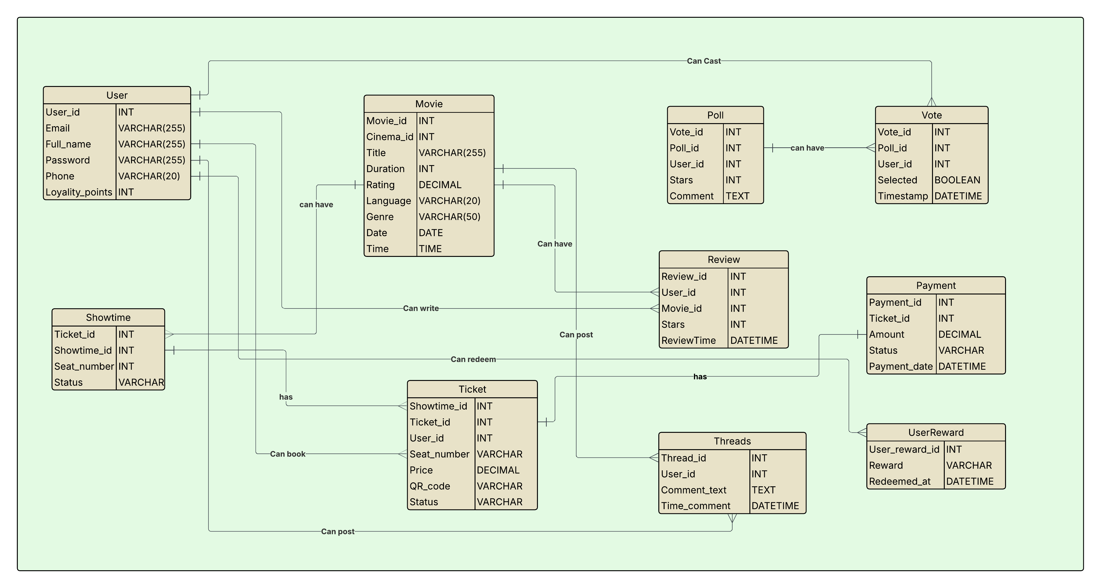
Link to ER diagram: https://lucid.app/lucidchart/43a9be1b-026a-43de-ae6d-63be2cd3e97f/edit?invitationId=inv_f15cabc7-460b-47de-b8c8-97ad68219834

Components of ER diagram
Entity 1 | Relationship | Entity 2 | Connectivity
User | can book | Ticket | One-to-Many
User | can post | Threads | One-to-Many
User | can write | Review | One-to-Many
User | can cast | Vote | One-to-Many
User | can have | UserReward | One-to-Many
Movie | can have | Review | One-to-Many
Movie | can have | Poll | One-to-Many
Poll | can have | Vote | One-to-Many
Ticket | can redeem | Payment | One-to-One
Showtime | has | Ticket | One-to-Many
Ticket | has | Showtime | Many-to-One
Ticket | has | Payment | One-to-One
Ticket | can have | QR_code | One-to-One
Threads | belongs to | User | Many-to-One

Conclusion:
The Red Curtain cinema management platform redefines movie-going by prioritizing user empowerment, social engagement, and seamless technology. Through features like dynamic polling, cross-chain loyalty rewards, real-time seat booking, and interactive discussions, the platform bridges gaps in the traditional cinema experience while addressing modern demands for flexibility and community.
With a structured development approach, clear division of roles among team members, and robust risk mitigation strategies, Red Curtain is poised to deliver a secure, accessible, and engaging solution for Australian audiences. By combining innovative design with reliable backend systems, the project sets a new standard for cinema platforms—transforming passive viewers into active participants.
As we move toward deployment, Red Curtain remains committed to iterating based on user feedback, ensuring the platform evolves alongside its audience. The future of cinema is collaborative, and Red Curtain is leading the curtain call.

References
Burgess Rawson. (2025, March 2). Why cinemas are attracting investor interest. Commo. https://www.commo.com.au/news/2025/03/02/why-cinemas-are-attracting-investor-interest-%E2%80%93-burgess-rawson/1740872022Commo+69854
/.gtynhjmk,
Cooke, J. (2025, April). Cinemas in Australia. IBISWorld. https://www.ibisworld.com/australia/industry/cinemas/636/
Daily Telegraph. (2025, May 23). 'How is this garbage legal?': Aussies think fees have gone too far. https://www.dailytelegraph.com.au/lifestyle/how-is-this-garbage-legal-aussies-think-fees-have-gone-too-far/news-story/9ea89cb11d5859f42b0f004f7134ab00dailytelegraph
Lucid Software, Inc. (2023). Lucidchart [Online diagramming software]. https://www.lucidchart.com
PubNub. (2025, February 15). Live audience polling system. https://www.pubnub.com/blog/live-audience-polling-system/
PubNub. (n.d.). Live audience engagement. https://www.pubnub.com/solutions/live-audience-engagement/
SmartCompany. (n.d.). How demand-based ticket pricing is set to change the way people go to the cinema. https://www.smartcompany.com.au/marketing/demand-based-ticket-pricing-set-change-way-people-go-cinema/SmartCompany
Screen Australia. (n.d.). Screens and theatres – By exhibitor. https://www.screenaustralia.gov.au/fact-finders/cinema/industry-trends/screens-and-theatres/by-exhibitorScreen Australia+1Screen Australia+1
Taylor Wells. (2024, September 2). Cinema movie ticket prices – Testing a dynamic approach. https://taylorwells.com.au/cinema-movie-ticket-prices/Pricing Jobsq

