Covid Precautions Detector

Prachi Agarwal, Deepankur Singh, Palak Goel, Nupur Gupta, Palak Rastogi

Deptt. of Computer Science & Engineering, MIT, Moradabad (U.P.), India.

[reachprachi@gmail.com](mailto:reachprachi@gmail.com)

Deptt. of Computer Science & Engineering, MIT, Moradabad (U.P.), India.

<deepankur1singh@gmail.com>

Deptt. of Computer Science & Engineering, MIT, Moradabad (U.P.), India.

<gpalak7055@gmail.com>

Deptt. of Computer Science & Engineering, MIT, Moradabad (U.P.), India.

<nupurgupta616@gmail.com>

Deptt. of Computer Science & Engineering, MIT, Moradabad (U.P.), India.

<palakrstg10@gmail.com>

Abstract

As, we are facing this pandemic situation of Covid-19 which make us to take some precautions always like wearing Mask, sanitize our hands and keep some distance. But, nowadays, as the country has started to unlock amid surging COVID-19 cases, maintaining social distancing has become a key issue. It creates a major obstacle that how to monetize the meeting places, whether people wearing ‘mask’ or not.

So here our team takes a little initiative against this. We are preparing a system that keep an eye on the public place (i.e. College, Banks, Marts etc.) and search for a person not wearing mask and also check whether he/she is maintaining social distancing or not. And this is being done in a very efficient way. It will make task easier to check whether the person is wearing the mask or not. So, it can help in stopping the spread of ‘Corona Virus’.

Keywords

Face mask, Social distancing, Python, OpenCV, Tenserflow

1. Introduction

Social Distancing — the term that has taken the whole world by storm and is transforming the way we live. Social distancing also called “physical distancing”, means keeping a safe space between yourself and other people. As the country has started to unlock amid surging COVID-19 cases, maintaining social distancing has become a key issue. The biggest concern revolving around the COVID-19 situation is how quickly the infection spreads from one person to another through contact or even being within proximity of an infected person. Social Distancing is here to stay longer than expected to fight Covid-19.

So, this what our team thinking to develop a model that detect if people are following social distancing and at the same time are wearing masks or not.

As we know the face mask is another key solution in prevention of this virus. So, our initiation is to take crowd under the eye that monitor whether person follow the precautions or not.

On the norms given by WHO that gives information about How to protect yourself and others from COVID-19.

* Maintain at least a 2 feet distance between yourself and others to reduce your risk of infection when they cough, sneeze or speak. Maintain an even greater distance between yourself and others when indoors. The further away, the better.
* Make wearing a mask a normal part of being around other people. [1]

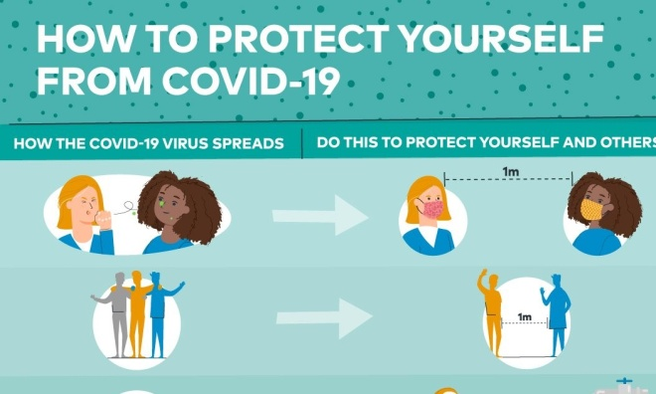

Figure1. Precautions by WHO

This can achieve in following steps:

Firstly, we read data, consisting all photographs of mask wearing person or not. We just go throw it and reach out all the outliers if exists.

Then we train it with the help of some machine learning algorithms. Now, we test and implement our efforts in real world.

So here is a sample of the outcome of the model:

Red bounding boxes indicate that the Person is in the proximity of another person so it will generate a message as “Alert” and the Green bounding box indicates the person is wearing masks and maintain social distancing. [2]

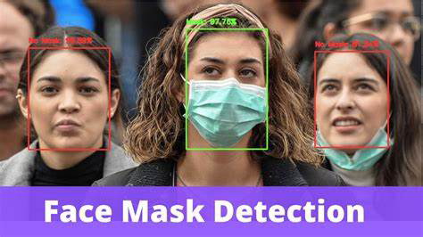

Figure2. Mask Detection

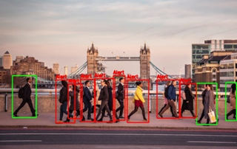

Figure3. Social Distancing

2. Problem Statement

The aim to creating a COVID PRECAUTIONS DETECTOR is to differentiate whether person wearing mask or not and follow 2 feet distance or not. This will judge the real-world data and compare with pre-trained data, on the basis of trained data it will recognize whether crowd follow precautions or not.

Our project is trained and tested over the real data set and work over real data set capture by the camera. Basically a ML based project that is working over real-time dataset.

3. Proposed Methodology

We have problem related to real-time data set and it needs facial recognition / image processing for detecting does mask wear properly or not. So here we use OpenCV and Tensorflow for our project.

The various machine learning algorithms that can be applied to trained data and return a result with a great accuracy. Here we use TensorFlow that is an end-to-end open source platform for machine learning. And use another library i.e. OpenCV for reading the images and real-world data for testing and training of model. [6]

To accomplish this task we utilized the triangle similarity, which requires us to know two important parameters prior to applying our algorithm:

1. The width (or height) in some distance measure, such as inches or meters, of the object we are using as a marker.
2. The distance of the camera to the marker in step 1.

Computer vision and image processing algorithms can then be used to automatically determine the perceived width/height of the object in pixels and complete the triangle similarity and give us our focal length. [4]

In regards of Facial detection having mask or not we have follow these steps:

Step: 1

Firstly, we read data, consisting all photographs of mask wearing person. We just go throw it and reach out all the outliers if exists.

Step: 2

Then we train it with the help of some machine learning algorithms

Step: 3

Now, we test and implement our efforts in real world.

Here the flowchart for module. [7]

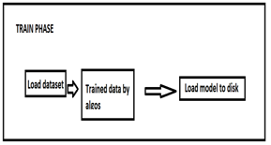

Figure4. Flow chart for training data

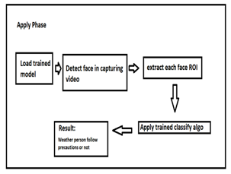

Figure5. Flow chart for testing and implementation of Model

4. Simulated Result and Discussion

In our project we have designed two modules. Both are working on same dataset as to judge the precautions are followed by the people or not. Whole project work over python and ML algorithms.

First module will judge the person having mask on their face or not. Mask should be on mouth and covering the nose too otherwise it will return that person as suspect.

While, Second module will detect the distance of 2 feet minimum as system catches more than 2 feet, it will return same thing as suspect. And give a warning to follow the precautions seriously.

It will return red box over the suspect and green box over the person who follow the precautions.[8]

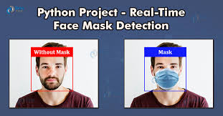

Figure7. Mask detection

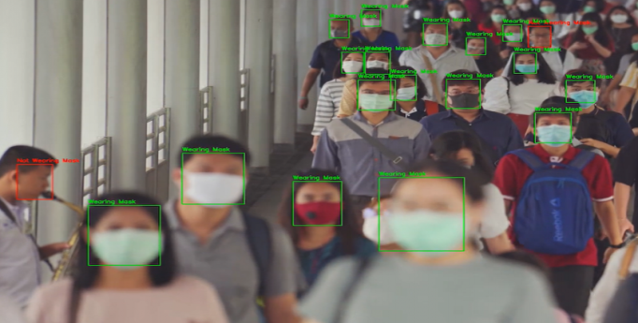

Figure8. Crowded area

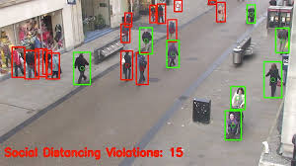

Figure9. Distance capturing by camera

5. CONCLUSION

As this pandemic, is become part of our life and we have to live with it. Here we are supposing to give a small support that lead to provide an ease in keeping an eye over the crowd and public places. This project will judge the suspect easily and gives the result efficiently. It is helpful in judging all the parameters like distance between the objects (persons) and face of a person (“mask covering part”) as show in figure:[8]

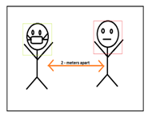

Figure10. Output review

6. FUTURE DIRECTION

Here we are proposing a detector that detects the mask on their face and distance of at least 2 feet between two people.

It can be enhance and be advance by adding some more features like not just by detecting it can recognize that particular person too by personality detector and AI frameworks.

This project implements by using the machine learning techniques but it can be implemented using another techniques like deep learning, CNN.

7. REFRENCES

[1] World Health Organization. <https://tinyurl.com/vr9owsn>

[2] Face Mask Against Covid-19: An Evidence Review.

[3] WC on the Ethics of Scientific Knowledge, Technical, The precautionary principle (2005)

[4] By Adrian Rosebrock , Distance marker OpenCV,pyimagesearch.com(2015).

[5] Social distancing and mask detector using TensorFlow, <towardsdatascience.com>

[6] Kaggel.com <https://www.kaggle.com/mirzamujtaba/face-mask-detection>

[7] My Great Learning Blogs <https://tinyurl.com/y5r9qykx>

[8] Facemask | google.com <https://tinyurl.com/y542qcdq>

[9] <https://tinyurl.com/y542qcdq>