# **Session 14: SCALA BASICS - 1**

# **Assignment 1**

**Problem Statement:**

**Task 1**

**Given a list of strings - List[String] (“alpha”, “gamma”, “omega”, “zeta”, “beta”)**

**- Find count of all strings with length 4.**

**Solution:**

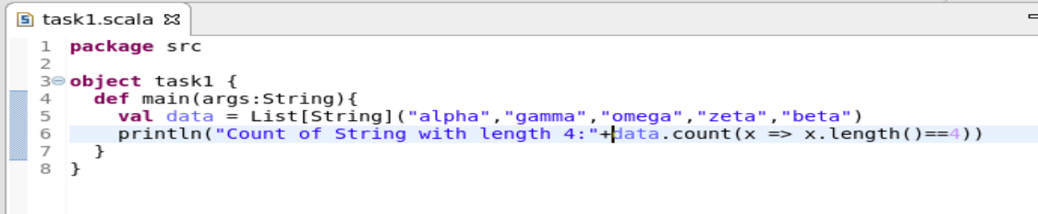

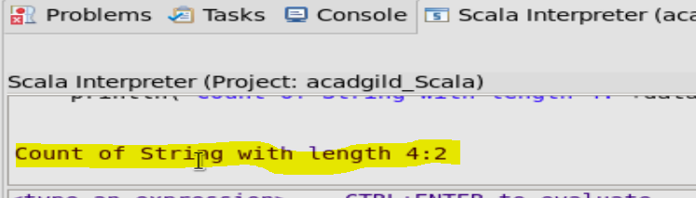

**- Convert the list of string to a list of integers, where each string is mapped to its**

**corresponding length.**

**Solution:**

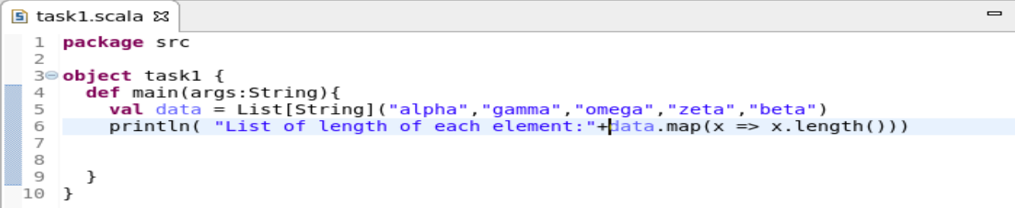

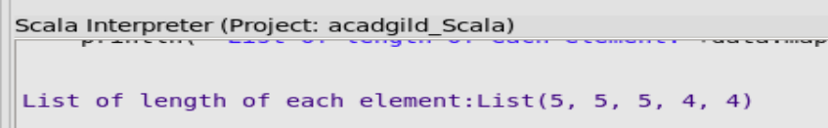

**- Find count of all strings which contain alphabet ‘m’.**

**Solution:**

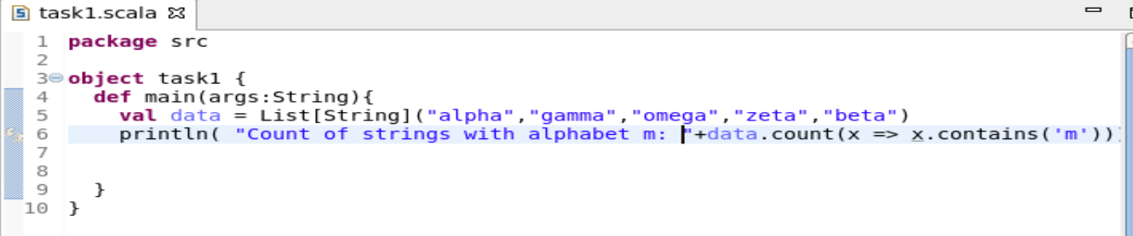

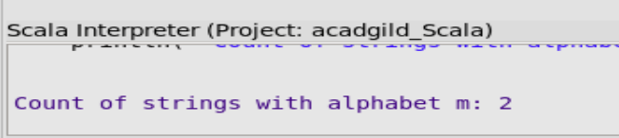

**- Find the count of all strings which start with the alphabet ‘a’.**

**Solution:**

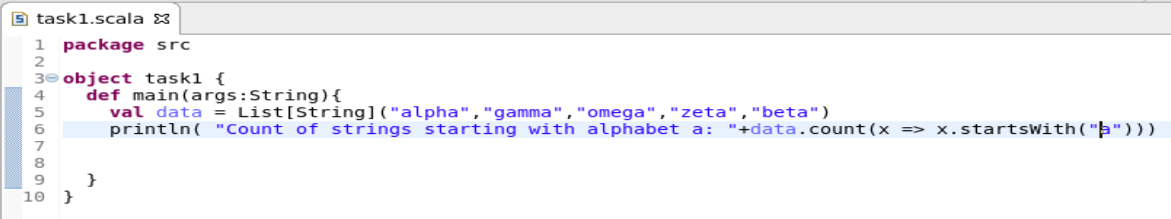

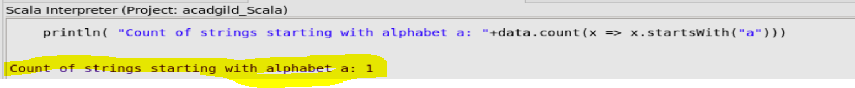

**Task 2:**

**- Create a list of tuples, where the 1st element of the tuple is an int and the second**

**element is a string.**

**Example - ((1, ‘alpha’), (2, ‘beta’), (3, ‘gamma’), (4, ‘zeta’), (5, ‘omega’))**

**- For the above list, print the numbers where the corresponding string length is 4.**

**- find the average of all numbers, where the corresponding string contains alphabet ‘m’or alphabet ‘z’.**

**Solution:**