# **Session 2: BIG DATA & HADOOP –INTRODUCTION & CASE STUDIES**

## **Assignment 2**

**Task 1:**

* Check whether /user/acadgild directory exists or not in the HDFS.

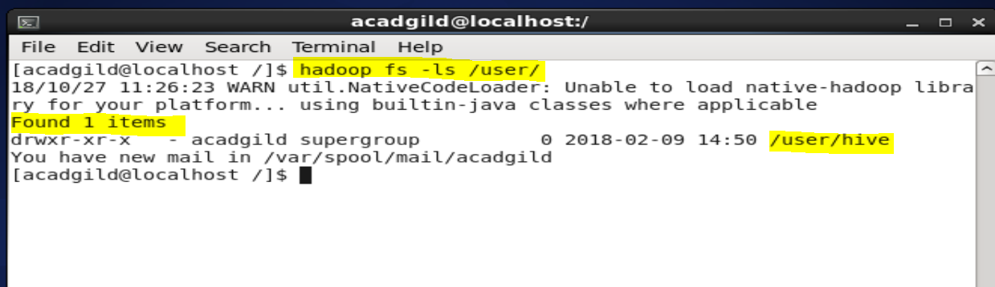

* Create a directory /user/acadgild/hadoop.

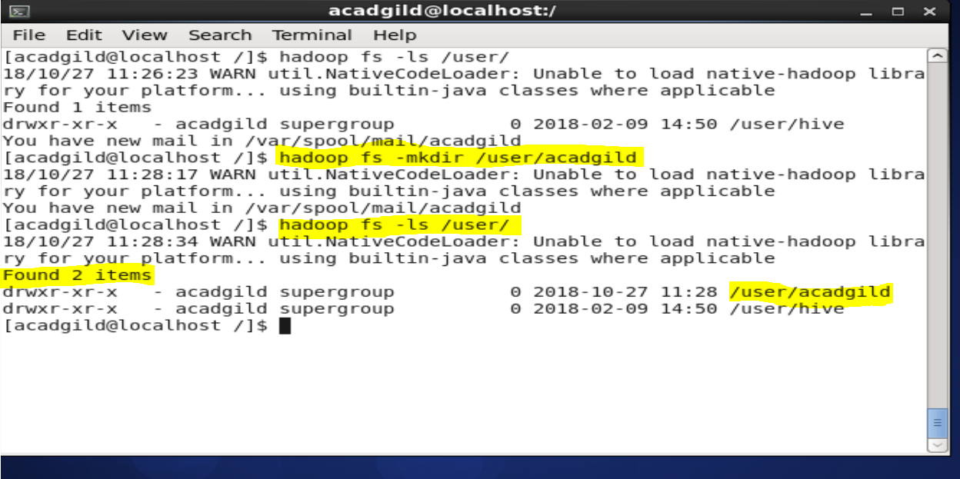

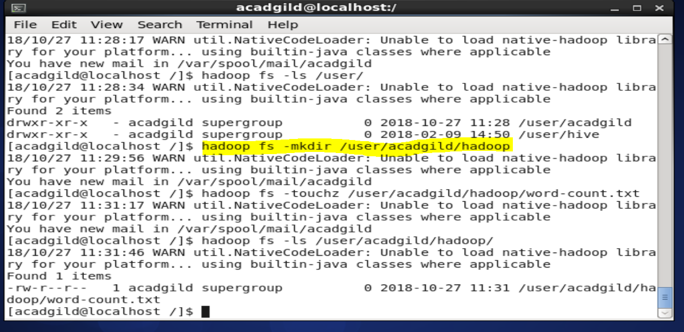

**Task 2:**

* Create a file in HDFS under directory /user/acadgild/hadoop, with name word-count.txt.

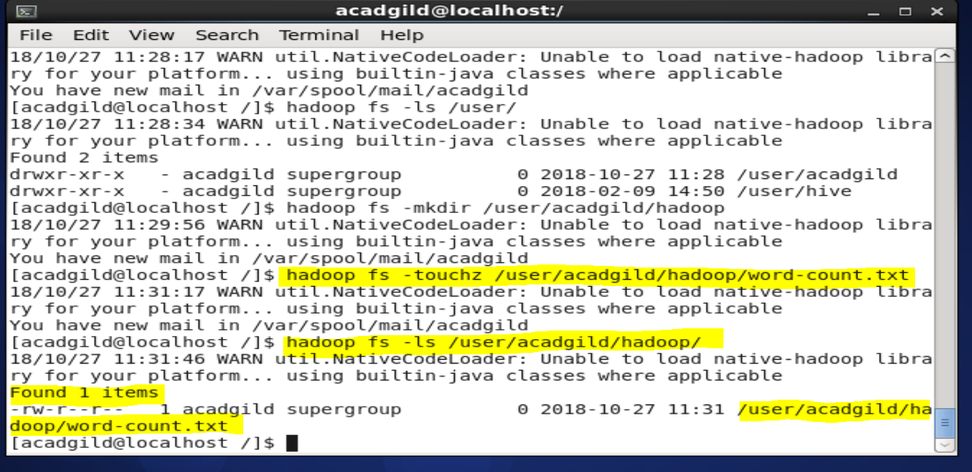

* Whatever we type on screen should get appended to the file

Use the **‘’appendToFile”** command to enter text in the file as shown below:

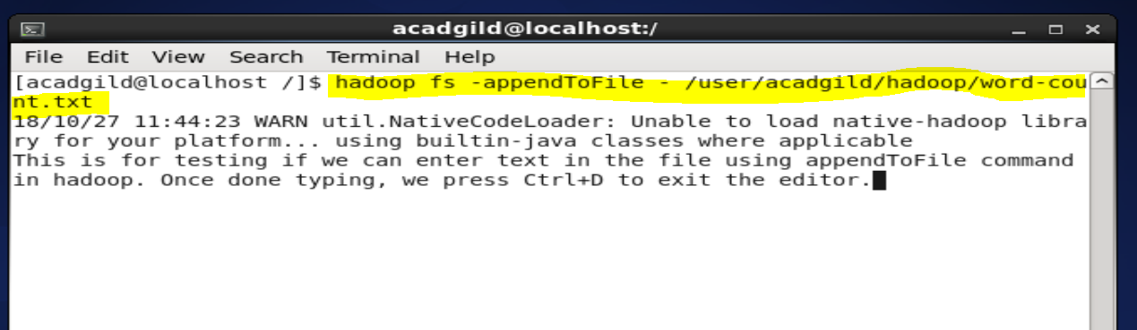

Then, we use “**cat”** command to see if the text we typed has been added to the file:

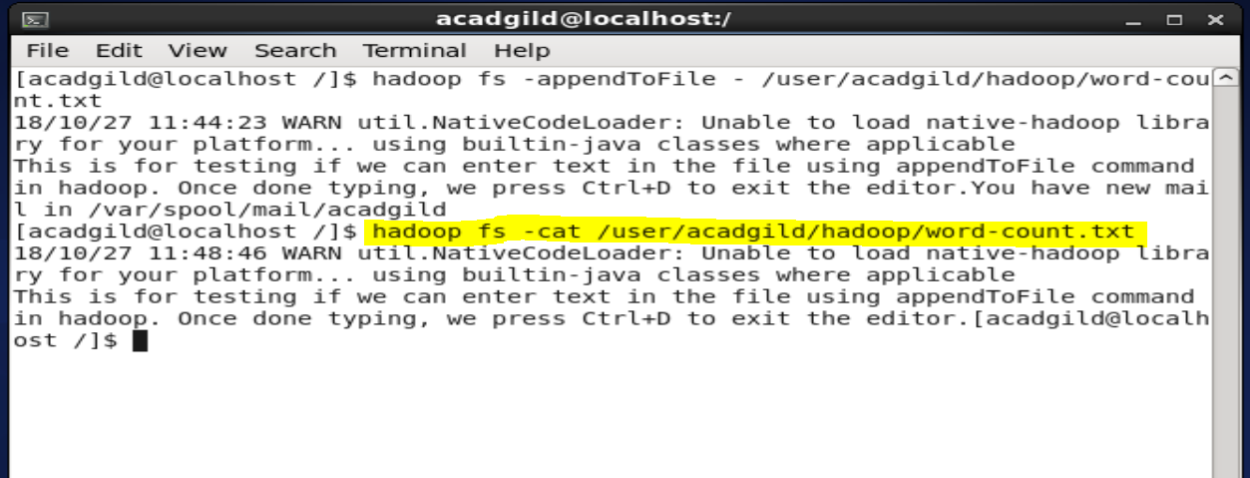

**Task 3:**

* Create a file max-temp.txt in local FS. Put some 10-15 records of date and temperature example: dd-mm-yyyy,temperature.

**Touch** command is used to create the file max-temp.txt in the local FS in a folder testfolder.



The command “**nano max-temp.txt”** is used to add records to the file

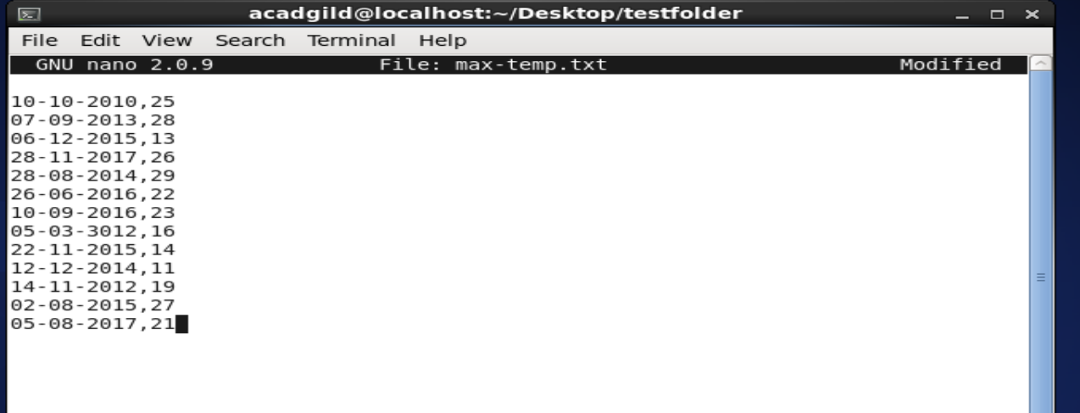

* Move this file to HDFS at /user/acadgild/hadoop.

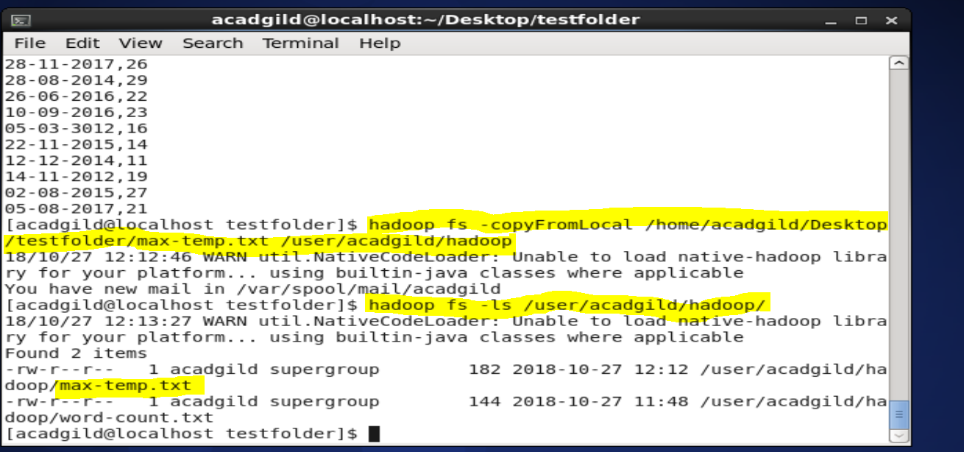

**Task 4:**

Change the permission of the file /user/acadgild/hadoop/max-temp.txt, such that only the owner and the group members have full control over the file. Others do not have any control over it.

The command **“chmod <mode> <filename with path>”** is used to change the permissions of a file. The mode can be written as both normal modes such as r for read, w for write and x for execute or octal mode where 4 stands for "read",2 stands for "write",1 stands for "execute", and 0 stands for "no permission." Hence, to give users and group members full rights(read, write and execute),the first two digits are 7 and 7. The last digit 0 denotes no permission for others.

The permission level is verified by executing the ls command.

