# **Session 11: ADVANCED HBASE**

# **Case Study II: Customer _ Transaction**

**Case Study Description**

**Let us take up the CUSTOMER and TRANSACTIONS table we have created in the**

**Let’s Do Together section. Let us solve the following use cases using these tables :-**

**1. Find out the number of transactions done by each customer (These should be**

**take up in module 8 itself)**

**Solution:**



**Output:**

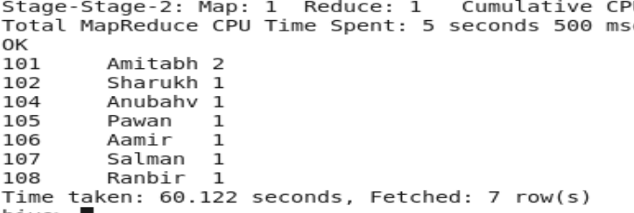

**2. Create a new table called TRANSACTIONS_COUNT. This table should have**

**3 fields - custid, fname and count. (Again to be done in module 8)**

**Solution:**



**3. Now write a hive query in such a way that the query populates the data**

**obtained in Step 1 above and populate the table in step 2 above. (This has to**

**be done in module 9).**

**Solution:**



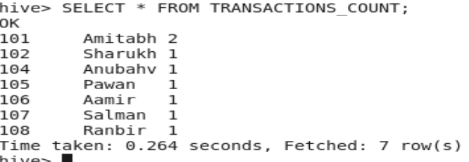

**4. Now lets make the TRANSACTIONS_COUNT table Hbase complaint. In the**

**sence, use Ser Des And Storate handler features of hive to change the**

**TRANSACTIONS_COUNT table to be able to create a TRANSACTIONS table**

**in Hbase. (This has to be done in module 10)**

**Solution:**

**5. Now insert the data in TRANSACTIONS_COUNT table using the query in step**

**3 again, this should populate the Hbase TRANSACTIONS table automatically**

**(This has to be done in module 10)**

**Solution:**

**6. Now from the Hbase level, write the Hbase java API code to access and scan**

**the TRANSACTIONS table data from java level.**

**Solution:**