# **Session 6.1 : DATA INGESTION TOOL SQOOP & INTRODUCTION TO CASE STUDY 1**

# **Assignment 1**

**Task 1:**

**Use Sqoop tool to export data present in SQOOPOUT folder made while demo of Import table**

**Solution:**



**Output:**

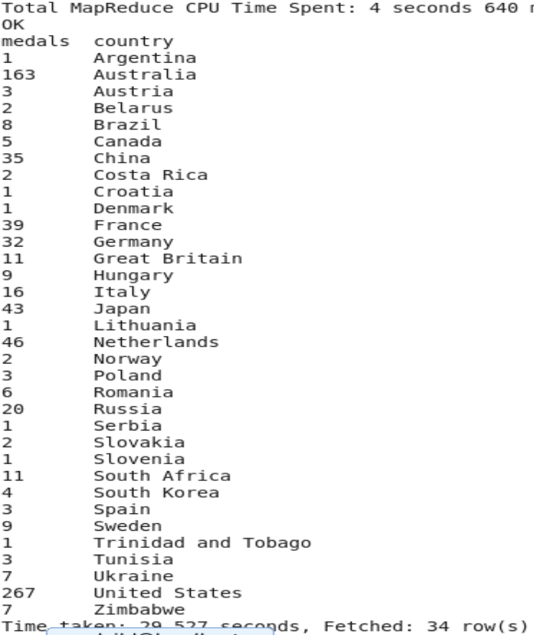

1. **Write a Hive program to find the number of medals that India won year wise.**

**Solution:**



**Output:**

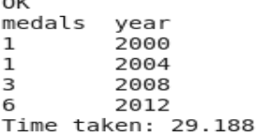

1. **Write a Hive Program to find the total number of medals each country won.**

**Solution:**



**Output:**

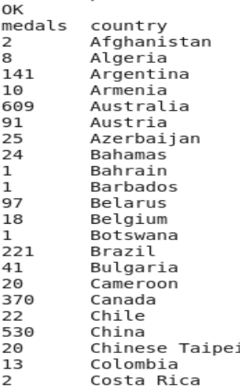

1. **Write a Hive program to find the number of gold medals each country won.**

**Solution:**



**Output:**

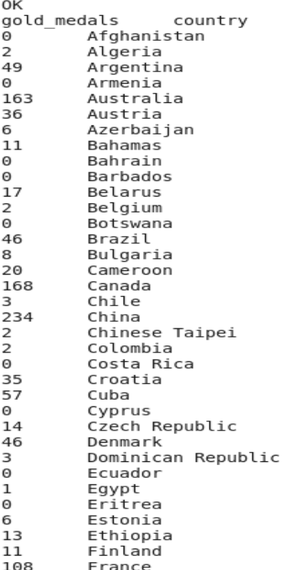

**Task 2:**

**Write a hive UDF that implements functionality of string concat_ws(string SEP, array<string>).**

**This UDF will accept two arguments, one string and one array of string.**

**It will return a single string where all the elements of the array are separated by the SEP.**

**Solution:**

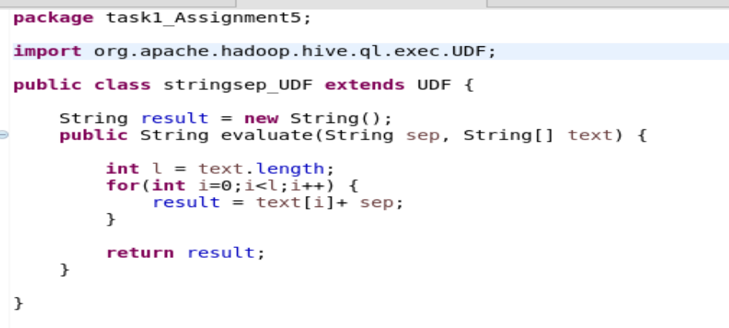

**Output:**

We packaged the code in a jar and added to hive and then run the function on a table of data as shown below:

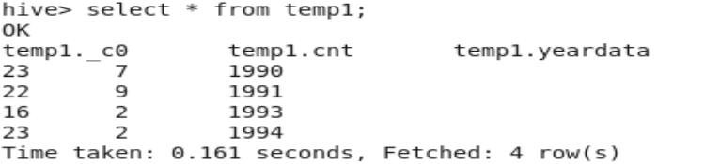



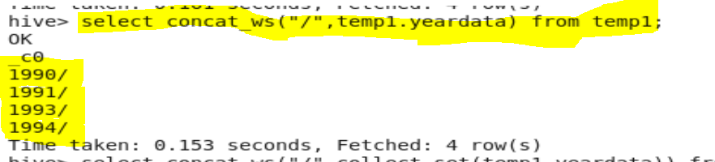

**Task 3**

**Link: https://acadgild.com/blog/transactions-in-hive/**

**Refer the above given link for transactions in Hive and implement the operations given in the blog using your own sample data set and send us the screenshot.**

**Output:**







**CREATE Statement:**

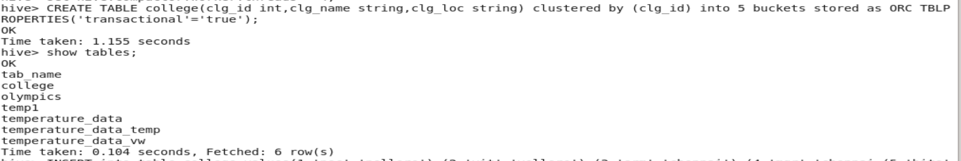

**INSERT Statement:**



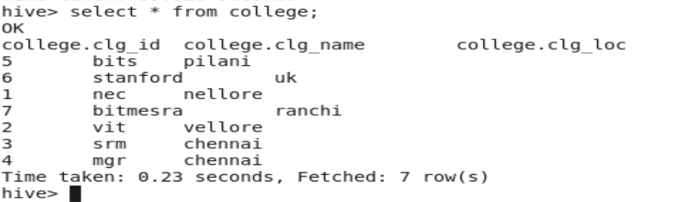

**UPDATE Statement:**



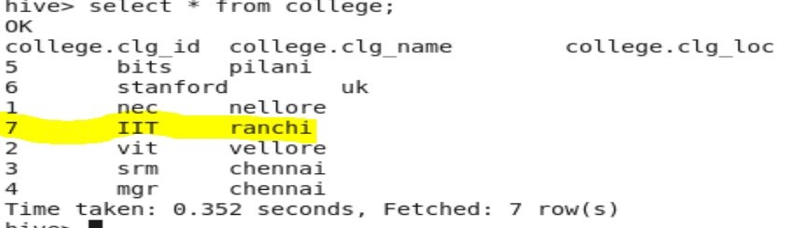

**DELETE Statement:**



