# **Session 8: HIVE BASICS**

# **Assignment 1**

**Task 1:**

1. **Create a database named 'custom'.**

**Solution:**

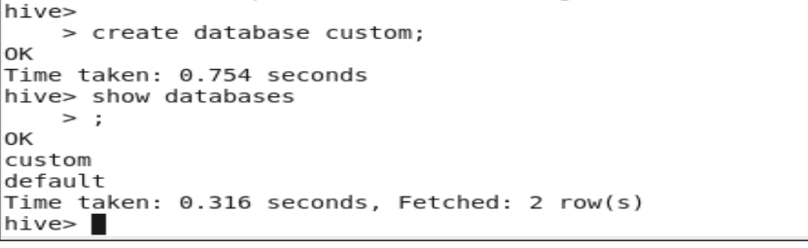

1. **Create a table named temperature_data inside custom having below fields:**

**1. date (mm-dd-yyyy) format**

**2. zip code**

**3. temperature**

**Solution:**



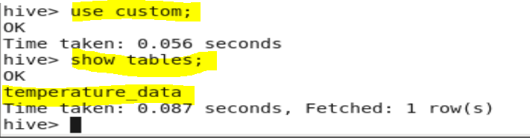

1. **The table will be loaded from comma-delimited** **file**.

**Load the dataset.txt (which is ',' delimited) in the table.**

**Solution:**

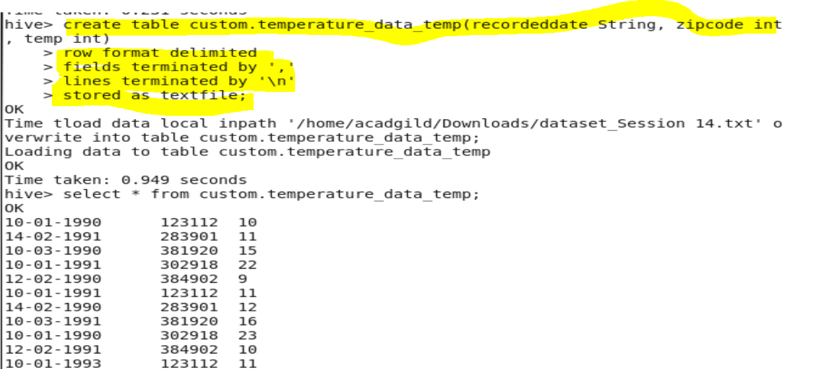

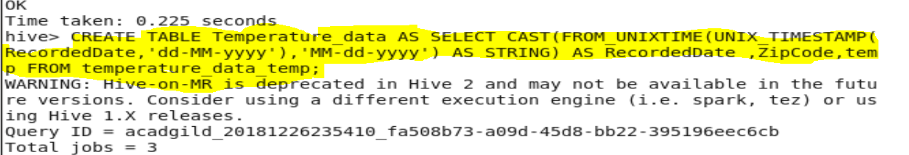

**Output:**

Column in MM-dd-yyyy format as asked

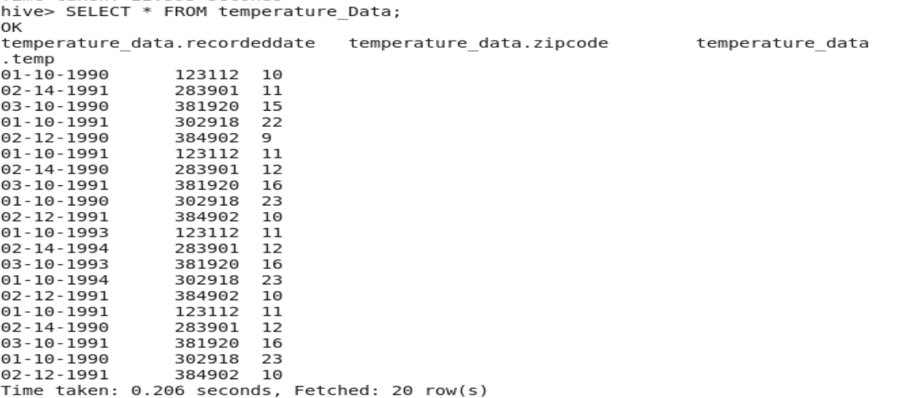

**Task 2:**

**(a)Fetch date and temperature from temperature_data where zip code is greater than**

**300000 and less than 399999.**

**Solution/Output:**

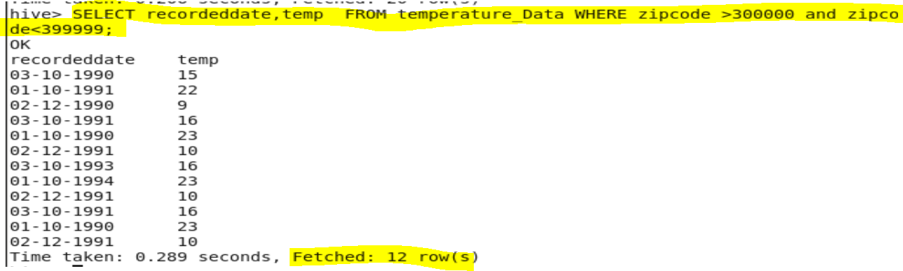

**(b) Calculate maximum temperature corresponding to every year from temperature_data**

**table.**

**Solution:**



**Output:**

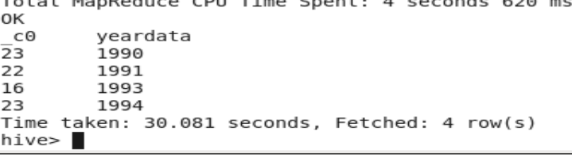

**(c) Calculate maximum temperature from temperature_data table corresponding to those**

**years which have at least 2 entries in the table.**

**Solution:**

**Output:**

**(d) Create a view on the top of last query, name it temperature_data_vw.**

**Solution:**

**Output:**

**(e) Export contents from temperature_data_vw to a file in local file system, such that each**

**file is '|' delimited.**

**Solution:**

**Output:**