CloudBlitz Student Registration
Project Documentation: Deployment on AWS EC2 with Amazon RDS (MariaDB)

Project Screenshots
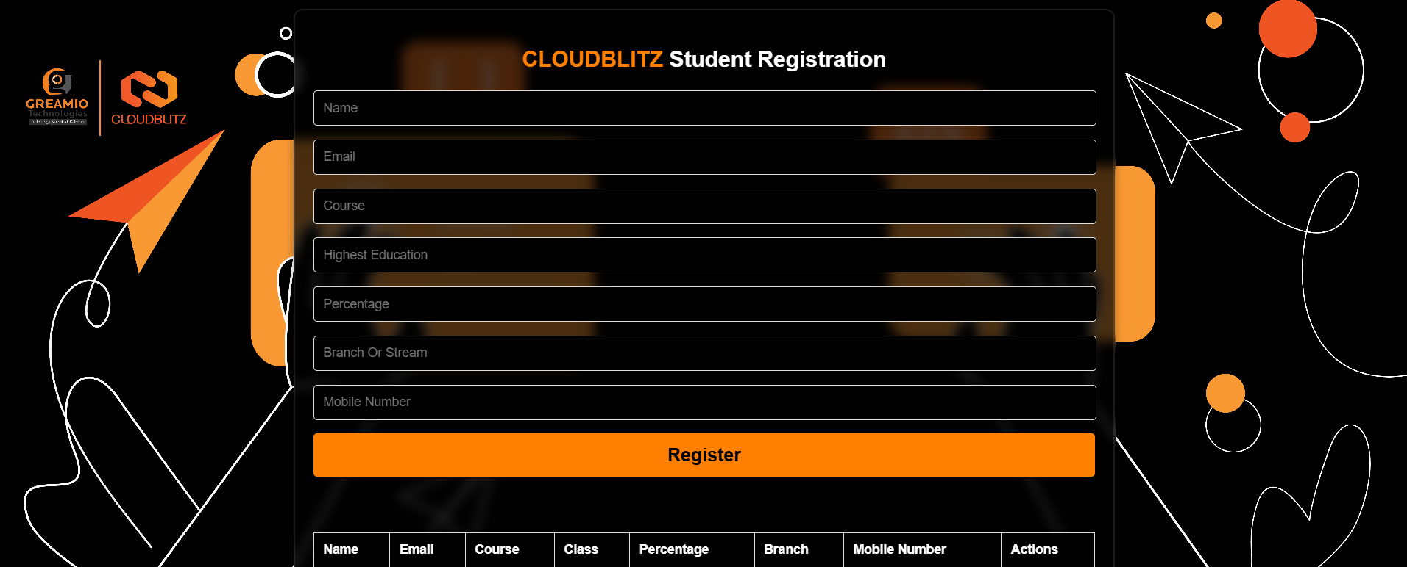
Figure 1: CloudBlitz Student Registration Form
The front-end of the project. Students enter their Name, Email, Course, Highest Education, Percentage, Branch/Stream and Mobile Number and click Register. A table below the form lists all saved records with a Delete action.
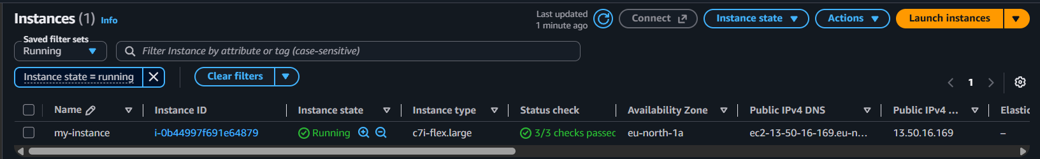
Figure 2: AWS EC2 Instance Running
The EC2 instance "my-instance" (type c7i-flex.large) in the eu-north-1a Availability Zone. It is in the Running state with 3/3 status checks passed and has a public IPv4 address. This server hosts the web application.
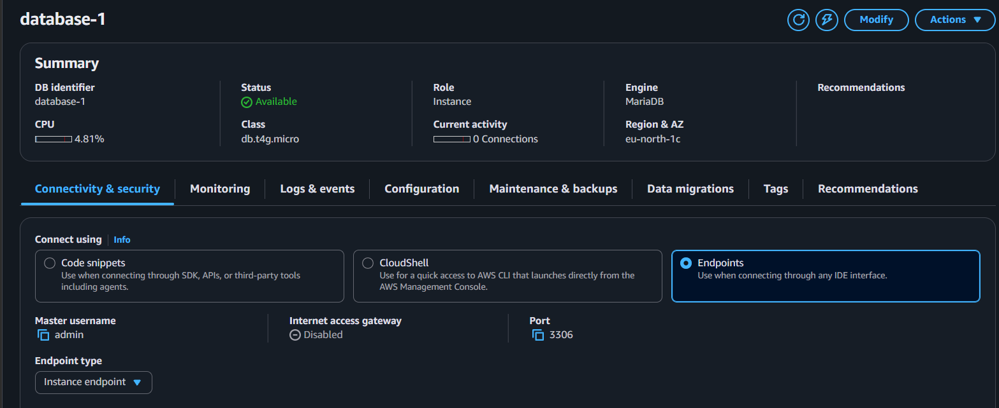
Figure 3: Amazon RDS Database Summary
The RDS instance "database-1" is Available and uses the MariaDB engine on a db.t4g.micro class in eu-north-1c. The Connectivity & security tab shows master username "admin" and port 3306.
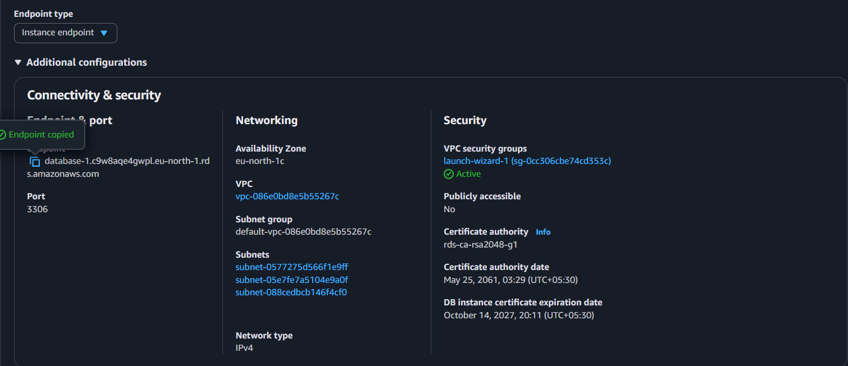
Figure 4: RDS Endpoint and Network Configuration
Shows the database endpoint (copied for use as DB_HOST), the VPC, subnet group and subnets, and the security group launch-wizard-1. The database is not publicly accessible, so only resources inside the VPC (such as the EC2 instance) can reach it.
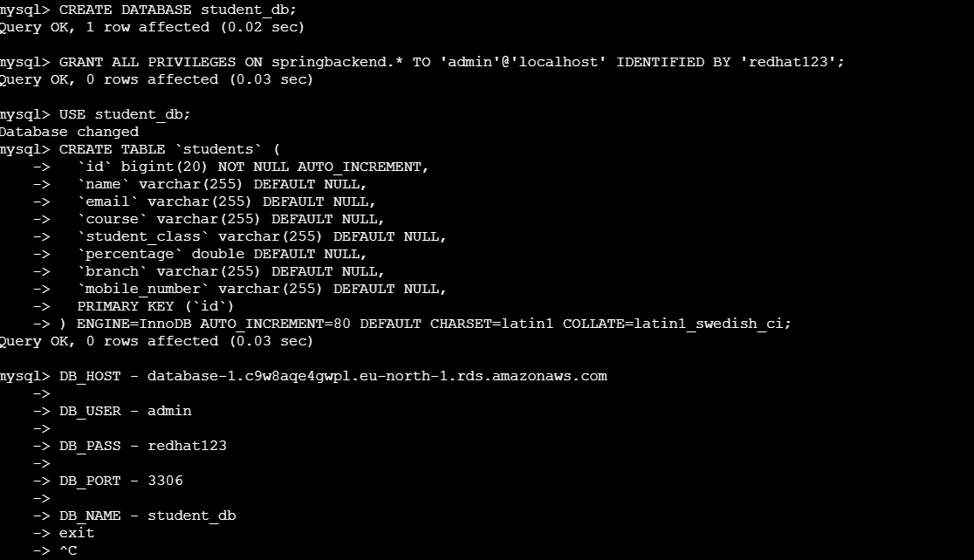
Figure 5: Database and Table Creation in MySQL
The MySQL client is used to create the student_db database and the "students" table with columns id, name, email, course, student_class, percentage, branch and mobile_number. The connection details (host, user, password, port, database name) are also noted for the application configuration.
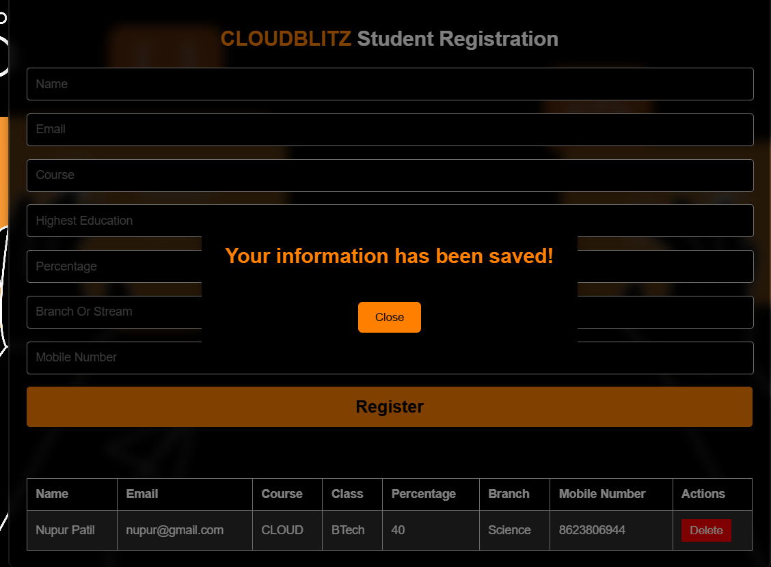
Figure 6: Successful Registration Output
After submitting the form, the message "Your information has been saved!" appears. The new record (Nupur Patil, CLOUD, BTech, 40%, Science) is displayed in the table, confirming data is stored in and read back from the RDS database.
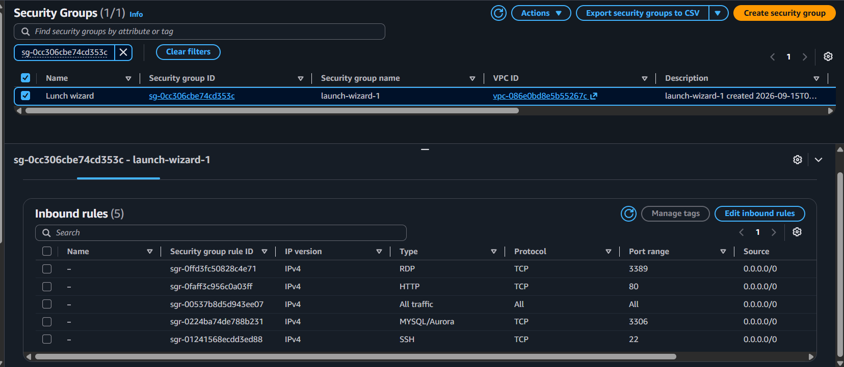
Figure 7: Security Group Inbound Rules
Inbound rules of the security group launch-wizard-1: RDP (3389), HTTP (80), MySQL/Aurora (3306), SSH (22) and an all-traffic rule. These control which traffic can reach the EC2 and RDS resources, including the web port 80 and database port 3306.

Project Explanation

1. Overview
CloudBlitz Student Registration is a three-tier web application that lets students register for a course and stores their details in a cloud database. It was built and deployed on Amazon Web Services (AWS) to demonstrate how a web server and a managed database work together in the cloud.

2. Architecture
- Presentation layer: A dark-themed registration page with a form and a records table, showing a confirmation pop-up after each successful save.
- Application layer: The application runs on an Amazon EC2 instance (c7i-flex.large, eu-north-1a). It handles form submissions, saves records, lists them and deletes them. Database credentials are supplied through settings such as DB_HOST, DB_USER, DB_PASS, DB_PORT and DB_NAME.
- Data layer: An Amazon RDS MariaDB instance (database-1, db.t4g.micro) holds the student_db database and the students table. It is private (not publicly accessible) and reachable only from inside the VPC.

3. Database Design
The students table stores: id (auto-increment primary key), name, email, course, student_class, percentage, branch and mobile_number. Each form submission becomes one row, and the table in the UI is populated by reading these rows.

4. Workflow
- Launch an EC2 instance to host the application.
- Create an RDS MariaDB instance in the same VPC and note its endpoint and port 3306.
- Configure the security group so the EC2 instance can reach the database on port 3306 and users can reach the web app on port 80.
- Connect with the MySQL client, then create student_db and the students table.
- Set the database connection details (host, user, password, port, name) in the application configuration.
- Open the registration page, fill in the form and click Register; the record is saved and appears in the table.
- Use the Delete button to remove a record when needed.

5. Technologies Used
AWS EC2, Amazon RDS (MariaDB), VPC and Security Groups, MySQL client, HTML/CSS front-end.

6. Security Notes and Improvements
- The security group allows all inbound traffic (0.0.0.0/0) including SSH, RDP and MySQL. For production, limit SSH to your own IP and allow port 3306 only from the EC2 instance's security group.
- Do not keep database passwords in screenshots or plain notes; store them in environment variables or AWS Secrets Manager, and use a dedicated database user instead of the master user.
- Add input validation (email, 10-digit mobile number, percentage 0-100) and HTTPS.

7. Conclusion
The project successfully shows an end-to-end cloud deployment: a user-facing form on EC2, a managed MariaDB database on RDS, and secure networking through a VPC and security groups. Data entered in the form is stored in the database and displayed back in the table, confirming the full setup works.

