**1.Introduction**

This assignment will help you to consolidate the concepts learnt in the session.

**2.Problem Statement**

1. Write a program which accepts a sequence of comma-separated numbers from console  and generate a list.

1. Create the below pattern using nested for loop in Python.

*

* *

* * *

* * * *

* * * * *

* * * *

* * *

* *

*

1.       def func(n):

2.           for i in range(0,n):

3.               for j in range(0, i+1):

4.                   print("*", end = "")

5.               print("\r")

6.           for i in reversed(range(0,n)):

7.               for j in range(0,i+1):

8.                   print("*", end ="")

9.               print("\r")

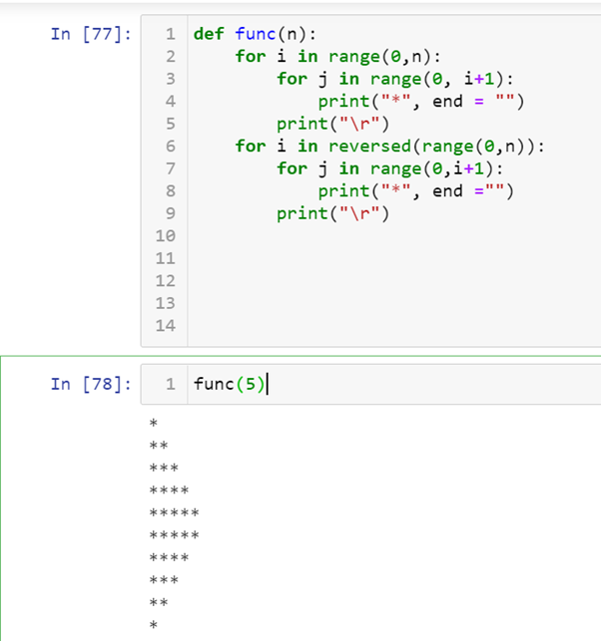

2. Write a Python program to reverse a word after accepting the input from the user. **Sample Output:**

Input word: ineuron

Output: norueni

2. def string_reverse(name):

for s in reversed(name):

     print(s, end = "")

