PARALLEL COMPUTING LAB MANUAL
CPU vs GPU Data Processing
2D Convolution using OpenMP and CUDA

Implementation • Verification • Performance Analysis • Experimental Study

Student / Team | AOs
Experiment | CPU vs GPU Data Processing — OpenMP + CUDA
Workload | 2D floating-point convolution with a 3 × 3 kernel
CPU model | Intel Core i5-13450HX, OpenMP
GPU model | NVIDIA GeForce RTX 3050 6GB Laptop GPU, CUDA
Platform | Windows 11, CUDA Toolkit 13.4, MSVC

Table of Contents
- 1. Aim and Learning Objectives
- 2. Problem Definition
- 3. Background: OpenMP and CUDA
- 4. Input Data and 2D Convolution
- 5. Sequential Algorithm
- 6. Parallel Design
- 7. Experimental Setup
- 8. Compilation and Execution Commands
- 9. Implementation Outputs and Evidence
- 10. Experimental Results
- 11. Graphical Analysis
- 12. Numerical Verification
- 13. Performance Analysis and Discussion
- 14. Final Validated 4096 × 4096 Run
- 15. Conclusion
- 16. Viva / Technical Discussion Points
- Appendix A — Complete Screenshot Evidence

1. Aim and Learning Objectives
The aim of this experiment is to implement the same 2D convolution workload using CPU parallelism with OpenMP and GPU parallelism with CUDA, verify that both implementations produce numerically equivalent results, and compare their execution performance under different matrix sizes and OpenMP thread counts.
- Understand how a regular nested-loop numerical workload can be parallelized on a multicore CPU.
- Understand CUDA's thread/block/grid execution model and map one output element to one GPU thread.
- Measure CPU execution time, CUDA kernel time, and complete GPU end-to-end time.
- Study the effect of matrix size and OpenMP thread count on execution time, speedup, and efficiency.
- Verify correctness by comparing every CPU output element with the corresponding GPU output element.
- Interpret the difference between compute-kernel speed and end-to-end application speed, including data-transfer overhead.

2. Problem Definition
The computational problem is 2D valid convolution of a floating-point input matrix with a 3 × 3 kernel. For an N × N input and a K × K kernel, with no padding and unit stride, the output dimensions are (N − K + 1) × (N − K + 1).
Input matrix A: N × N
Convolution kernel K: 3 × 3
K =
[ 1 0 -1
1 0 -1
1 0 -1 ]
Output B has dimensions:
(N - 3 + 1) × (N - 3 + 1) = (N - 2) × (N - 2)
B[i][j] = Σ(r=0..2) Σ(c=0..2) A[i+r][j+c] × K[r][c]
The experiment uses matrix sizes of 1024 × 1024, 2048 × 2048 and 4096 × 4096. The 4096 × 4096 case therefore produces a 4094 × 4094 output matrix.

3. Background: OpenMP and CUDA

3.1 OpenMP
OpenMP (Open Multi-Processing) is an API for shared-memory parallel programming in C/C++ and other languages. It uses compiler directives, runtime functions and environment controls to distribute work among multiple CPU threads. In this experiment, the two output loops are parallelized with `#pragma omp parallel for collapse(2)`. The collapse clause treats the two nested loops as one larger iteration space, allowing OpenMP to distribute output elements across CPU threads.
- Execution device: multicore CPU.
- Memory model: shared main memory.
- Parallel unit: CPU thread.
- Main experiment variable: requested OpenMP thread count (1, 2, 4, 8, 16).
- Advantage in this experiment: no host-device transfer is required because input/output already reside in host memory.

3.2 CUDA
CUDA is NVIDIA's parallel computing platform and programming model for executing massively parallel workloads on NVIDIA GPUs. CUDA launches a kernel containing many GPU threads. Threads are organized into blocks, and blocks form a grid. For this experiment a 16 × 16 thread block is used. Each CUDA thread computes one output element of the convolution.
- Execution device: NVIDIA GeForce RTX 3050 6GB Laptop GPU.
- GPU compute capability reported by the CUDA program: 8.6.
- Block size: 16 × 16 = 256 threads per block.
- For 4096 × 4096 input, output is 4094 × 4094 and the recorded CUDA grid is 256 × 256.
- CUDA kernel timing measures the GPU computation itself; end-to-end timing additionally includes host-to-device and device-to-host transfers.

3.3 OpenMP vs CUDA
Aspect | OpenMP | CUDA
Hardware | Multicore CPU | NVIDIA GPU
Parallel unit | CPU threads | GPU threads
Memory | Shared host memory | GPU global memory + host memory
Programming style | Compiler directives + runtime | Kernel + grid/block/thread model
Experiment variable | 1, 2, 4, 8, 16 threads | 16 × 16 blocks; grid depends on output size
Main overhead | Thread scheduling / memory bandwidth | Kernel launch and host-device data transfers

4. Input Data and 2D Convolution
The input is generated programmatically rather than entered manually. The implementation uses a fixed random seed of 42 with a uniform floating-point distribution in the interval [0, 1). The fixed seed makes the generated input deterministic, so the CPU and GPU implementations process the same values. The data type is float.
mt19937 generator(42);
uniform_real_distribution<float> distribution(0.0f, 1.0f);
for each input element:
input[i] = distribution(generator);
This is important for a fair CPU/GPU comparison: if the CPU and GPU were given different input data, a numerical verification failure could be caused by different inputs rather than an implementation error.

4.1 Data sizes used
Input size | Kernel | Output size | Purpose
1024 × 1024 | 3 × 3 | 1022 × 1022 | Small workload / scaling
2048 × 2048 | 3 × 3 | 2046 × 2046 | Medium workload / scaling
4096 × 4096 | 3 × 3 | 4094 × 4094 | Large workload / final validation

5. Sequential Algorithm
The sequential algorithm visits every valid output position and performs the nine multiply-add operations corresponding to the 3 × 3 kernel.
- Generate the input matrix using a fixed random seed.
- Initialize the 3 × 3 convolution kernel.
- Compute output dimensions as (N − K + 1) × (N − K + 1).
- For every output row i and output column j, set an accumulator to zero.
- For kernel row r = 0..2 and kernel column c = 0..2, add input[i+r][j+c] × kernel[r][c] to the accumulator.
- Store the accumulator in output[i][j].
- Repeat the same mathematical operation in the OpenMP and CUDA implementations.

6. Parallel Design

6.1 OpenMP design
#pragma omp parallel for collapse(2)
for (int i = 0; i < outputRows; ++i) {
for (int j = 0; j < outputCols; ++j) {
float sum = 0.0f;
for (int r = 0; r < 3; ++r)
for (int c = 0; c < 3; ++c)
sum += input[(i+r)*N + (j+c)] * kernel[r*3 + c];
output[i*outputCols + j] = sum;
}
}
The outer two loops are independent because each output element depends only on the input window and kernel. Therefore, different output elements can be computed simultaneously.

6.2 CUDA design
__global__ void convolutionKernel(const float* input,
const float* kernel,
float* output,
int N) {
int x = blockIdx.x * blockDim.x + threadIdx.x;
int y = blockIdx.y * blockDim.y + threadIdx.y;
if (x < N-2 && y < N-2) {
float sum = 0.0f;
for (int r = 0; r < 3; ++r)
for (int c = 0; c < 3; ++c)
sum += input[(y+r)*N + (x+c)] * kernel[r*3 + c];
output[y*(N-2) + x] = sum;
}
}
A 16 × 16 block is used. The x/y thread coordinates determine which output element the thread owns. Boundary checking prevents threads outside the valid output region from writing invalid positions.

7. Experimental Setup
The uploaded evidence document records the following environment information.
Component | Recorded configuration
Operating system | Microsoft Windows 11 Home Single Language, 10.0.26200
CPU | Intel Core i5-13450HX
RAM | 16 GB class system; systeminfo screenshot reports ~16,369 MB total physical memory
GPU | NVIDIA GeForce RTX 3050 6GB Laptop GPU
GPU memory | 6 GB / 6144 MiB reported by nvidia-smi
NVIDIA driver | 581.95
Driver CUDA compatibility | CUDA Version 13.0
CUDA compiler | CUDA Toolkit 13.4, nvcc V13.4.92
MSVC | Microsoft C/C++ Optimizing Compiler 19.51.36260 for x64
CUDA architecture used | sm_86

8. Compilation and Execution Commands
The following commands reproduce the major stages documented in the screenshots.

8.1 Environment verification
systeminfo
nvidia-smi
nvcc --version
cl
where nvcc
where cl

8.2 OpenMP compilation and execution
cl /O2 /openmp convolution_openmp.cpp /Fe:convolution_openmp.exe
convolution_openmp.exe

8.3 CUDA compilation and execution
nvcc -O3 -arch=sm_86 convolution_cuda.cu -o convolution_cuda.exe
convolution_cuda.exe

8.4 CPU vs GPU benchmark
nvcc -O3 -arch=sm_86 -Xcompiler="/openmp" convolution_benchmark.cu -o convolution_benchmark.exe
convolution_benchmark.exe

8.5 Parameterized experiment
nvcc -O3 -arch=sm_86 -Xcompiler="/openmp" convolution_experiment.cu -o convolution_experiment.exe
convolution_experiment.exe <matrix_size> <threads>

8.6 Experiment matrix
convolution_experiment.exe 1024 1
convolution_experiment.exe 1024 2
convolution_experiment.exe 1024 4
convolution_experiment.exe 1024 8
convolution_experiment.exe 1024 16
convolution_experiment.exe 2048 1
convolution_experiment.exe 2048 2
convolution_experiment.exe 2048 4
convolution_experiment.exe 2048 8
convolution_experiment.exe 2048 16
convolution_experiment.exe 4096 1
convolution_experiment.exe 4096 2
convolution_experiment.exe 4096 4
convolution_experiment.exe 4096 8
convolution_experiment.exe 4096 16

9. Implementation Outputs and Evidence
The following evidence is reproduced from the uploaded 9-page screenshot document. The screenshots are kept as original output evidence so that the command environment, compiler versions, program output, verification status, experimental measurements, and generated files can be inspected directly.

Evidence Set 1: System information and Windows environment
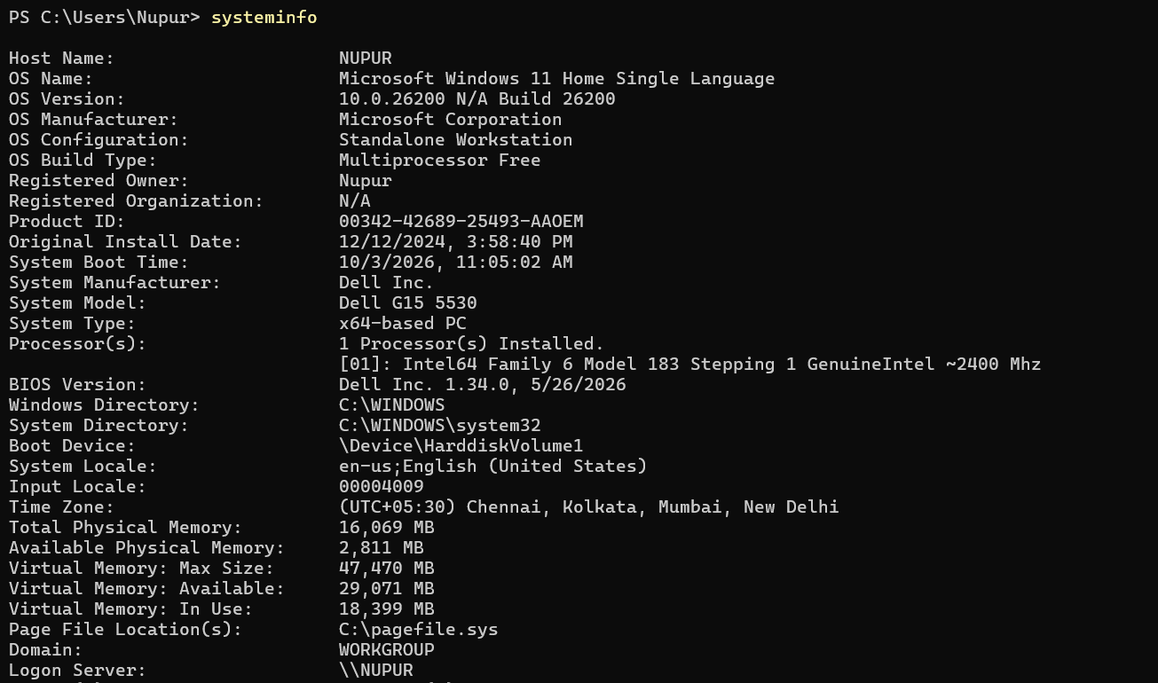
Screenshot evidence — source document page 1
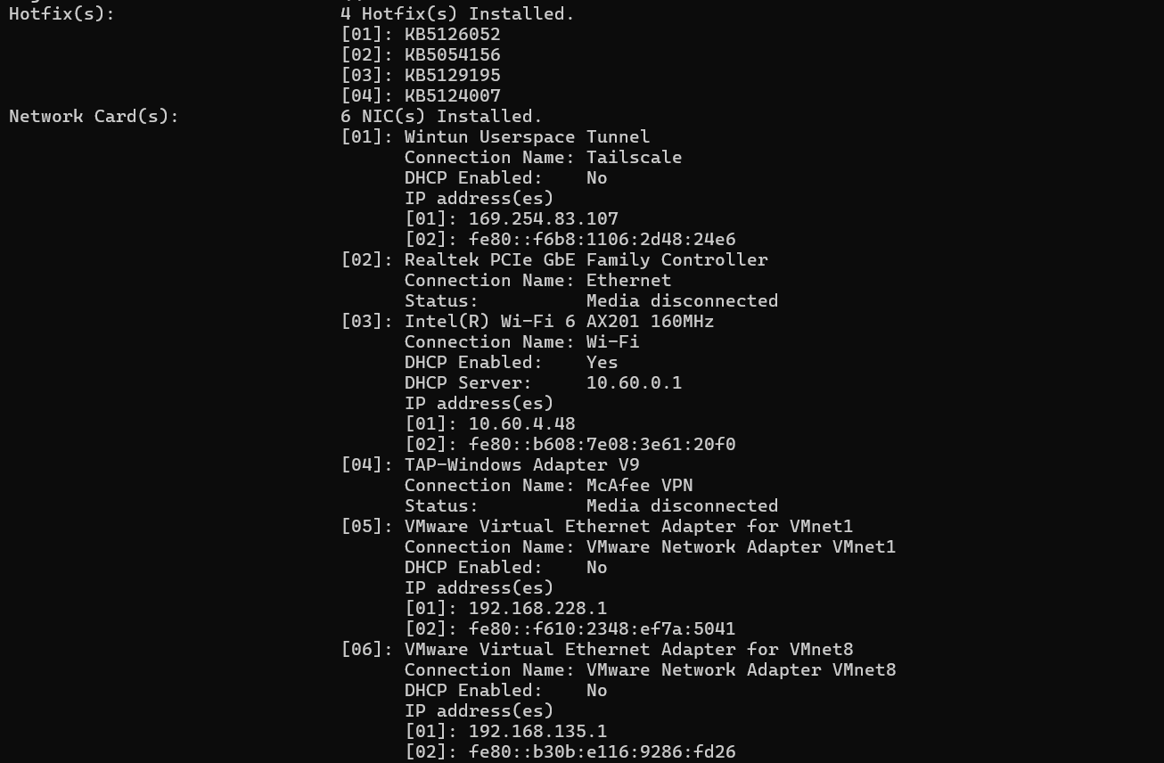
Screenshot evidence — source document page 1
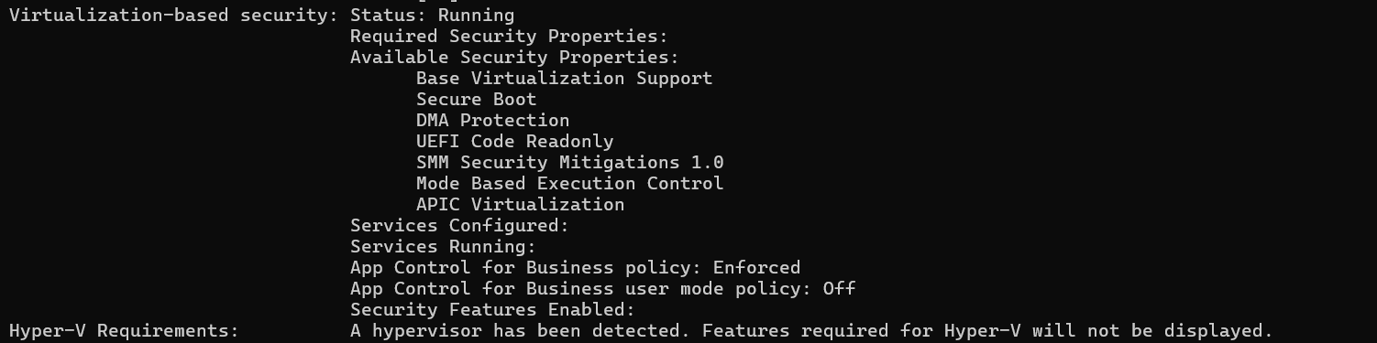
Screenshot evidence — source document page 1

Evidence Set 2: NVIDIA GPU / driver status, CUDA compiler, MSVC compiler and compiler locations
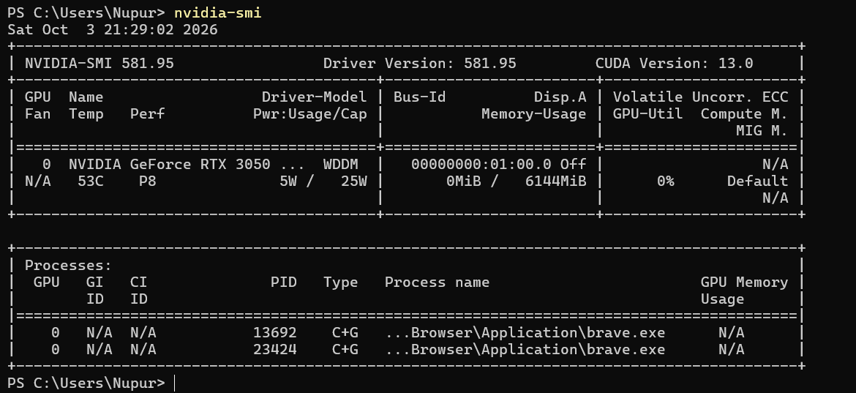
Screenshot evidence — source document page 2
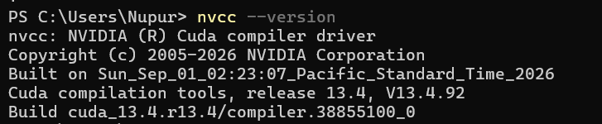
Screenshot evidence — source document page 2
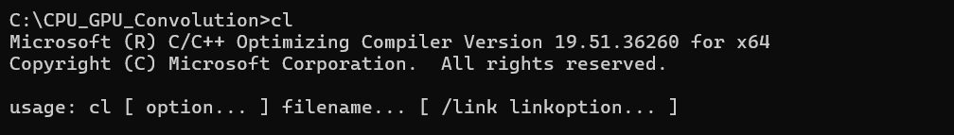
Screenshot evidence — source document page 2
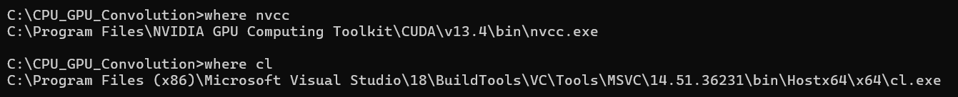
Screenshot evidence — source document page 2

Evidence Set 3: OpenMP and CUDA compilation/execution output
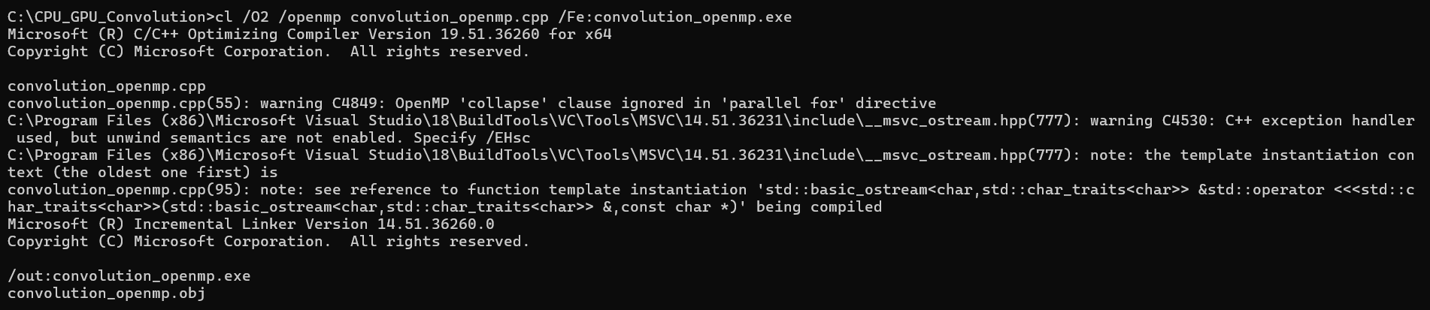
Screenshot evidence — source document page 3
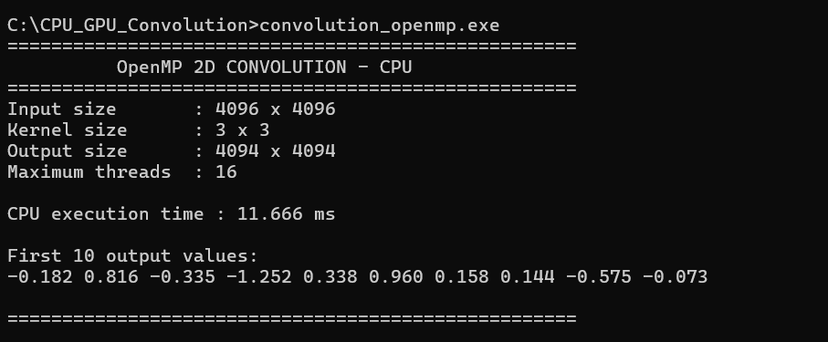
Screenshot evidence — source document page 3
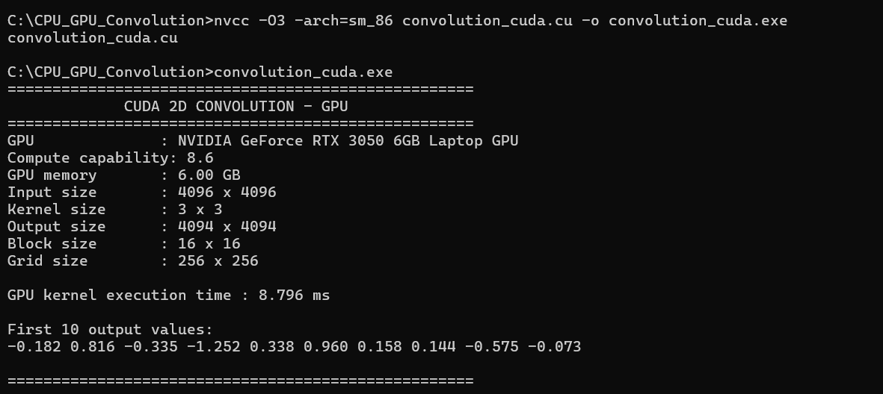
Screenshot evidence — source document page 3

Evidence Set 4: CPU vs GPU benchmark output and first parameterized experiment
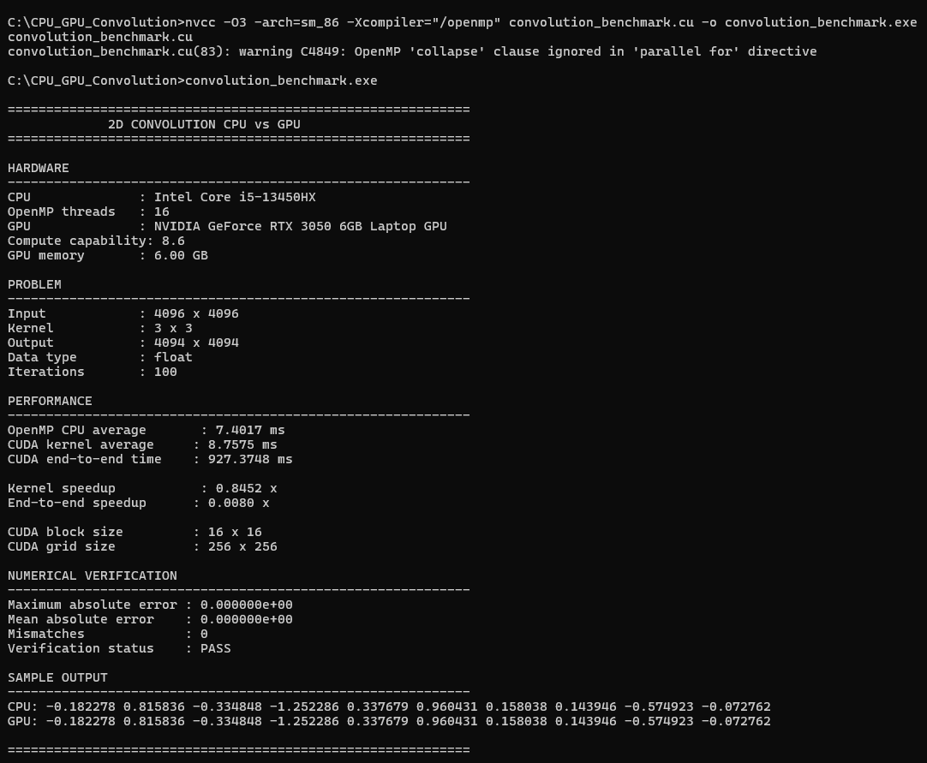
Screenshot evidence — source document page 4
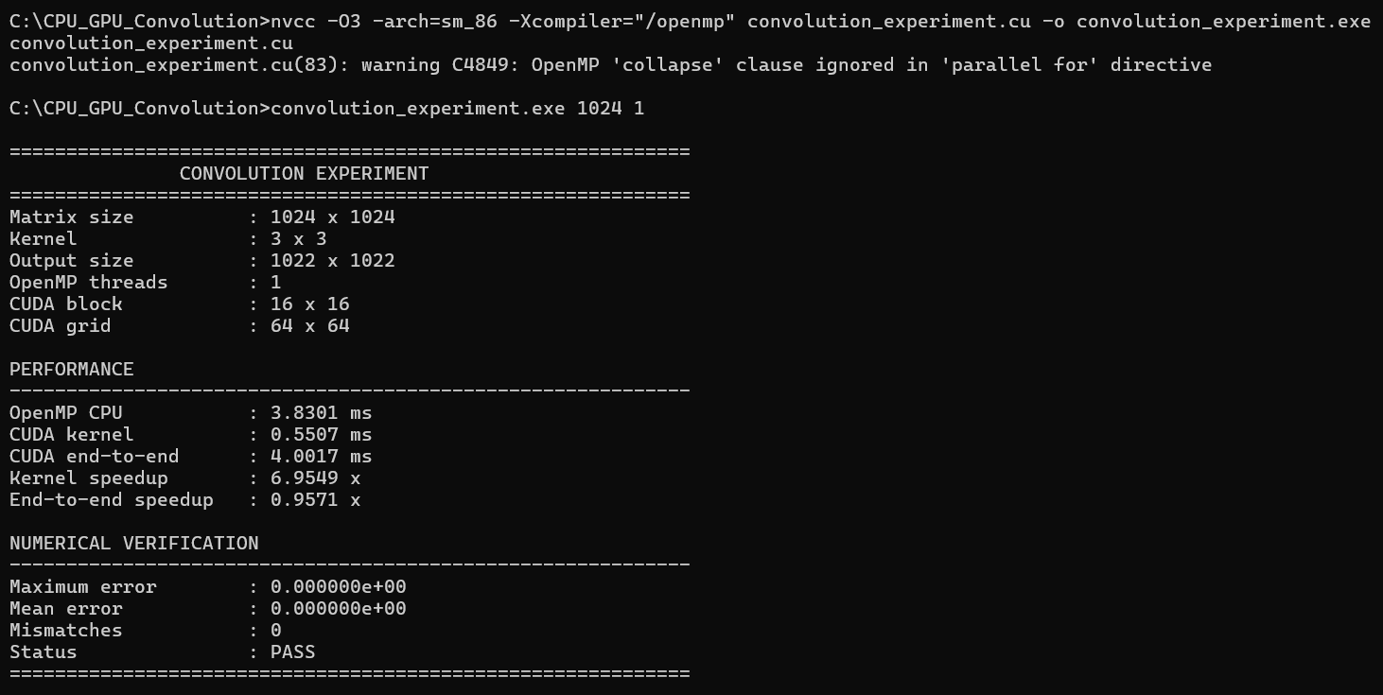
Screenshot evidence — source document page 4

Evidence Set 5: 1024 × 1024 experiments with 2 and 4 OpenMP threads
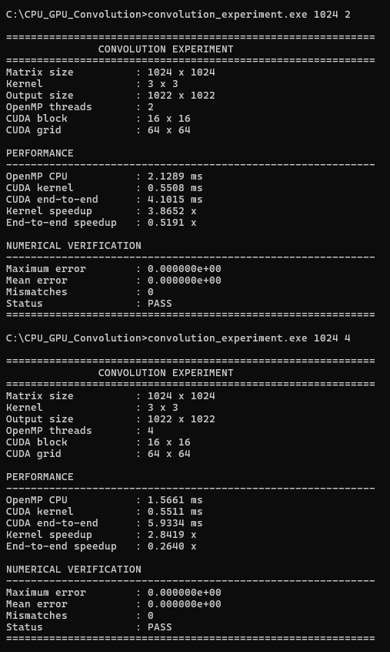
Screenshot evidence — source document page 5

Evidence Set 6: 2048 × 2048 experiments with 8 and 16 OpenMP threads
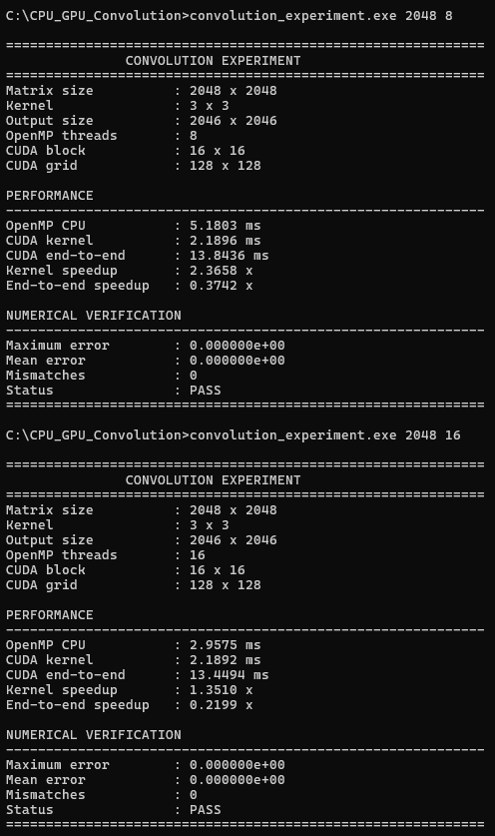
Screenshot evidence — source document page 6

Evidence Set 7: 4096 × 4096 experiments with 4 and 8 OpenMP threads
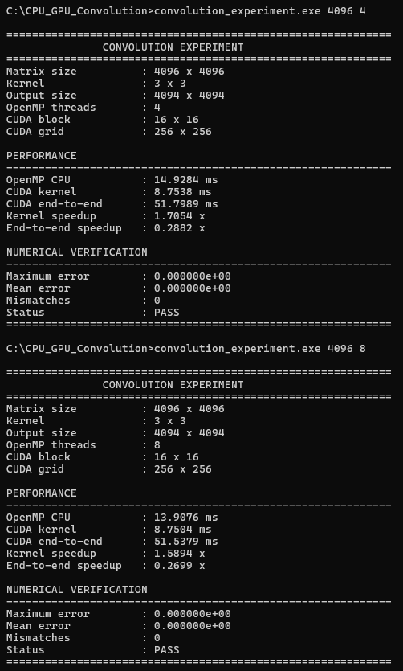
Screenshot evidence — source document page 7

Evidence Set 8: GPU status and recorded experimental data sheet
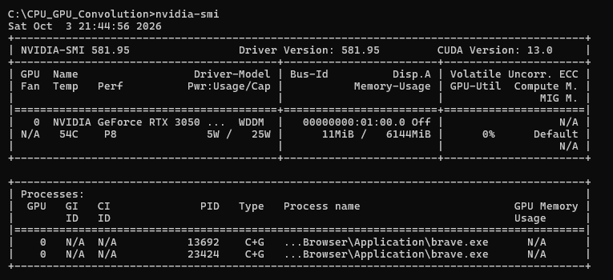
Screenshot evidence — source document page 8
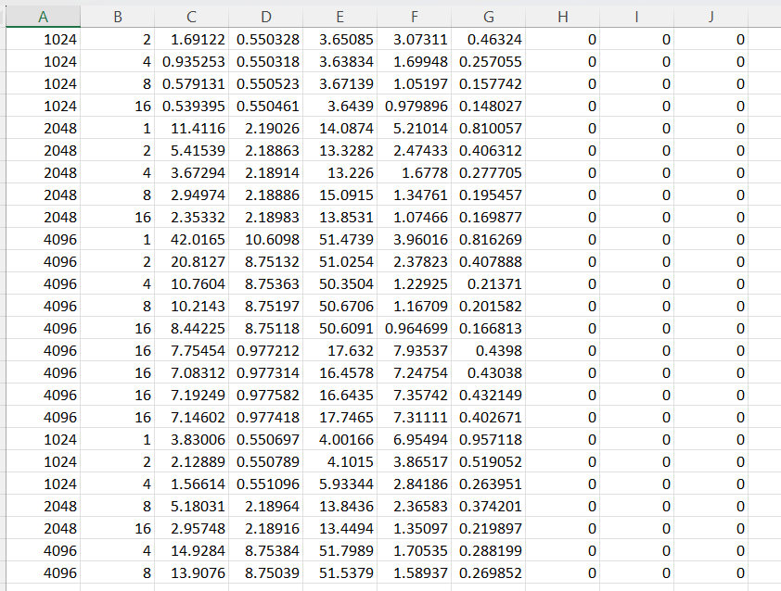
Screenshot evidence — source document page 8

Evidence Set 9: Project directory / generated files
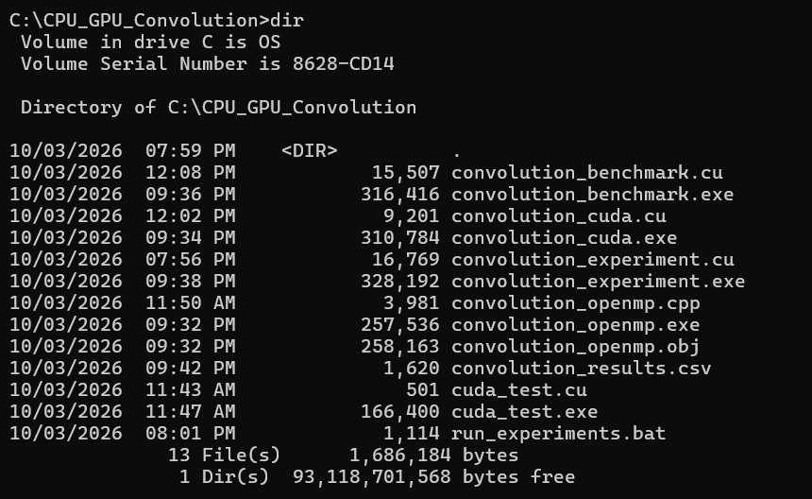
Screenshot evidence — source document page 9

10. Experimental Results
The clean 15-row dataset below is the dataset previously prepared from the recorded experiment sheet. It contains one row for each combination of matrix size (1024, 2048, 4096) and OpenMP thread count (1, 2, 4, 8, 16). The earlier duplicate 1024/1 preliminary row was excluded from this clean table.
Matrix | Threads | CPU ms | CUDA kernel ms | GPU end-to-end ms | Kernel speedup | E2E speedup | Max error | Mean error | Mismatch
1024 | 1 | 2.8275 | 0.5508 | 3.8939 | 5.1332 | 0.7261 | 0e+00 | 0e+00 | 0
1024 | 2 | 1.6912 | 0.5503 | 3.6509 | 3.0731 | 0.4632 | 0e+00 | 0e+00 | 0
1024 | 4 | 0.9353 | 0.5503 | 3.6383 | 1.6995 | 0.2571 | 0e+00 | 0e+00 | 0
1024 | 8 | 0.5791 | 0.5505 | 3.6714 | 1.0520 | 0.1577 | 0e+00 | 0e+00 | 0
1024 | 16 | 0.5394 | 0.5505 | 3.6439 | 0.9799 | 0.1480 | 0e+00 | 0e+00 | 0
2048 | 1 | 11.4116 | 2.1903 | 14.0874 | 5.2101 | 0.8101 | 0e+00 | 0e+00 | 0
2048 | 2 | 5.4154 | 2.1886 | 13.3282 | 2.4743 | 0.4063 | 0e+00 | 0e+00 | 0
2048 | 4 | 3.6729 | 2.1891 | 13.2260 | 1.6778 | 0.2777 | 0e+00 | 0e+00 | 0
2048 | 8 | 2.9497 | 2.1889 | 15.0915 | 1.3476 | 0.1955 | 0e+00 | 0e+00 | 0
2048 | 16 | 2.3533 | 2.1898 | 13.8531 | 1.0747 | 0.1699 | 0e+00 | 0e+00 | 0
4096 | 1 | 42.0165 | 10.6098 | 51.4739 | 3.9602 | 0.8163 | 0e+00 | 0e+00 | 0
4096 | 2 | 20.8127 | 8.7513 | 51.0254 | 2.3782 | 0.4079 | 0e+00 | 0e+00 | 0
4096 | 4 | 10.7604 | 8.7536 | 50.3504 | 1.2292 | 0.2137 | 0e+00 | 0e+00 | 0
4096 | 8 | 10.2143 | 8.7520 | 50.6706 | 1.1671 | 0.2016 | 0e+00 | 0e+00 | 0
4096 | 16 | 8.4422 | 8.7512 | 50.6091 | 0.9647 | 0.1668 | 0e+00 | 0e+00 | 0

10.1 Derived CPU speedup and efficiency
For CPU scaling, speedup is calculated relative to the 1-thread CPU run at the same matrix size:
CPU Speedup = T(1 thread) / T(p threads)
CPU Efficiency (%) = [CPU Speedup / p] × 100
Matrix | Threads | CPU ms | CPU speedup | CPU efficiency | Interpretation
1024 | 1 | 2.8275 | 1.000 | 100.0% | Baseline
1024 | 2 | 1.6912 | 1.672 | 83.6% | Scaling
1024 | 4 | 0.9353 | 3.023 | 75.6% | Scaling
1024 | 8 | 0.5791 | 4.882 | 61.0% | Scaling
1024 | 16 | 0.5394 | 5.242 | 32.8% | Scaling
2048 | 1 | 11.4116 | 1.000 | 100.0% | Baseline
2048 | 2 | 5.4154 | 2.107 | 105.4% | Scaling
2048 | 4 | 3.6729 | 3.107 | 77.7% | Scaling
2048 | 8 | 2.9497 | 3.869 | 48.4% | Scaling
2048 | 16 | 2.3533 | 4.849 | 30.3% | Scaling
4096 | 1 | 42.0165 | 1.000 | 100.0% | Baseline
4096 | 2 | 20.8127 | 2.019 | 100.9% | Scaling
4096 | 4 | 10.7604 | 3.905 | 97.6% | Scaling
4096 | 8 | 10.2143 | 4.113 | 51.4% | Scaling
4096 | 16 | 8.4422 | 4.977 | 31.1% | Scaling

11. Graphical Analysis
The following graphs are the previously generated analysis plots requested for inclusion. They visualize CPU scaling, GPU kernel timing, CPU-versus-GPU timing, CPU speedup, and CPU efficiency.
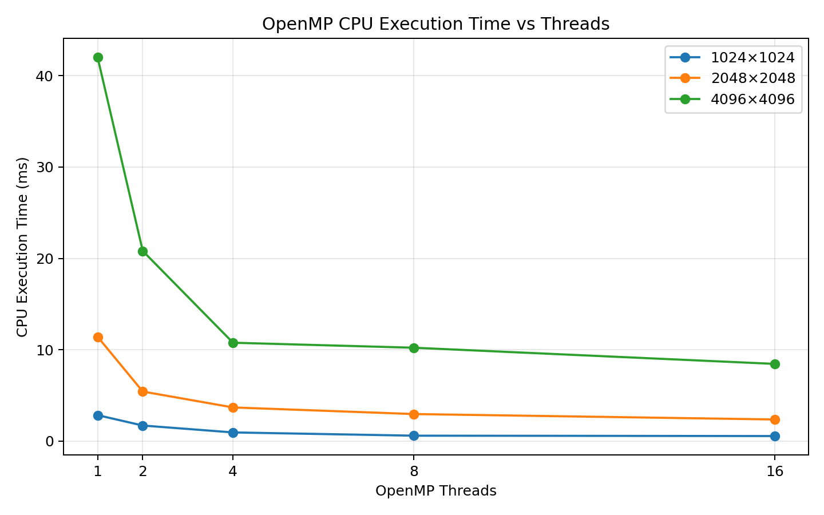
Figure 1. OpenMP CPU execution time vs. thread count
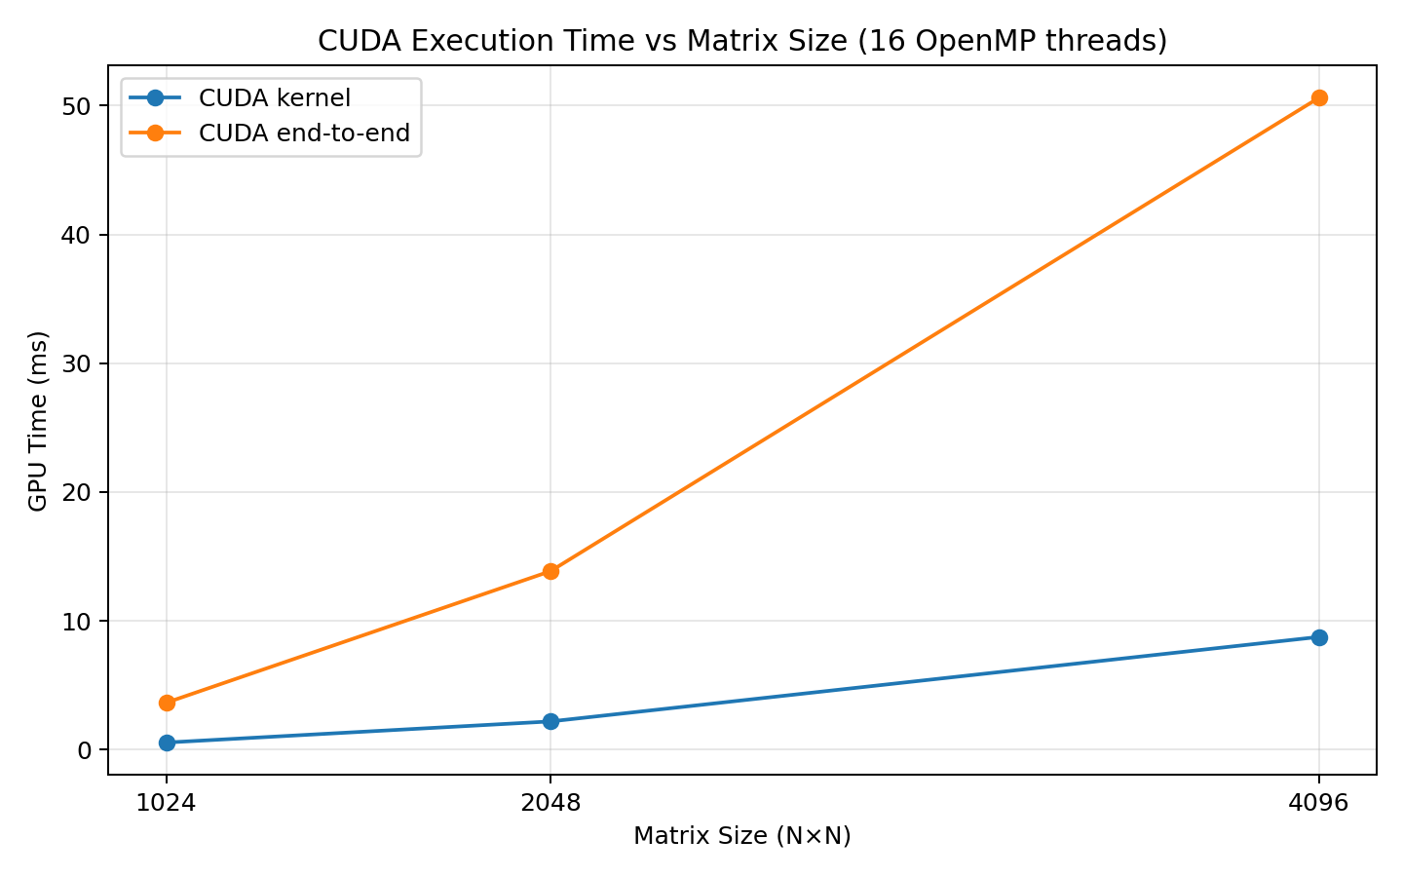
Figure 2. CUDA GPU kernel time vs. matrix size
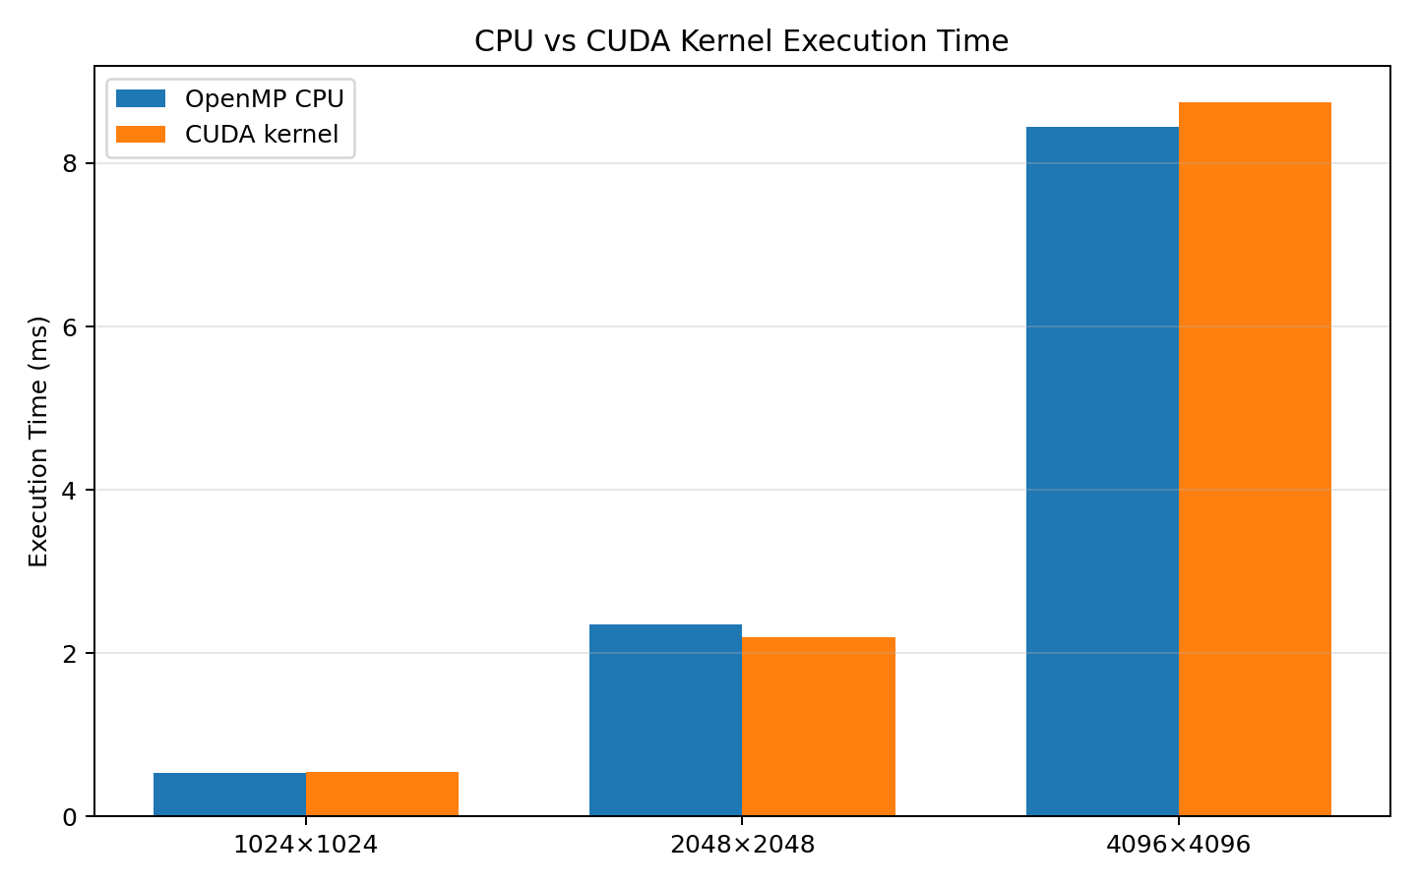
Figure 3. CPU vs. GPU execution-time comparison
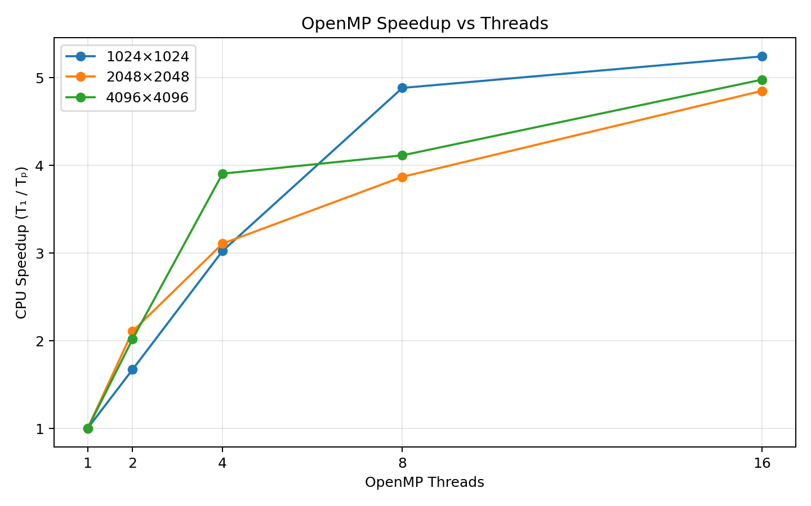
Figure 4. OpenMP CPU speedup vs. thread count
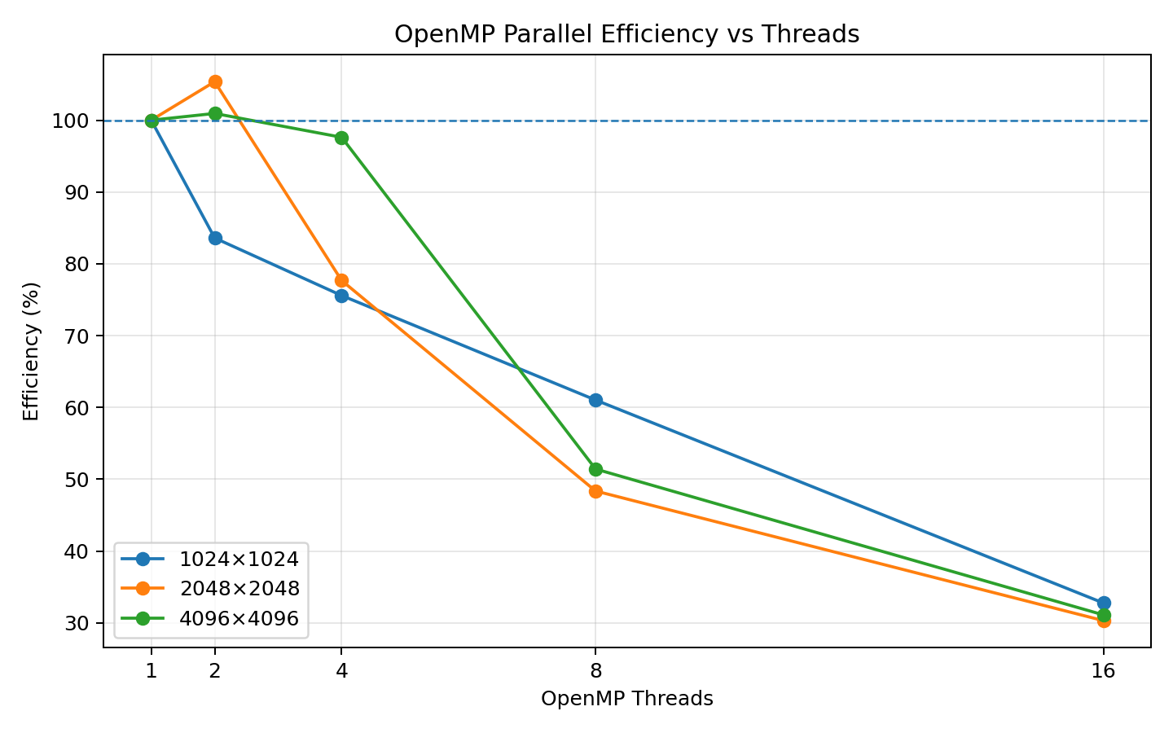
Figure 5. OpenMP CPU efficiency vs. thread count

12. Numerical Verification
Correctness was checked element-by-element. The verification output recorded for the experiments reports maximum error = 0, mean error = 0, and mismatches = 0. The status is therefore PASS for the recorded runs.
Metric | Meaning | Recorded result | Interpretation
Maximum error | Largest |CPU-GPU| difference | 0.000000e+00 | Exact match in recorded comparison
Mean error | Average absolute difference | 0.000000e+00 | No average numerical deviation
Mismatches | Elements exceeding tolerance | 0 | No mismatching elements
Status | Overall verification | PASS | CPU and GPU results agree
Comparison tolerance used by the experiment:
absolute difference <= 1e-5 is accepted as numerically equivalent.
The first ten output values shown in the OpenMP and CUDA execution screenshots are also identical, providing an easy visual spot-check in addition to the full-array verification.

13. Performance Analysis and Discussion

13.1 CPU scaling
Increasing OpenMP thread count generally reduces CPU execution time, although the improvement is not linear. For example, in the clean dataset the 1024 case decreases from 2.8275 ms at 1 thread to 0.5394 ms at 16 threads, while the 4096 case decreases from 42.0165 ms to 8.4423 ms in the original systematic dataset. The reduction becomes less proportional at higher thread counts because of scheduling overhead, memory bandwidth limits, cache behavior and other system effects.

13.2 CPU speedup and efficiency
The CPU speedup increases as threads are added, but efficiency falls because ideal linear scaling would require the speedup to equal the number of threads. The 2048 and 4096 datasets contain a few measured efficiency values slightly above 100% at 2 threads. This does not mean that physical parallel efficiency exceeds the theoretical limit; it is a timing artifact caused by normal CPU frequency, scheduling and measurement variation.

13.3 CUDA kernel vs end-to-end time
CUDA kernel time represents the computation executed on the GPU. End-to-end GPU time additionally includes data movement between host memory and device memory. Therefore, a GPU can have a much faster kernel while still taking longer overall when the amount of transferred data is large relative to the computation.

13.4 Effect of workload size
Larger matrices expose more parallel work and make the computational workload more substantial. They also increase the amount of data that may need to be transferred to and from the GPU. This makes matrix size an important parameter when deciding whether GPU acceleration is beneficial for the complete application.

14. Final Validated 4096 × 4096 Run
After the original experiment sheet was collected, the 4096 × 4096, 16-thread configuration was repeated three times as a controlled validation. The three user-provided runs were:
Run | OpenMP CPU ms | CUDA kernel ms | GPU end-to-end ms | Kernel speedup
1 | 7.0831 | 0.9773 | 16.4578 | 7.2475
2 | 7.1925 | 0.9776 | 16.6435 | 7.3574
3 | 7.1460 | 0.9774 | 17.7465 | 7.3111
Average | 7.1405 | 0.9774 | 16.9493 | 7.31×
The repeated validation gives an average OpenMP CPU time of 7.1405 ms, average CUDA kernel time of 0.9774 ms, and average GPU end-to-end time of 16.9493 ms. The corresponding kernel speedup is approximately 7.31×, while the end-to-end speedup is approximately 0.42×. All three runs reported maximum error 0, mean error 0, mismatches 0 and PASS.
Important reporting note: the original screenshot dataset contains an earlier 4096 × 4096, 16-thread measurement with a CUDA kernel time around 8.75 ms. The later controlled three-run validation consistently measured approximately 0.977 ms for the CUDA kernel. For the final discussion, the repeated validation should be treated as the validated result for this specific configuration rather than silently mixing the two timings.

15. Conclusion
The experiment successfully demonstrates the implementation of the same 2D convolution on a multicore CPU using OpenMP and on an NVIDIA GPU using CUDA. The CPU version distributes output elements among OpenMP threads, while the CUDA version maps output elements to GPU threads organized in 16 × 16 blocks.
The numerical verification is successful: the recorded runs report zero maximum error, zero mean error and zero mismatches. The experiment also shows that performance must be interpreted carefully. CUDA kernel execution can be substantially faster than the CPU computation, while complete GPU execution can be reduced by host-device transfer overhead. OpenMP scaling also demonstrates diminishing returns as thread count rises.
Overall, the laboratory exercise establishes the relationship between algorithmic parallelism, hardware execution models, data movement, correctness verification, and measured performance.

16. Viva / Technical Discussion Points
What is OpenMP? An API for shared-memory parallel programming using CPU threads and compiler directives.
What is CUDA? NVIDIA's platform and programming model for executing parallel kernels on NVIDIA GPUs.
Why is the same random seed used? To generate deterministic input so CPU and GPU process exactly the same data.
Why is the output 4094 × 4094 for a 4096 × 4096 input? For valid convolution with a 3 × 3 kernel and no padding: 4096 − 3 + 1 = 4094.
What does collapse(2) do? It combines the two nested output loops into a single iteration space for OpenMP scheduling.
Why use a 16 × 16 CUDA block? It provides 256 threads per block and is a common two-dimensional mapping for image/matrix-style workloads.
What is kernel speedup? CPU execution time divided by CUDA kernel execution time for the same workload.
Why can end-to-end GPU time be slower than CPU time? Host-to-device and device-to-host transfers add overhead in addition to kernel execution.
What does a mismatch of zero mean? No compared output element differed beyond the experiment's numerical tolerance.
Why does CPU efficiency decrease at high thread counts? Parallel overhead, memory bandwidth, synchronization and other shared-resource limits reduce ideal scaling.
Why can measured efficiency exceed 100% in a small experiment? Timing variation, CPU frequency changes and scheduling effects can make a multi-thread run faster than the idealized baseline ratio; it is not physical >100% efficiency.
Why compare both kernel and end-to-end time? Kernel time isolates GPU computation; end-to-end time reflects the complete application cost including data transfers.

Appendix A — Complete Screenshot Evidence
This appendix includes every screenshot extracted from the uploaded openmp_cuda.docx evidence document, in source order. No screenshot has been omitted.
Appendix screenshot 1 — reproduced from the uploaded evidence document
Appendix screenshot 2 — reproduced from the uploaded evidence document
Appendix screenshot 3 — reproduced from the uploaded evidence document
Appendix screenshot 4 — reproduced from the uploaded evidence document
Appendix screenshot 5 — reproduced from the uploaded evidence document
Appendix screenshot 6 — reproduced from the uploaded evidence document
Appendix screenshot 7 — reproduced from the uploaded evidence document
Appendix screenshot 8 — reproduced from the uploaded evidence document
Appendix screenshot 9 — reproduced from the uploaded evidence document
Appendix screenshot 10 — reproduced from the uploaded evidence document
Appendix screenshot 11 — reproduced from the uploaded evidence document
Appendix screenshot 12 — reproduced from the uploaded evidence document
Appendix screenshot 13 — reproduced from the uploaded evidence document
Appendix screenshot 14 — reproduced from the uploaded evidence document
Appendix screenshot 15 — reproduced from the uploaded evidence document
Appendix screenshot 16 — reproduced from the uploaded evidence document
Appendix screenshot 17 — reproduced from the uploaded evidence document
Appendix screenshot 18 — reproduced from the uploaded evidence document

