PGC Lab Experiment 2
Multithreading Scalability Analysis
Figures arranged in a logical sequence: environment setup, thread creation, synchronization, performance execution, and analysis charts.
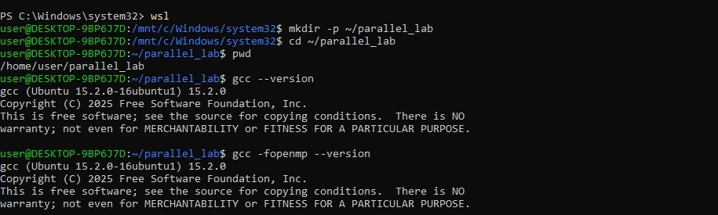
Figure 1: Linux/WSL Environment and GCC Compiler Version Verification

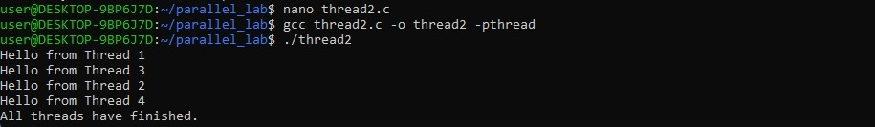
Figure 2: Pthread Thread Creation and Completion Output

Figure 3: Main Thread Execution Example

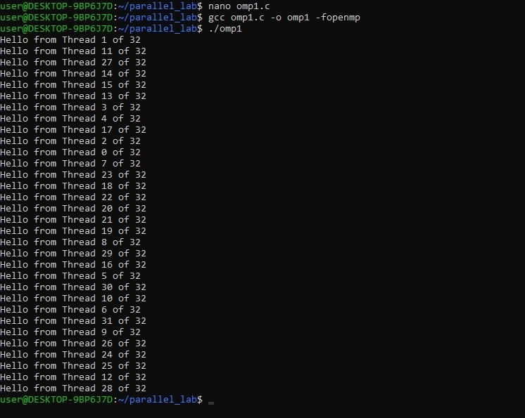
Figure 4: OpenMP Parallel Hello-World Program Output

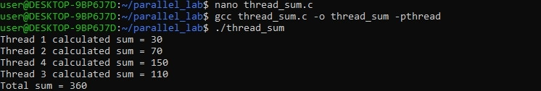
Figure 5: Pthread-Based Array Summation Output

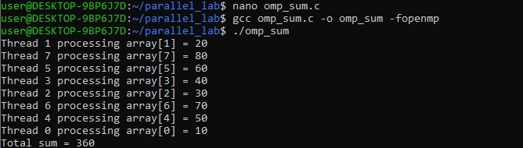
Figure 6: OpenMP Parallel Array Summation Output

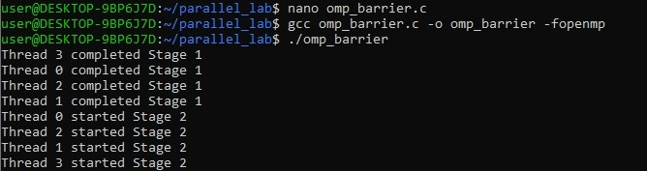
Figure 7: OpenMP Barrier Synchronization Demonstration

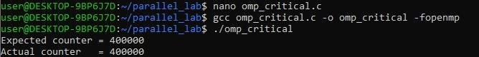
Figure 8: OpenMP Critical Section for Safe Counter Updates

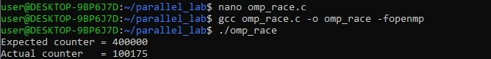
Figure 9: OpenMP Race Condition Demonstration

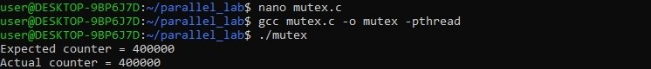
Figure 10: Pthread Mutex-Based Counter Synchronization

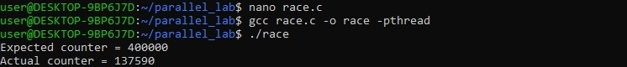
Figure 11: Pthread Race Condition Demonstration

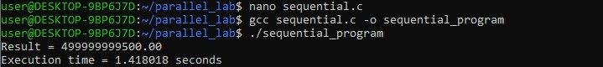
Figure 12: Sequential Baseline Execution and OpenMP Barrier Program Setup

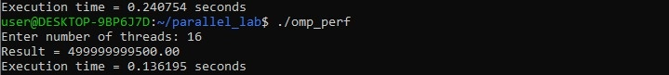
Figure 13: OpenMP Performance Run with 16 Threads

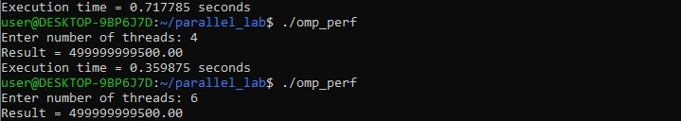
Figure 14: OpenMP Performance Runs with 4 and 6 Threads

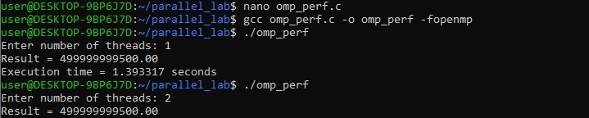
Figure 15: OpenMP Performance Runs with 1 and 2 Threads

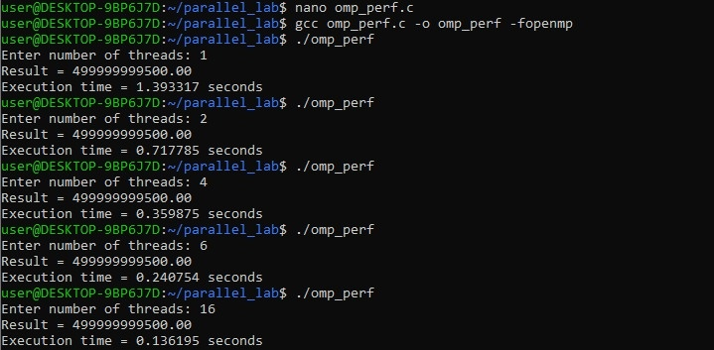
Figure 16: Consolidated OpenMP Performance Results Across Thread Counts

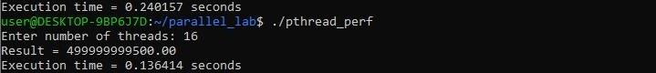
Figure 17: Pthread Performance Run with 16 Threads

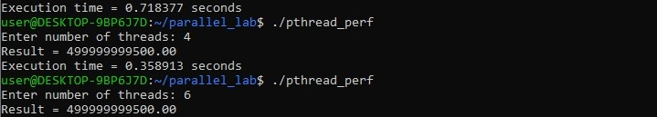
Figure 18: Pthread Performance Runs with 4 and 6 Threads

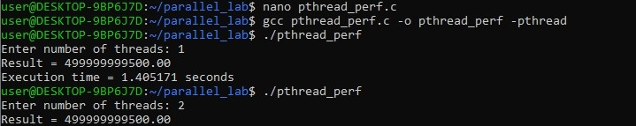
Figure 19: Pthread Performance Program Compilation and Initial Run

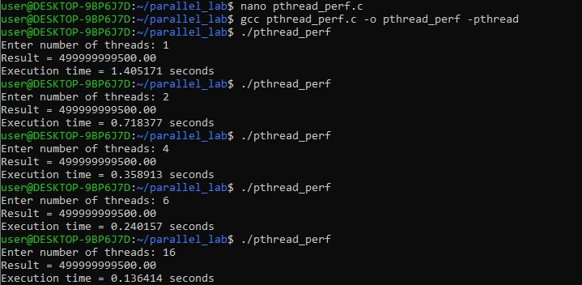
Figure 20: Consolidated Pthread Performance Results Across Thread Counts

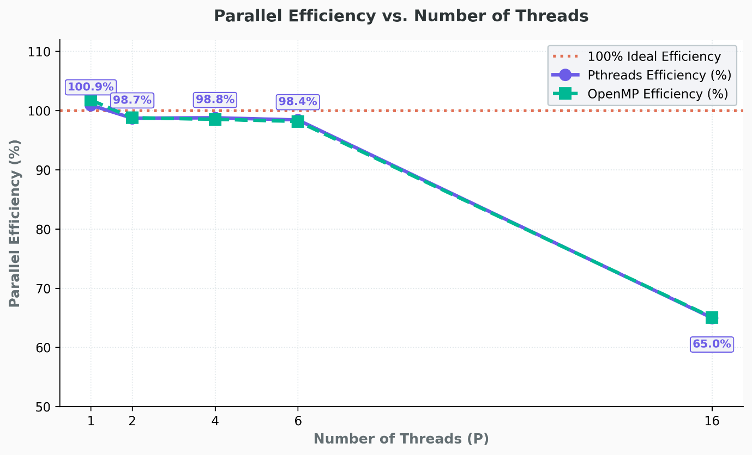
Figure 21: Parallel Efficiency versus Number of Threads

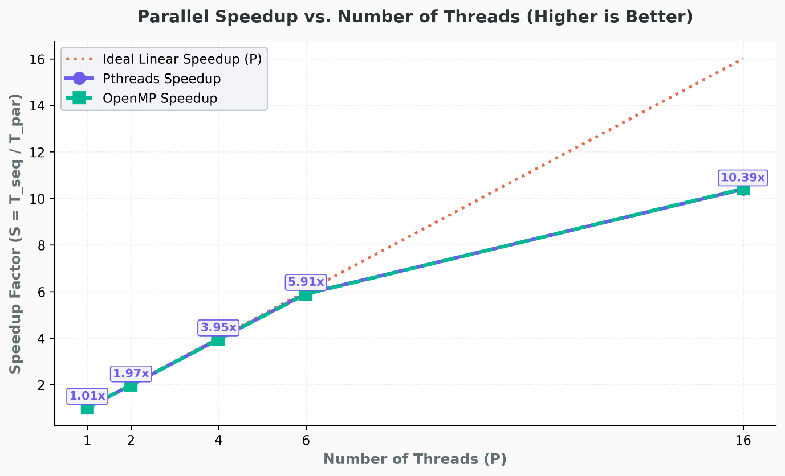
Figure 22: Parallel Speedup versus Number of Threads

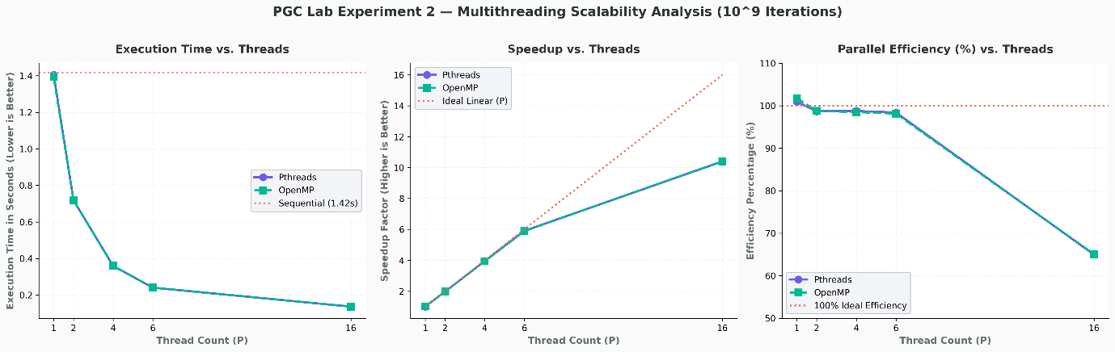
Figure 23: Multithreading Scalability Analysis Dashboard

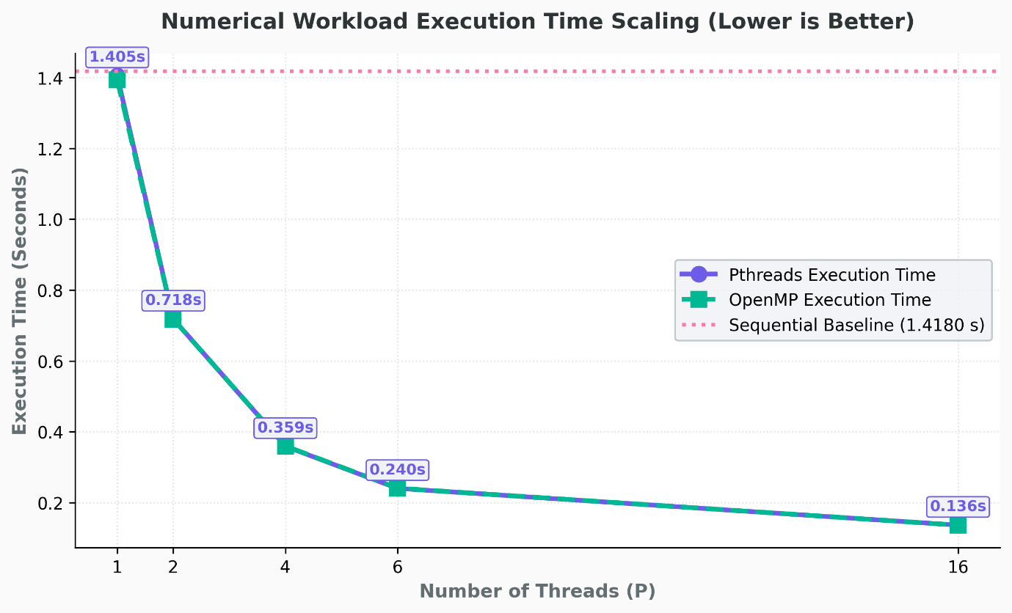
Figure 24: Numerical Workload Execution Time versus Number of Threads

