|  |
| --- |
| **Title: Prepare problem specification related to your mini project** |

**______________________________________________________________________Objective:** Prepare problem definition of a Mini project **______________________________________________________________________**

**Expected Outcome of Experiment:**

|  |  |
| --- | --- |
|  | **At the end of successful completion of the course the student will be able to** |
| CO1 | Define the problem statement and scope of problem |
| CO2 | Identify various hardware and software requirements for problem solution |
| CO5 | Prepare a technical report based on the Mini project. |

**______________________________________________________________________**

**Books/ Journals/ Websites referred:**

**1.**

**2.**

**3.**

**______________________________________________________________________**

**Introduction**:

**As studied in Software Engineering, developing a successful product (software: including the code and documents) needs a systematic approach.** In this experiment you will prepare the basic documents required to develop a product, a software system, a website or a mobile app to provide certain services or facilities.

Students will be required to prepare a document specifying.

**Problem statement: Creating an e voting system using blockchain technology.**

The contemporary company electoral systems face significant challenges, marked by a widespread lack of trust among the populace. Issues such as vote rigging, EVM hacking, and election manipulation persist, even in major democracies like India and the United States. The imperative to enhance the integrity of these systems has become evident, demanding innovative solutions.

To address these concerns, our project aims to leverage blockchain technology in the realm of electronic voting (e-voting). The existing trust deficit in traditional voting systems necessitates a robust, secure, and transparent alternative. Blockchain, with its decentralized and immutable nature, emerges as a promising solution to mitigate the flaws plaguing current electoral processes. Our objective is to implement and test a blockchain-based e-voting application, utilizing the Ethereum platform and Solidity language, to ensure security, transparency, and the privacy of voters.

**Motivation:**

The motivation behind our project stems from the need to address issues undermining the credibility of current company electoral systems. Key motivating factors include:

* **Distrust in Traditional Voting Systems:**
  + Widespread skepticism and lack of trust among citizens in existing electoral processes.
  + Instances of vote rigging, EVM hacking, and other malpractices have eroded confidence in democratic systems globally.
* **Importance of Elections in any company:**
  + Recognizing the pivotal role elections play in determining the fate of the candidates and thus the company
  + Acknowledging the significance of a transparent and secure electoral process in upholding the principles of fair and just elections.
* **Technological Solutions for Modern Challenges:**
  + Embracing technology as an enabler for overcoming challenges in the democratic process.
  + Understanding that traditional methods fall short in ensuring the integrity, security, and transparency needed for a fair and reliable election.
* **Blockchain's Potential in Enhancing Trust:**
  + Recognizing blockchain as a transformative, decentralized technology with the ability to address trust issues in various industries.
  + The motivation to explore and harness blockchain's capabilities to create a secure, transparent, and tamper-resistant e-voting system.

By combining these motivations, our project aspires to contribute to the evolution of a more trustworthy, efficient, and technologically advanced electoral system, thereby reinforcing the foundations of democratic governance.

**Objectives of the Project:**

* Implementing a Blockchain-Based E-Voting System:
  + Develop and deploy a functional e-voting system built on blockchain technology.
* Enhancing Security and Transparency:
  + Ensure the security of the voting process by leveraging the decentralized and tamper-resistant nature of blockchain.
  + Integrate transparency measures to foster trust in the electoral system.
* Utilizing Ethereum and Solidity:
  + Implement the e-voting application using the Ethereum platform and the Solidity programming language, capitalizing on the capabilities of smart contracts.
* Addressing Trust Issues in Elections:
  + Alleviate concerns related to vote rigging, hacking, and manipulation by providing a secure and transparent platform for voters.
* Preserving Voter Privacy:
  + Design the system to safeguard the privacy of voters while maintaining the transparency required for a democratic process.
* Verification and Validation:
  + Conduct thorough testing to validate the functionality and security of the e-voting application.
* Ease of Use:
  + Ensure that the e-voting system is user-friendly, allowing voters to participate in the process with ease and convenience.
* Documentation and Knowledge Transfer:
  + Create comprehensive documentation for the implemented system to facilitate understanding and knowledge transfer.

**Scope of the project:**

**Blockchain-Based E-Voting Application:**

* + The project focuses on the development of a complete e-voting application utilizing blockchain technology.

**Ethereum Platform and Solidity Language:**

* + The implementation specifically utilizes the Ethereum platform and the Solidity programming language for creating smart contracts.

**Decentralized and Tamper-Resistant System:**

* + Leveraging the decentralized and tamper-resistant nature of blockchain to enhance the security and integrity of the voting process

**Privacy-Preserving Design:**

* + Incorporating measures to protect voter privacy while maintaining transparency and traceability in the blockchain.

**User-Friendly Interface:**

* Designing the e-voting system with a user-friendly interface to encourage widespread participation.

**Potential for Future Scaling:**

* Designing the system with scalability in mind, allowing for potential expansion and adaptation to larger-scale elections.

**Hardware requirements (for development)**

1. **Processor:**
   1. **Justification:** A processor with a minimum speed of 3.5 GHz ie Ryzen 3 4th gen or i5 10th gen - is recommended to ensure efficient execution of the Ethereum development environment and associated tools. Solid processing power is essential for compiling and running complex smart contracts during development.
2. **RAM:**
   1. **Justification:** A minimum of 8 GB RAM is necessary to support the simultaneous operation of the development tools, Ethereum node, and other components. Ample RAM ensures smooth performance and responsiveness during the development and testing phases.
3. **Storage:**
   1. **Justification:** Adequate storage, preferably a 1TB HDD, is crucial for storing development tools, Ethereum blockchain data, and project files. Blockchain development involves substantial data storage requirements, and having sufficient space helps in maintaining a smooth workflow.
4. **Development Environment:**
   1. **Justification:** The hardware should be capable of supporting the development tools required for Ethereum and Solidity. This includes compilers, Ethereum nodes, and related software components. A robust development environment is essential for efficient coding, testing, and debugging.

**Software requirements (for development) (Tech Stack)**

1. **Solidity/Web3 (for writing/connecting the Blockchain contract):**
   1. **Solidity:**
      1. **Justification:** Solidity is specifically designed for writing smart contracts on the Ethereum blockchain. It provides the necessary tools and syntax for creating secure and decentralized applications.
   2. **Web3.js:**
      1. **Justification:** Web3.js allows seamless interaction between the front-end application and the Ethereum blockchain, enabling the execution of smart contracts and retrieval of blockchain data.
2. **Next.js & Semantic UI React (front-end):**
   1. **Next.js:**
      1. **Justification:** Next.js is a React framework that facilitates the creation of server-side rendered and statically generated web applications. It enhances performance and provides a smooth development experience.
   2. **Semantic UI React:**
      1. **Justification:** Semantic UI React is a user interface framework that simplifies the design process by offering pre-designed components. It ensures a consistent and visually appealing front-end.
3. **MongoDB/ExpressJS/Node.js (back-end):**
   1. **MongoDB:**
      1. **Justification:** MongoDB, a NoSQL database, is chosen for its scalability and flexibility. It allows the storage of diverse data types and supports rapid development.
   2. **ExpressJS/Node.js:**
      1. **Justification:** The Express.js framework, coupled with Node.js, provides a robust and scalable back-end infrastructure. It facilitates the creation of RESTful APIs, ensuring smooth communication between the front-end and the database.
4. **IPFS (file storage for images):**
   1. **Justification:** IPFS (InterPlanetary File System) is employed for decentralized and distributed file storage. It ensures the availability and integrity of images used in the application, reducing reliance on a centralized server.
5. **Operating System:**
   1. **Justification:** Windows 7 or a compatible operating system is chosen based on its widespread use and compatibility with the Ethereum development tools. It provides a stable and supported environment for blockchain application development.

**Hardware and software requirements (for deployment)**

**Version Control - Git:**

**Justification:** Git is a widely used version control system that facilitates collaboration, tracks changes, and ensures code integrity throughout the development process.

**Type of Application: Web / PWA/ Desktop/ Mobile (Android)/other**

The proposed blockchain-based e-voting system will be developed as a **Web Application**. The system will be accessible through web browsers, enabling users to participate in the voting process using their desktop computers, laptops, tablets, or mobile devices with internet connectivity.

The choice of a web application will offer several advantages, including cross-platform accessibility, ease of deployment, and the ability for voters to cast their votes from various devices with internet access. Additionally, a web application will provide a user-friendly interface for the registration process, voting, and accessing live voting status.

It's important to note that the system can be accessed on different devices with a web browser, making it versatile and convenient for users. The development will leverage web technologies, such as HTML5 and Bootstrap, to ensure a responsive and adaptive user interface suitable for different screen sizes.

While the primary interface will be web-based, users will also have the option to interact with the system through MetaMask, a browser extension that will allow the execution of Ethereum decentralized applications (dApps) directly within the browser. This approach will provide a seamless and secure connection between the web application and the Ethereum blockchain.

**Literature survey**

Through an in-depth survey of existing literature and research on blockchain-based e-voting systems, several key findings have emerged:

* Challenges in Traditional Voting Systems:
  + Current voting systems, even in large democracies like India and the United States, face challenges such as vote rigging, EVM hacking, election manipulation, and concerns about the overall integrity of the electoral process. On a smaller scale, companies struggle with hosting just elections. It is a time consuming task.
* Trust Issues and the Need for Innovation:
  + Widespread distrust in traditional voting systems has highlighted the urgent need for innovative solutions to enhance transparency, security, and trust in the electoral process.
* Blockchain Technology as a Solution:
  + Blockchain technology has emerged as a promising and decentralized solution to address the shortcomings of existing voting systems. Its features, such as immutability, transparency, and smart contracts, make it a suitable candidate for building secure and transparent e-voting systems.
* Use of Ethereum and Smart Contracts:
  + Ethereum, with its robust blockchain and smart contract capabilities, is identified as a suitable platform for developing e-voting systems. Smart contracts enable secure and automated execution of voting processes, reducing the risk of manipulation.
* Decentralization and Transparency:
  + Blockchain's inherent decentralized nature ensures that no single entity has control over the entire voting process. This decentralization contributes to increased transparency and trust in the electoral system.
* Security Measures:
  + The use of cryptographic techniques, such as hash values and digital signatures, enhances the security of the e-voting system. These measures prevent data manipulation and ensure the integrity of the voting results.
* Previous Research Contributions:
  + Various research papers and projects, such as "Votereum," "Decentralized Voting Platform Based on Ethereum Blockchain," and "Blockchain-Based E-Voting System," have explored the potential of blockchain in creating more secure, transparent, and efficient e-voting systems.
* Integration with Existing Systems:
  + Proposed e-voting systems aim to integrate with current voting systems rather than completely replace them. This approach is designed to minimize confusion and resistance, leveraging the familiarity of voters with the existing processes.
* Technological Components:
  + A typical e-voting system based on blockchain involves components like smart contracts, Ethereum network, Web3.js for interaction, and additional technologies like AES algorithm for encryption and IPFS for decentralized file storage.
* Development and Deployment Tech Stack:
  + The development tech stack often includes Solidity for smart contracts, HTML/Bootstrap for the user interface, MySQL for the database, and deployment may involve technologies such as Nginx, Node.js, MongoDB, and IPFS.
* Security and Privacy Considerations:
  + The proposed systems prioritize security, privacy, and prevention of duplicate votes. Techniques like AES algorithm, digital signatures, and secure registration processes contribute to the overall robustness of the e-voting solution.

In conclusion, the survey underscores the potential of blockchain technology, particularly Ethereum, in revolutionizing e-voting systems. The findings emphasize the importance of addressing trust issues, enhancing transparency, and leveraging innovative technologies to ensure the integrity of democratic processes in the digital age. The ongoing research and development in this field signal a positive shift toward more secure and reliable e-voting solutions.

**References:**

**https://ieeexplore.ieee.org/document/9491734**

[**https://ieeexplore.ieee.org/document/9670245**](https://ieeexplore.ieee.org/document/9670245)

[**https://ieeexplore.ieee.org/document/9887759**](https://ieeexplore.ieee.org/document/9887759)

[**https://ieeexplore.ieee.org/document/10169552**](https://ieeexplore.ieee.org/document/10169552)

[**https://ieeexplore.ieee.org/document/10053410**](https://ieeexplore.ieee.org/document/10053410)

[**https://ieeexplore.ieee.org/document/10125883**](https://ieeexplore.ieee.org/document/10125883)

[**https://www.investopedia.com/terms/b/blockchain.asp**](https://www.investopedia.com/terms/b/blockchain.asp)

**Plan:**

Planning is very essential for successful completion of any activity in which multiple stakeholders are involved. To start with one will write down all activities needed to be carried out mentioning the role and responsibility of each human resource. This will also help in sequencing and tracking the progress of the development process. A sample Role and Responsibility matric could be as follows, Please prepare according to needs of your project.

(Sample plan)

|  |  |  |  |  |
| --- | --- | --- | --- | --- |
| Activity | R1 | R2 | R3 | Mentor |
| **1.** **Requirement Gathering** |  |  |  |  |
| 1.1 Interaction with customer | C | C | C | A |
| 1.2 Preparing SRS | C | C | C | A |
| **2.** **Design** |  |  |  |  |
| 2.1 Preparing Block diagram | C | C | R | A |
| 2.2 Writing Functional Requirements | C | R | C | A |
| 2.3 Writing Non-Functional Requirements | R | C | C | A |
| 2.4 Developing Use Case | C | C | R | A |
| 2.5 Developing Test Cases | R | C | C | A |
| 1. **Planning** |  |  |  |  |
| 1. **Coding** |  |  |  |  |
| 4.1 Unit 1 | C | R | R | A |
| 4.2 Unit 2 | R | C | R | A |
| 4.3 Front end/ UI | R | C | C | A |
| 1. **Testing** |  |  |  |  |
| 5.1 Unit 1 | E | A | E |  |
| 5.2 Unit 2 | A | E | E |  |
| 5.3 System Testing | E | E | E | A |

C: Creator, R: Reviewer, A: Approver E: Executor

Also prepare timeline chart which will help to assign resources, deadlines etc. This will also help in monitoring and tracking the progress of the project.

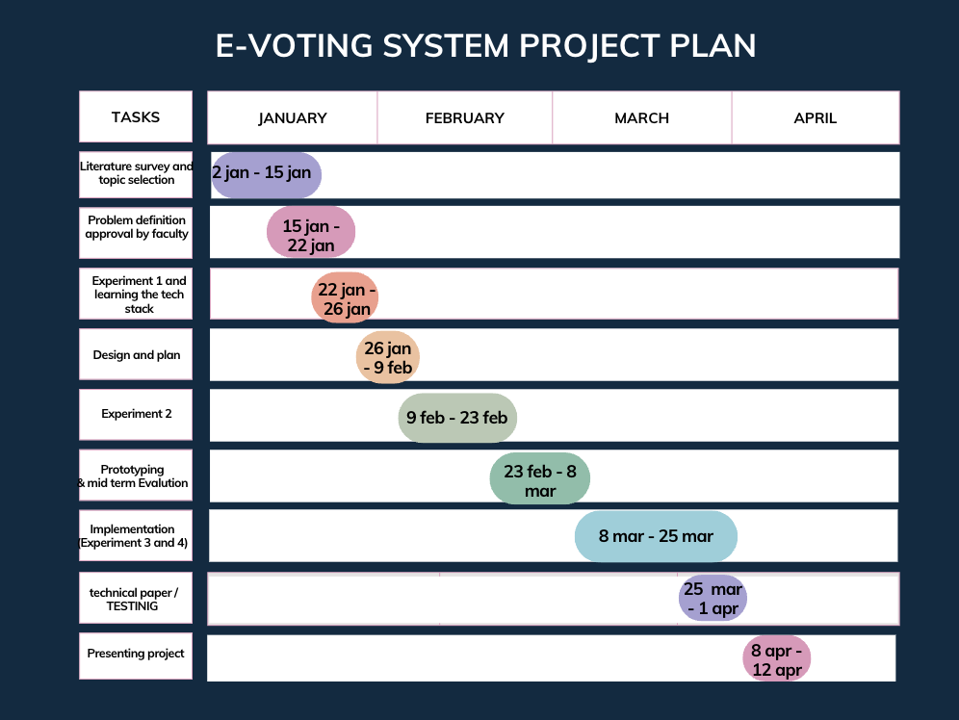



**Conclusion:**

The survey on blockchain-based e-voting systems has brought to light critical challenges in traditional voting mechanisms, including issues such as vote rigging and EVM hacking, leading to widespread distrust in major democracies like India and the United States. In response, blockchain technology has emerged as a viable solution, offering attributes like immutability, transparency, and the implementation of smart contracts. Ethereum, recognized for its robust blockchain and smart contract capabilities, stands out as an appropriate platform for developing secure and transparent e-voting systems. The survey highlights cryptographic techniques, such as hash values and digital signatures, as crucial security measures to prevent data manipulation and ensure the integrity of voting results. Privacy considerations and the prevention of duplicate votes are also prioritized in the proposed blockchain-based e-voting systems. Moreover, the survey emphasizes the integration of these systems with existing processes to minimize confusion and resistance, leveraging the familiarity of voters with current voting systems. Overall, the findings underscore the potential of blockchain technology to revolutionize e-voting, providing enhanced security, transparency, and efficiency in democratic processes without explicitly mentioning specific research paper names. Ongoing research and development in this area signal a positive shift toward more reliable e-voting solutions tailored for the digital age. Moreover , our e voting system will haave the future scope of executing at a national level.