## Page:1

# Introduction-To-Database

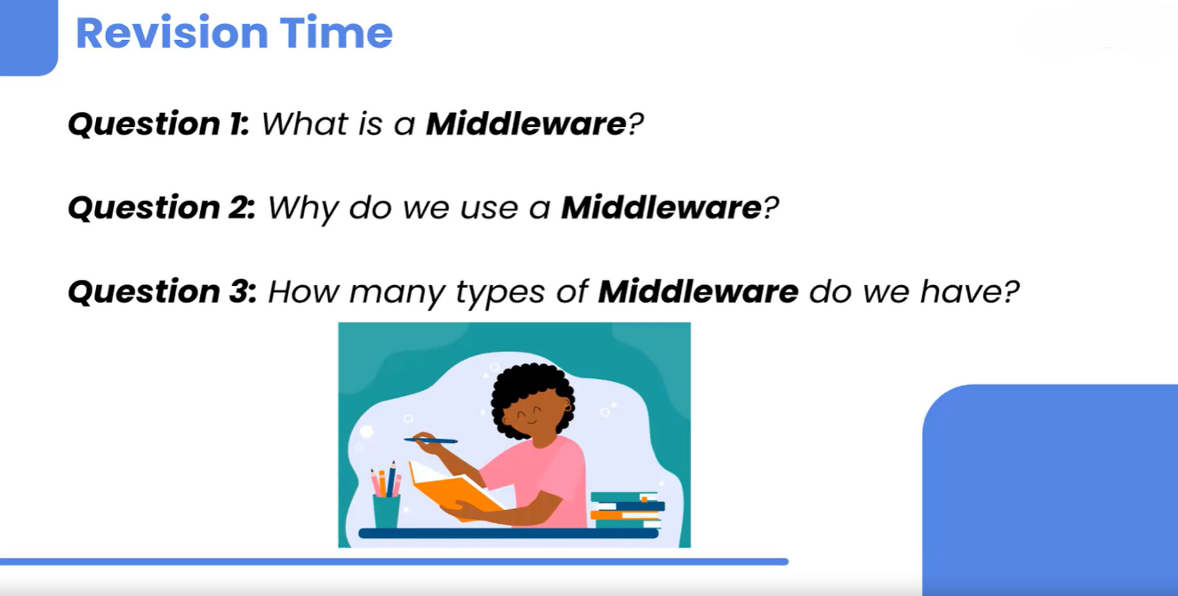

What is Middleware in Node.js? 🤔

Middleware in Node.js is a function that sits between the request made by the client and the response sent by the server. It’s a powerful feature that allows you to handle various tasks, such as request validation, authentication, logging, and error handling, before the request reaches the final route handler or after the response is sent.

# Why Do We Use Middleware? 🚀

Middleware is used for several reasons:

1. **Modularity**: Middleware functions help break down your application logic into smaller, manageable pieces, making your code more modular and easier to maintain.
2. **Reusability**: You can reuse middleware functions across different routes, reducing code duplication.
3. **Flexibility**: Middleware provides a flexible way to manage tasks that need to be executed before or after the main logic of your application, such as handling authentication or logging.
4. **Error Handling**: Middleware can also be used to catch and manage errors, ensuring they are handled gracefully and consistently across your application

## Page:2

# Conclusion 🎯

Middleware in Node.js is essential for handling a variety of tasks in a structured and efficient way. By understanding and utilizing different types of middleware, you can greatly enhance the functionality, security, and maintainability of your application.



## Difference Between Query and Param in URLs 🌐

In web development, both **query parameters** and **route parameters (params)** are used to pass data in a URL, but they serve different purposes and are used in different contexts.

**1. Query Parameters 🔍**

* **Location**: Query parameters are part of the URL after the question mark (?).
* **Usage**: They are typically used to filter, sort, or provide additional data to a resource without changing the URL structure.
* **Format**: Key-value pairs separated by &. The key and value are separated by =.

**Example:**

plaintextCopy code

https://example.com/products?category=books&sort=price

In this example:

* category=books is a query parameter that might filter products to show only books.
* sort=price could be used to sort the results by price.

**2. Route Parameters (Params) 🛤️**

## Page:3

* **Location**: Route parameters are part of the URL path itself, typically used to identify a specific resource.
* **Usage**: They are used to capture dynamic values in the URL that are part of the route.
* **Format**: Defined in the route with a colon (:) and are part of the URL path.

**Example:**

plaintextCopy code

<https://example.com/products/12345>

In this example:

* 12345 is a route parameter that might represent the ID of a specific product.

## Simple Example in Express.js 🚀

Here's a simple Express.js application demonstrating both query and route parameters:

javascriptCopy code

const express = require('express');

const app = express();

// Route with Route Parameter (Param)

app.get('/products/:id', (req, res) => {

const productId = req.params.id; // Accessing route parameter

res.send(`Product ID: ${productId}`);

});

// Route with Query Parameters

app.get('/search', (req, res) => {

## Page:4

const category = req.query.category; // Accessing query parameter

const sort = req.query.sort; // Accessing query parameter

res.send(`Category: ${category}, Sort by: ${sort}`);

});

app.listen(3000, () => {

console.log('Server is running on port 3000');

});

* **URL Example 1**: http://localhost:3000/products/12345
  + **Output**: Product ID: 12345 (Route Parameter)
* **URL Example 2**: http://localhost:3000/search?category=books&sort=price
  + **Output**: Category: books, Sort by: price (Query Parameters)

## Summary 📝

* **Query Parameters** are used to pass optional data to the server and are typically used for filtering or sorting.
* **Route Parameters** are part of the URL path and are used to capture specific values that identify resources.

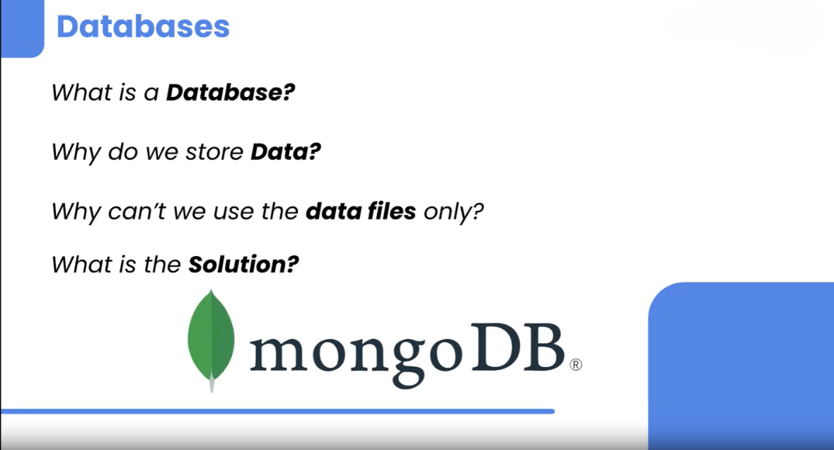

## Page:5

**What is a Database? 🗄️**

A **database** is an organized collection of structured information, or data, that is stored electronically in a computer system. Databases are managed by database management systems (DBMS) and are designed to store, retrieve, and manage large amounts of data efficiently. They allow users to easily access, manipulate, and manage data through queries and operations.

**Why Do We Store Data? 💾**

We store data for several important reasons:

1. **Persistence**: Data needs to be saved so it can be retrieved and used later, even after the application or system is turned off.
2. **Efficiency**: Storing data in a database allows for quick and efficient retrieval, manipulation, and storage, which is crucial for performance, especially with large datasets.
3. **Data Integrity**: Databases help ensure data is consistent and accurate by providing mechanisms like constraints, transactions, and backups.
4. **Scalability**: As the amount of data grows, databases are designed to handle large volumes of data and multiple users accessing the data simultaneously.
5. **Security**: Databases provide various security features like encryption, authentication, and access control to protect sensitive information.

**Why Can't We Use Data Files (like db.json) Only? 📄**

While using a simple data file like db.json can work for small-scale projects or testing purposes, it has significant limitations:

1. **Scalability Issues**: As the amount of data grows, accessing and managing data in a flat file becomes slow and inefficient.
2. **Concurrency Problems**: Flat files do not handle multiple users or processes accessing the file at the same time very well. This can lead to data corruption or loss.
3. **Lack of Advanced Features**: Databases provide powerful features such as indexing, querying, transactions, and relationships between data, which are not available with simple data files.
4. **Data Integrity**: Ensuring data consistency and integrity is more challenging with flat files, especially in scenarios where data needs to be updated or deleted.
5. **Security**: Flat files do not offer robust security mechanisms like encryption, role-based access control, or auditing, which are essential for protecting sensitive data.

## Page:6

# What is the Solution? ✅

The solution to these limitations is to use a **Database Management System (DBMS)**, which provides a structured way to store, retrieve, and manage data. Depending on the use case, you can choose between different types of databases:

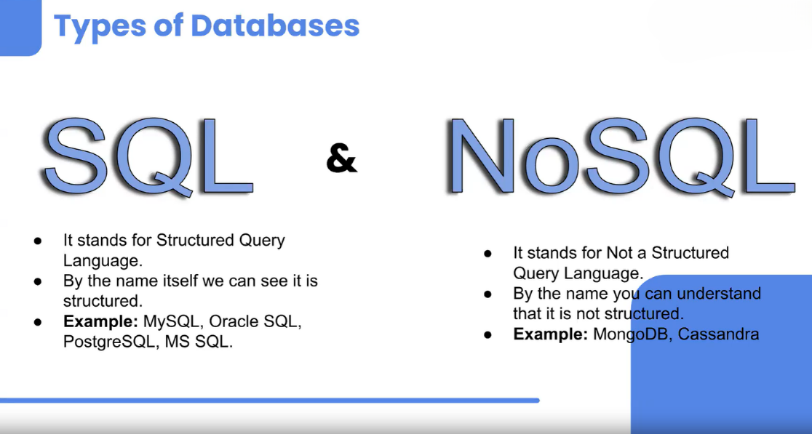

1. **Relational Databases** (e.g., MySQL, PostgreSQL) 🗃️: Use tables to store data and SQL for querying. They are ideal for applications requiring complex queries and transactions.
2. **NoSQL Databases** (e.g., MongoDB, Cassandra) 🌐: Use a variety of data models, including document, key-value, graph, or wide-column stores. They are ideal for unstructured data or applications that require high scalability.

## Page:7

## What is an SQL Database? 🗃️

An **SQL database** is a type of database that uses **Structured Query Language (SQL)** for defining, manipulating, and querying data. SQL databases are also known as **relational databases** because they store data in tables that are related to each other through keys. These databases are widely used in various applications due to their ability to handle large amounts of structured data and support complex queries and transactions.

What is MongoDB? 🍃

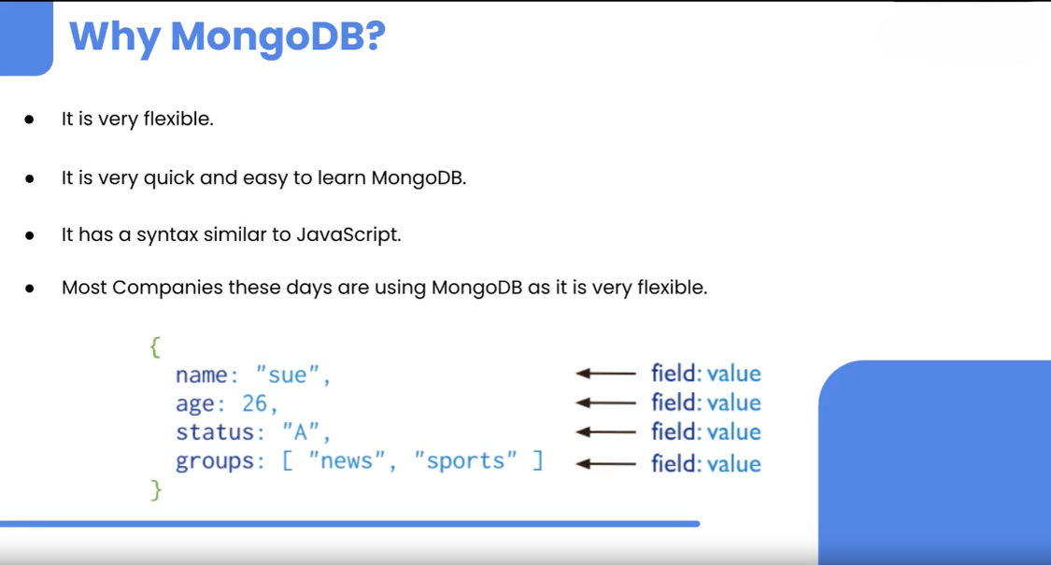

**MongoDB** is a popular **NoSQL** database known for its flexibility, scalability, and ease of use. Unlike traditional SQL databases, MongoDB is a **document-oriented** database, which means it stores data in a format similar to JSON (JavaScript Object Notation) called **BSON** (Binary JSON). This allows for a more flexible and dynamic data model, making MongoDB an excellent choice for applications that require handling large amounts of unstructured or semi-structured data.

## Page:8

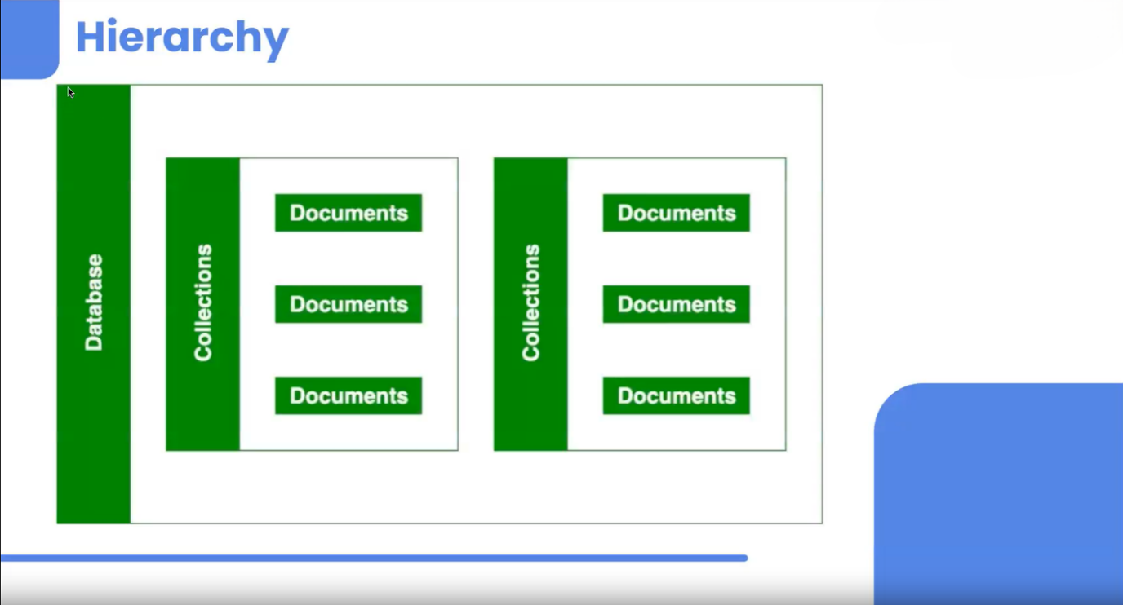

**Key Features of MongoDB 🎯**

1. **Document-Oriented** 📄:
   * MongoDB stores data as **documents** in collections, where each document is a set of key-value pairs. Documents are similar to JSON objects and can contain nested fields, arrays, and more complex data types.
2. **Schema Flexibility** 🛠️:
   * MongoDB is **schema-less**, meaning documents within the same collection can have different structures. This flexibility allows developers to iterate quickly without needing to define a rigid schema upfront.
3. **Scalability** 📈:
   * MongoDB supports horizontal scaling through a process called **sharding**, where data is distributed across multiple servers. This makes MongoDB well-suited for handling large-scale, high-throughput applications.
4. **High Availability** ⏱️:
   * MongoDB provides **replication** via replica sets, which ensures data redundancy and high availability. A replica set consists of a primary node and multiple secondary nodes, where data is replicated across all nodes.
5. **Rich Query Language** 🔍:
   * MongoDB supports a powerful query language that allows for filtering, sorting, and aggregating data. It also supports indexing, which improves query performance.
6. **Aggregation Framework** 🔄:
   * MongoDB's aggregation framework enables complex data processing and transformation, similar to SQL's GROUP BY and JOIN operations, but designed for document data.

## Page:9

1. **Geospatial Data** 🌍:
   * MongoDB has built-in support for geospatial queries, making it a popular choice for applications dealing with location-based data.
2. **Built-in Support for JSON-like Storage** 📦:
   * Since MongoDB uses BSON, which is a binary representation of JSON-like documents, it naturally integrates with modern web technologies that use JSON.

# Essential MongoDB Terminal Commands: A Quick Reference Guide 🚀

## 1. **Create a Database** 🏗️

In MongoDB, databases are created automatically when you insert data into them. You just need to switch to the database name you want to create.

bashCopy code

use myNewDatabase

This command switches to (or creates) the database named myNewDatabase.

**2. Show Databases 📂**

To list all databases in your MongoDB server, use:

bashCopy code

show dbs

This will display a list of all existing databases.

**3. Insert a Single Document 📝**

To insert a single document (record) into a collection:

bashCopy code

db.myCollection.insertOne({ name: "John Doe", age: 30, city: "New York" })

This command inserts a single document into the myCollection collection in the currently selected database. If the collection does not exist, it will be created automatically.

**4. Insert Multiple Documents 📝📝📝**

## Page:10

To insert multiple documents into a collection:

bashCopy code

db.myCollection.insertMany([

{ name: "Alice", age: 28, city: "Los Angeles" },

{ name: "Bob", age: 32, city: "Chicago" },

{ name: "Charlie", age: 25, city: "San Francisco" }

])

This command inserts multiple documents into the myCollection collection.

**5. Show Collections 📋**

To list all collections within the currently selected database:

bashCopy code

show collections

This command will display all collections within the current database.

**6. Find Documents 🔍**

To retrieve all documents from a collection:

bashCopy code

db.myCollection.find()

This command returns all documents within the myCollection collection.

**7. Find Documents with a Filter 🔍🔍**

To retrieve documents that match a specific filter:

bashCopy code

db.myCollection.find({ city: "New York" })

This command returns all documents where the city field is "New York".

## Page:11

**8. Update a Document 🛠️**

To update a single document in a collection:

bashCopy code db.myCollection.updateOne( { name: "John Doe" }, // Filter { $set: { age: 31 } } // Update operation )

This command updates the age field of the document where the name is "John Doe".

**9. Delete a Document ❌**

To delete a single document from a collection:

bashCopy code

db.myCollection.deleteOne({ name: "Charlie" })

This command deletes the document where the name is "Charlie".

**10. Drop a Collection 🗑️**

To delete a collection from the database:

bashCopy code

db.myCollection.drop()

This command removes the myCollection collection from the current database.

**11. Drop a Database 🗑️**

To delete an entire database:

bashCopy code

db.dropDatabase()

This command deletes the currently selected database.

## Page:12

## Summary 📝

* **use myNewDatabase**: Creates or switches to a database.
* **show dbs**: Lists all databases.
* **db.myCollection.insertOne()**: Inserts a single document.
* **db.myCollection.insertMany()**: Inserts multiple documents.
* **show collections**: Lists all collections in a database.
* **db.myCollection.find()**: Retrieves documents.
* **db.myCollection.updateOne()**: Updates a document.
* **db.myCollection.deleteOne()**: Deletes a document.
* **db.myCollection.drop()**: Deletes a collection.
* **db.dropDataba**