# Page:1

# INTRO-To-NODE.js(Lecture-1)

# 

# 1. Basic Knowledge of JavaScript

Node.js uses JavaScript, so a strong understanding of JavaScript fundamentals is crucial. This includes:

* **Syntax and Operators**: Familiarity with JavaScript syntax, operators, and expressions.
* **Variables and Data Types**: Understanding of how to declare variables and the different data types (string, number, boolean, object, array, etc.).
* **Functions**: Ability to write and understand functions, including arrow functions, callback functions, and higher-order functions.
* **Control Flow**: Knowledge of loops (for, while), conditional statements (if, else), and error handling (try, catch).
* **ES6+ Features**: Familiarity with modern JavaScript features such as let/const, template literals, destructuring, spread/rest operators, classes, and modules.

# 2. Understanding of Asynchronous Programming

Node.js heavily relies on asynchronous programming. Key concepts include:

# Page:2

* **Callbacks**: Functions passed as arguments to other functions that are invoked when an asynchronous operation completes.
* **Promises**: Objects representing the eventual completion (or failure) of an asynchronous operation and its resulting value.
* **async/await**: Syntactic sugar for working with promises, making asynchronous code look and behave more like synchronous code.

# **3. Basic Knowledge of HTML and CSS**

While Node.js is used for server-side programming, understanding how the front end works is beneficial. Basic knowledge of HTML and CSS is essential for:

* **Serving Static Files**: Understanding how to serve HTML, CSS, and JavaScript files to clients.
* **Integrating with Front-End Frameworks**: Working with front-end technologies like React, Angular, or Vue.js.

# 4. Understanding of HTTP and RESTful APIs

Node.js is commonly used to build web servers and APIs. Understanding HTTP and RESTful principles is essential:

* **HTTP Methods**: GET, POST, PUT, DELETE, etc.
* **Status Codes**: Familiarity with common HTTP status codes (200, 404, 500).
* **Headers and Body**: Understanding how to work with HTTP headers and request/response bodies.

# 5. Understanding of JSON

Node.js applications frequently work with JSON (JavaScript Object Notation) for data interchange. Understanding how to read and write JSON is crucial.

## Client-Server Model

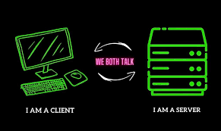

# Page:3

# The Client-Server Model

The client-server model is a foundational concept in network computing and is used extensively in modern web applications. It describes the relationship between two primary entities: clients and servers.

**Key Concepts**

* **Client**: The client is a device or application that requests services or resources from a server. Clients are typically web browsers, mobile applications, or other network-enabled devices. The client's primary role is to interact with the user and send requests to the server.
* **Server**: The server is a device or application that provides services or resources to clients. Servers handle the business logic, database interactions, and provide the requested resources back to the client. They are responsible for processing incoming requests, performing necessary operations, and sending the appropriate responses back to the clients.

**How the Client-Server Model Works**

1. **Request**: The client initiates a request to the server. This could be an HTTP request for a web page, a database query, or any other type of request for resources or services.
2. **Processing**: The server receives the client's request and processes it. This processing might involve querying a database, performing calculations, accessing files, or other operations.
3. **Response**: After processing the request, the server sends a response back to the client. This response could be the requested data, an HTML page, a file, or a status message.

**Example Workflow**

Let's take a simple example of a user logging into a website.

1. **Client Side**:
   * The user opens their web browser (the client).
   * They enter their username and password on the login page and click the "Login" button.
   * The browser sends an HTTP POST request to the server with the login credentials.
2. **Server Side**:
   * The server receives the login request.
   * It validates the username and password against the database.
   * If the credentials are valid, the server creates a session for the user and sends back a response indicating successful login.
   * If the credentials are invalid, the server sends a response indicating an error.
3. **Client Side**:
   * The browser receives the response from the server.

# Page:4

* + If the login was successful, the browser redirects the user to the dashboard or home page.
  + If there was an error, the browser displays an error message to the user.

# Benefits of the Client-Server Model

* **Centralized Resources**: Servers can centralize resources, data, and business logic, making it easier to manage and update the system.
* **Scalability**: Servers can be scaled independently of clients. This means you can add more server resources (like CPU, memory, or additional servers) to handle more client requests.
* **Security**: Servers can implement security measures to protect data and resources, ensuring that only authorized clients can access certain services.
* **Maintenance**: Easier to maintain and update because changes made on the server side are immediately reflected to all clients.

# Real-World Examples

* **Web Applications**: Websites like Amazon, Facebook, and Google operate on a client-server model where the user's browser (client) makes requests to web servers.
* **Email Services**: Email clients (like Outlook or Gmail) connect to mail servers to send and receive emails.
* **Online Gaming**: Game clients connect to game servers to play multiplayer games, synchronize data, and manage game states.

# Client-Server Communication Protocols

1. **HTTP/HTTPS**: Used for web communication between browsers and web servers.
2. **FTP**: Used for transferring files between clients and servers.
3. **SMTP/IMAP/POP3**: Used for sending and receiving emails between email clients and servers.
4. **WebSockets**: Used for real-time communication between clients and servers.

# Programming Languages and Technologies

* **Client-Side**: HTML, CSS, JavaScript, React, Angular, Vue.js
* **Server-Side**: Node.js, Python (Django, Flask), Java (Spring), PHP (Laravel), Ruby (Rails), C# ([ASP.NET](http://ASP.NET))

# Page:5

# Client-Server Architecture Variations

* **Two-Tier Architecture**: The simplest form where the client communicates directly with the server.
* **Three-Tier Architecture**: Adds an intermediate layer (usually the application server) between the client and the database server.
* **N-Tier Architecture**: Further divides the application into more layers for better separation of concerns, scalability, and maintainability.

luaCopy code

+----------------+ HTTP Request +-----------------+

| Client |------------------------->| Server |

| (Web Browser) | | (Web Server) |

+----------------+ +-----------------+

^ |

| |

| HTTP Response |

+--------------------------------------------+

# Example Diagram

luaCopy code

+----------------+ HTTP Request +-----------------+

| Client |------------------------->| Server |

| (Web Browser) | | (Web Server) |

+----------------+ +-----------------+

^ |

| |

| HTTP Response |

+--------------------------------------------+

# Conclusion

The client-server model is a robust and scalable architecture that underpins much of the internet and network computing. By separating the roles of clients and servers, it enables efficient resource

# Page:6

management, centralized control, and easier scalability. Understanding this model is fundamental for developing modern web applications and network services.

# Programming Language Vs Programming Environment

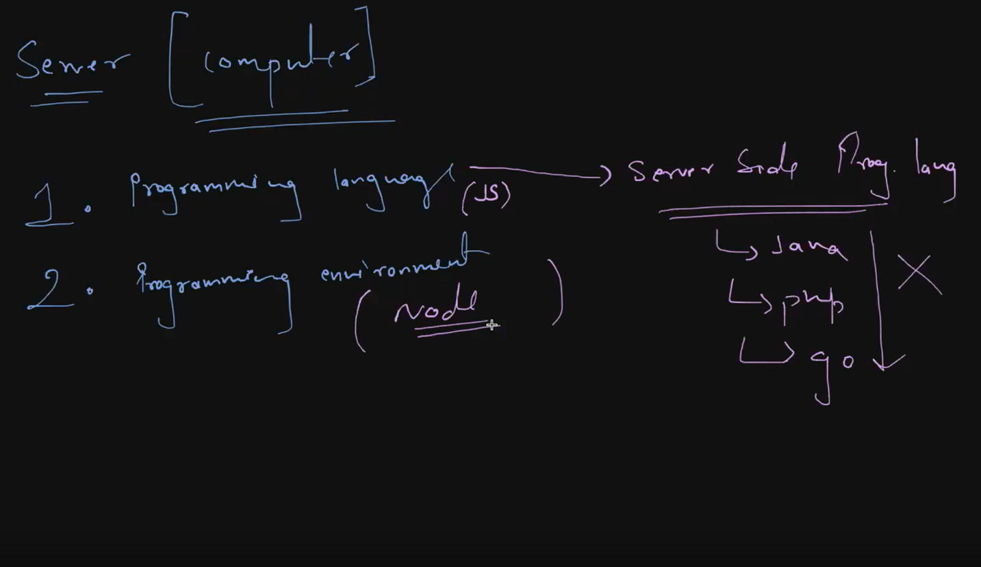

# What is a Programming Language?

A programming language is a formal language comprising a set of instructions that produce various kinds of output. It is used by programmers to write code that a computer can execute to perform specific tasks. Programming languages are essential tools in software development, allowing developers to create software applications, scripts, and other sets of instructions for computers to follow.

# Page:7

# What is a Programming Environment?

A programming environment refers to the collection of tools and resources used to write, test, and debug code. It encompasses everything needed to develop software efficiently and effectively. The programming environment can vary based on the language being used and the type of development work being done.

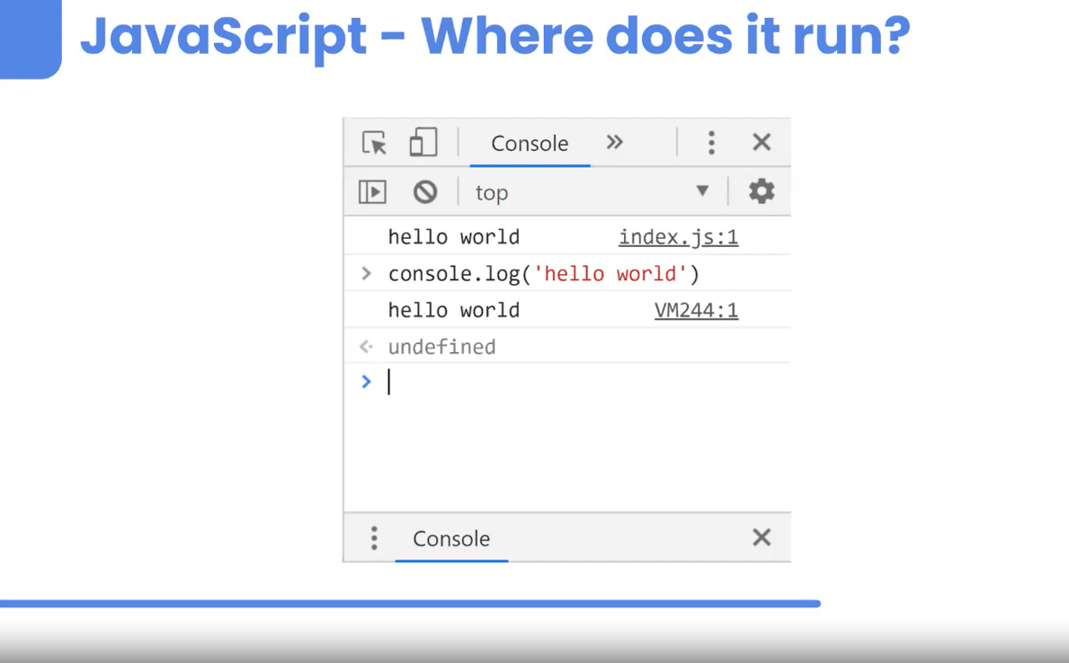

Node.js is a powerful runtime environment that allows JavaScript to be executed outside of a web browser. Traditionally, JavaScript was used exclusively for client-side scripting within web browsers. However, Node.js extends the capabilities of JavaScript to the server-side, enabling developers to build server-side applications, command-line tools, and more using JavaScript.

# What is the V8 Engine?

The V8 engine is an open-source JavaScript engine developed by Google. It was originally designed to power Google Chrome but has been used in various other projects, including Node.js. The V8 engine is written in C++ and is known for its high performance and ability to convert JavaScript code into optimized machine code.

# Page:8

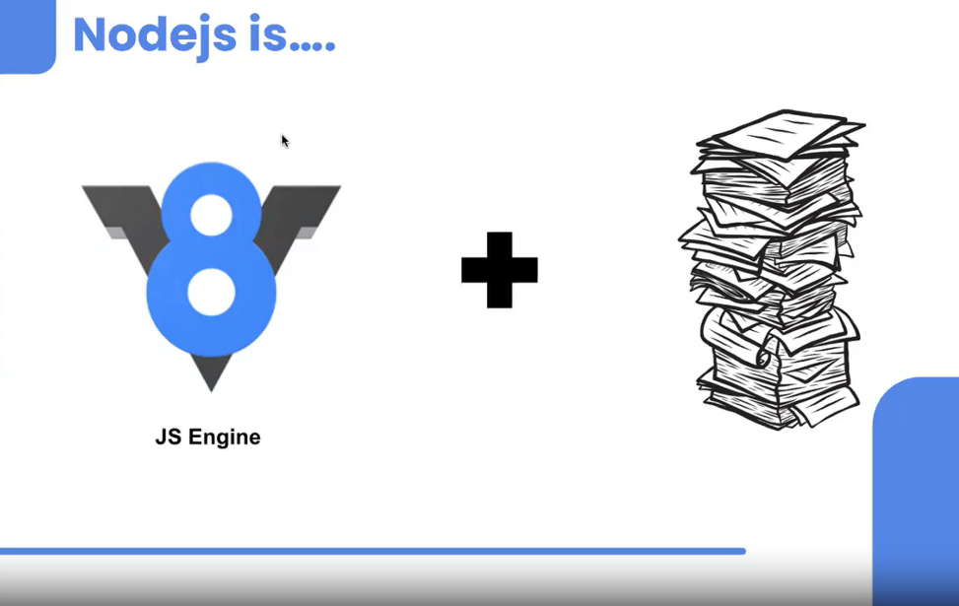

# Node.js Provides Extra Stuff

While V8 provides the core JavaScript execution capabilities, Node.js extends these capabilities with additional features and modules specifically designed for server-side development. Here are some of the key additions that Node.js provides:

# 1. Core Modules

Node.js includes a set of core modules that provide essential functionalities for server-side development. These modules are written in JavaScript and C++ and are compiled into the Node.js binary. Some of the most commonly used core modules include:

* **http**: Used to create HTTP servers and handle HTTP requests and responses.
* **fs**: Provides an API for interacting with the file system, allowing you to read and write files.
* **path**: Utilities for working with file and directory paths.
* **os**: Provides operating system-related utility methods and properties.
* **events**: Implements the event-driven programming model, allowing for event emitters and listeners.
* **net**: Provides a way to create servers and clients for TCP and other network protocols.