**Step 1: Download Java Development Kit (JDK)**

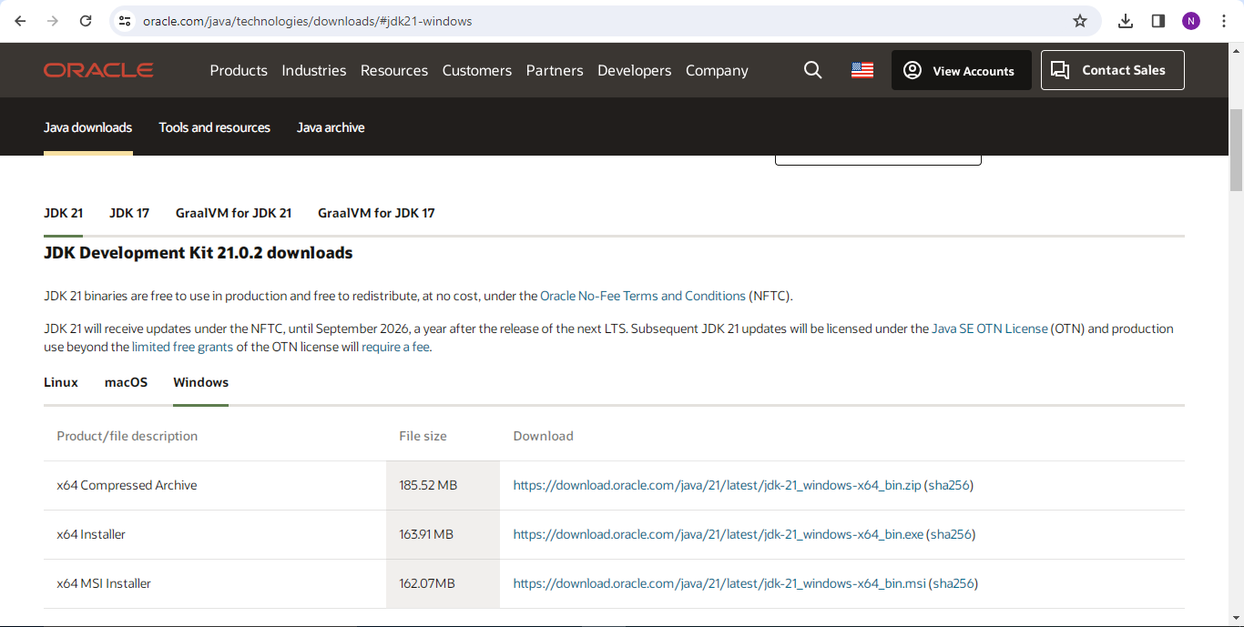

**Step 2: Install Java Development Kit (JDK)**

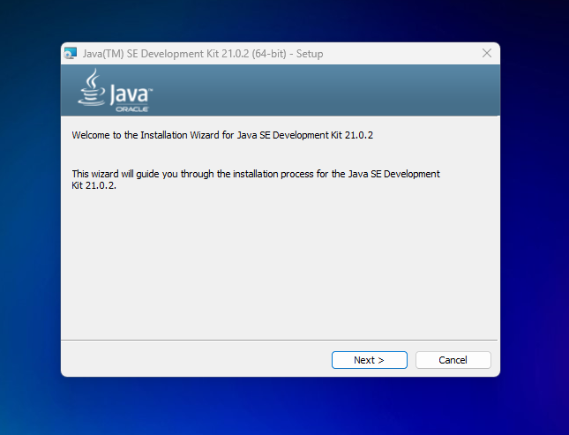

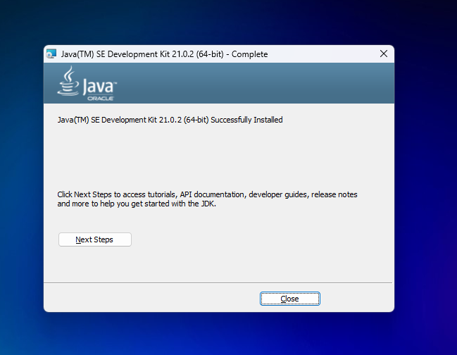

**Step 3: Check the Java Version**

